**Supplementary Information**

**Sample Measurement**

The MSL drill typically penetrates ~5-6 cm into the solid regolith. The lowermost few cm of powdered material pass up the drill stem and are delivered to CHIMRA. Prior to receiving a new sample, CHIMRA is opened and shaken to remove material remaining from the previous drilling campaign; nevertheless, ~5% contamination is expected. Within CHIMRA, drill fines are sieved to <150 µm and a ~50 mg aliquot of this material is delivered to the CheMin instrument. Samples can be delivered to either pristine or previously used cells having Kapton® or Mylar windows (Blake et al., 2012). Both window types contribute broad scattering signatures to the diffraction patterns. Kapton® contributes a broad peak centered at ~6.5° 2θ, whereas Mylar has insignificant scattering at low angles but contributes a minor diffuse peak at ~19° 2θ. In addition, an aluminized light shield in the beam path contributes “peaks” to the observed diffraction patterns at ~25.6° and ~31.9° 2θ. Mylar® cells are preferred when searching for diffraction signatures from phyllosilicates or other materials having diffraction peaks at low angles.

CheMin collects XRD and XRF data simultaneously in a transmission geometry using a Co X-ray tube (Blake et al., 2012). The instrument is operated in single-photon counting mode, meaning that the CCD imager is read and erased rapidly (10 sec/frame) so that in the vast majority of cases, an individual x,y pixel on the CCD only accumulates the charge from either a single X-ray photon or background. When operated in this fashion, the instrument can record both the energy of each photon and its x,y position on the array. The energy and positional information of detected photons in each frame are summed over repeated 10-sec measurements into a “minor frame” of 30 min of data (180 single frames). CheMin operates for up to ~8 hours each night when the CCD can be cooled to its lowest temperature. As a result, XRD data are acquired over multiple sols for each sample to provide acceptable counting statistics. CheMin generally collects ~15 minor frames per sol, and 3-4 sols of data are accumulated during a complete analysis.

Only ~10 mm3 of material is required to fill the active portion of the sample cell, which is a disc- shaped volume 8 mm in diameter and 175 μm thick. The collimated ∼70 μm diameter X-ray beam illuminates the center of the sample cell. A piezoelectric vibration system on each cell shakes the material during analysis, causing all of the grains to pass through the X-ray beam in random orientations over the time course of an analysis. The quality of the 2D XRD pattern is critically dependent on proper grain motion.

Drilled and sieved material from the CH sample was placed into a pristine cell having Mylar windows, and 75 minor frames of data were collected over five sols (0776, 0772, 0777, 0779 and 0786). Grain motion was excellent for all sols; as a result all 75 minor frames are included in the analysis. Drilled and sieved material for the MJ sample was placed into a pristine cell having Kapton® windows, and 60 minor frames were collected over four sols (0885, 0891, 0895 and 0954). Grain motion was excellent for the first three sols while the 4th sol’s data showed signs of grain sticking and poor motion; as a result, only the first 45 minor frames of data are included in the MJ analysis. Drilled and sieved material for the TP sample was placed into a pristine cell having Kapton® windows, and 75 minor frames of data were collected over five sols (0923, 0926, 0934, 0941and 0949). For TP, signs of grain sticking and poor motion were evident throughout the analysis, so that although all 75 minor frames were included in the analysis, the quality of the diffraction result is compromised to an unknown extent (generally, in cases of poor grain motion, qualitative mineralogy is not affected; however the quantitative abundance of individual phases may deviate by several percent from their true values. Drilled and sieved material from the BK sample was placed into a pristine cell having Kapton® windows, and 45 minor frames were collected over three sols (1062, 1074 and 1079). For BK, only the first four minor frames displayed good grain motion; grain sticking and poor grain motion were evident in the last 41 minor frames. For this reason, only the first four minor frames of data are utilized in the BK analysis (Morris et al., 2016).

**Data processing**

The 2-D distribution of Co-Kα X-ray intensity comprises the XRD pattern of the sample and circumferential integration of these rings, corrected for arc length, produces a conventional 1-D XRD pattern. CheMin was calibrated on the ground before flight using a quartz-beryl standard, and measurement of this standard on Mars showed no changes in instrument geometry or dimensions.

For each sample, two-dimensional minor frame images were summed and converted to a 1-D diffraction pattern using the computer code “GSE_ADA© for NASA” beta version 1.09 (Dera et al., 2013). The GSE_ADA code sums diffraction events circumferentially around the 2-D diffraction image based on the distance from sample to CCD, the location of the X-ray beam center, the shape of the beam, and the tilt of the CCD surface with respect to the X-ray beam.

Individual sample cells can vary from the ideal distance from sample to CCD by as much as ±70 µm. These offsets do not impede phase identification but will slightly shift unit-cell parameters calculated during Rietveld refinement. Plagioclase is present in all samples measured to date and is used to calculate and correct for the individual offsets of each cell based on unit-cell measurements of terrestrial plagioclase samples (Morrison et al., 2016). The sample cell offsets determined for CH, MJ, and TP are -42, +2, and -29, respectively. These offsets were used in calculating the 1-D patterns, effectively removing this source of error from the analysis.

**Equilibrium Modeling**

Equilibrium calculations were performed using GEM-Selektor geochemical modeling software (Kulik et al., 2013). Solid phase with a Confidence Hills (CH) composition (APXS post-sieve dump pile) was equilibrated with water in the presence of a gas phase at 25 °C and 1 bar. The gas phase had a composition of Mars present day atmosphere (CO2 95.9%, Ar 2%, N2 1.9%, O2 0.14%, CO 0.06%; Mahaffy et al., 2013). Equilibrium speciation under anoxic conditions was estimated for the following conditions: 10 g CH solid phase, 1000 g H2O(l) and 10 g gas phase (0.01 rock to water ratio). Then 10 g O2 was introduced into the initial system to calculate speciation under oxic conditions. Equilibrium modeling was run in the pH range from 2 to 10, and pH was adjusted by adding H2SO4 or NaOH.

**References**

Dera, P., Zhuravlev, K., Prakapenka, V., Rivers, M.L., Finkelstein, G.J., Brubor-Urosevic, O., Tschauner, O., Clark, S.M., Downs, R.T., 2013. High pressure single-crystal micro X-ray diffraction analysis with GSE_ADA/RSV software. High Pressure Res., 33, doi:10.1080/08957959.2013.806504.

Kulik, D.A., Wagner, T., Dmytrieva, S.V., Kosakowski, G., Hingerl, F.F., Chudnenko, K.V., Berner, U.R., 2013. GEM-Selektor geochemical modeling package: revised algorithm and GEMS3K numerical kernel for coupled simulation codes. Computat. Geosci. 17, 1-24, doi:10.1007/s10596-012-9310-6.

Mahaffy, P.R., Webster, C.R., Atreya, S.K., Franz, H., Wong, M., Conrad, P.G., Harpold, D., Jones, J.J., Leshin, L.A., Manning, H., Owen, T., Pepin, R.O., Squyres, S., Trainer, M., MSL Science Team, 2013. Abundance and isotopic composition of gases in the martian atmosphere from the Curiosity rover. Science 341, 263-266, doi:10.1126/science.1237966.

Morrison, S.M., Downs, R.T., Blake, D.F., Vaniman, D.T., Ming, D.W., Rampe, E.B., Bristow, T.F., Chipera, S.J., Yen, A.S., Morris, R.V., Treiman, A.H., Sarrazin, P.C., Achilles, C.N., Fendrich, K.V., Morookian, J.M., Crisp, J.A., Farmer, J.D., Des Marais, D.J., Craig, P.I., 2016. Improving the accuracy of unit-cell parameters obtained from the CheMin instrument on Mars through an internally calibrated sample offset. Goldschmidt Abstract #2822.

**Supplementary Tables**

**Table S1.** Calculated composition of the bulk sample, crystalline component, and amorphous+phyllosilicate component of Confidence Hills using APXS measurements of the post-sieved dump pile and amorphous and mineral abundances determined with CheMin data.

|  |  |  |  |
| --- | --- | --- | --- |
| Elemental Oxide | Bulk | Crystalline | Amorphous+Phyllosilicate |
| SiO2 | 47.51 | 43.03 | 52.61 |
| TiO2 | 1.12 | 0.07 | 2.30 |
| Al2O3 | 9.61 | 12.54 | 6.27 |
| Cr2O3 | 0.39 | 0.13 | 0.67 |
| FeOT | 20.63 | 25.09 | 15.55 |
| MnO | 0.37 | 0.15 | 0.61 |
| MgO | 5.48 | 5.49 | 5.46 |
| CaO | 4.52 | 7.58 | 1.05 |
| Na2O | 2.62 | 2.38 | 2.89 |
| K2O | 0.97 | 1.54 | 0.31 |
| P2O5 | 1.01 | 1.02 | 1.00 |
| SO3 | 4.80 | 0.67 | 9.49 |
| Cl | 0.40 | 0.00 | 0.86 |
| H2O | 0.22 | 0.27 | 0.00 |
| CO2 | 0.00 | 0.00 | 0.00 |
| Sum | 99.63 | 99.98 | 99.06 |
| % component |  | 53.2 | 46.8 |

**Table S2.** Calculated composition of the bulk sample, crystalline component, and amorphous+phyllosilicate component of Mojave 2 using APXS measurements of the post-sieved dump pile and amorphous and mineral abundances determined with CheMin data.

|  |  |  |  |
| --- | --- | --- | --- |
| Elemental Oxide | Bulk | Crystalline | Amorphous |
| SiO2 | 48.86 | 41.29 | 55.39 |
| TiO2 | 1.18 | 0.04 | 2.15 |
| Al2O3 | 11.29 | 15.41 | 7.73 |
| Cr2O3 | 0.37 | 0.09 | 0.61 |
| FeOT | 16.74 | 21.41 | 12.72 |
| MnO | 0.40 | 0.09 | 0.66 |
| MgO | 4.49 | 3.22 | 5.59 |
| CaO | 4.28 | 9.21 | 0.02 |
| Na2O | 2.97 | 3.05 | 2.91 |
| K2O | 0.72 | 0.90 | 0.57 |
| P2O5 | 1.27 | 1.78 | 0.84 |
| SO3 | 6.19 | 2.40 | 9.46 |
| Cl | 0.42 | 0.00 | 0.79 |
| H2O | 0.41 | 0.88 | 0.00 |
| CO2 | 0.00 | 0.00 | 0.00 |
| Sum | 99.59 | 99.77 | 99.43 |
| % component |  | 46.3 | 53.7 |

**Table S3.** Calculated composition of the bulk sample, crystalline component, and amorphous component of Telegraph Peak using APXS measurements of the post-sieved dump pile and amorphous and mineral abundances determined with CheMin data.

|  |  |  |  |
| --- | --- | --- | --- |
| Elemental Oxide | Bulk | Crystalline | Amorphous |
| SiO2 | 52.10 | 50.29 | 55.04 |
| TiO2 | 1.22 | 0.03 | 3.14 |
| Al2O3 | 10.62 | 13.48 | 5.97 |
| Cr2O3 | 0.36 | 0.07 | 0.82 |
| FeOT | 19.41 | 19.32 | 19.56 |
| MnO | 0.25 | 0.08 | 0.51 |
| MgO | 2.90 | 3.58 | 1.78 |
| CaO | 4.32 | 6.72 | 0.43 |
| Na2O | 3.30 | 2.60 | 4.45 |
| K2O | 0.97 | 1.43 | 0.21 |
| P2O5 | 1.31 | 1.43 | 1.38 |
| SO3 | 2.51 | 1.27 | 5.34 |
| Cl | 0.30 | 0.77 | 0.78 |
| H2O | 0.19 | 0.00 | 0.00 |
| CO2 | 0.00 | 0.31 | 0.00 |
| Sum | 99.75 | 0.00 | 99.42 |
| % component |  | 61.9 | 38.1 |

**Table S4.** Calculated composition of the bulk sample, crystalline component, and amorphous component of Buckskin using APXS measurements of the post-sieved dump pile and amorphous and mineral abundances determined with CheMin data.

|  |  |  |  |
| --- | --- | --- | --- |
| Elemental Oxide | Bulk | Crystalline | Amorphous |
| SiO2 | 73.65 | 68.20 | 77.01 |
| TiO2 | 1.57 | 0.12 | 2.54 |
| Al2O3 | 5.66 | 13.91 | 0.04 |
| Cr2O3 | 0.10 | 0.00 | 0.17 |
| FeOT | 5.49 | 7.27 | 4.71 |
| MnO | 0.09 | 0.00 | 0.15 |
| MgO | 0.82 | 0.16 | 1.26 |
| CaO | 3.05 | 5.25 | 1.54 |
| Na2O | 2.08 | 2.80 | 1.58 |
| K2O | 0.96 | 1.35 | 0.69 |
| P2O5 | 1.25 | 0.00 | 2.09 |
| SO3 | 4.80 | 1.06 | 7.31 |
| Cl | 0.29 | 0.00 | 0.49 |
| Sum | 99.81 | 100.12 | 99.60 |
| % component |  | 40 | 60 |

**Supplementary Figures**

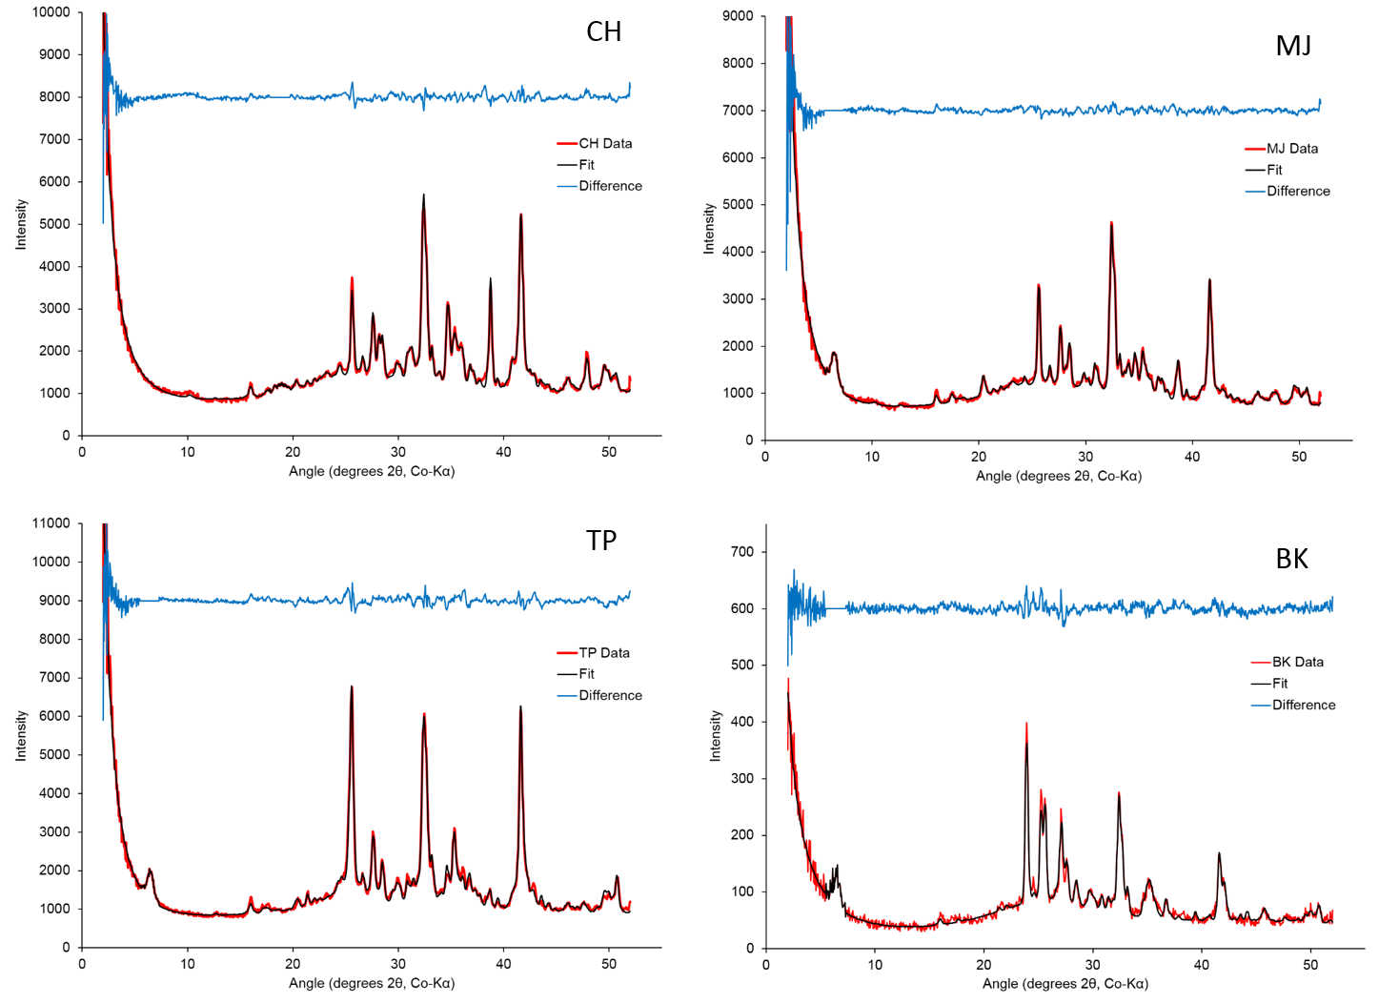

**Figure S1.** Measured CheMin XRD patterns of the samples taken from the Pahrump Hills (red), calculated patterns from Rietveld refinement (black), and difference patterns (blue) for Confidence Hills (CH), Mojave 2 (MJ), Telegraph Peak (TP), and Buckskin (BK). Data for Buckskin are reported by Morris et al. (2016).

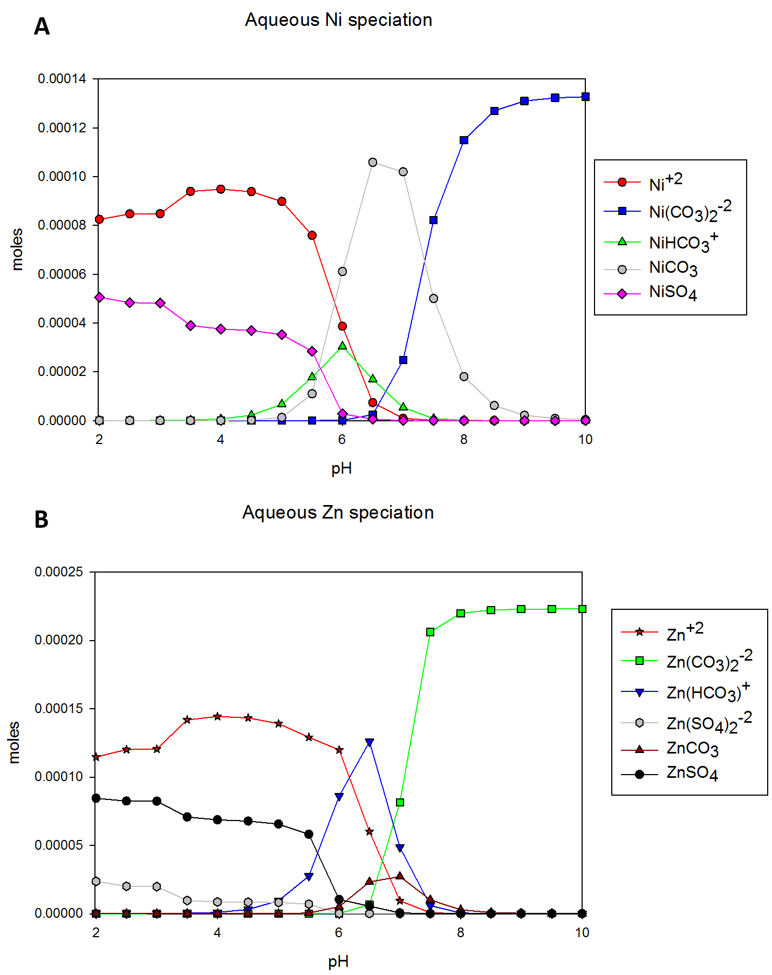

**Figure S2.** Aqueous speciation of (A) nickel species and (B) zinc species from equilibrium modeling of a solid phase of CH composition in oxic conditions. (See Supplementary Information for details of modeling methods.)



**Figure S3.** The effects of cation substitution and/or structural vacancies on the a-cell length in magnetite. The number of Fe atoms per formula unit (apfu) are plotted against *a*-cell length for magnetites with various substitutions. The vertical dashed pink line represents the refined *a*-cell length for the magnetite in the Murray formation.