High-rate and efficient ethylene electrosynthesis using a catalyst:promoter:transport layer
Adnan Ozden^{1†}, Fengwang Li^{2†}, F. Pelayo García de Arquer², Alonso Rosas-Hernández³, Arnaud Thevenon³, Yuhang Wang², Sung-Fu Hung², Xue Wang², Bin Chen², Jun Li^{1,2}, Joshua Wicks², Mingchuan Luo², Ziyun Wang², Theodor Agapie³*, Jonas C. Peters³*, Edward H. Sargent²* & David Sinton¹*
¹Department of Mechanical and Industrial Engineering, University of Toronto, 5 King’s College Road, Toronto, Ontario, M5S 3G8, Canada.
²Department of Electrical and Computer Engineering, University of Toronto, 10 King’s College Road, Toronto, Ontario, M5S 3G4, Canada.
³Joint Center for Artificial Photosynthesis and Division of Chemistry and Chemical Engineering, California Institute of Technology, Pasadena, California, 91125, USA.
†These authors contributed equally to this work.
*Correspondence and requests for materials should be addressed to David Sinton (D.S.) (sinton@mie.utoronto.ca), Edward H. Sargent (E.H.S.) (ted.sargent@utoronto.ca), Jonas C. Peters (J.C.P.) (jpeters@caltech.edu), and Theodor Agapie (T.A.) (agapie@caltech.edu).
ABSTRACT
Carbon dioxide (CO₂) electroreduction to valuable chemicals such as ethylene is an avenue to store renewable electricity and close the carbon cycle. Membrane electrode assembly (MEA) electrolyzers have attracted recent interest in light of their high stability, and despite low productivity: a modest partial current density in CO₂-to-ethylene conversion of approximately 100 mA cm⁻². Here we present an adlayer functionalization catalyst design: a catalyst:tetrahydro-phenanthrolinium:ionomer (CTPI) interface in which the catalytically-active copper is functionalized using a phenanthrolinium-derived film and a perfluorocarbon-based polymeric ionomer. We find, using electroanalytical tools and operando spectroscopies, that this hierarchical adlayer augments both the local CO₂ availability and the adsorption of the key reaction intermediate CO on the catalyst surface. Using this CTPI catalyst, we achieve an ethylene Faradaic efficiency of 66% at a partial current density of 208 mA cm⁻² – a two-fold increase over the best prior MEA electrolyzer report – and an improved full-cell energy efficiency of 21%.

TOC GRAPHIC
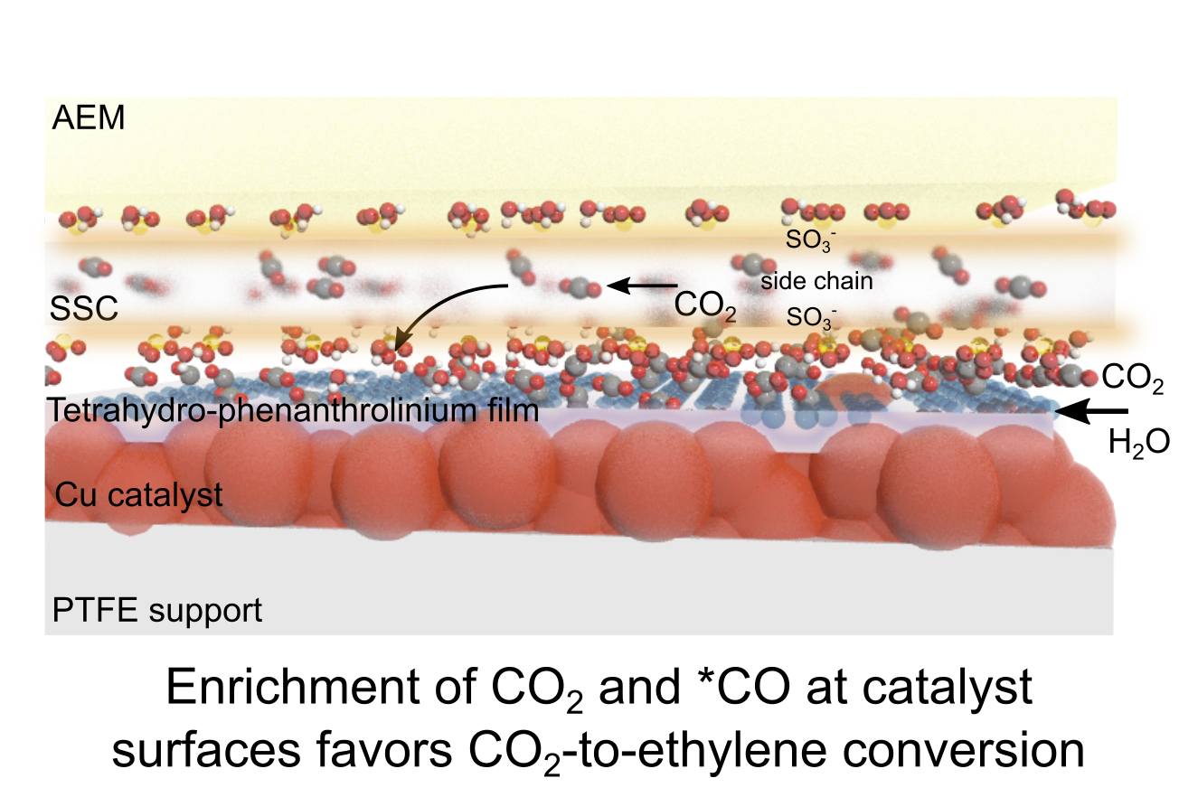
The electrochemical CO₂ reduction reaction (CO₂RR) offers storage of intermittent electricity from solar and wind in the form of fuels and value-added chemicals,^{1–3} enabling further penetration of renewables in the transportation and chemical industries.^{4–8}
Implementation of CO₂RR will require high productivity to reduce capital cost, and high energy efficiencies (EE) to reduce operating cost. Techno-economic assessments further emphasize the need for high activity in generating high-value CO₂RR products, such as ethylene, well beyond the 100 mA cm⁻² threshold.^{9,10} Conventional H-cells deliver current densities of only tens of mA cm⁻² due to CO₂ mass transport limitations in aqueous solutions.^{11,12}
Introducing CO₂ in the gas phase enables facile CO₂ mass transport from the bulk to the local electrode by decreasing the thickness of the diffusion layer from tens of micrometers to tens of nanometers, permitting CO₂RR current densities above 100 mA cm⁻².^{13–15} In such a flow-cell configuration, a gas diffusion electrode (GDE) separates gas-phase CO₂ from either alkaline or neutral electrolyte.^{16,17} However, ohmic loss across the neutral electrolyte that extends between cathode and anode leads to a high overpotential when the current density is high, limiting EE.¹⁸ Though the use of alkaline electrolyte increases ionic conductivity and enables higher current densities and EEs,¹⁷ the formation of carbonate salt from the reaction of CO₂ with alkali electrolyte wastes reactant CO₂, reduces system stability, and increases cost.⁸
Membrane electrode assembly (MEA) electrolyzers form an integrated layered stack by removing the catholyte and merging the cathode:ion-exchange membrane:anode (Figure 1a).^{16–20} MEAs developed for fuel cells and water electrolyzers and achieved current densities >1 A cm⁻².^{21–23} However, with present day MEAs, CO₂RR activities towards ethylene are still limited to approximately 100 mA cm⁻².^{18,24,25}
Here we present hierarchical adlayer – a catalyst:tetrahydro-phenanthrolinium:ionomer (CTPI) structure – that enables high-rate and efficient electrosynthesis of ethylene in an MEA electrolyzer. In this design, the catalytically-active copper is modified by a phenanthrolinium-derived molecular film and a perfluorocarbon based polymeric ionomer. This hierarchical adlayer augments simultaneously the availability of reactant CO₂ and the binding strength of *CO, a key intermediate along the pathway to ethylene.^{26,27} These two factors contribute to current densities and EEs in CO₂RR.
We achieve as a result ethylene partial current densities greater than 200 mA cm⁻² – a two-fold enhancement in rate compared to the best prior reports in MEA electrolyzers.^{18,24} We do this with an ethylene Faradaic efficiency (FE) of 66% and a full-cell EE of 21% – the highest selectivity, and the highest efficiency, reported for MEA-based CO₂RR electrolyzers.
We sought to diagnose the origins of low current densities in MEA electrolyzers. Using polycrystalline Cu (150 nm thick) sputtered on a porous polytetrafluoroethylene (PTFE, average pore size of 450 nm) gas diffusion layer (Figure S1) as the cathode (Cu/PTFE), iridium oxide supported on a titanium mesh as the anode, and an anion exchange membrane (AEM) as the solid-state electrolyte, we assembled the MEA (Figure S2) and explored the CO₂RR performance at the voltage range of -3 V – -4.5 V. Both total current density and ethylene FE increase with increasing voltage, and the peak ethylene FE reaches 45% at -3.8 V. This trend results in a peak ethylene partial current density of ~75 mA cm⁻² (Figure 1b). The limiting current density was positively correlated with the partial pressure of CO₂ supplied (Figure S3), suggesting that mass transport of CO₂ could be limiting the reaction rate. The full-cell EE was 14% based on Equation (1):
$\text{EE = }\frac{\text{E}\text{°}}{{\text{E}}_{\text{applied}}}\text{ ×}{\text{ FE}}_{\text{ethylene}}$ Equation (1)
where E° is 1.15 V, the thermodynamic potential for the overall reaction 2CO₂ + 2H₂O → C₂H₄ + 3O₂.
It is suggested that the CO₂ concentration decreases rapidly at the gas/liquid/solid three-phase interface (Figure 1c): since CO₂RR uses water as the proton source²⁶ and generates local hydrated OH⁻, a significant portion of the catalyst surface is likely inaccessible to CO₂,^{28,29} and the competing HER dominates in these areas (Figure 1d).
We took the view that CO₂RR kinetics would increase if the transport of CO₂ to catalyst surfaces was unimpeded by OH⁻/H₂O, i.e. with separate gas and ion/liquid transport channels that improve CO₂ transport and avoid consumption of CO₂ by OH⁻. We took inspiration from the role of ionomers in the enhancement of oxygen reduction reaction (ORR) kinetics in fuel cells through concurrent transport of reactants, by-products and charged species,^{30,31} and explored the viability of ionomers on CO₂RR performance of Cu catalysts. We reasoned that the hydrophobic and hydrophilic segments of the ionomer would allow the transport of gas and hydrated ions, respectively.³²
We formed nm-thick polymeric films via the spray-coating of an ionomer solution onto the Cu/PTFE substrate and tested CO₂RR performance (Figure S4 for the morphology). A short-side-chain (SSC) perfluorocarbon polymer^{32,33} (Figure 1b) was used as the ionomer. It is composed of a hydrophobic PTFE backbone and a hydrophilic side chain terminated by sulfonic acid. We found that the SSC extends the ethylene partial current density to 280 mA cm⁻² (Figure 1b and S5). The increased current density is attributed to increased CO₂ transport achieved by the separation of CO₂ and ion/H₂O pathways. As in prior reports,^{32,34} a much larger portion of the catalyst becomes accessible to gas (CO₂) via a hydrophobic backbone while the transport of ions/H₂O is retained within hydrophilic side chains (Figures 1e and 1f). This effect is akin to the well-coordinated, simultaneous transport of O₂ and proton/H₂O transports in fuel cells.^{30,31} The length of the side chain in the ionomer does not markedly affect the productivity of ethylene from CO₂RR (Figure S6). Although the partial current density for ethylene is increased to >200 mA cm⁻², the ethylene FE around 52% is only slightly higher than that of the reference Cu/PTFE case, and the high (-4.5 V) potential required (Figures 1b and S5) renders a low full-cell EE <15%. We realized that, at the optimum voltage for the reference Cu/PTFE, -3.8 V, the FE towards CO for the SSC-modified Cu is 25% while that for the Cu/PTFE is 13%. Converting the excess CO to ethylene while maintaining a similar applied voltage would improve EE.
We sought to introduce a further adlayer on catalyst surfaces with an organic film functioning similar to pyridinium-derived films.^{24,35} We postulated that conformal hierarchical deposition of such a layer together with SSC ionomer on the Cu surface – without disrupting SSC benefits and blocking the catalytically active sites (Figure S7) – may optimize the binding of *CO, and therefore promote CO-to-ethylene conversion (Figure 2a).
We electro-reduced N,N’-ethylene-phenanthrolinium dibromide onto the Cu/PTFE catalyst to form a 20±5 nm continuous and conformal film (Figure S8) comprising primarily the 4,4' and 2,2' dimeric structures (Figure 2b and S9), in accordance with previous findings on polycrystalline copper.³⁵ While it is possible that during extended storage the molecular film composition evolves (Figure S9), for example via partial oxidation, its CO₂RR performance is high even after a period of weeks. We then spray-deposited the electrode with a 15±5 nm SSC ionomer layer, and the resulting electrode possessed a similar morphology to the unmodified Cu/PTFE (Figures 2c, S1 and S10).
We found that the phenanthrolinium-derived molecular film enables an improved ethylene FE. Applying the optimal tetrahydro-phenanthrolinium loading to the Cu/PTFE surface (Figure S11), we achieved an ethylene FE of 58% at an applied voltage of -3.7 V (Figures 2d and S12). The increased ethylene FE at the expense of CO FE (Figure S12) is consistent with the prior report.²⁴ Due mainly to the improved FE, the full-cell EE improved from 14% for the reference Cu/PTFE, to 18%.
Although the ethylene FE is high for the tetrahydro-phenanthrolinium-modified Cu/PTFE catalyst, the partial current density was capped at around 110 mA cm⁻², in agreement with the picture of limited CO₂ transport. To recover the already-achieved high current density observed in the SSC-modified Cu/PTFE case, we re-introduced the outermost SSC layer to the tetrahydro-phenanthrolinium-modified Cu/PTFE catalyst (see Figures 2c and S13 for the SEM images). We found that the FE and partial current density towards ethylene are increased, especially at the applied voltage region where the CO₂RR is otherwise limited by CO₂ mass transport, as in the case of tetrahydro-phenanthrolinium-modified Cu/PTFE electrode (Figure 2e). By optimizing the tetrahydro-phenanthrolinium loading and the hierarchical ordering in the tetrahydro-phenanthrolinium/SSC film (Figures S14 and S15), we achieved (at -4.4 V) a peak ethylene FE of 69% with a partial current density of 304 mA cm⁻², both of which are the highest performance metrics for CO₂RR MEA electrolyzers to date. The full-cell EE is 18%, a similar value to that achieved by the tetrahydro-phenanthrolinium-modified Cu, due to the compromise between increased ethylene FEs and simultaneously increased applied potentials.
By performing electrochemical impedance spectroscopy (EIS) measurements, we found that modification of the Cu/PTFE electrode with tetrahydro-phenanthrolinium or together with SSC ionomer does not substantially change the resistances at the interface (Table S1), thus yielding similar cell resistances overall (Figure S16).
This tetrahydro-phenanthrolinium molecule was reported in a recent flow cell electrolyzer study, with operating current densities lower than 10 mA cm⁻²,³⁵ and has not been applied to GDE-based CO₂RR MEA electrolyzers. To clarify the CO-adsorption enhancing role of the tetrahydro-phenanthrolinium in this new system, we used CO as a probe molecule and carry out the CO reduction reaction (CORR) using 3 M KOH as the anolyte, a condition that has been proven to promote CORR.^{36,37} We found that the tetrahydro-phenanthrolinium-modified Cu/PTFE shows a higher ethylene FE (Figure 2f) and partial current density (Figure 2g) in both cases, with and without the SSC layer. We note also that the SSC ionomer layer promotes higher current densities, benefiting from the improved availability of CO near the active sites, akin to the case of CO₂.
Using in situ Raman spectroscopy, we found that the tetrahydro-phenanthrolinium increases the ratio of atop- to bridge- bound CO from 0.14 on Cu to 0.51 (Figure 2h), an optimum value we found previously²⁴ that resulted in a low activation barrier for C–C coupling, the first step in CORR.^{26,27,38} We further confirmed that the modification of the tetrahydro-phenanthrolinium on Cu does not promote CO₂RR through the tuning of Cu’s electronic structure, a finding we concluded from the unaltered Cu L-edge soft X-ray adsorption spectroscopy (XAS) on the tetrahydro-phenanthrolinium deposited Cu/PTFE upon one-hour electrolysis at an applied voltage of -3.7 V (Figure 2i).
We sought further to improve current densities at similar, if not increased, EEs. A prior report¹⁸ has shown that a lower CO₂ partial pressure favours the ethylene selectivity, which the authors attributed to a high local pH by mitigating the reaction of OH⁻ with excess CO₂. However, at the relatively high current densities tested here, lowering CO₂ partial pressure decreases current density due to less reactant CO₂ availability. Instead, we extended the developed CTPI architecture into three dimensions by establishing a tetrahydro-phenanthrolinium:ionomer hierarchy together with Cu nanoparticles (NPs) on a Cu/PTFE substrate (Figures 3a and 3b): more active sites lead to higher current densities per geometric area and thus meanwhile consume more CO₂ by CO₂RR, resulting in less CO₂ “free” to react with OH⁻.
We spray-coated a homogenous dispersion of Cu NPs, tetrahydro-phenanthrolinium, and SSC ionomer, onto the Cu/PTFE substrate (see Figure S17 for the morphology and microstructure of the mortem electrodes). The tetrahydro-phenanthrolinium precursor was electro-dimerized in situ when CO₂RR was initiated in the MEA (Figure S18), establishing a highly porous catalyst comprised of Cu NPs:tetrahydro-phenanthrolinium:SSC ionomer (Figure S19). The X-ray photoelectron spectroscopy (XPS) peaks corresponding to S2p, N1s, F1s, and Cu2p confirm the presence of each component in the Cu NPs:tetrahydro-phenanthrolinium:SSC catalyst upon completion of CO₂RR (Figure 3c). The N1s spectrum consist of two peaks located at 400.2 eV and 402.5 eV, indicating that the tetrahydro-phenanthrolinium includes tertiary amine and quaternary ammonium, consistent with the prior report.³⁵ The thickness of sputtered Cu, loadings of Cu NPs, and the ratios among Cu NPs, SSC ionomer and tetrahydro-phenanthrolinium, were optimized (Figures S20-S23). We observed the typical gas and liquid products for CO₂RR with a total FE of ~100% (Figure S24).
We investigated the electrochemical performance of the 3D CTPI catalyst in an MEA electrolyzer in neutral media. The electro-dimerized molecular film resulted in an increased ethylene FE compared to the control samples (Figure 3d). The working principle is similar to the planar CTPI catalyst – the tetrahydro-phenanthrolinium promotes ethylene selectivity via favourable conversion of CO (Figure S25), and the SSC ionomer enables higher reaction rates by enhanced CO₂ transport.
The extended reaction interface provided by the 3D catalyst yielded improved reaction rates compared to its 2D counterpart at lower full-cell voltages (Figures 3e and S25), reaching an ethylene partial current density of 208 mA cm⁻² at only -3.9 V. In contrast, the 2D catalyst provides 97 mA cm⁻² at the same potential. The full-cell EE is 21% for the 3D CTPI catalyst, slightly higher than the best prior value in MEA electrolyzers,²⁴ but along with a 2.8x larger current density.
We further assessed the performance of 3D CTPI catalyst under challenging conditions: a diluted CO₂ stream;³⁹ a direct intake of flue gas;^{10,40} and a variable CO₂ feed rate.¹⁷ We simulated the dilution of CO₂ streams (down to 10%) via co-feeding with N₂. The 3D CTPI catalyst maintained ethylene partial current densities >120 mA cm⁻² – along with EEs over 20% – at all concentrations including 10% CO₂ (Figures 4a and S26). Markedly, it yields an ethylene FE of 69% at -3.7 V at a 40% CO₂ concentration, corresponding to a full-cell EE of 22%. We further assessed the 3D CTPI catalyst using a simulated flue gas composed of CO₂ (15.1%), O₂ (3.99%), CO (190 ppm), SO₂ (698 ppm) and N₂ (balance). The 3D CTPI catalyst yields FEs towards ethylene of 22% at -3.8 V, whereas the reference Cu/PTFE provides an ethylene FE below 5% across -3 V – -4.0 V (Figure S27). The direct intake of flue gas decreases selectivity toward CO₂RR at the current densities investigated (Figure S28). This is ascribed to the parasitic ORR,⁴¹ which is thermodynamically more favourable than CO₂RR by more than 1 V, as well as the poisoning of catalysts by SO₂.⁴²
We varied the CO₂ flow rate 25-fold (80 to 3 sccm) while performing CO₂RR with the 3D CTPI catalyst at a constant current density of 300 mA cm⁻². The ethylene FE reached a peak of 67% at ~30 sccm (Figures 4b and S29). Lower flow rates reduced the selectivity, although ethylene production continued with an FE of ~28%, for the lowest CO₂ flow rate of 3 sccm. At this low CO₂ flow rate, the 3D CTPI produced an outlet gas stream with 37% ethylene (molar ratio) (Figure 4b). The comparative value at 80 sccm is 1%. The production of concentrated CO₂RR products reduces downstream product separation/purification costs.^{6,19}
The 3D CTPI catalyst was stable – presenting an average ethylene FE of 63% at a constant current density of 220 mA cm⁻² for over 100 hrs of continuous operation (Figure 4c). We found that the catalyst maintained its morphology and microstructure following the extended electrosynthesis (Figure S30).
By comparing the performance metrics presented herein with literature benchmarks (Figure 4d), we conclude that the 3D CTPI catalyst offers a means to achieve efficient, high-rate CO₂-to-ethylene conversion in MEA electrolyzers.
In summary, this work devises a hierarchical adlayer structure that enables stable, selective CO₂-to-ethylene conversion at high productivity and EE. Benefiting from the catalyst:tetrahydro-phenanthrolinium:ionomer augmentation, the structure offers improved CO₂ availability and optimized adsorption of a key intermediate, CO. In an MEA electrolyzer this strategy achieved an ethylene FE of 66% at partial current densities >200 mA cm⁻² and full-cell EE of 21%. The tetrahydro-phenanthrolinium-augmentation approach extends the boundaries of what can be achieved in today’s CO₂RR MEA electrolyzers and sets out a path for future development.
FIGURES
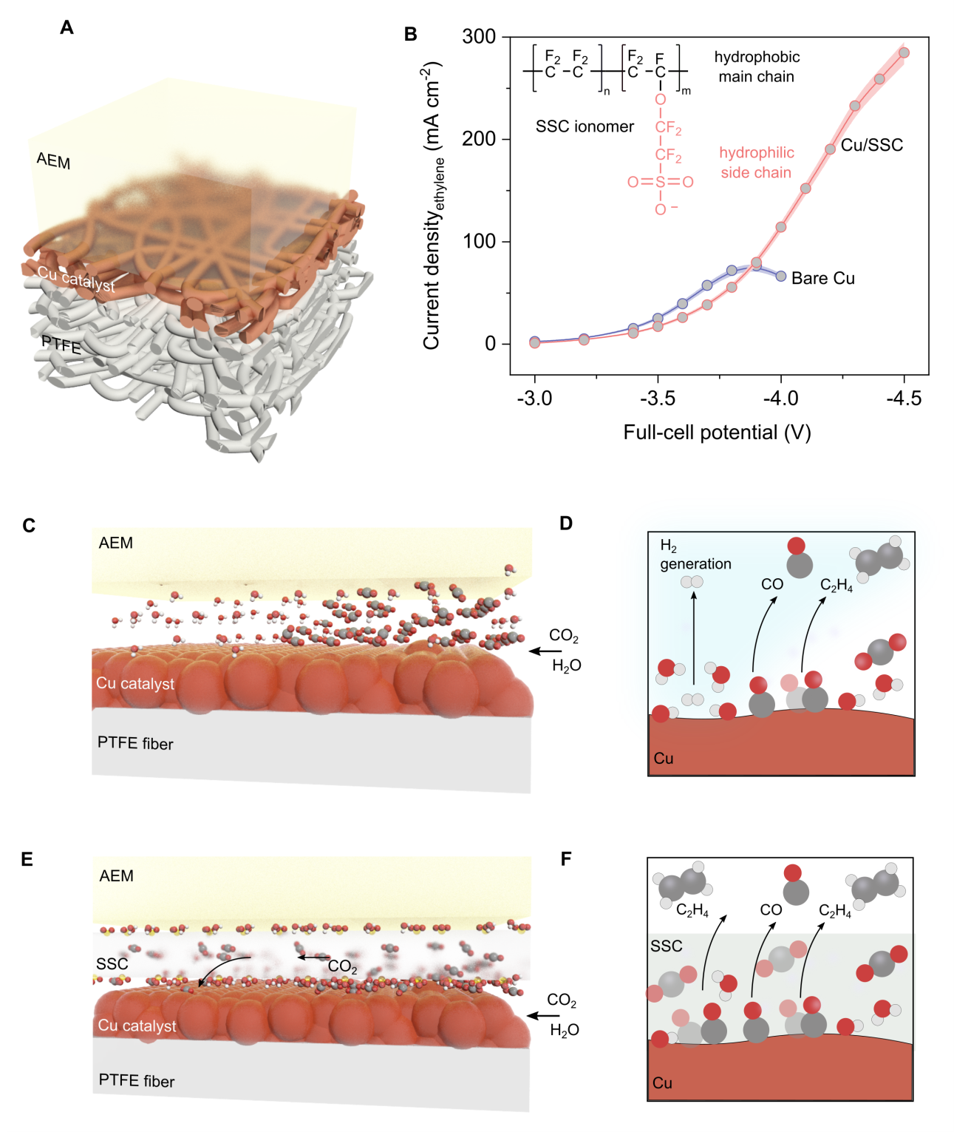

Figure 1. Ionomer-augmented CO₂ availability in an MEA electrolyzer. (A) Cu/PTFE electrode and its interface with the AEM. (B) Ethylene partial current densities under a range of applied voltage for bare Cu/PTFE, and SSC-modified Cu/PTFE electrodes. Inset B describes the chemical structure of the SSC ionomer. The SSC is comprised of hydrophobic PTFE backbone and hydrophilic side chain terminated by sulfonic acid. Full-cell potentials are presented without iR compensation. The CO₂RR electrolysis was operated using CO₂ with a flow rate of 80 sccm, 0.1 M KHCO₃ anolyte with a flow rate of 20 mL min⁻¹. (C) Limited CO₂ availability on unmodified Cu surface. The schematic illustrates the local CO₂ and H₂O transport for a single Cu/PTFE fiber in the cross-sectional direction. (D) Competition between the CO₂RR and HER on unmodified Cu surface. The limited CO₂ availability surface dominates the competing HER over CO₂RR at elevated current densities. (E) Enrichment of CO₂ species in the local reaction environment enabled by SSC ionomer conformably surrounding Cu surface. The schematic illustrates the local CO₂ and H₂O transport for a single Cu/PTFE fiber coated with the SSC ionomer in the cross-sectional direction. (F) Dominancy of the CO₂RR over the HER upon SSC ionomer modification. Note: SSC stands for SSC ionomer.

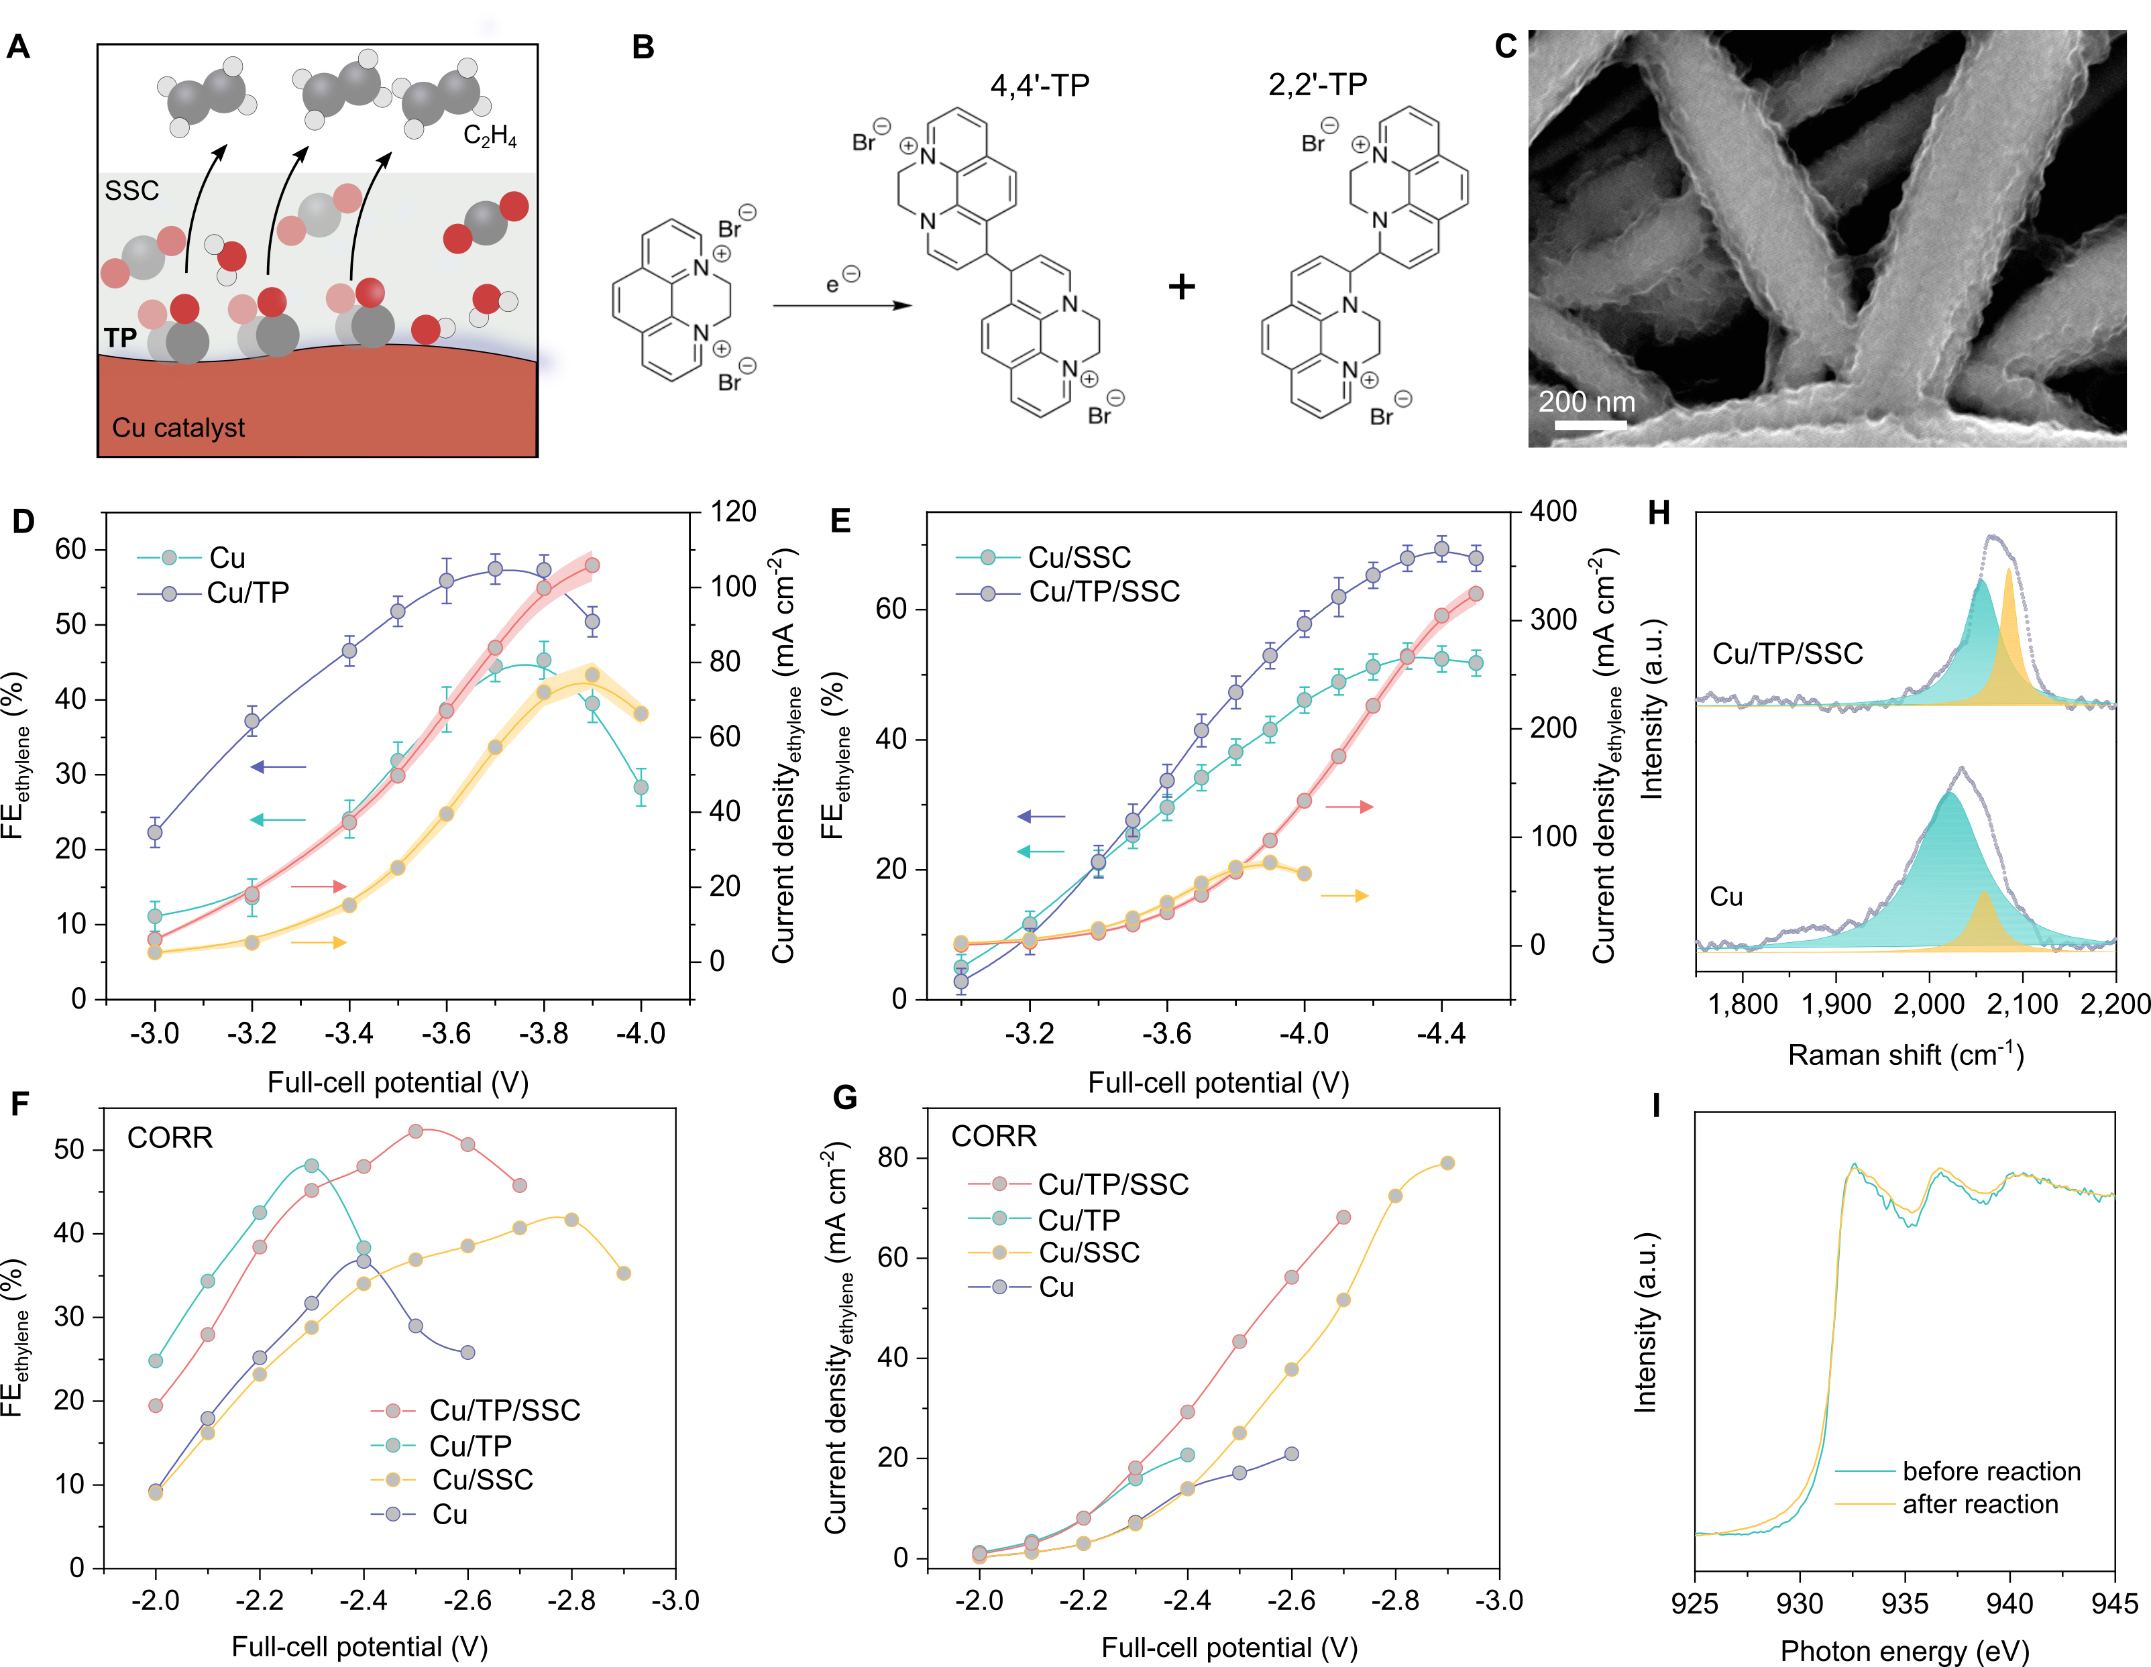
Figure 2. CO₂-to-ethylene conversion in an MEA electrolyzer. (A) Hierarchical tetrahydro-phenanthrolinium:ionomer modified Cu/PTFE surface allows more CO₂ and *CO. (B) Electrodimerization of the phenanthrolinium into the 4,4' and 2,2'-tetrahydro-phenanthrolinium dimeric structures. (C) SEM images of tetrahydro-phenanthrolinium/ionomer on Cu/PTFE. (D) Ethylene FE and partial current density for unmodified Cu/PTFE (yellow line) and tetrahydro-phenanthrolinium-modified Cu/PTFE (red line). (E) Ethylene FE for SSC-modified Cu/PTFE, and ethylene FE and partial current density for tetrahydro-phenanthrolinium/SSC-modified Cu/PTFE (red line), and ethylene partial current density for unmodified Cu/PTFE (yellow line). Full-cell potentials of the CO₂RR electrolysis are presented without iR compensation. The CO₂RR electrolysis was operated using CO₂ with a flow rate of 80 sccm, 0.1 M KHCO₃ anolyte with a flow rate of 20 mL min⁻¹. (F) Ethylene FE for unmodified Cu/PTFE, SSC-modified Cu/PTFE, tetrahydro-phenanthrolinium-modified Cu/PTFE, and tetrahydro-phenanthrolinium/SSC-modified Cu/PTFE for CO-to-ethylene conversion. (G) Ethylene partial current density for unmodified Cu/PTFE, SSC-modified Cu/PTFE, tetrahydro-phenanthrolinium-modified Cu/PTFE, and tetrahydro-phenanthrolinium/SSC-modified Cu/PTFE for CO-to-ethylene conversion. Full-cell potentials of the CORR electrolysis are presented without iR compensation. The CORR electrolysis was operated using CO with a flow rate of 80 sccm, 3 M KOH anolyte with a flow rate of 20 mL min⁻¹. (H) Raman spectra of tetrahydro-phenanthrolinium/SSC ionomer modified Cu/PTFE and unmodified Cu/PTFE (the areas highlighted in blue and yellow indicate the bridge and atop adsorptions of CO on the Cu surface, respectively). (I) XAS spectra of the tetrahydro-phenanthrolinium/SSC-modified Cu/PTFE. Note: TP and SSC stand for tetrahydro-phenanthrolinium and SSC ionomer, respectively.

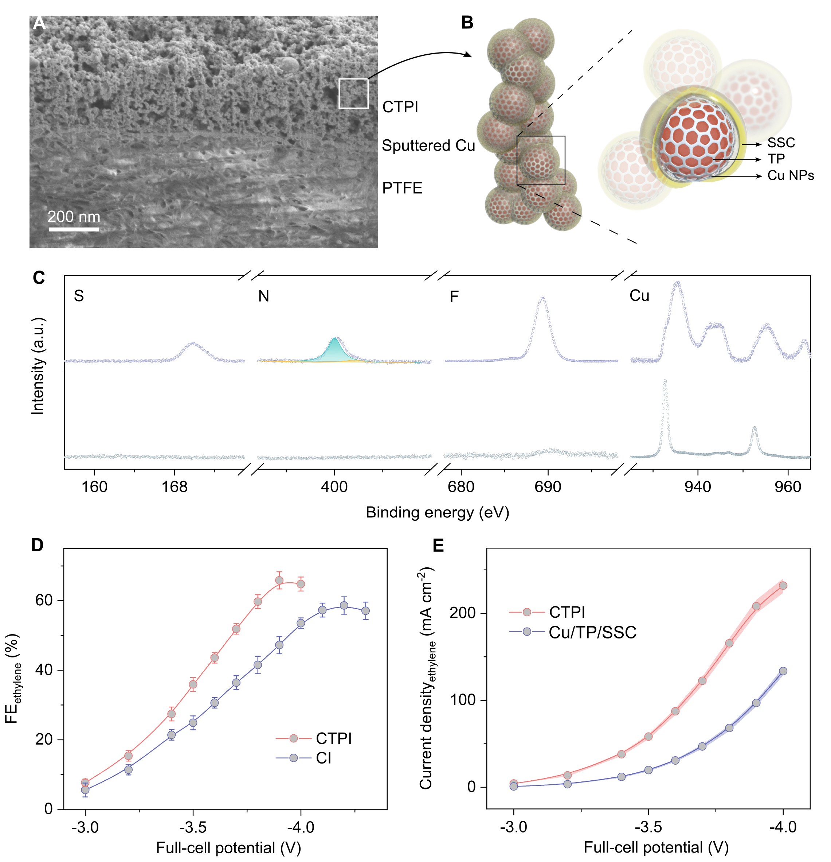
Figure 3. 3D CTPI catalyst enables selective and efficient CO₂-to-ethylene conversion in an MEA electrolyzer. (A) Cross-sectional SEM image of the tetrahydro-phenanthrolinium/SSC ionomer hierarchy established together with Cu NPs on a Cu/PTFE substrate. (B) Schematic illustration of the tetrahydro-phenanthrolinium/SSC ionomer hierarchy on Cu NPs. (C) XPS spectra of the 3D CTPI catalyst. (D) Ethylene FE for 3D CTPI (tetrahydro-phenanthrolinium/SSC-modified Cu NPs on Cu/PTFE) and 3D CI (SSC modified-Cu NPs on Cu/PTFE) for CO₂-to-ethylene conversion. (E) Ethylene partial current density for 3D CTPI (tetrahydro-phenanthrolinium/SSC-modified Cu NPs on Cu/PTFE) and 2D CTPI (tetrahydro-phenanthrolinium/SSC-modified Cu/PTFE (Cu/TP/SSC)). Full-cell potentials are presented without iR compensation. The CO₂RR electrolysis was operated using CO₂ with a flow rate of 80 sccm, 0.1 M KHCO₃ anolyte with a flow rate of 20 mL min⁻¹.

Figure 4. Applied CO₂RR performance of the 3D CTPI catalyst in an MEA electrolyzer. (A) Full-cell EEs and ethylene partial current densities as a function of CO₂ concentration in a diluted CO₂ stream. (B) Ethylene concentrations in the cathode outlet and FEs as a function of CO₂ flow rate. The CO₂RR electrolysis was operated using CO₂ with a flow rate of 80 sccm, 0.1 M KHCO₃ anolyte with a flow rate of 20 mL min⁻¹. (C) Extended CO₂RR performance of the 3D CTPI catalyst at a constant current density of 220 mA cm⁻² and with a feeding gas of CO₂:N₂ (40%:60%) at a flow rate of 80 sccm. The anolyte was 0.1 M KHCO₃ with a flow rate of 20 mL min⁻¹. Blue line represents the voltage recorded during the extended CO₂RR experiment (primary y-axis). Each red square represents the ethylene FE averaged from three independent measurements (secondary y-axis). (D) Comparison of the performance metrics of the MEA electrolyzer based on 3D CTPI catalyst with literature benchmarks (for each report, the plotted values are those from the longest duration test).

ASSOCIATED CONTENT
Notes
The authors declare no competing financial interest.
ACKNOWLEDGMENT
This work was financially supported by the Ontario Research Fund: Research Excellence Program, the Natural Sciences and Engineering Research Council (NSERC) of Canada, the CIFAR Bio-Inspired Solar Energy program and the Joint Centre of Artificial Synthesis, a DOE Energy Innovation Hub, supported through the Office of Science of the US Department of Energy under award no. DE-SC0004993. X-ray absorption spectra were performed on SXRMB beamlines at the Canadian Light Source (CLS), which is supported by the Canada Foundation for Innovation, Natural Sciences and Engineering Research Council of Canada, the University of Saskatchewan, the Government of Saskatchewan, Western Economic Diversification Canada, the National Research Council Canada, and the Canadian Institutes of Health Research. The authors acknowledge Ontario Centre for the Characterization of Advanced Materials (OCCAM) for sample preparation and characterization facilities and thank Dr. Alexander H. Ip, Dr. Christine Gabardo and Mr. Colin P. O’Brien for useful discussions. A.T. acknowledges Marie Skłodowska-Curie Fellowship H2020-MSCA-IF-2017 (793471). J.L. acknowledges the Banting postdoctoral fellowship. D.S. acknowledges the NSERC E.W.R. Steacie Memorial Fellowship.
Supporting Information
Experimental details and additional data. The Supporting Information is available free of charge on the ACS Publications website.

AUTHOR CONTRIBUTIONS
D.S. and E.H.S. supervised the project. A.O. conceived the idea and carried out the electrochemical experiments with advice from F.L.. A.T. and A.R.H. synthesized and characterized the tetrahydro-phenanthrolinium. A.O. carried out Raman and EIS measurements. Y.W. and A.O. carried out SEM imaging. F.L. and S.F.H. designed the XAS measurements. S.F.H. performed the XAS measurements. X.W. performed the NMR analysis and provided help in EIS measurements. B.C. and Y.W. performed the TEM analysis. J.W. performed XPS measurements. M.L., J.L., and Z.W. provided help in electrochemical experiments. A.O. and F.L. wrote the manuscript. F.P.G.A. provided help in manuscript writing. All authors discussed the results and assisted during manuscript preparation.

REFERENCES
(1) Hepburn, C. et al. The technological and economic prospects for CO₂ utilization and removal. Nature 2019, 575, 87-97.
(2) Birdja, Y. Y. et al. Advances and challenges in understanding the electrocatalytic conversion of carbon dioxide to fuels. Nat. Energy 2019, 4, 732-745.
(3) Ren, S. et al. Molecular electrocatalysts can mediate fast, selective CO₂ reduction in a flow cell. Science 2019, 365, 367-369.
(4) Luna, P. De et al. What would it take for renewably powered electrosynthesis to displace petrochemical processes? Science 2019, 364, eaav3506.
(5) Wang, Y. et al. Catalyst synthesis under CO₂ electroreduction favours faceting and promotes renewable fuels electrosynthesis. Nat. Catal. 2020, 3, 98-106.
(6) Xia, C. et al. Continuous production of pure liquid fuel solutions via electrocatalytic CO₂ reduction using solid-electrolyte devices. Nat. Energy 2019, 4, 776-785.
(7) Kauffman, D. R. & Alfonso, D. Directing CO₂ conversion with copper nanoneedles. Nat. Catal. 2018, 1, 99-100.
(8) Jouny, M., Hutchings G. S. & Jiao F. Carbon monoxide electroreduction as an emerging platform for carbon utilization. Nat. Catal. 2019, 2, 1062-1070.
(9) Verma, S., Kim, B., Jhong, H., Ma, S. & Kenis, P. J. A. A Gross-margin model for defining technoeconomic benchmarks in the electroreduction of CO₂. ChemSusChem. 2016, 9, 1972-1979.
(10) Jouny, M., Luc, W. & Jiao F. General techno-economic analysis of CO₂ electrolysis systems. Ind. Eng. Chem. Res. 2018, 57, 2165-2177.
(11) Hori, Y. in Modern Aspects of Electrochemistry (eds Vayenas, C. G. et al.) Springer, 2008, 42, 89-189.
(12) Gao, D., Arán-Ais, R. M., Jeno, H. S. & Cuenya, B. R. Rational catalyst and electrolyte design for CO₂ electroreduction towards multicarbon products. Nat. Catal. 2019, 2, 198-210.
(13) Dinh, C. et al. CO₂ electroreduction to ethylene via hydroxide-mediated copper catalysis at an abrupt interface. Science 2018, 360, 783-787.
(14) Hoang, T. T. H. et al. Nanoporous copper–silver alloys by additive-controlled electrodeposition for the selective electroreduction of CO₂ to ethylene and ethanol. J. Am. Chem. Soc. 2018, 140, 5791-5797.
(15) Li, F. et al. Cooperative CO₂-to-ethanol conversion via enriched intermediates at molecule–metal catalyst interfaces. Nat. Catal. 2020, 3, 75-82.
(16) Weekes, D. M., Salvatore, D. A., Reyes, A., Huang, A. & Berlinguette, C. P. Electrolytic CO₂ reduction in a flow cell. Acc. Chem. Res. 2018, 51, 910-918.
(17) Higgins, D., Hahn, C., Xiang, C., Jaramillo, T. F. & Weber, A. Z. Gas-diffusion electrodes for carbon dioxide reduction: a new paradigm. ACS Energy Lett. 2018, 4, 317-324.
(18) Gabardo, C. M. et al. Continuous carbon dioxide electroreduction to concentrated multi-carbon products using a membrane electrode assembly. Joule 2019, 3, 2777-2791.
(19) Ripatti, D. S., Veltman, T. R., Kanan, M. W. Carbon monoxide gas diffusion electrolysis that produces concentrated C₂ products with high single-pass conversion. Joule 2019, 3, 240-256.
(20) Weng, L., Bell, A. T. & Weber A. Z. Towards membrane-electrode assembly systems for CO₂ reduction : a modeling study. Energy Environ. Sci. 2019, 12, 1950-1968.
(21) Carmo, M., Fritz, D. L., Mergela, J. & Stolten, D. A comprehensive review on PEM water electrolysis. Int. J. Hyd. Energy 2013, 38, 4901-4934.
(22) Debe, M. K. Electrocatalyst approaches and challenges for automotive fuel cells. Nature 2012, 486, 43-51.
(23) Ozden, A., Shahgaldi, S., Li, X. & Hamdullahpur, F. A review of gas diffusion layers for proton exchange membrane fuel cells—With a focus on characteristics, characterization techniques, materials and designs. Prog. Energy Combust. Sci. 2019, 74, 50-102.
(24) Li, F. et al. Molecular tuning of CO₂-to-ethylene conversion. Nature 2020, 577, 509-513.
(25) Merino-garcia, I., Albo, J., Solla-Gullón, J., Montiel, V. & Irabien, A. Cu oxide/ZnO-based surfaces for a selective ethylene production from gas-phase CO₂ electroconversion. J. CO₂ Util. 2019, 31, 135-142.
(26) Montoya, J. H., Shi, C., Chan, K. & Norskov J. K. Theoretical insights into a CO dimerization mechanism in CO₂ electroreduction. J. Phys. Chem. Lett. 2015, 6, 2032-2037.
(27) Calle-vallejo, F. & Koper, M. T. M. Theoretical considerations on the electroreduction of CO to C₂ species on Cu(100) electrodes. Angew. Chem. Int. Ed. 2013, 52, 7282-7285.
(28) Gu, J. & Hu, X. Homogeneous reactions limit the efficiency of gold electrodes in CO₂ electroreduction. ACS Cent. Sci. 2019, 5, 933-935.
(29) Burdyny, T. & Smith A. W. CO₂ reduction on gas-diffusion electrodes and why catalytic performance must be assessed at commercially-relevant conditions. Energy Environ. Sci. 2019, 12, 1442-1453.
(30) Huang, J., Li, Z. & Zhang, J. Review of characterization and modeling of polymer electrolyte fuel cell catalyst layer: the blessing and curse of ionomer. Front. Energy. 2017, 11, 334-364.
(31) Ott, S. et al. Ionomer distribution in porous carbon-supported catalyst layers for high-power and low Pt-loaded proton exchange membrane fuel cells. Nat. Mater. 2020, 19, 77-85.
(32) Kusoglu, A. & Weber, A. Z. New insights into perfluorinated sulfonic-acid ionomers. Chem. Rev. 2017, 117, 987-1104.
(33) Siracusano, S. et al. Performance analysis of short-side-chain Aquivion® perfluorosulfonic acid polymer for proton exchange membrane water electrolysis. J. Memb. Sci. 2014, 466, 1-7.
(34) García de Arquer et al. CO₂ electrolysis to multicarbon products at activities greater than 1 A cm⁻². Science 2020, 367, 661-667.
(35) Thevenon, A., Rosas-Hernández, A., Peters, J. C. & Agapie, T. In-situ nanostructuring and stabilization of polycrystalline copper by an organic salt additive promotes electrocatalytic CO₂ reduction to ethylene. Angew. Chem. Int. Ed. 2019, 58, 16952-16958.
(36) Li, J. et al. Constraining CO coverage on copper promotes high-efficiency ethylene electroproduction. Nat. Catal. 2019, 2, 1124-1131.
(37) Jouny, M., Luc, W. & Jiao, F. High-rate electroreduction of carbon monoxide to multi-carbon products. Nat. Catal. 2018, 1, 748-755.
(38) Xiao, H., Cheng, T. & Goddard, W. A. Atomistic mechanisms underlying selectivities in C₁ and C₂ products from electrochemical reduction of CO on Cu(111). J. Am. Chem. Soc. 2017, 139, 130-136.
(39) Wang, X. et al. Mechanistic reaction pathways of enhanced ethylene yields during electroreduction of CO₂-CO co-feeds on Cu and Cu-tandem electrocatalysts. Nat. Nanotechnol. 2019, 14, 1063-1070.
(40) Xu, Y. et al. Oxygen-tolerant electroproduction of C₂ products from simulated flue-gas. Energy Environ. Sci. 2020, 13, 554-561.
(41) Lu, X. et al. A bio-inspired O₂-tolerant catalytic CO₂ reduction electrode. Sci. Bull. 2020, 64, 1890-1895.
(42) Luc, W. et al. SO₂-induced selectivity change in CO₂ electroreduction. J. Am. Chem. Soc. 2019, 141, 9902-9909.

