JGR- Earth Surface
Supporting Information for
Hurricane Deposits on Carbonate Platforms: a case study of Hurricane Irma deposits on Little Ambergris Cay, Turks and Caicos Islands

Sarah Jamison-Todd¹*, Nathan Stein², Irina Overeem¹, Arslaan Khalid³, and Elizabeth J. Trower¹

¹Department of Geological Sciences, University of Colorado Boulder, Boulder, CO 80309

²Division of Geological and Planetary Sciences, California Institute of Technology, Pasadena, CA 91125

³Department of Civil, Environmental and Infrastructure Engineering, George Mason University, Fairfax, VA 22030

*corresponding author: saja4038@colorado.edu

Contents of this file

Text S1
Figures S1 to S9
Tables S1 to S6

Introduction
This supplementary information document includes a text section describing in detail the models and the processes used for modelling the height of the storm surge and waves on LAC during Hurricane Irma (Text S1), in addition to figures and a table supporting this information (Figures S1-S5, Table S1). Further figures include a visual representation of tide level in the island interior (Figure S6), SEM images of biofilm on oolitic sediment (Figure S7), topographical profiles of beach ridges (Figure S8), and a representative image of microbial mat regrowth on the washover fan deposits (Figure S9). Tables include: measurements taken of clasts transported into the island interior during the storm (Table S2), dimensions of washover fans and calculated volume estimates (Table S3), a comparison of grain properties of the channel lobe deposits in March and July 2018 (Table S4), dimensions and volume estimates of scour pits adjacent to and between the washover fans (Table S5), and a master table of data pertaining to all the samples taken between Hurricane Irma and the present (Table S6, attached as a csv file).

Text S1:

Coupled ADCIRC+SWAN Surge-Wave Model:

The Advanced Circulation (ADCIRC) model is a finite-element hydrodynamic model based on generalized wave continuity equation (GWCE). The equations are solved on an unstructured computational grid in space and time to simulate the behavior of open water bodies like oceans, lakes, and rivers, forced by astronomical tides and coastal storms. ADCIRC is a FORTRAN based open source numerical model and is well documented, both in the published scientific literature [Luettich et al., 1992] and on the ADCIRC web site (http://adcirc.org/). ADCIRC has been used extensively for modeling historical storm surges [Garzon et al., 2018; Li et al., 2013; Westerink et al., 2008]. Only recently has this model been applied to carbonate platforms [Sahoo et al., 2019].The storm surge model is often coupled with a wave model to predict increase in storm surge nearshore as a result of wave breaking processes. For our simulations we use the two-dimensional, depth-integrated version of ADCIRC (ADCIRC-2DDI) in a tightly coupled scheme with the Simulating WAves Nearshore (SWAN) model [Booij et al., 1999]. SWAN is a third-generation phase-averaged wave numerical model used to calculate wave energy generation, propagation and dissipation in shallow waters. The ADCIRC model computes the wind radiation stress produced by winds and pressure forcing which in the coupled scheme is read by SWAN model to compute the wave radiation stress. Detailed information on the on the governing equations of ADCIRC and SWAN numerical models can be in found in [Dietrich et al., 2011].

Numerical Mesh Development:

The hydrodynamic model domain for this study extends from 100° to 60° W and from 8° to 45.7° N, encompassing the Western Atlantic, the Gulf of Mexico and the Caribbean Sea. The unstructured computational grid was developed using an automated mesh generator, OceanMesh2D [Roberts et al., 2019]. The high-resolution coastline from the Global Self-consistent, Hierarchical, High-resolution Geography Database (GSHHG) [Wessel & Smith, 1996] was manually updated surrounding the Little and Big Ambergris Cays to accurately represent the islands in the numerical grid. The open ocean boundary was located in the deep ocean at 60° W, as the tidal signal is dominated by the major tidal constituents. The horizontal mesh resolution in the modeling grid varies from 50 kilometers in the deep ocean to as small as 170 meters surrounding the Turks and Caicos Islands. The grid contains 284,861 vertices and 562,284 connecting triangulated elements. The islands including Little Ambergris Cay and Big Ambergris Cay were modeled as island boundaries onto the unstructured mesh.
Topography and bathymetry data were extracted from the General Bathymetric Chart of the Oceans (GEBCO) datasets published in 2019 [Tozer et al., 2019] with a vertical reference set as Mean Sea Level (MSL). The global topo-bathy dataset in the modeling domain has a grid resolution of 15 arc-second (~450 m) that represents the deep ocean accurately, however, the shallower areas surrounding the Turks and Caicos Islands were represented inadequately. The original topo-bathy dataset from the GEBCO had topographic areas expanding well beyond the island boundaries, verified from satellite imagery. Therefore, for improved representation of the shallower areas in the Turks and Caicos Islands, any topographic areas falsely represented by water were removed and water depths were interpolated using the surrounding bathymetry values. The GEBCO dataset also overestimated water depth across the entire Caicos platform (>30 m depth in GEBCO, vs. <10 m depth in reality), so we replaced it with a high-resolution Caicos bathymetric dataset based on >3700 soundings and satellite data [Harris and Ellis, 2008].

Surge-Wave Model Setup:

Tidal components are modeled along the open ocean boundary by 15 tidal constituents (M2, S2, N2, K2, K1, O1, P1, Q1, MM, MF, M4, MN4, MS4, 2N2, S1) from the latest tidal database of TPXO 9 [Egbert & Erofeeva, 2002]. Nodal factors and equilibrium arguments for the tidal forcing are time-dependent and were set based on the start date of the simulation. A ramp-up period of 5 days was used to bring the tidal solutions in the modeling domain to an equilibrium. The resulting tidal simulation was used as the initial boundary condition to simulate storm surges resulting from the Hurricane Irma (September 2017). Hindcasted parameters (storm track, radius of maximum winds, minimum central pressure, maximum sustained winds, etc.) pertaining to Hurricane Irma were extracted from the National Hurricane Center’s HURicane DATabase (HURDAT2). These parameters were used to calculate the wind and pressure forcing at each vertex of the numerical mesh based on the Generalized Asymmetric Holland Model (GAHM), algorithms operational within the ADCIRC model. The resulting wind stresses were used by the SWAN model to incorporate the increase in water levels as a result of wave energy nearshore.
The ADCIRC model was configured to run in explicit form with barotropic setup while using the spatially varying Coriolis forcing. The model time step was 2 seconds to gain computational efficiency. Additional attributes included primitive_weighting_in_ continuity_equation, quadratic_friction_coefficient_at_sea_floor, advection_state (http://adcirc.org/). Spatially varying values of primitive weighting attribute were based on the distance between the nodes and a constant value of 0.025 was used for the bottom friction coefficient in the entire modeling domain. Advection state was locally turned off near the Turks and Caicos Islands as they were resulting in model instabilities.
The SWAN model simulations used third-generation mode for realistic estimates of waves nearshore. The water level, currents, wind stress and bottom friction were read from the unstructured mesh of ADCIRC to compute wave radiation stresses. Wave processes including white capping and wave breaking, and a first order upwind-space backward-time (BSBT) scheme of propagation was used.

Model Validation
There are no local water level measurements or wave buoy data for hurricane Irma in the Turks and Caicos. To provide a first-order validation of ADCIRC-SWAN water level simulations, we compared against observed data at a NOAA NDBC buoy. Station 41046 - EAST BAHAMAS - 335 NM East of San Salvador Island in the Bahamas, is located in the large encompassing domain of the ADCIRC-SWAN simulations. Data was downloaded from the NDBC web portal (https://www.ndbc.noaa.gov/station_page.php?station=41046).
At Station 41046, which is a deepwater location at 5549m water depth, ADCIRC-SWAN wave significant wave heights are 5.5 m, whereas observed wave heights peak at 6.4 m (Fig. S3). The duration of the event is more spread out in time in reality than in the modeled event, with storm conditions starting a few hours earlier and lasting longer than captured in the model.
Results:

The time series data of the seven recording stations surrounding Little Ambergris Cay was extracted for surge only (ADCIRC only), storm surge (ADCIRC+SWAN) and wave heights. Water level time series data for almost all the stations showed a very small increase in the storm surges computed using ADCIRC only versus the coupled ADCIRC+SWAN simulations. Modeled highest water levels (storm surge and tide combined) ranged between 3.0 and 3.2 m on the South side of Little Ambergris Cay, and the water level heights were smaller (~2.0-2.2 m) on the Northward side of the island. The local beach berm height is ~1.7 m near LAC 3, as measured from the detailed drone DEM (Fig. S9). Modeled water level exceeded this height for >3 hrs on September 8th over the duration of the passing of Hurricane Irma. Observation stations LAC 2 and LAC 3, closest to the washover fan deposits, experienced 3.26 m as the highest water level.
Significant wave heights at the recording stations ranged between 1 to 6 meters (Fig. S5). Simulated wave heights are vastly higher for the simulations that used the globally compiled GEBCO bathymetry, and were much dampened for the simulations using the detailed local bathymetry of the Turks and Caicos platform [Harris and Ellis, 2008]. We deem the latter more representative because the GEBCO bathymetry significantly overestimates depth across the platform.

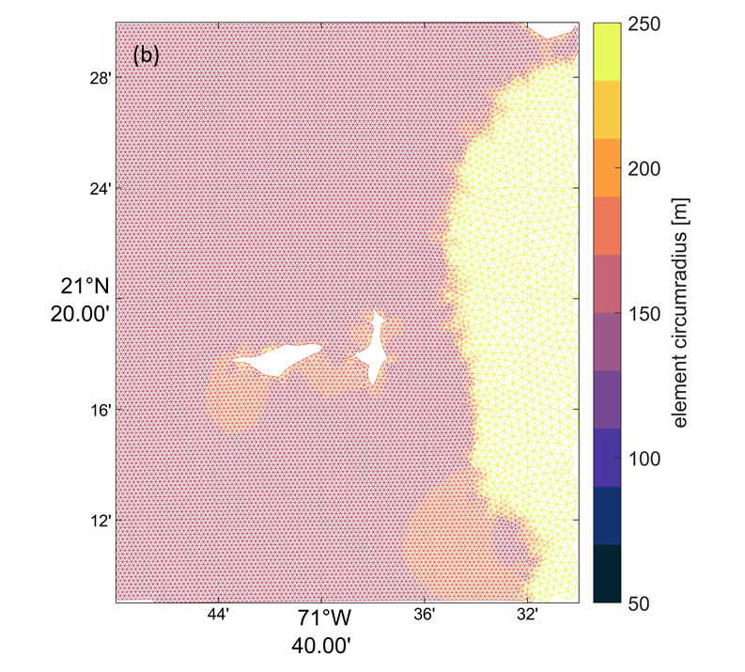
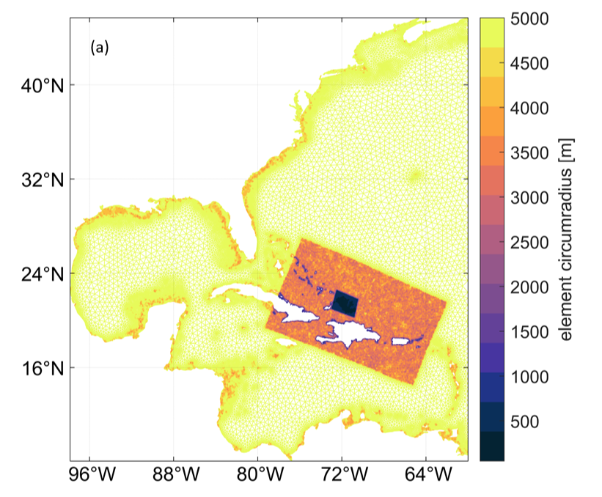

Figure S1: Numerical unstructured model grid resolution a) Full Domain top panel) b) Little Ambergris Cay (bottom panel). The smallest grid resolution was 200 m.

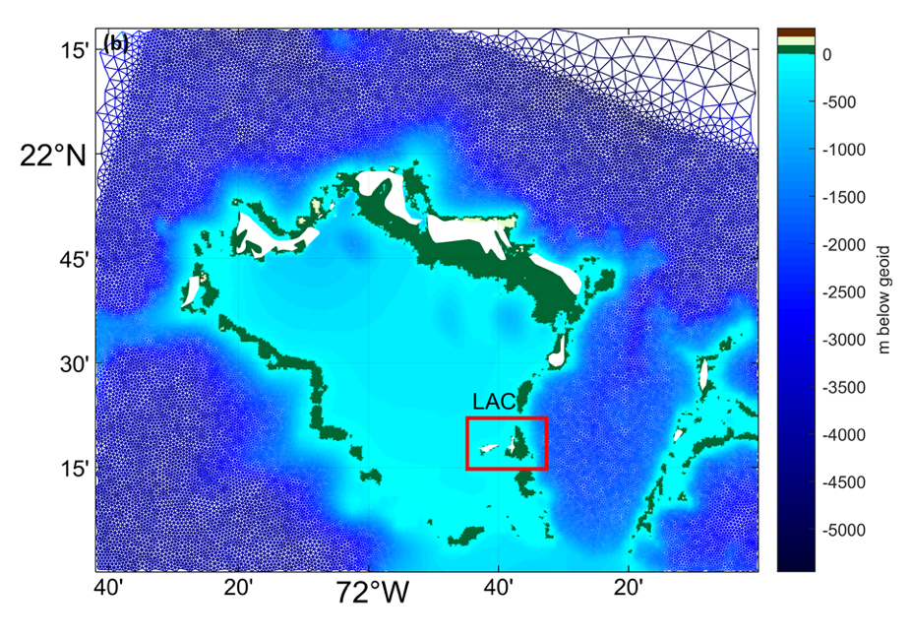
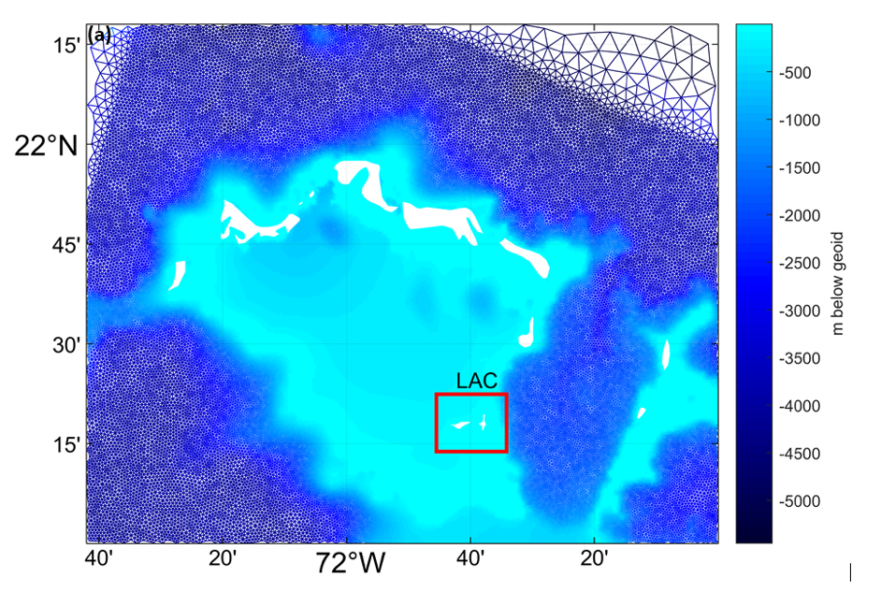

Figure S2: Bathymetry representation of the Turks and Caicos Islands on unstructured mesh a) Raw topo-bathy values from the GEBCO (top panel) b) Improved bathymetric representation using surrounding depth values (bottom panel).

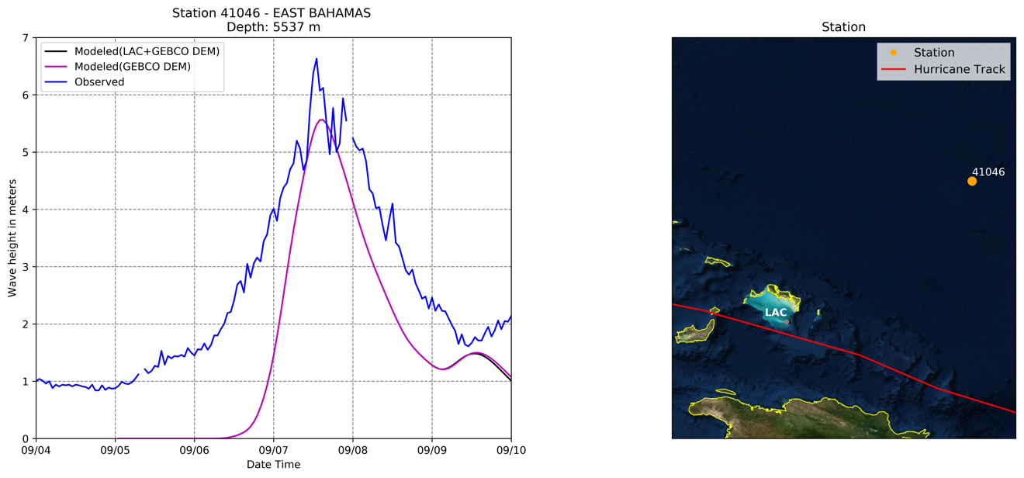

Fig. S3: Time series of simulated significant wave heights (Hisg) in meters above mean sea level at NOAA NDBC station 41046 during Hurricane Irma (September 2017). At this deep water location, ADCIRC-SWAN wave height simulation are close to observed (~15% underestimation of Hsig).

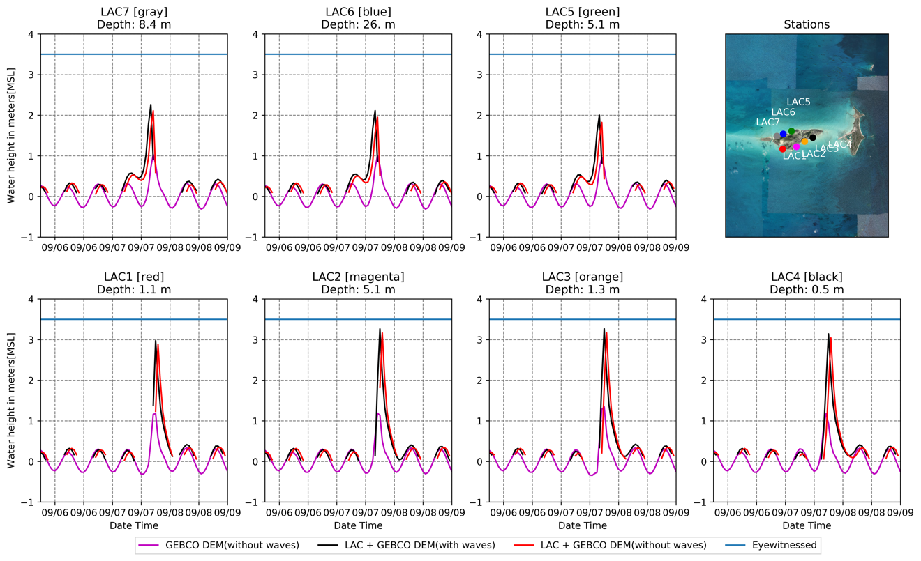

Fig. S4 Time series of simulated storm surges in meters above mean sea level around Little Ambergris Cay during Hurricane Irma (September 2017). The highest water level was simulated at LAC 2 and LAC 3 on the south side of the island.

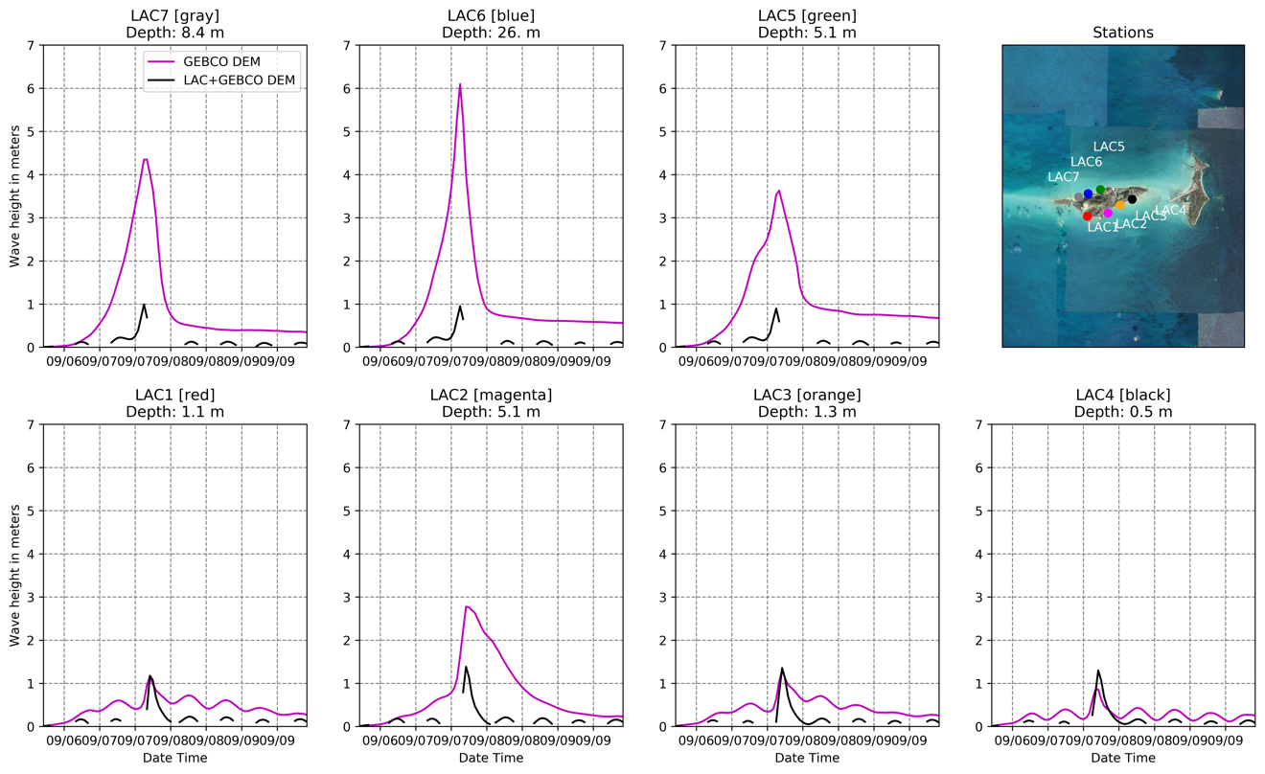

Fig. S5 Time series of simulated significant wave heights in meters around the Little Ambergris Cay during Hurricane Irma (September 2017). Black lines represent the simulations including local bathymetry of the Turks and Caicos platform; purple lines show results when using the coarse-resolution GEBCO bathymetry. The GEBCO-only model overestimates wave heights on the north side of the platform because of its overestimate of platform depth to the north of the island (>30 m in the bathymetric model, vs. <10 m as measured by Harris and Ellis, [2008]).

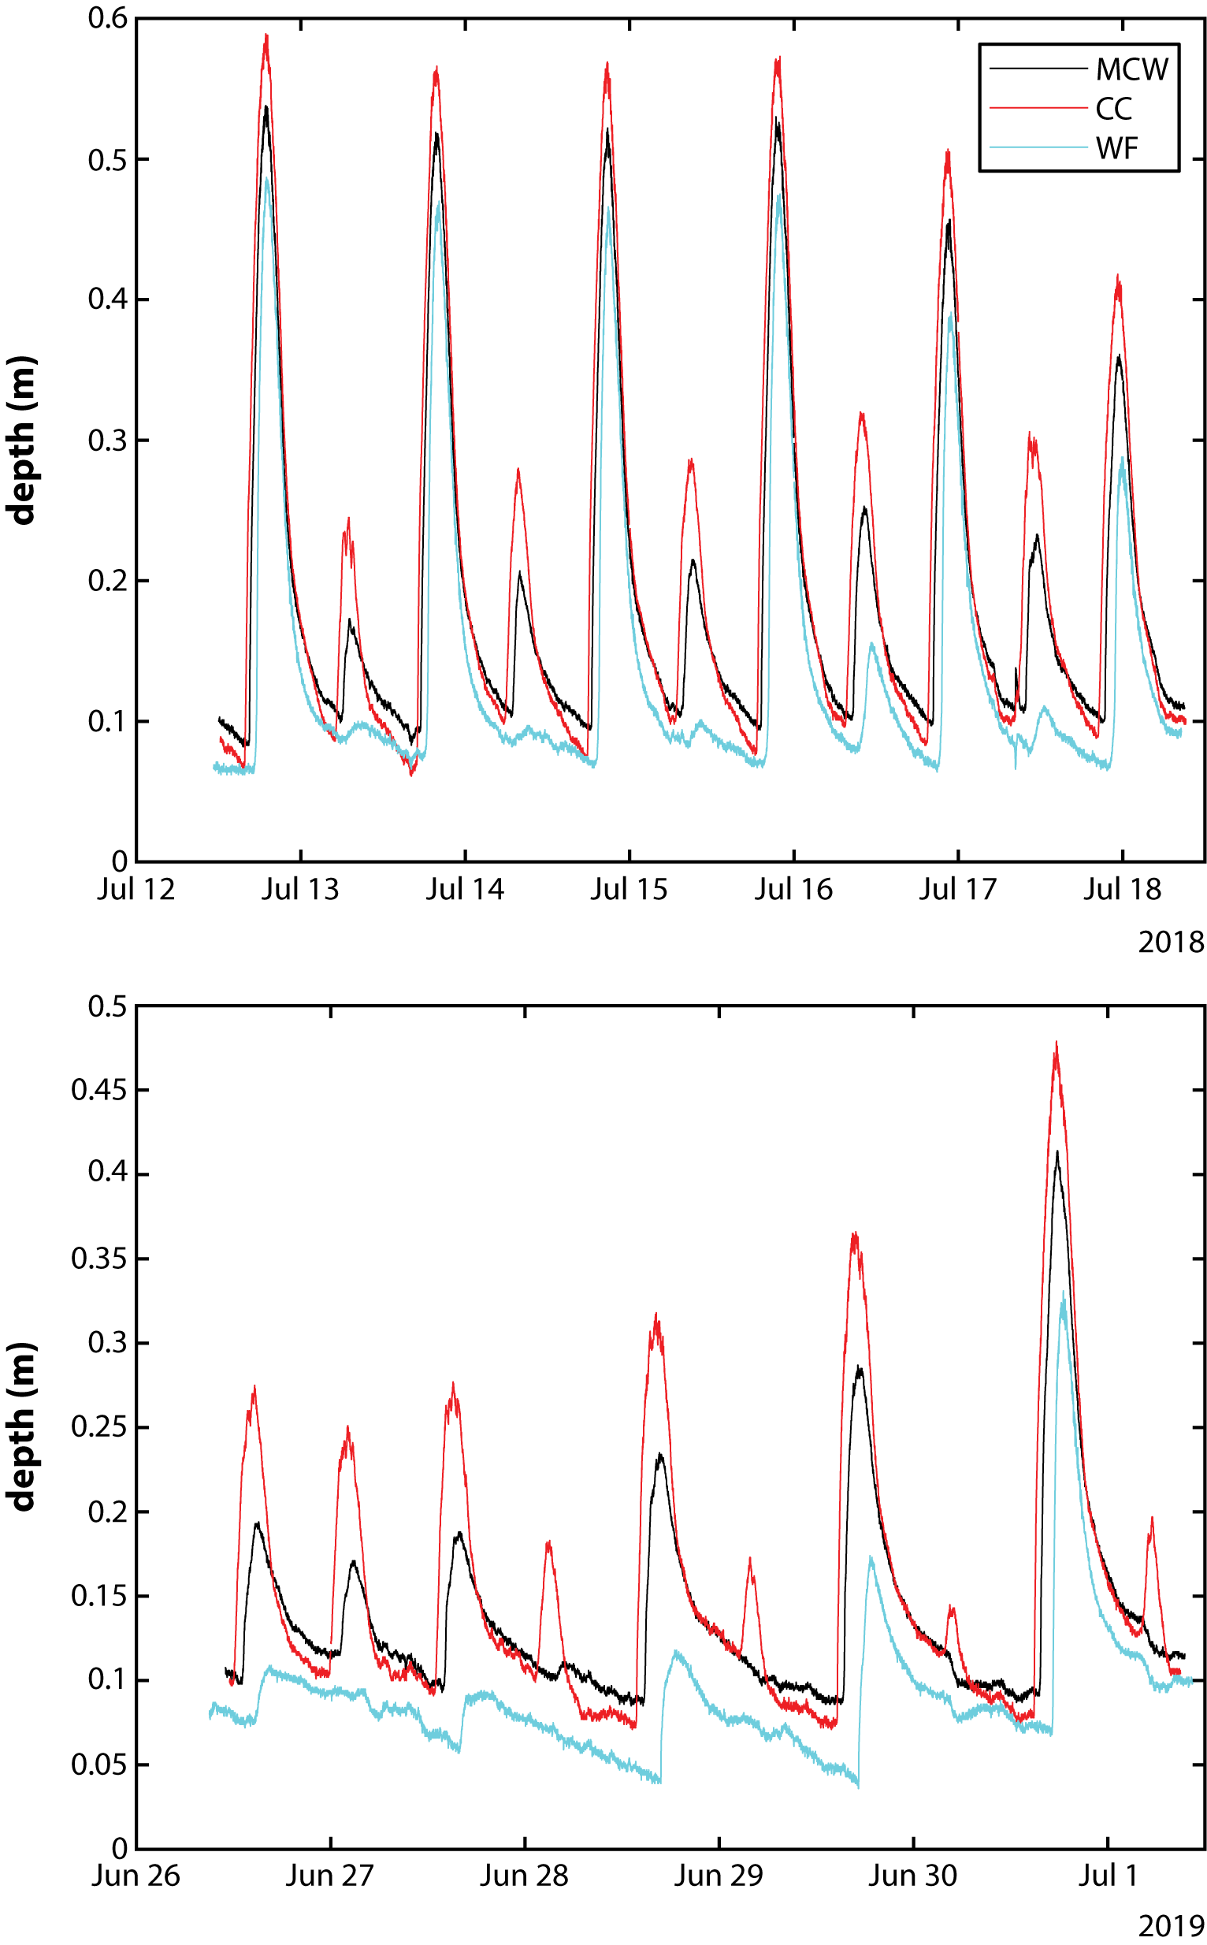

Figure S6: Tidal variations in water depth in different locations on the interior of Little Ambergris Cay collected with HOBO U20L water depth loggers and corrected with barometric data collected with an additional HOBO U20 logger. Little Ambergris Cay is microtidal with a mixed tidal cycle (two daily high tides of unequal magnitude): peak tidal range is < 0.6 m. Due to its location far from tidal inlets, tidal range, particularly of the lower high tide, is muted in the vicinity of the washover fans (WF) relative to other locations on the island interior (MCW and CC); this pattern was observed in both July 2018 (upper panel) and June 2019 (lower panel), although these data were collected at different points in the monthly tidal cycle.
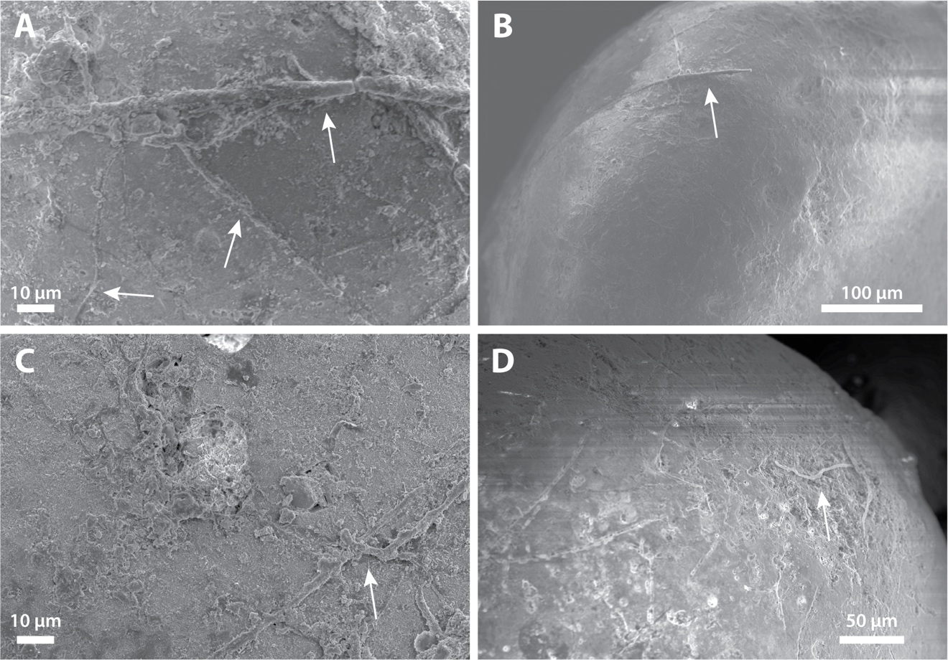

Figure S7: Scanning electron microscope (SEM) images of filaments on surfaces of ooid sand from beach ridges adjacent to washover fans (A-B) and washover fans (C-D), both of which had an unusual pink-ish coloration. Energy dispersive spectroscopy (EDS) analysis revealed no minerals other than CaCO₃, but secondary electron imaging revealed common filaments on grain surfaces, which are not observed on ooids sampled from shoal or foreshore environments. These filaments are interpreted as evidence of surface colonization by microbial communities specific to LAC soil environments that occur above the water table. The vertical zonation in coloring, only occurring about 1 cm below the sediment surface, is consistent with the soil biofilm community colonizing the washover fan sediment after it was deposited. We therefore interpreted that the pink-ish coloration of washover fan sediment was acquired after deposition and is not reflective of the origin of the sediment.

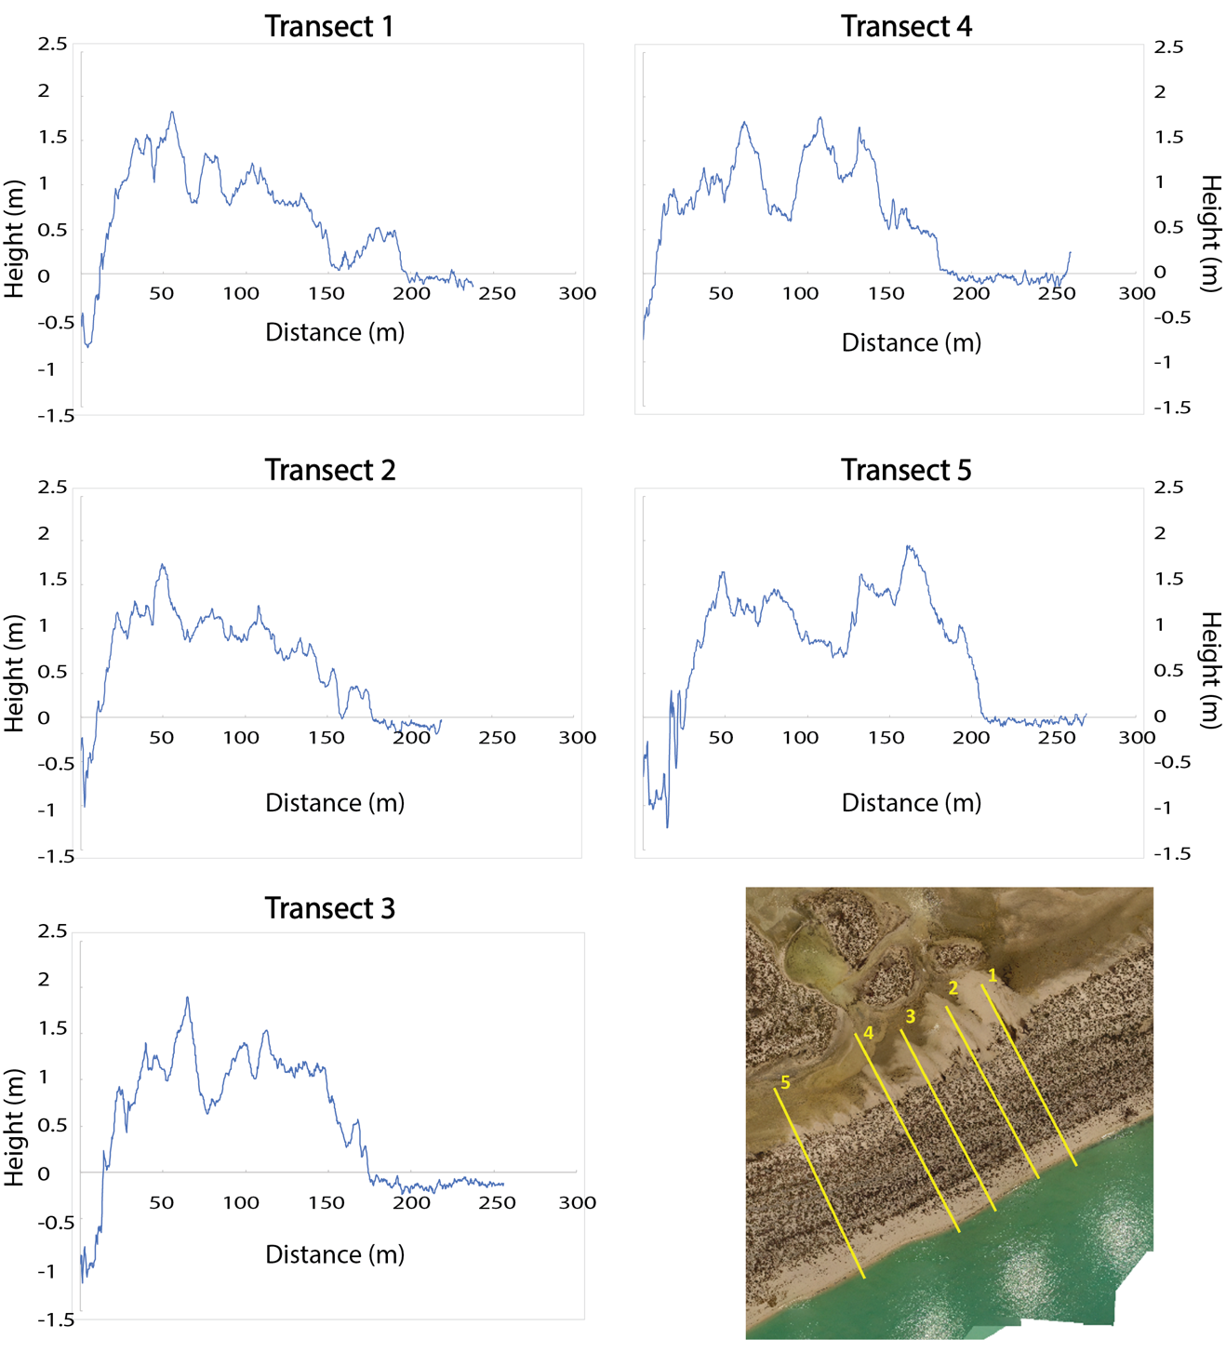

Figure S8: Topographical profiles of the beach ridges and washover fans at five transects, as numbered in the image and beside the plots. Elevation of the beach ridges does not exceed 2 m. The storm surge was likely higher than these ridges in order to deposit the washover fans. The transects are derived from a UAV DEM, and when translated up by 0.23 m are relative to mean tide level.

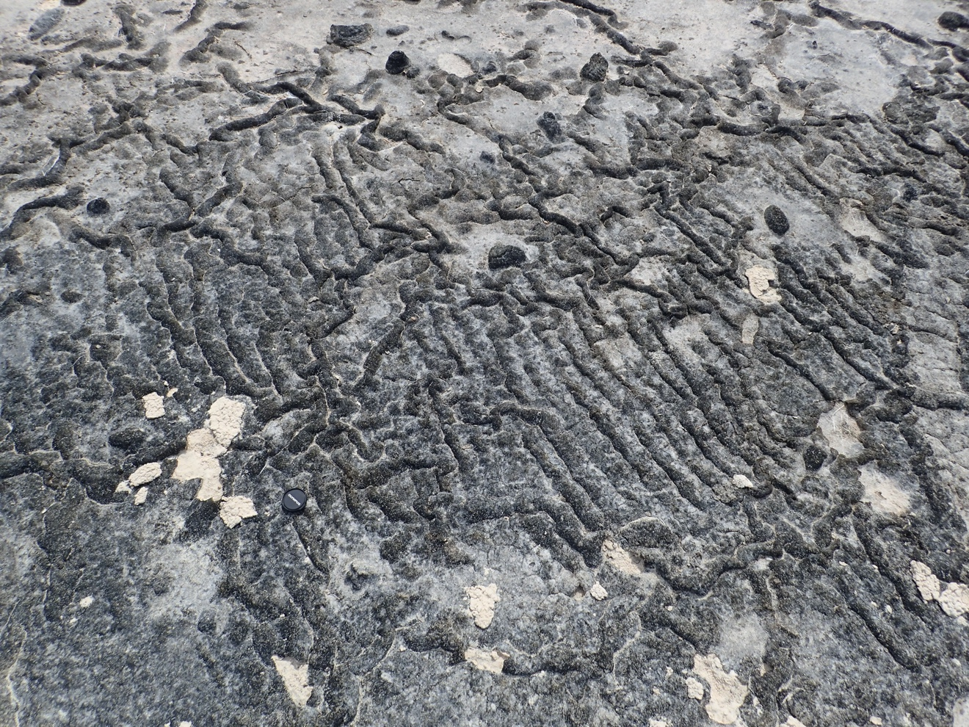

Figure S9: Ripples on the margin of a washover fan colonized and stabilized by microbial mat.

Sr. No | Identifier | Longitude | Latitude
1 | LAC1 | -71.70387 | 21.28671
2 | LAC2 | -71.69027 | 21.28893
3 | LAC3 | -71.68224 | 21.29423
4 | LAC4 | -71.67421 | 21.29800
5 | LAC5 | -71.69518 | 21.30438
6 | LAC6 | -71.70335 | 21.30169
7 | LAC7 | -71.70959 | 21.29956

Table S1: The geographical location of the recording stations surrounding LAC, used for the storm surge modeling.

Long axis (cm) | Intermediate axis (cm) | Short axis (cm)
72 | 46
28 | 15
32 | 19
19 | 16
22 | 16
31 | 20
46 | 34
30 | 26
63 | 47
27 | 20
50 | 33
22 | 15
20 | 19
47
32 | 20
53 | 32
46 | 35
38 | 21
35 | 25
44 | 26
49 | 43
68 | 43
17 | 12
33 | 30
16 | 17
18 | 16
22 | 20
33 | 26 | 8
44 | 32
32 | 25
32 | 20
32 | 29
70 | 42
21 | 15
26 | 19
27 | 19
54 | 26
67 | 42
32 | 24
39 | 32
45 | 32
51 | 39
33 | 40
16 | 15
30 | 15
28 | 19
33 | 21
27 | 23
27 | 18
24 | 22
34 | 23 | 12
27 | 10
27 | 27
37 | 29
59 | 57
51 | 32
39 | 26
79 | 51 | 18
29 | 22
44 | 38
26 | 17
67 | 48
21 | 18
36 | 23
26 | 16
19 | 19
23 | 18
38 | 30 | 13
34 | 20 | 16
27 | 22
36 | 23
39 | 25
54 | 47
34 | 25
29 | 26 | 20

Table S2: Measurements of carbonate clasts transported by the storm surge into the island interior. Clasts are roughly tabular. Averages for the in-text flow velocity calculations are taken from the six examples with short axis data.

length (m) | width (m) | area (m²) | minimum volume, assuming 10cm depth (m³) | maximum volume, assuming 30 cm depth (m³)
29 | 24 | 348 | 35 | 104
32 | 30 | 480 | 48 | 144
27 | 24 | 324 | 32 | 97
23 | 16 | 184 | 18 | 55
27 | 23 | 311 | 31 | 93
37 | 20 | 370 | 37 | 111
89 | 44 | 1958 | 196 | 587
99 | 37 | 1832 | 183 | 549
118 | 49 | 2891 | 289 | 867

Table S3: Washover fan dimensions and maximum/ minimum volume estimates from the nine sampled deposits.

 | March 2018 | July 2018
Average D₅₀ (µm) | 421 | 432
Average D₁₀ (µm) | 290 | 301
Average D₉₀ (µm) | 582 | 587
Average aspect ratio | 1.29 | 1.29
Average roundness | 0.75 | 0.75
Average sphericity | 0.93 | 0.93

Table S4: Sediment properties of channel lobe samples collected in March and July 2018. Grain sizes increased between March and July 2018, indicating that significant reworking, with finer grains advected westward.

length (m) | width (m) | depth (m) | volume (m³)
5.8 | 3.5 | 0.45 | 4.5675
9.4 | 6 | 0.45 | 12.69
5.2 | 2.9 | 0.45 | 3.393
4.5 | 2.2 | 0.25 | 1.2375
2.6 | 3.2 | 0.34 | 1.4144
2.3 | 2.3 | 0.2 | 0.529
14.2 | 3.1 | 0.78 | 17.1678
5.3 | 3.9 | 0.75 | 7.75125
16.3 | 3.8 | 1.2 | 37.164

Table S5: Dimensions of 9 measured scour pits adjacent to and between washover fans. Volumes were estimated by approximating their shape to a triangular trough.

References:

Booij, N., R.C. Lis, L. H. Holthuijsen (1999), A third-generation wave model for coastal regions 1. Model description and validation, J. Geophys. Res. Ocean., 104(C4), 7649-7666.

Dietrich, J.C., M. Zijlema, J.J. Westerink, L.H. Holthuijsen, C. Dawson, R.A. Luettich, R.E. Jensen, J.M. Smith, G.S. Stelling, G.W. Stone (2011), Modeling hurricane waves and storm surge using integrally-coupled, scalable computations, Coast. Eng., 58(1), 45-65.

Egbert, G.D., S.Y. Erofeeva (2002), Efficient Inverse Modeling of Barotropic Ocean Tides, J. Atmos. Ocean. Technol., 19, 183–204.

Garzon, J.L., C.M. Ferreira, R. Padilla-Hernandez (2018), Evaluation of weather forecast systems for storm surge modeling in the Chesapeake Bay, Ocean Dyn., 68, 91–107.

Li, H., L. Lin, K.A. Burks-Copes (2013), Modeling of Coastal Inundation, Storm Surge, and Relative Sea-Level Rise at Naval Station Norfolk, Norfolk, Virginia, U.S.A., J. Coast. Res., 286, 18–30.

Luettich, R.A., J.J. Westerink, N.W. Scheffner (1992), ADCIRC: An Advanced Three-Dimensional Circulation Model for Shelves, Coasts, and Estuaries, Report 1, Theory and Methodology of ADCIRC-2DDI and ADCIRC-3DL.

Roberts, K.J., W.J. Pringle, J.J. Westerink, (2019), OceanMesh2D 1.0: MATLAB-based software for two-dimensional unstructured mesh generation in coastal ocean modeling, Geosci. Model Dev., 12, 1847–1868.

Tozer, B., D.T. Sandwell, W.H.F. Smith, C. Olson, J.R. Beale, P. Wessel (2019), Global Bathymetry and Topography at 15 Arc Sec: SRTM15+.

Wessel, P., W.H.F. Smith (1996), A global, self-consistent, hierarchical, high-resolution shoreline database, J. Geophys. Res., Solid Earth 101, 8741–8743.

Westerink, J.J., R.A. Luettich, J.C. Feyen, J.H. Atkinson, C. Dawson, H.J. Roberts, M.D. Powell, J.P. Dunion, E.J. Kubatko, H. Pourtaheri (2008), A Basin- to Channel-Scale Unstructured Grid Hurricane Storm Surge Model Applied to Southern Louisiana, Mon. Weather Rev.

