Supplementary Figures
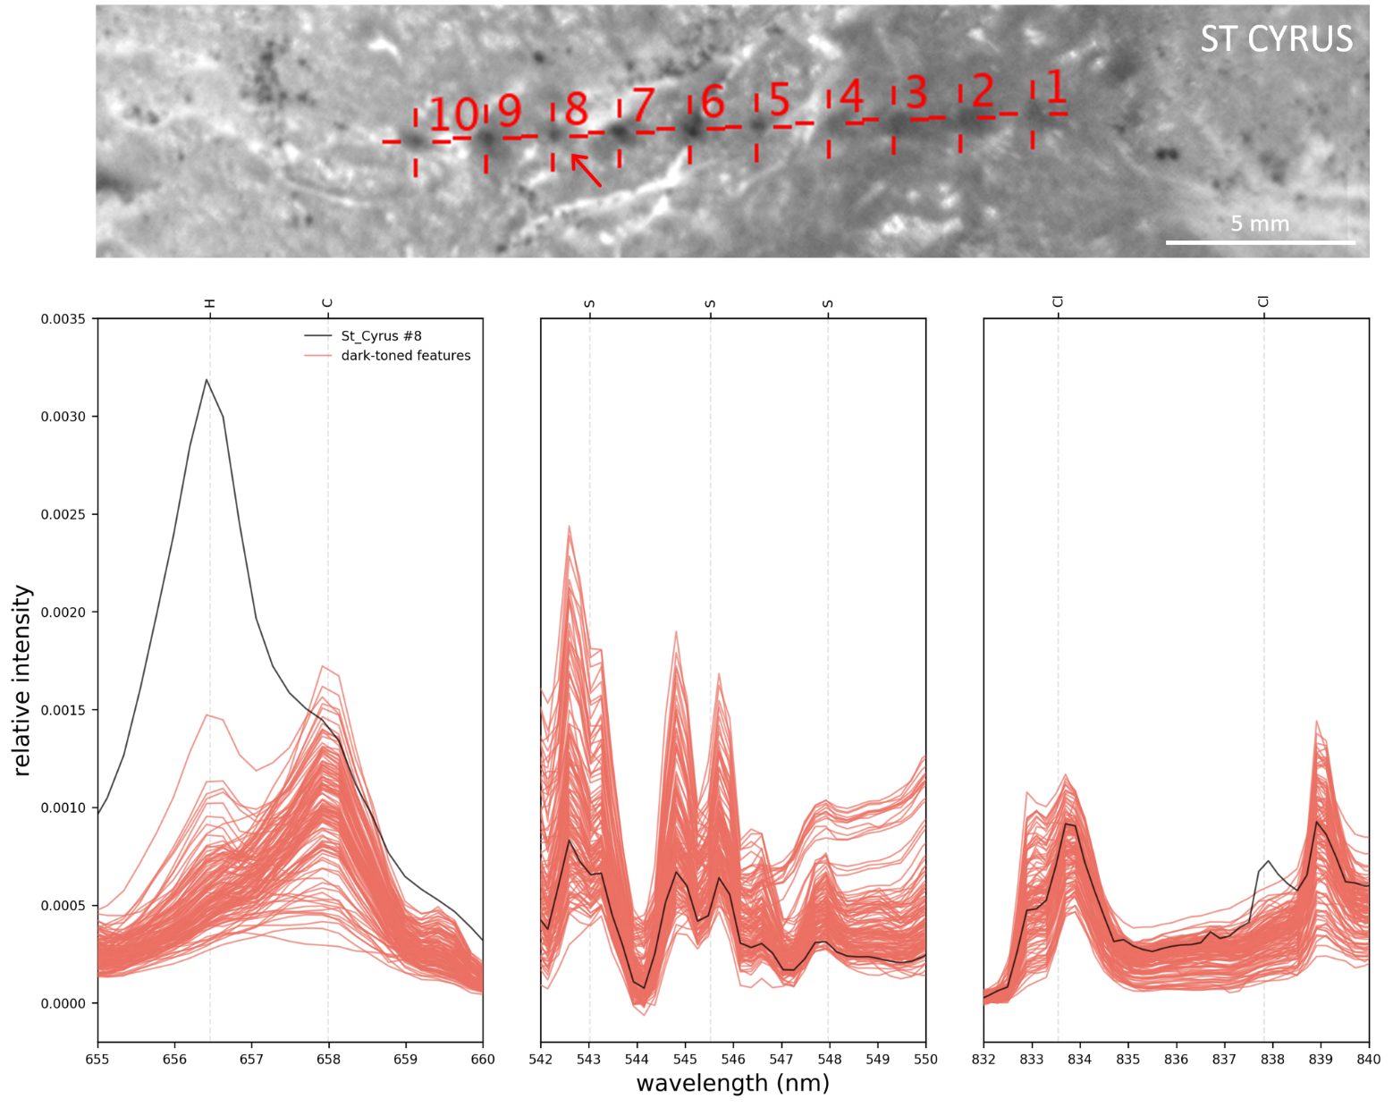
Figure S-1: LIBS spectra (normalized) of dark-toned features (red), showing the spectral region corresponding to the H, S, and Cl peaks location. St Cyrus #3 present high H and Cl peaks (at 837.9 nm), no S detection, as well as elevated Fe—thus suggesting the presence of akaganeite [Fe³⁺O(OH,Cl)].
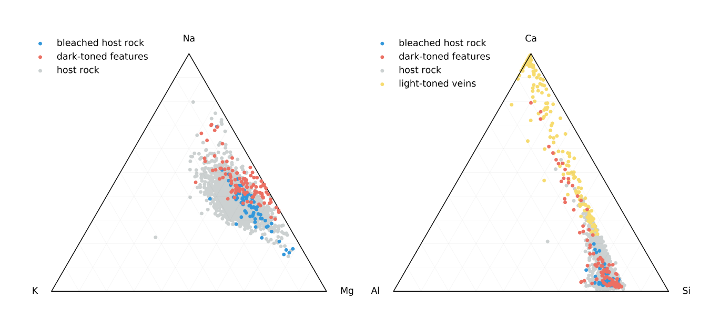
Figure S-2: Ternary diagrams showing ChemCam quantified abundances (molar percentages) for Na, K and Mg (left) as well as Ca, Al and Si (right). The trend toward the Ca summit is due to the sampling of Ca-sulfate veins, and the variability in K, Mg and Na is not correlated to the variability in Fe (either enrichments or depletions) as observed in Figure 5.

