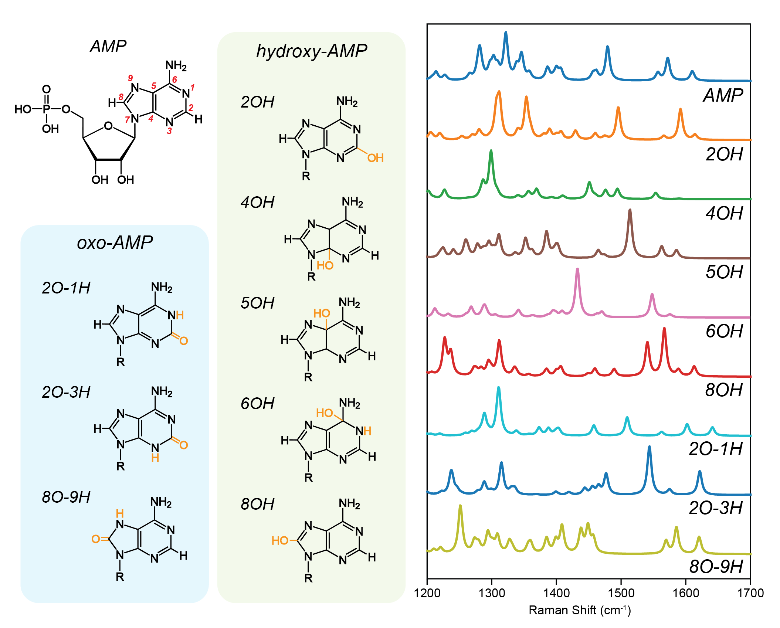
Figure S5. Molecular structures of pristine AMP and 9 possible oxidation products of the adenine unit, and their predicted Raman spectra between 1200 and 1700 cm⁻¹ predicted by Density Functional Theory simulations.

