Supporting Information

Substitution of Cetyltrimethylammonium for OSDA Cations During B-SSZ-70 Zeotype Synthesis and Its Influence on Delamination
Maya Ramamurthy¹, Nicolás A. Grosso-Giordano¹, Son-Jong Hwang², Le Xu¹, Dan Xie³, Manish Mishra¹, Alexander Okrut^{*,4}, Stacey Zones^{*,3}, Alexander Katz^{*,1}
¹Department of Chemical and Biomolecular Engineering, University of California, Berkeley, Berkeley, California 94720, United States
²Division of Chemistry and Chemical Engineering, California Institute of Technology, Pasadena, California 91125, USA
³Chevron Energy Technology Company, Richmond, California 94804, United States
⁴Berkeley Materials Solutions, Richmond, California 94803, United States

Table S1. Gel compositions for samples prepared with varying CTAOH contents. The CTAOH solution has a concentration of 10 wt. % in water and the OSDA solution (diisobutylimidazolium hydroxide) has a concentration of 9 wt. % in water. mol% CTAOH = n_{CTAOH}/(n_{OSDA}+n_{CTAOH}).
CTAOH solution (g) | SDA solution (g) | Resulting CTAOH in synthesis gel (mol%)
0 | 8.32 | 0
0.51 | 7.99 | 4
1.14 | 7.57 | 10
1.77 | 7.16 | 15
2.00 | 6.32 | 19 (sample 1 in manuscript)
2.53 | 6.66 | 22
3.17 | 6.24 | 27
6.34 | 4.16 | 53
9.50 | 2.08 | 77
11.40 | 0.83 | 91
12.67 | 0 | 100

Characterization of Ti-exchanged materials via UV-Vis spectroscopy

Diffuse-reflectance UV-Vis spectroscopy was used to investigate the environment surrounding Ti in these catalysts. All spectra exhibit an absorption maximum in the range of 218 – 234 nm (see Table S2 and Figure S4,), which can be assigned to tetrahedral, tripodal Ti species coordinated to three Si-O groups (Ti(OH)(OSi)₃) at the zeotype surface. All spectra also exhibit a slight shoulder around 260 nm, indicating the possibility of a small fraction of higher coordination titanium sites (such sites have been previously ascribed to water ligated to Ti-sites (Ti(OH)(H₂O)(OSi)₃)).⁵⁶

Table S2. DR-UV-Vis peak maxima for materials that were high-shear mixed prior to Ti insertion.
mol% CTAOH in synthesis gel | UV-Vis Band (nm)
0 | 230 ± 3
4 | 224 ± 3
10 | 222 ± 3
15 | 225 ± 3
19 (sample 1 in manuscript) | 226 ± 3
22 | 223 ± 3
27 | 218 ± 3
53 | 234 ± 3
77 | 227 ± 3
91 | 226 ± 3
100 | 231 ± 3

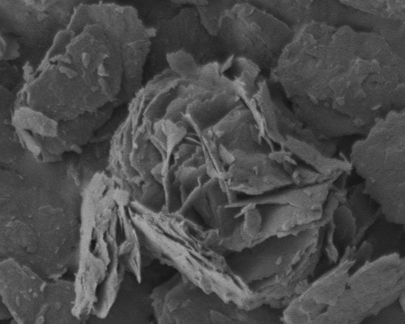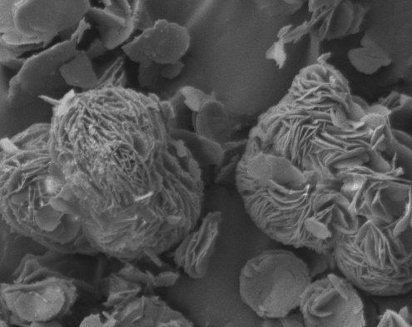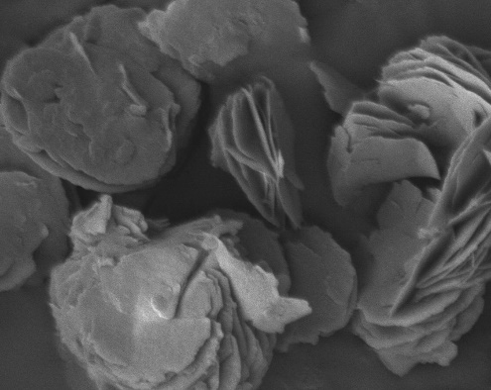
A
B
C
1 μm
1 μm
1 μm
Figure S1. SEM data for calcined materials A) B-SSZ-70, B) 1, and C) a material prepared similarly to 1 but with 4 mol% CTAOH in the synthesis gel.
SEM images in Figure S1 show the layered nature of calcined B-SSZ-70, 1, and a material prepared similarly to 1 but with 4 mol% CTAOH in the synthesis gel. All materials have crystallites of relatively uniform size. Altogether, SEM data show that aside from delamination, high-shear mixing does not destroy or break the crystallites.

Figure S2. N₂ physisorption plots of calcined materials synthesized with 91 mol. % and 100 mol. % CTAOH in the synthesis gel.

Figure S3. Pore size distribution for materials calcined B-SSZ-70 (), 1 () and UCB-4 (), where normalized incremental pore volume is plotted as a function of pore width. Pore size distribution was determined from density functional theory, assuming a slit pore model and N₂ at 77 K.

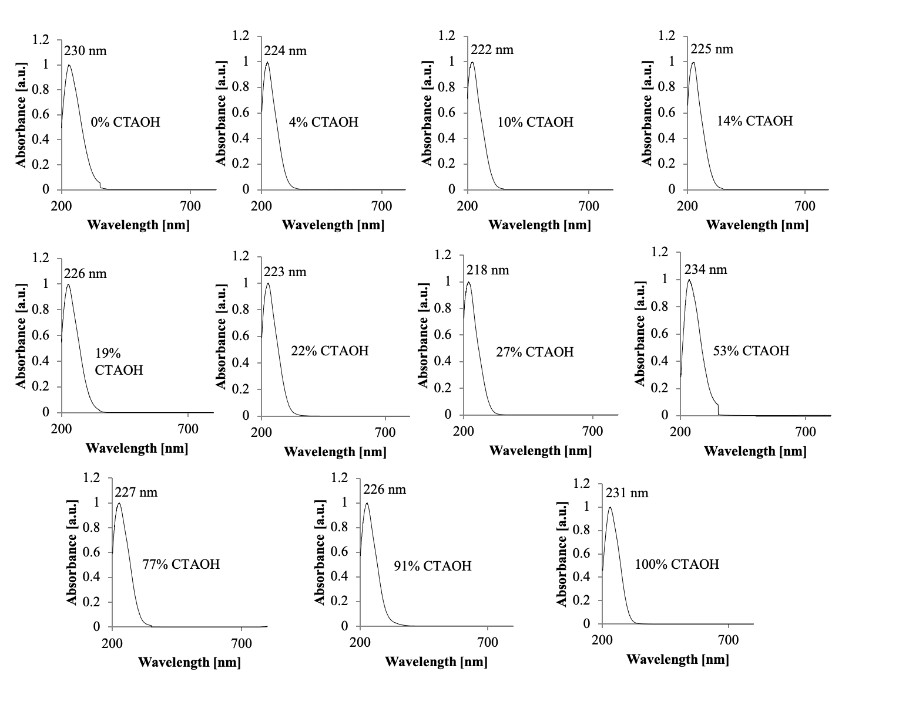
Figure S4. DR-UV-Vis spectra of all materials that were high-shear mixed prior to Ti-insertion. CTAOH contents are reported in mol. % CTAOH. The 19% CTAOH sample corresponds to Ti-1 in the manuscript.

Synthesis and characterization of control material Ti-2

The catalytic properties of Ti-1 were compared with those of a material that was synthesized with 19 mol% CTAOH in the synthesis gel and that was not high-shear mixed prior to calcination and titanium-insertion (Ti-2) (Scheme S1).

Scheme S1. Synthesis of Ti-1 and control material Ti-2.

Figure S5: EBHP Conversion vs. time in a large-scale batch reaction for 1-octene epoxidation with EBHP as oxidant for materials Ti-1, Ti-UCB-4, Ti-SSZ-70, and control material Ti-2.

Calculations

Calculation of mol. % CTAOH in the synthesis gel

$$mol. \% CTAOH= \frac{ \frac{m_{CTAOH}*0.1}{{MW}_{CTAOH}}}{ \frac{m_{CTAOH}*0.1}{{MW}_{CTAOH}}+\frac{m_{SDA}*0.09}{{MW}_{SDA}} }$$

$m_{CTAOH}$ = mass of CTAOH solution added to the synthesis gel (10 wt. % in water)
$m_{SDA}$ = mass of SDA solution added to the synthesis gel (9 wt. % in water)
${MW}_{CTAOH}$ = 302 g/mol
${MW}_{SDA}$ = 198 g/mol

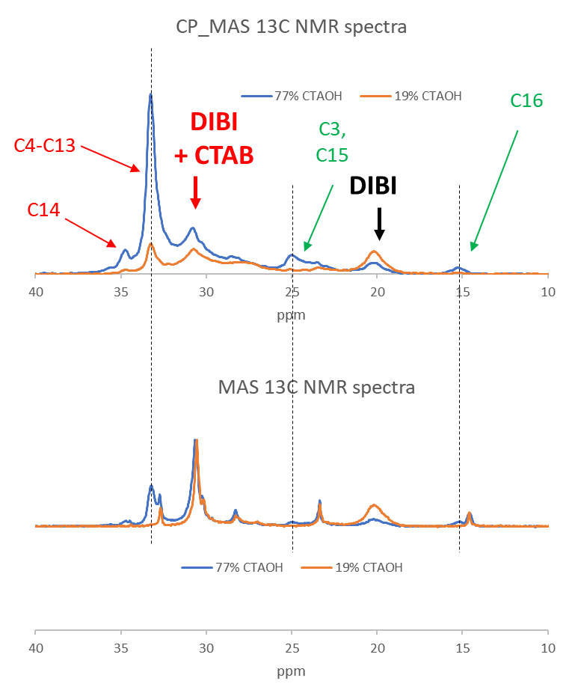
Figure S6. Comparison of CP-MAS ¹³C NMR spectra of 19 mol% CTAOH and 77 mol% CTAOH materials with MAS ¹³C NMR spectra of the same materials. The strongest peaks in the CP-MAS spectra are those that appear as result of CTAOH in new environments (intercalated into SSZ-70 layers) – these peaks are strong in CP-MAS because their corresponding nuclei are immobile.

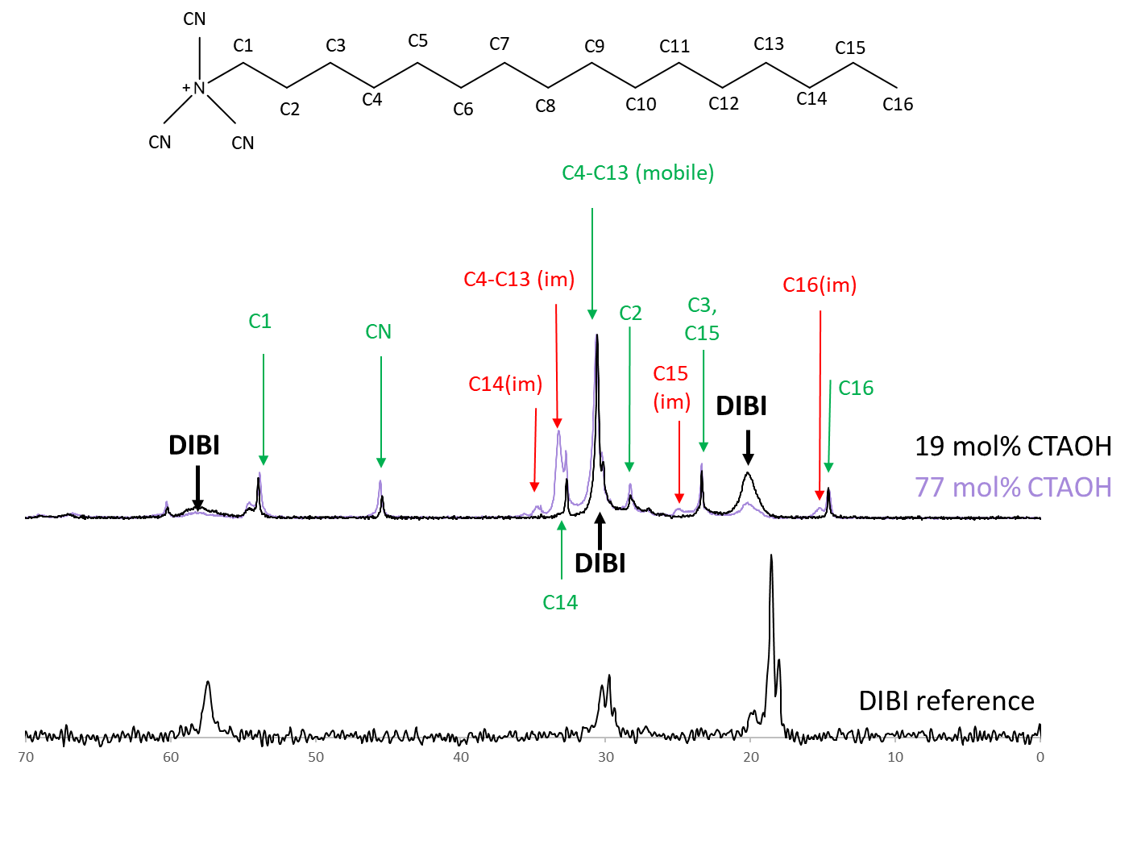
Figure S7. Overlay of ¹³C MAS NMR spectra of materials made with 19 mol% CTAOH in the synthesis gel (black), made with 77 mol% CTAOH in the synthesis gel (purple), and a reference spectrum of the OSDA disobutyl imidazolium hydroxide (DIBI). For the CTA+ cation in the 77 mol% CTAOH sample, assignments in red with the note “(im)” are assigned to CTA⁺ in an immobile environment.

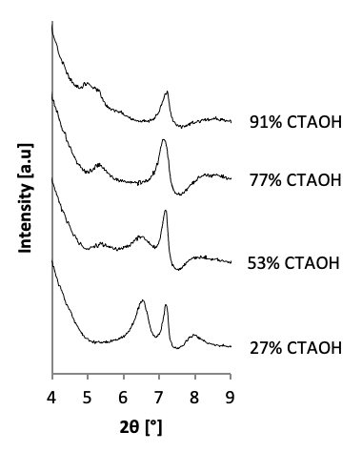
Figure S8. Highlight of the disappearance of the [002] peak at 6-7 ° 2θ as well as the [003] peak at 5-6 ° 2θ that appears in materials synthesized with 53-91 mol% CTAOH.

Calculation of the interlayer distance in the as-synthesized materials

The interlayer distance in the as-made materials is calculated by subtracting the thickness of a single MWW-layer (25 Å, determined from the structure of related ITQ-2²) from the unit cell parameter c (the unit cell parameter c represents the sum of the thickness of a single MWW-layer and the interlayer distance). This calculation is performed using the 2θ value of a [00l] peak using Bragg’s law to determine the unit cell parameter c. In regime I of the as-synthesized material, the [002] peak is observed and can be used for this calculation and in regime II, the [003] peak is observed.

$$[l]∙λ=2∙c∙\sin{(θ)}$$
$$(λ=1.5406 Å)$$

For materials in regime I, the [002] peak is located at 6.42° 2θ, therefore giving a value for c of 27.5 Å and a value for the interlayer distance of (27.5 – 25 = ) 2.5 Å. For swollen materials in regime II, the [003] peak is located at 5.6° 2θ, therefore giving a value for c of 47.3 Å and a value for the interlayer distance of (47.3 – 25 =) 22.3 Å.

Comparison of textural properties of 1 with UCB-4 and B-SSZ-70

We investigated the textural properties of sample 1 in more detail and compared them to UCB-4 and the corresponding non-delaminated calcined B-SSZ-70. Crystallinity and structural integrity of 1 after high-shear mixing was confirmed using powder X-ray diffraction (PXRD, Figure S9). 1, UCB-4, and B-SSZ-70 show the same peaks at 7.2°, 7.9°, 9.9°, 14.4°, 22.7°, and 26.2° 2θ, which are characteristic of the B-SSZ-70 framework structure. These data show that 1 is a crystalline material that structurally resembles B-SSZ-70.

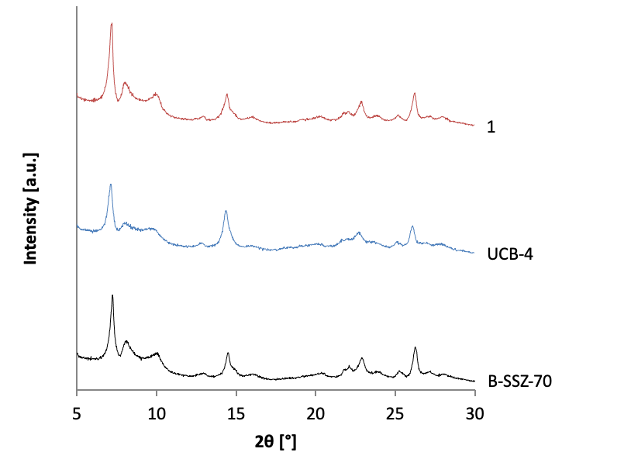
Figure S9. Powder X-Ray diffraction data of material 1 (top), UCB-4 (center), and calcined B-SSZ-70 (bottom)

N₂ physisorption isotherms and physicochemical properties for materials 1, B-SSZ-70, and UCB-4 are shown in Figure S10 and Table S3. All materials show characteristic type I/IV-mixed isotherms, indicating the presence of both micropores and mesopores. In the isotherm region between P/P₀ = 0 and P/P₀ = 0.4 in Figure S10, the N₂ uptake of B-SSZ-70 is higher than that of 1, controlled by a higher micropore volume for B-SSZ-70 (0.21 cm³ g⁻¹ for B-SSZ-70 and 0.18 cm³ g⁻¹ for 1). This is consistent with 1 being a delaminated zeotype material.¹ Further evidence for delamination of 1 is shown in the region between P/P₀ = 0.5 and P/P₀ = 0.7 in Figure S10, where the slope of the isotherm for 1 is larger than that of B-SSZ-70, consistent with a higher external-surface area of 1 (S_{ext} = 109 m² g⁻¹) compared to B-SSZ-70 (S_{ext} = 77 m² g⁻¹). Delamination of 1 is further supported by comparing its physisorption data with that of delaminated zeotype UCB-4 shown in Figure S10 and Table S3, which shows a comparable external surface area (100 m² g⁻¹) and micropore volume (0.15 cm³ g⁻¹). All materials show hysteresis between the adsorption and desorption curves due to the presence of mesopores. A pore size distribution analysis in Figure S3 shows that 1 and delaminated zeotype UCB-4 possess mesoporosity between 21 and 40 Å, which does not exist in the 3D zeotype B-SSZ-70. The similarity of the pore types between 1 and UCB-4 provides further evidence for the delamination of 1. UCB-4 contains additional mesopores greater than 40 Å that are not observed in 1 or B-SSZ-70 (see Figure S3). This explains the greater degree of hysteresis seen in the physisorption plot of UCB-4 compared to 1 and B-SSZ-70, which both show very low degrees of hysteresis in Figure S10.

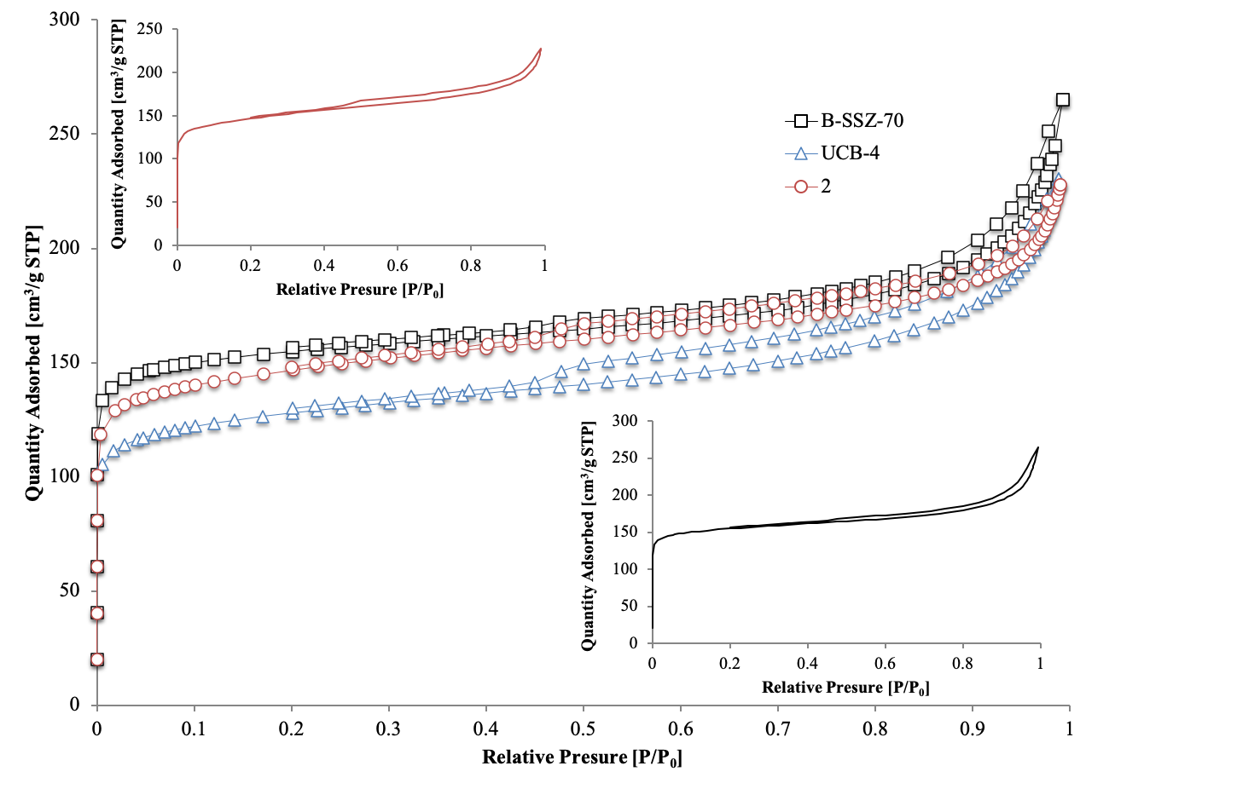
Figure S10. N₂ physisorption data for materials 1 (), UCB-4 (), and B-SSZ-70 (). Inset graphs show 1 (top left) and B-SSZ-70 (bottom right).

Table S3. Physicochemical properties of materials 1, UCB-4 and B-SSZ-70.
Material | S_{ext} (m² g⁻¹) | S_{total} (m² g⁻¹) | V_{micro} (cm³ g⁻¹) | V_{total} (cm³ g⁻¹)
1 | 109 | 549 | 0.18 | 0.34
UCB-4 | 100 | 479 | 0.15 | 0.34
B-SSZ-70 | 77 | 588 | 0.21 | 0.39

Table S4. Properties of the amorphous Ti/SiO₂ material that was used in flow epoxidation catalysis
 | S_{ext} (m² g⁻¹) | S_{total} (m² g⁻¹) | V_{micro} (cm³ g⁻¹) | V_{total} (cm³ g⁻¹) | Ti-content (μmol g⁻¹) | UV-Vis peak maximum (nm)
Ti/SiO₂ | 450 | 450 | 0.00 | 0.71 | 355 | 267-296

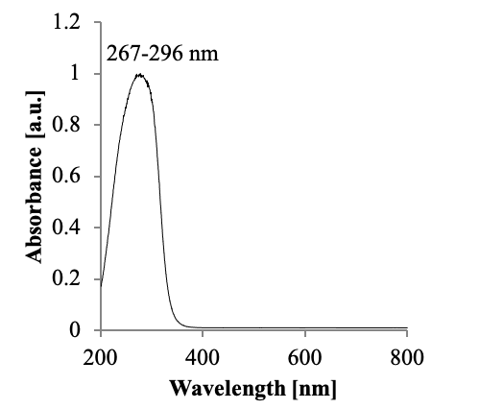
Figure S11. UV-Vis spectrum of amorphous Ti/SiO₂

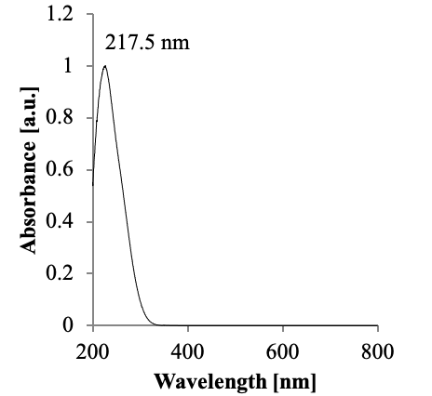
Figure S12. UV-Vis spectrum of Ti-UCB-4.

Olefin epoxidation catalysis in a flow reactor

Zeotype catalysts were pelletized to a particle size of 180-250 μm. Approximately 0.1 g of catalyst was packed into a stainless-steel reactor (l = 41 mm, ∅ = 6 mm) between layers of glass wool. Layers of glass beads before and after the catalyst layer were used to stabilize the catalyst bed in the middle of the reactor and enable thorough mixing of the reaction solution. The reaction solution consisted of 80.6 g (720 mmol) of 1-octene, 9.54 g (62.7 mmol) of cumene hydroperoxide (cumene HP), and 7.4 g (64.8 mmol) of octane as an internal standard. The packed reactor was heated under vacuum at 120°C for 16 h. After cooling to room temperature, the reactor was flushed with octane and connected to a syringe that contained the reaction solution. The flow rate was controlled using a syringe pump. The reactor was placed in an oven at 45°C. The flow was started at a rate of 3 mL/h and was decreased to 0.3 mL/h after two hours. The temperature of the reactor was step-wise increased in ~10 K increments, until the EBHP conversion exceeded 90%. In order to allow the system to equilibrate, material collection started at least 1 h after the experiments were started. EBHP conversion of initial samples (less than 10 h time on stream) was determined via iodometric titration and subsequent samples were analyzed by gas chromatography (Agilent 6890, HP-1 methylsilicone capillary column, FID detector).

Calculation of k’

Calculation of reaction rate constant k’ for flow reaction, based on catalyst mass

$$k^{'}= \frac{-\ln\left(1-X_{cumene HP}\right)*v}{m_{cat}}$$

Calculation of reaction rate constant k’ for flow reaction, based on Ti-content

$$k'= \frac{-\ln\left(1-X_{cumene HP}\right)*v}{m_{Ti}}$$

$X_{cumene HP}$ = cumene HP conversion; 0.88 for Ti-2, 0.91 for Ti/SiO₂
$v$ = flow rate; 0.3 mL/hr
$m_{cat}$ = mass of catalyst; 0.1g
$m_{Ti}$ = mass of Ti in the catalyst; 6.7 * 10⁻⁴ g for Ti-2, 1.7 *10⁻³ g for Ti/SiO₂

Comparison of TI-1 with Ti-UCB-4, Ti-SSZ-70, and Ti/SiO₂

Up to now, we have described a new approach for B-SSZ-70(P) delamination based on high-shear mixing, when zeotype layered precursor synthesis is conducted in the presence of CTA⁺OH⁻ substituting for OSDA⁺OH⁻. Building on our previous demonstration of delaminated B-SSZ-70 as a support for synthesis of highly active and selective olefin epoxidation catalysts,³ we now use Ti-1 as a representative crystalline catalyst. Ti-1 is one of the highly active olefin epoxidation catalysts in our initial testing in Figure 6 in the manuscript, possessing the highest titanium content of all crystalline materials arising from our new delamination method, and involves the 19 mol% CTAOH material as a support. We next compare Ti-1 as an olefin epoxidation catalyst with conventionally delaminated Ti-UCB-4, which was synthesized by previously reported procedures.¹
We thus performed a larger-scale batch epoxidation of the terminal olefin 1-octene with EBHP as oxidant using Ti-1, Ti-UCB-4, and three-dimensional calcined Ti-SSZ-70. These larger-scale batch-catalysis data are summarized in Table S5 (see also Figure S5). Both delaminated zeotypes Ti-1 and Ti-UCB-4 are more active than 3D zeotype Ti-SSZ-70 based on their first-order reaction rate constants (1.26 h⁻¹ for Ti-1, 1.56 h⁻¹ for Ti-UCB-4, 0.81 h⁻¹ for Ti-SSZ-70). The higher catalytic activities of Ti-1 and Ti-UCB-4 are consistent with both delaminated materials having a higher external-surface area than Ti-SSZ-70 (109 m² g⁻¹ for 1, 100 m² g⁻¹ for UCB-4, 77 m² g⁻¹ for B-SSZ-70 in Table 1).
Although Ti-1 has a higher Ti-content than Ti-UCB-4 (169 μmol g⁻¹ for Ti-1 vs. 120 μmol g⁻¹ for Ti-UCB-4), its catalytic activity is lower (k’ = 1.26 h⁻¹ for Ti-1, k’ = 1.56 h⁻¹ for Ti-UCB-4). This difference may be correlated with differences in the environment of Ti-sites, as represented by the UV-Vis spectra shown in Figure S4 and Figure S12. The frequency of the UV-Vis maximum (225 nm for Ti-1 and 217.5 nm for Ti-UCB-4) is slightly blue-shifted for Ti-UCB-4, suggesting that Ti-UCB-4 may have a higher fraction of Ti in tetrahedral, tetrapodal positions (Ti(OSi)₄) compared to Ti-1, known to be the preferred active environment for grafted Ti-sites on silica for epoxidation catalysis.⁴

Table S5. Characteristics of Ti catalysts for batch 1-octene epoxidation at 70°C with EBHP as oxidant. Reaction mixture consisted of 0.05 g material, 14.02 g octane, 1.32 g 1-octene, 0.12 g n-nonane, 0.17 g EBHP and 0.34 g ethyl benzene. Selectivity was measured at 60 min.
Material | Ti- Content (μmol g⁻¹) | UV-Vis Peak (nm) | Pseudo 1st Order Rate Constant k’ (h⁻¹)
Ti-1 | 169 | 225 ± 3 | 1.26
Ti-UCB-4 | 120 | 218 ± 3 | 1.56
Ti-SSZ-70 | 107 | 236 ± 3 | 0.81

We further compared the catalytic activity and selectivity of Ti-1 with that of Ti/SiO₂, a relevant model of the industrial heterogeneous propylene epoxidation catalyst,⁵ by performing epoxidation of 1-octene with organic hydroperoxide as oxidant in a flow (packed-bed) reactor. The UV-Vis spectrum of this amorphous Ti/SiO₂ is distinctly different from all other materials synthesized in this manuscript based on B-SSZ-70 and instead reflects a 280 nm band, which is characteristic of Ti grafted on amorphous silica (see Table S4 and Figure S11). We chose the industrially relevant cumene hydroperoxide as organic oxidant under conditions that led to its conversion of around 90%. Table S6 shows the temperature required to achieve approximately 90% conversion, as well as the selectivity and pseudo-first-order rate constants for each material, which were calculated assuming ideal plug flow. Ti-1 is more active than Ti/SiO₂ on a Ti-site basis, (k_{Ti-1} = 967 mL h⁻¹ g Ti⁻¹, k_{Ti/SiO2} = 530 mL h⁻¹ g Ti⁻¹), likely a consequence of partial confinement in pockets on the external surface of the zeotype,^{6,7} and slightly less active than Ti/SiO₂ on a catalyst mass basis (k’_{Ti-1} = 6.5 mL h⁻¹ g cat⁻¹, k’_{Ti/SiO2} = 7.3 mL h⁻¹ g cat⁻¹). Previous flow experiments have used delaminated-zeotype catalysts Ti-UCB-4^{3,8} and Ti-DZ-2⁹ with ethylbenzene hydroperoxide as the oxidant, under tail-end (high conversion) conditions. These materials also exhibited greater activity than Ti/SiO₂ on a Ti-site basis, but were considerably less active than Ti/SiO₂ when compared on a catalyst-mass basis.
The selectivity (i.e. fraction of converted cumene HP that is used to synthesize 1,2-epoxyoctane) of Ti-1 is significantly higher than that of Ti/SiO₂ (82% for Ti-1, 71% for Ti/SiO₂), which is consistent with prior delaminated zeotype catalysts (Ti-DZ-2, Ti-DZ-3, and Ti-UCB-4) for alkene epoxidation using organic hydroperoxides, which all also exhibited higher selectivities compared to amorphous Ti/SiO₂.^{8,9} Altogether, these data demonstrate that, consistent with other delaminated titano-zeotypes, Ti-1 is a competitive catalyst for olefin epoxidation with organic hydroperoxides. These data show that our delamination method described here can synthesize delaminated-zeolite catalysts via an economic and scalable route. Ti-1 exhibits a 1.5-fold higher catalytic activity for 1-octene epoxidation with EBHP compared to three-dimensional Ti-SSZ-70, and only a slightly lower activity compared to Ti-UCB-4, a material that was delaminated using corrosive and environmentally unfriendly halide reagents and non-scalable ultrasonication. During epoxidation of 1-octene with cumene hydroperoxide in a flow reactor, Ti-1 is more active on a Ti-site basis and more selective than the conventional amorphous Ti/SiO₂ catalyst, the established model for the industrial catalyst for PO epoxidation.

Table S6. Conversion, selectivity and reaction rate constants for materials Ti-1 and Ti/SiO₂ in a flow reactor.
Material | Temperature (°C) | Conversion (%) | Initial reaction rate constant k’ mass –based (mL h⁻¹ g cat⁻¹) | Initial reaction rate constant k Ti-content based (mL h⁻¹ g Ti⁻¹) | Selectivity (%)
Ti-1 | 80 | 88 | 6.5 | 967 | 82
Ti/SiO₂ | 85 | 91 | 7.3 | 530 | 71

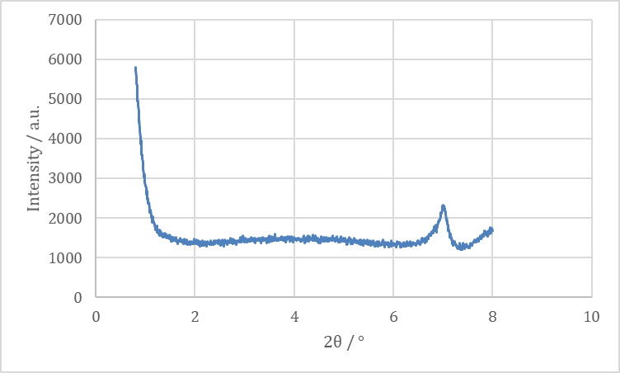
Figure S13. Low angle PXRD pattern of the material made with 77 mol% CTAOH after calcination. The absence of a peak at 2 ° 2θ confirms the absence of amorphous mesoporous silica.
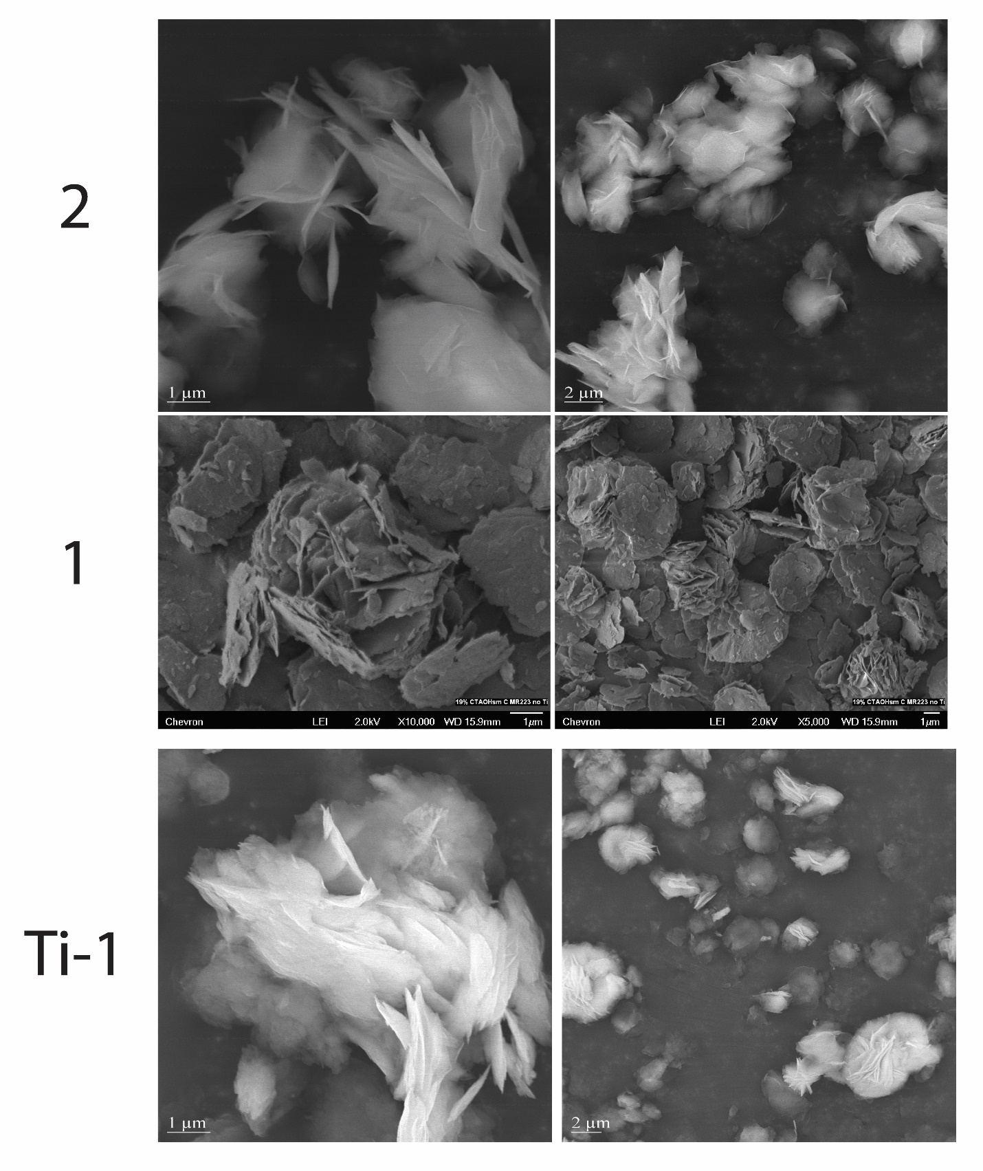
Figure S14. SEM images of 1, 2 and Ti-1 show that the surface area difference between 1 and 2 cannot be due to the break-up of crystallites as a result of high-shear mixing, because the crystallite size in the a-b plane is similar before and after high-shear mixing: it must be due to greater extents of delamination (i.e., changes in thickness along c direction)

Figure S15. In order to investigate whether disappearance of 002 peak at 6.42° and growth of a peak at 5.6° (5.1° for the 91 mol% CTAOH material) is indeed due to swelling and not due to the change of the extinction law due to a change in symmetry of the material with almost similar lattice constants, we performed an additional control: We extracted CTAOH using DMF solvent, from the material made with 77 mol% CTAOH. Upon doing so, we observed a change in the PXRD pattern of the material as follows. The peak at 5.6° (which literature assigns to the 003 peak of a swollen material) disappeared and a peak at 6.42 ° appeared (which literature assigns to the 002 peak of the non-swollen material). The rest of the PXRD pattern remained unchanged. Because DMF washing could not possibly induce a change in symmetry of the MWW-layers, such that the extinction law changes, these data demonstrate that the structure of the 77 mol% CTAOH material changed from a swollen structure to a non-swollen structure upon DMF wash.

(1) Ogino, I.; Eilertsen, E. A.; Hwang, S. J.; Rea, T.; Xie, D.; Ouyang, X.; Zones, S. I.; Katz, A. Heteroatom-Tolerant Delamination of Layered Zeolite Precursor Materials. Chem. Mater. 2013, 25 (9), 1502–1509. https://doi.org/10.1021/cm3032785.
(2) Corma, A.; Fornes, V.; Pergher, S. B.; Maesen, T. L. M.; Buglass, J. G. Delaminated Zeolite Precursors as Selective Acidic Catalysts. Nature 1998, 396 (6709), 353–356. https://doi.org/10.1038/24592.
(3) Aigner, M.; Grosso-Giordano, N. A.; Okrut, A.; Zones, S.; Katz, A. Epoxidation of 1-Octene under Harsh Tail-End Conditions in a Flow Reactor I: A Comparative Study of Crystalline vs. Amorphous Catalysts. React. Chem. Eng. 2017, 2 (6), 842–851. https://doi.org/10.1039/C7RE00076F.
(4) Notestein, J. M.; Iglesia, E.; Katz, A. Grafted Metallocalixarenes as Single-Site Surface Organometallic Catalysts. J. Am. Chem. Soc. 2004, 126 (50), 16478–16486. https://doi.org/10.1021/ja0470259.
(5) Buijink, J. K. F.; Lange, J. P.; Bos, A. N. R.; Horton, A. D.; Niele, F. G. M. Propylene Epoxidation Via Shell’s Smpo Process: 30 Years of Research and Operation. Mech. Homog. Heterog. Epoxidation Catal. 2008, 355–371. https://doi.org/10.1016/B978-0-444-53188-9.00013-4.
(6) Grosso-Giordano, N. A.; Schroeder, C.; Okrut, A.; Solovyov, A.; Schöttle, C.; Chassé, W.; Marinković, N.; Koller, H.; Zones, S. I.; Katz, A. Outer-Sphere Control of Catalysis on Surfaces: A Comparative Study of Ti(IV) Single-Sites Grafted on Amorphous versus Crystalline Silicates for Alkene Epoxidation. J. Am. Chem. Soc. 2018, No. Iv, jacs.7b11467. https://doi.org/10.1021/jacs.7b11467.
(7) Grosso-Giordano, N. A.; Hoffman, A. S.; Boubnov, A.; Small, D. W.; Bare, S. R.; Zones, S. I.; Katz, A. Dynamic Reorganization and Confinement of Ti IV Active Sites Controls Olefin Epoxidation Catalysis on Two-Dimensional Zeotypes. J. Am. Chem. Soc. 2019, 141 (17), 7090–7106. https://doi.org/10.1021/jacs.9b02160.
(8) Aigner, M.; Grosso-Giordano, N. A.; Schöttle, C.; Okrut, A.; Zones, S.; Katz, A. Epoxidation of 1-Octene under Harsh Tail-End Conditions in a Flow Reactor II: Impact of Delaminated-Zeolite Catalyst Surface Area and Structural Integrity on Catalytic Performance. React. Chem. Eng. 2017, 2 (6), 852–861. https://doi.org/10.1039/C7RE00138J.
(9) Okrut, A.; Aigner, M.; Schöttle, C.; Grosso-Giordano, N. A.; Hwang, S. J.; Ouyang, X.; Zones, S.; Katz, A. SSZ-70 Borosilicate Delamination without Sonication: Effect of Framework Topology on Olefin Epoxidation Catalysis. Dalt. Trans. 2018, 47 (42), 15082–15090. https://doi.org/10.1039/C8DT03044H.

