Supporting Information

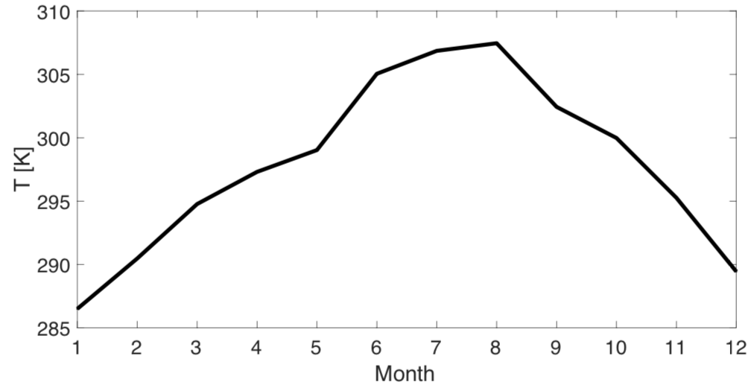
Figure S1. Surface temperature from GEOS-FP in the 0.25° x 0.3125° grid cell that includes Yuma in 2017.

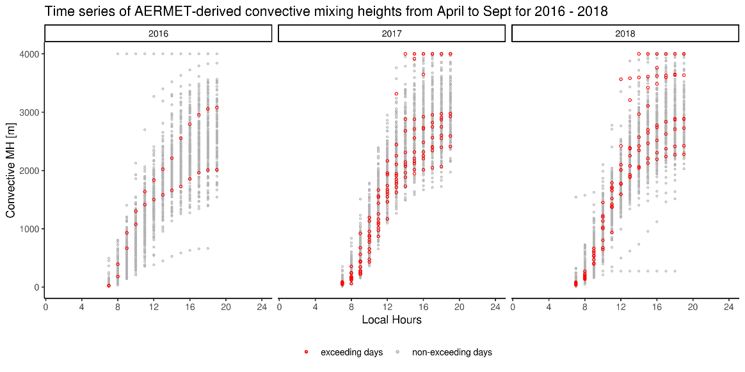
Figure S2. Convective mixing heights in Yuma calculated using AERMET for 2016 – 2018. The calculation uses meteorological data from Yuma Marine Corps Air Station and radiosonde data (e.g., pressure, temperature, relative humidity, and wind) at Tucson (the only radiosonde station in central and south Arizona). AERMET calculates convective mixing heights based on Carson [1973] and Weil and Brower [1983] during unstable conditions using the time-varying surface heat flux. Previous evaluations of the AERMET calculations show good agreement with the observed mixing heights [Simpson, 2007; Weil and Brower, 1983].

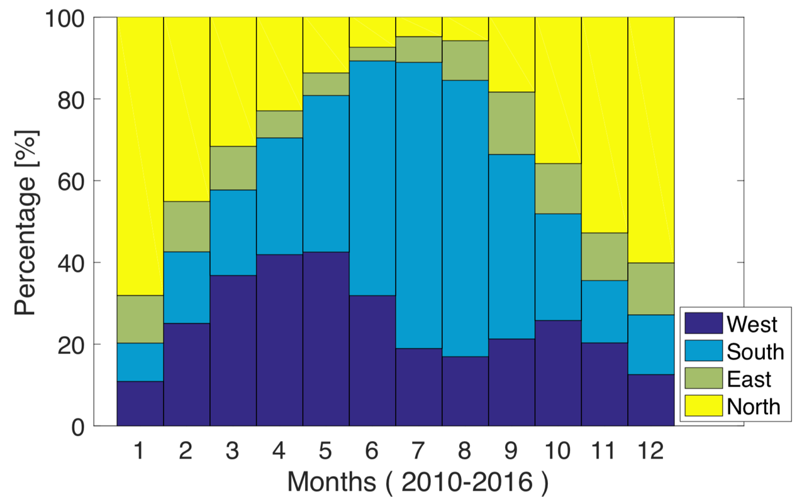
Figure S3. The percentage of the hours in which the winds come from West, South, East and North directions at Yuma International Airport. Hourly wind data from all days from 2010 to 2016 are used for the calculation.

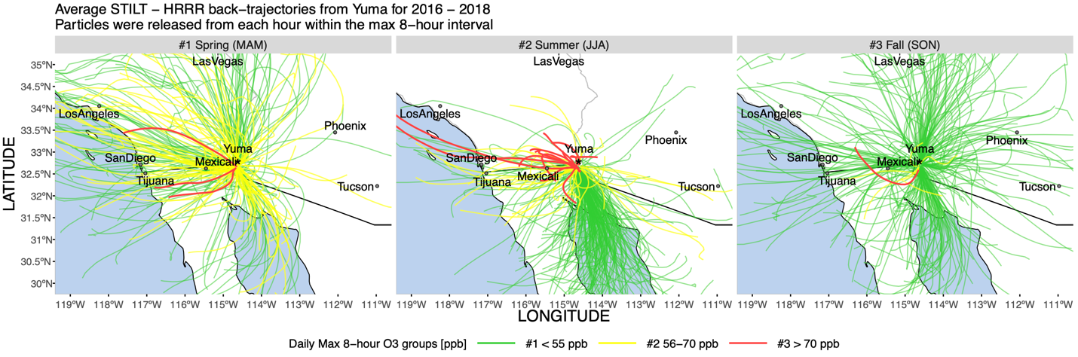

Figure S4. STILT 24 hours back trajectories for Yuma in 2016-2018 in Spring, Summer and Fall. Each line is the daily mean trajectory of 800 particles released 4.3 m above the surface during the eight hours that have the maximum ozone concentrations of the day. Back trajectories in red represent days when MDA8 exceed the EPA standard of 70 ppb; trajectories in yellow represent days when air quality is acceptable; trajectories in green represent days when air quality is good.

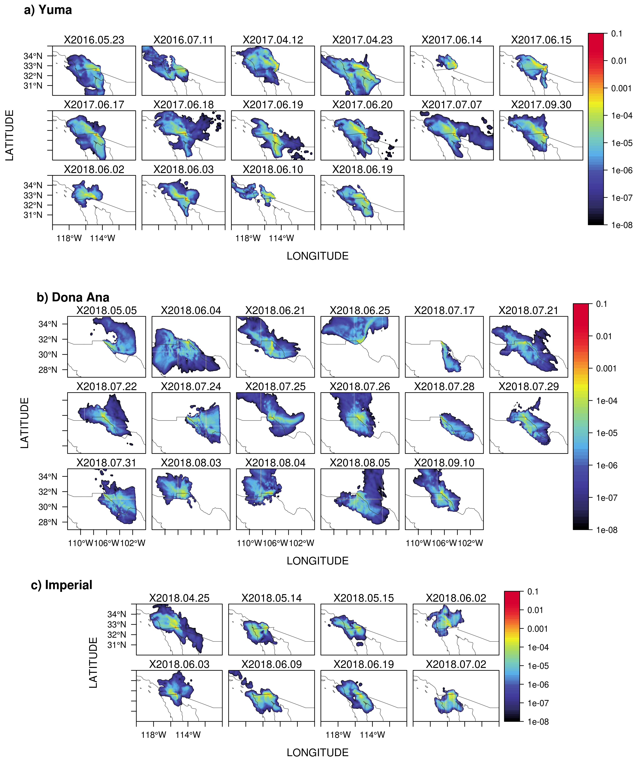
Figure S5. Spatial distributions of daily mean STILT footprints (averaged over 8 hours), in log₁₀ scale) on exceeding days (dates are labeled at the top of each panel). We examined all exceeding events during 2016 – 2018 for Yuma, and only 2018 for the other two sites. 0.01° footprints are generated over 20° x 20° spatial regions, i.e., 120°W – 100°W and 20°N – 40°N for Yuma and Imperial; 115°W – 95°W and 20°N – 40°N for Dona Ana. About 12 out of the 16 exceeding days for Yuma, 11 out of 17 days for Dona Ana, and 6 out of 8 days for Imperial saw relatively strong surface influence (i.e., footprint > 10⁻⁴ ppm $μ$mol⁻¹ m² s) from Northern Mexico. Note that near-field land usually gets the strongest footprint values, as air parcels are concentrated near the site before being dispersed outwards.
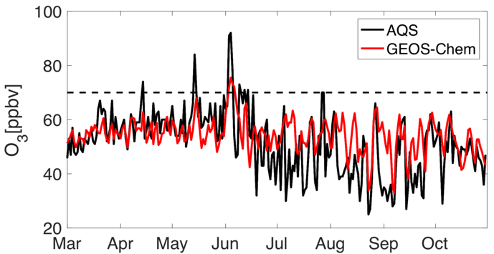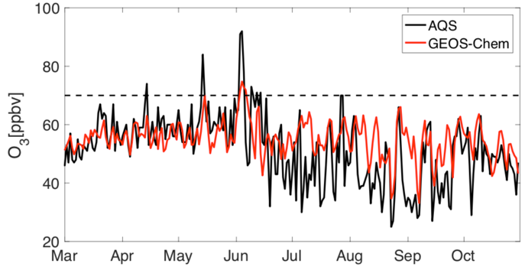

Figure S6. Evaluation of MDA8 ozone simulations using prior NOx emissions (left) and the NASA posterior NOx emissions (right) with measurements in 2014.
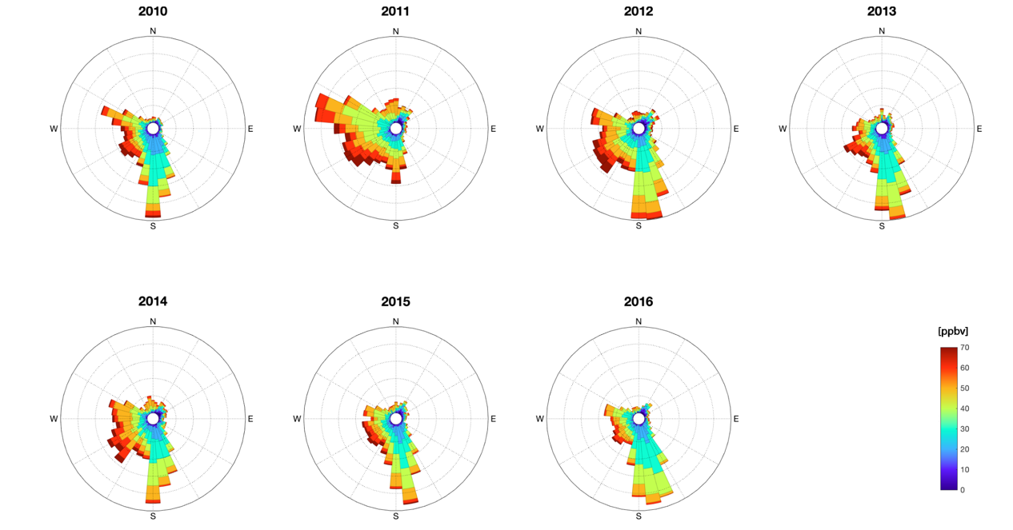
Figure S7. Wind directions and ozone concentrations in Yuma from April to July of each year from 2010 to 2016. The length of each “spoke” represents the frequency of wind blew from that direction.

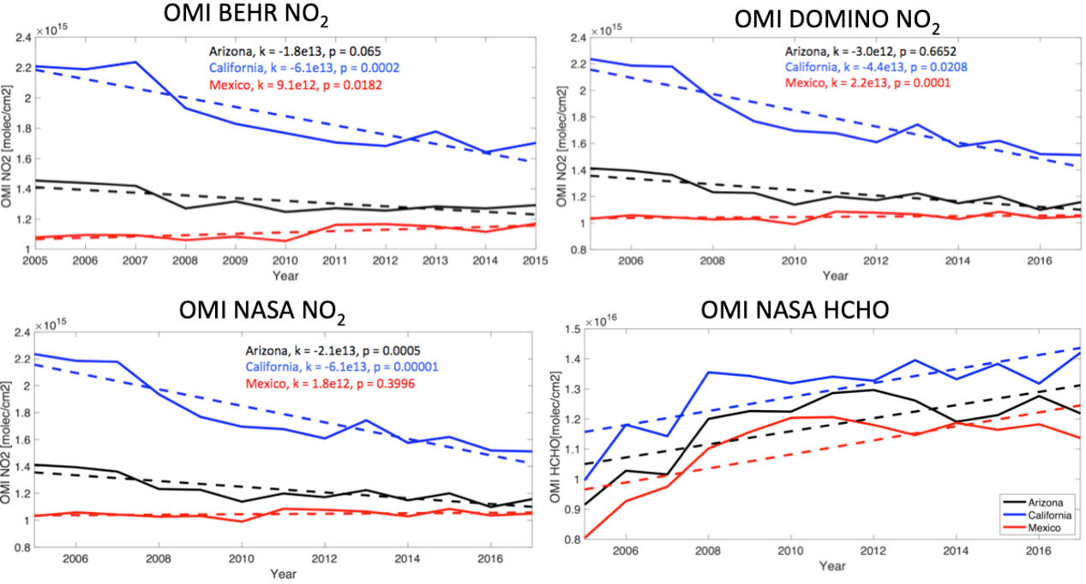
Figure S8. OMI vertical column densities of NO₂ and HCHO in Arizona (black), southern California (blue), and northern Mexico (red) from 2005 to 2017. Areas of the state included in the calculation are shown in the map in Fig. S5.

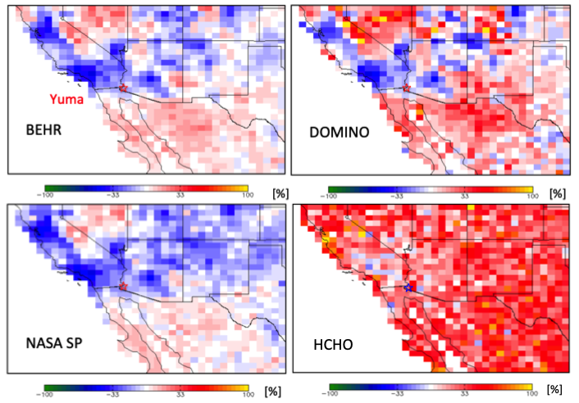

Figure S9. Changes in tropospheric NO₂ and HCHO column concentration from the average of 2005 and 2006 to the average of 2014 and 2015 based on three OMI NO₂ products, i.e., BEHR, DOMINO and NASA SP, and OMI HCHO NASA product.

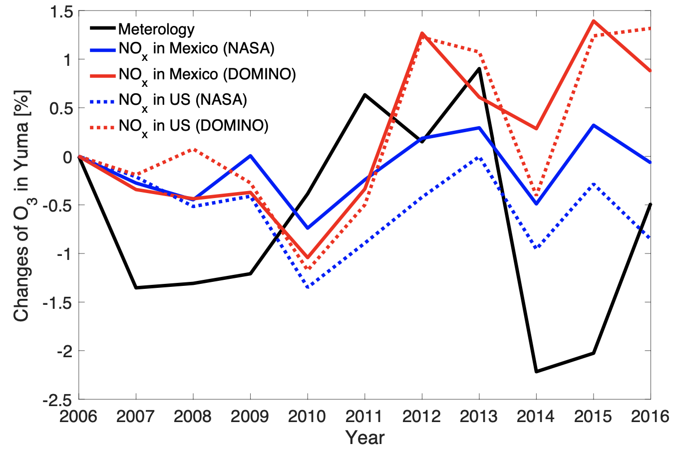
Figure S10. Changes of MDA8 ozone in Yuma due to changes in NO_{x} emissions (DOMINO posterior shown in red, NASA posterior shown in blue) and meteorology.

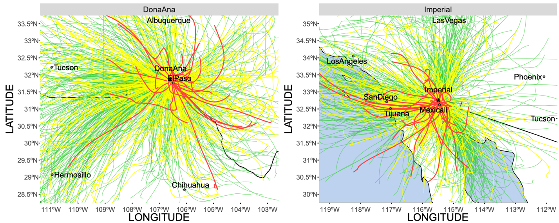
Figure S11. STILT 24 hours back trajectory of ozone at Desert View (Dona Ana County, left) and Calexico (Imperial County, right) from 2016 to 2018. Each line is the daily mean trajectory of 800 particles released during the eight hours that have the maximum ozone concentrations of the day.

Table S1. Designated areas that exceed the ozone NAAQS in 2015 but not exceed the ozone NAAQS in 2008, based on measurements from 2018.
Designated Area | 2015-2017 Design Value (ppm) | Population (2017)
Atlanta, GA | 0.075 | 486,290
Baltimore, MD | 0.075 | 621,647
Mariposa County, CA | 0.075 | 17,569
San Francisco Bay Area, CA | 0.075 | 884,363
Cleveland, OH | 0.074 | 385,525
Las Vegas, NV | 0.074 | 641,676
Louisville, KY-IN | 0.074 | 1,293,953
Manitowoc County, WI | 0.074 | 79,175
Muskegon County, MI | 0.074 | 173,693
San Antonio, TX | 0.074 | 1,500,000
Allegan County, MI | 0.073 | 116,447
Berrien County, MI | 0.073 | 154,259
Cincinnati, OH-KY | 0.073 | 301,301
Detroit, MI | 0.073 | 673,104
Door County, WI | 0.073 | 27,483
Milwaukee, WI | 0.073 | 595,351
Amador County, CA | 0.072 | 38,626
Dona Ana County, NM | 0.072 | 215,579
San Luis Obispo (Eastern part), CA | 0.072 | 283,405
Southern Wasatch Front, UT | 0.072 | 2,000,000
St. Louis, MO-IL | 0.072 | 317,000
Yuma, AZ | 0.072 | 95,502
Columbus, OH | 0.071 | 879,170
Sutter Buttes, CA | 0.071 | 96,648
Washington, DC-MD-VA | 0.071 | 693,972

Table S2. Air Quality, Emissions, and Emissions-Related Data of Yuma, Imperial, Doña Ana, and Maricopa Counties
County Name | Yuma County,  Arizona | Imperial County, California | Doña Ana County,  New Mexico | Maricopa County, Arizona
EPA’s Air Quality Site Name (ID) | Yuma Supersite (04-027-8011) | Calexico-Ethel Street (06-025-0005) | Desert View (35-013-0021) | Pinnacle Peak (04-013-2005)
2014-2016 Design Value (ppm*) | 0.074 | 0.076 | 0.072 | 0.077
Total County-Level NOx Emission (tons per year) | 8,236 | 6,192 | 10,729 | 61,528
Total County-Level VOC Emission (tons per year) | 7,462 | 7,063 | 6,096 | 80,493
2015  Population | 204,275 | 180,191 | 214,295 | 4,167,947
2015  Population  Density (per square mile) | 37 | 43 | 56 | 453
2014 Total VMT (Million Miles) | 1,787 | 2,590 | 2,024 | 32,590

Table S3. NMB between GEOS-Chem annual MDA8 ozone simulations and AQS measurement at Yuma Supersite.
 | NMB 2014 | NMB 2015 | NMB 2016
Prior | 5% | 13% | 17%
NASA posterior | 7% | 16% | 19%
DOMINO posterior | 16% | 26% | 30%

Table S4. Ozone exceedance days in Yuma from AQS sites (MDA 8 larger than 0.070 ppm), Arizona.
Year | Exceedance days
2010 (8) | 5/4, 5/21, 6/11, 6/17, 6/21, 6/23, 6/30, 7/1
2011 (12) | 4/12, 5/24, 5/25, 6/1, 6/3, 6/9, 6/14, 6/17, 6/19, 6/21, 7/1, 7/2
2012 (16) | 4/18, 4/19, 5/13, 5/15, 5/16, 5/19, 5/21, 5/22, 5/30, 5/31, 6/1, 6/5, 6/6, 6/20, 8/2, 8/11,
2013 (5) | 5/19, 5/22, 5/26, 6/6, 6/11
2014 (8) | 4/16, 5/16, 6/5, 6/6, 6/7, 6/11, 6/14, 6/16
2015 (9) | 4/18, 4/19, 4/30, 6/3, 6/4, 6/6, 6/11, 6/18, 6/19,
2016 (2) | 5/23, 7/11
2017 (10) | 4/12, 4/23, 6/14, 6/15, 6/17, 6/18, 6/19, 6/20, 7/7, 9/30
2018 (6) | 5/6, 5/8, 6/2, 6/3, 6/10, 6/19,

References:

Carson, D. J. (1973). The Development of a Dry Inversion-Capped Convectively Unstable Boundary Layer. Quart. J. Royal Meteor. Soc., 99:450-467.

Weil, J. C., and R. P. Brower (1983). Estimating Convective Boundary Layer Parameters for Diffusion Applications, Draft Report, prepared by the Environmental Center, Martin Marietta Corp, for the state of Maryland.

Simpson M, Raman S, Lundquist JK, Leach M. A study of the variation of urban mixed layer heights. Atmospheric Environment. 2007 Oct 1;41(33):6923-30.

