Supplementary Information

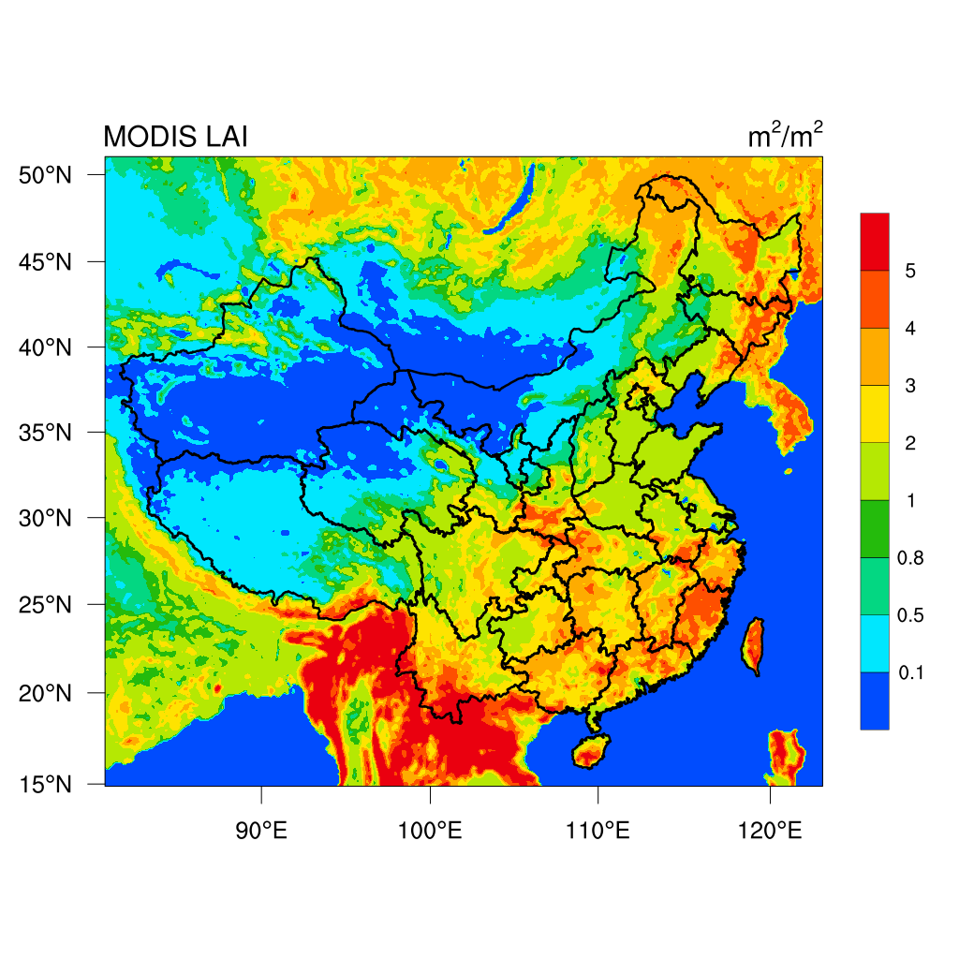

Fig. S1 Spatial distributions of leaf area indices (LAI) in summer season in China.



Fig. S2 Scatter plot and linear regression between leaf area indices (LAI) and correlation coefficients of O3 and RH (R) across all the 74 cities.

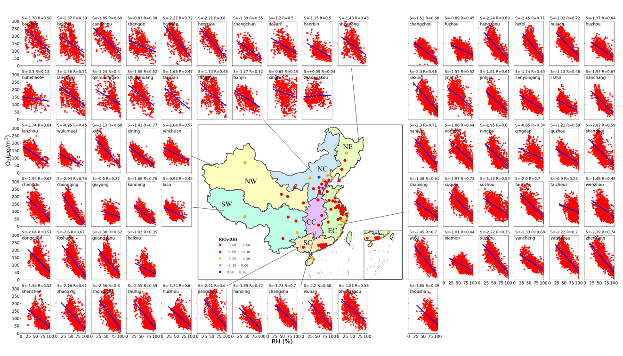

Fig. S3 Correlations between noontime O3 and relative humidity (RH) (11:00 to 16:00, local time) by excluding data points with precipitation and low T (T≤15℃) in different warm seasons of 2017 and 2018 for the major 74 cities in China but for all RH values when compared to Fig. 2.



Fig. S4 Scatter plots of O3 against relative humidity (RH) grouped by T during the noontime (11:00 to 16:00, local time) excluding precipitation in different warm seasons during 2017-2018 in (a) Hangzhou and (b) Chengdu. Points represent the average values of O3 concentration versus RH for each RH bin (5% intervals). Scatter plots of O3 against T grouped by RH during the same period as above in (c) Hangzhou and (d) Chengdu. Points represent the average values of O3 concentrations versus T for each T bin (2℃ intervals). The slopes of linear regression equations are also provided in the plots (α<0.05).



Fig. S5 Ozone variance attributed to meteorology conditions (relative humidity (RH), temperature (T), wind speed (WS))

during the noontime (11:00 to 16:00, local time) excluding precipitation in warm seasons in 2017-2018 averaged across all cities in seven regions. The variance explained is equal to the square of the correlation coefficient between O3 and each factor multiplied by 100. The error bars represent standard deviation from the mean.

Table S1 Related water vapor-involved chemical reactions of O3 formation (Yu, 2019).

|  |  |  |
| --- | --- | --- |
| O3 decomposition by water vapor | hydroxyl radicals termination reactions | NO2 termination reactions |
| O3 + hv → O(1D) + O2 | HO2 + CO + nH2O → CO2 + OH | O(3P) + NO2 + M → NO3 + M |
| O(1D) + H2O → 2OH | HO2 + NO + nH2O → nonradical products | NO2 + O3 → NO3 + O2 |
| O3 + OH → HO2 + O2 | OH + CO + nH2O →nonradical products | NO2 + NO3 + M → N2O5 + M |
| O3 + HO2 → OH + 2O2 |  | 2NO2 + H2O → HONO + HNO3 |
|  |  | N2O5 + H2O → 2HNO3 |
|  |  | N2O5(gas) + NaCl → ClNO2 +NaNO3 |

Table S2 Average leaf area indices (LAI) in summer season, topography height (HGT_M) and at each of 74 major cities.

|  |  |  |  |  |  |  |  |  |  |
| --- | --- | --- | --- | --- | --- | --- | --- | --- | --- |
| Region | City | LAI  (m2/m2) | HGT_M  (m) | R | Region | City | LAI  (m2/m2) | HGT_M  (m) | R |
| Northeast  China | Dalian | 0.61 | 28.34 | -0.57 | East  China | Changzhou | 1.65 | 10.08 | -0.67 |
| Haerbin | 2.11 | 160.38 | -0.48 | Fuzhou | 2.62 | 146.11 | -0.41 |
| Shenyang | 2.26 | 93.31 | -0.54 | Hangzhou | 1.74 | 40.92 | -0.69 |
| Changchun | 1.91 | 225.63 | -0.53 | Hefei | 1.96 | 30.96 | -0.71 |
| North  China | Baoding | 1.95 | 9.38 | -0.65 | Huzhou | 0.57 | 10.86 | -0.63 |
| Beijing | 1.77 | 99.48 | -0.46 | Huaian | 2.24 | 10.05 | -0.69 |
| Cangzhou | 1.23 | 6.25 | -0.74 | Jinan | 1.57 | 200.80 | -0.58 |
| Chengde | 2.70 | 573.66 | -0.36 | Jiaxing | 2.22 | 7.02 | -0.67 |
| Handan | 2.01 | 42.66 | -0.71 | Jinhua | 2.56 | 166.92 | -0.61 |
| Hengshui | 1.80 | 16.84 | -0.84 | Lishui | 3.39 | 423.98 | -0.48 |
| Huhehaote | 1.07 | 1243.88 | -0.38 | Lianyungang | 0.70 | 22.56 | -0.6 |
| Langfang | 1.71 | 8.34 | -0.59 | Nanchang | 1.82 | 18.14 | -0.67 |
| Qinhuangdao | 0.17 | 19.13 | -0.37 | Nanjing | 1.78 | 32.89 | -0.71 |
| Shijiazhuang | 1.94 | 55.65 | -0.65 | Nantong | 2.28 | 3.60 | -0.58 |
| Taiyuan | 1.27 | 1059.15 | -0.55 | Ningbo | 0.98 | 30.16 | -0.59 |
| Tangshan | 1.48 | 51.95 | -0.51 | Qingdao | 0.72 | 80.12 | -0.37 |
| Tianjin | 1.38 | 5.08 | -0.59 | Quzhou | 2.06 | 94.15 | -0.52 |
| Xingtai | 2.02 | 43.76 | -0.52 | Xiamen | 0.61 | 58.70 | -0.45 |
| Zhangjiakou | 1.39 | 1221.46 | -0.17 | Shanghai | 0.21 | 2.58 | -0.6 |
| South  China | Dongguan | 1.88 | 54.88 | -0.57 | Shaoxing | 1.38 | 17.28 | -0.6 |
| Foshan | 1.26 | 16.69 | -0.67 | Suzhou | 1.21 | 7.51 | -0.5 |
| Guangzhou | 2.67 | 104.44 | -0.63 | Taizhouz | 1.73 | 41.10 | -0.24 |
| Haikou | 0.00 | 1.70 | -0.35 | Taizhouj | 2.80 | 17.88 | -0.67 |
| Huizhou | 2.46 | 91.05 | -0.6 | Wenzhou | 2.47 | 123.08 | -0.46 |
| Jiangmen | 0.67 | 10.09 | -0.61 | Wuxi | 1.90 | 9.70 | -0.7 |
| Nanning | 2.97 | 146.45 | -0.72 | Suqian | 2.52 | 14.67 | -0.71 |
| Shenzhen | 2.23 | 78.31 | -0.53 | Xuzhou | 2.06 | 42.81 | -0.76 |
| Zhaoqing | 3.22 | 133.32 | -0.61 | Yancheng | 1.86 | 3.23 | -0.64 |
| Zhongshan | 0.70 | 8.05 | -0.59 | Yangzhou | 2.20 | 2.27 | -0.69 |
| Zhuhai | 0.47 | 16.43 | -0.59 | Zhenjiang | 1.52 | 5.10 | -0.72 |
| Northwest  China | Lanzhou | 0.30 | 1802.68 | -0.58 | Zhoushan | 0.00 | 8.10 | -0.49 |
| Wulumuqi | 0.61 | 754.52 | -0.37 | Southwest  China | Chengdu | 2.18 | 591.93 | -0.67 |
| Xian | 1.33 | 456.64 | -0.68 | Guiyang | 2.59 | 1240.98 | -0.22 |
| Xining | 1.30 | 2569.29 | -0.73 | Kunming | 2.78 | 2100.75 | -0.76 |
| Yinchuan | 1.24 | 1138.26 | -0.62 | Chongqing | 2.02 | 356.03 | -0.76 |
| Central  China | Wuhan | 1.11 | 21.65 | -0.68 | Lasa | 0.80 | 4387.26 | -0.31 |
| Changsha | 2.58 | 65.72 | -0.68 |  |  |  |  |
| Zhengzhou | 1.87 | 90.75 | -0.65 |  |  |  |  |

Table S3 Statistical values of O3 concentrations under RH≥75% and RH under O3≥200 μg m-3. Min, Max, Mean, SD, 90% denotes the minimum, maximum, mean, standard deviation, and 90% percentile of corresponding parameters, respectively. NaN represents no values, that is, no O3 concentrations exceeds 200 μg m-3 for these cities. The average O3 concentrations varied in the range of 44.6 and 122.5 μg m-3 with 90% percentile of hourly O3 values ranging from 75.6 to 168.7 μg m-3 in all the 74 cities under RH over 75%, lower than China National Ambient Air Quality Standard (CNAAQS, GB3095-2012, 200 μg m-3), showing the important role of high RH in O3 attainment in warm seasons at all cities.

|  |  |  |  |  |  |  |  |
| --- | --- | --- | --- | --- | --- | --- | --- |
|  |  | O3 (μg m-3) under RH≥75% | | | RH (%) under O3≥200 μg m-3 | | |
| Region | City | [Min, Max] | Mean ± SD | 90% | [Min, Max] | Mean ± SD | 90% |
| Northeast  China | Dalian | [32.9, 190.8] | 93.5 ± 29.3 | 131.9 | [29, 70] | 47 ± 11 | 66 |
| Haerbin | [29.2, 157.4] | 70.7 ± 31.5 | 109.5 | [27, 54] | 43 ± 10 | 52 |
| Shenyang | [15.5, 126.1] | 59.0 ± 31.9 | 99.3 | [26, 69] | 43 ± 10 | 56 |
| Changchun | [20.6, 151.5] | 58.9 ± 21.7 | 79.4 | [28, 59] | 45 ± 10 | 57 |
| North  China | Baoding | [36.6, 199.7] | 110.8 ± 38.1 | 157.2 | [26, 71] | 44 ± 11 | 58 |
| Beijing | [16.2, 131.5] | 70.5 ± 28.7 | 111.2 | [26, 63] | 46 ± 10 | 57 |
| Cangzhou | [26.7, 189.0] | 95.1 ± 34.5 | 136.9 | [26, 73] | 42 ± 11 | 58 |
| Chengde | [15.2, 163.0] | 88.1 ± 34.2 | 128.9 | [27, 62] | 42 ± 9 | 54 |
| Handan | [31.5, 167.3] | 91.1 ± 30.0 | 125.9 | [26, 68] | 40 ± 10 | 54 |
| Hengshui | [19.3, 133.3] | 80.3 ± 27.7 | 110.9 | [26, 67] | 38 ± 8 | 47 |
| Huhehaote | [61.8, 159.9] | 101.2 ± 33.0 | 149.0 | [26, 39] | 32 ± 4 | 36 |
| Langfang | [26.3, 172] | 82.7 ± 35.6 | 125.2 | [27, 73] | 46 ± 11 | 60 |
| Qinhuangdao | [16.6, 302.2] | 110.7 ± 43.4 | 162.1 | [28, 82] | 63 ± 14 | 78 |
| Shijiazhuang | [13.5, 174.1] | 85.5 ± 37.4 | 136.8 | [26, 70] | 40 ± 10 | 52 |
| Taiyuan | [80.3, 134.5] | 103.4 ± 20.7 | 123.3 | [26, 49] | 34 ± 6 | 43 |
| Tangshan | [13.0, 211.2] | 90.3 ± 51.8 | 168.7 | [27, 76] | 48 ± 13 | 65 |
| Tianjin | [27.1, 185.4] | 77.0 ± 31.4 | 99.7 | [26, 62] | 39 ± 7 | 47 |
| Xingtai | [15.8, 226.0] | 98.0 ± 51 | 165.1 | [27, 78] | 46 ± 13 | 63 |
| Zhangjiakou | [77.8, 182.8] | 122.5 ± 25.9 | 155.4 | [26, 71] | 45 ± 9 | 58 |
| Northwest  China | Lanzhou | [37.0, 107.2] | 75.7 ± 22.4 | 105.7 | [26, 52] | 39 ± 8 | 46 |
| Wulumuqi | [39.7, 107.1] | 67.0 ± 22.3 | 90.5 | NaN | | |
| Xian | [34.7, 124.6] | 76.5 ± 23.0 | 109.9 | [26, 54] | 36 ± 7 | 47 |
| Xining | [34.8, 108.0] | 64.8 ± 16.8 | 85.9 | NaN | | |
| Yinchuan | [49.3, 110.9] | 82.6 ± 14.6 | 99.3 | [26, 38] | 31 ± 4 | 37 |
| Southwest  China | Chengdu | [15.8, 187.2] | 69.2 ± 25.8 | 103.6 | [32, 69] | 46 ± 9 | 58 |
| Guiyang | [23.6, 160.7] | 76.2 ± 27.9 | 114.9 | NaN | | |
| Kunming | [13.7, 115.1] | 53.5 ± 19.6 | 81.1 | NaN | | |
| Chongqing | [10.9, 151.1] | 44.6 ± 23.0 | 75.6 | [28, 55] | 41 ± 7 | 50 |
| Lasa | NaN | | | NaN | | |
| East  China | Changzhou | [10.6, 125.9] | 53.1 ± 24.0 | 88.5 | NaN | | |
| Fuzhou | [26.4, 180] | 91.2 ± 26.6 | 128.2 | NaN | | |
| Hangzhou | [18.4, 148.7] | 70.7 ± 28.1 | 113.9 | [27, 71] | 44 ± 9 | 54 |
| Hefei | [20.9, 168.6] | 76.2 ± 28.4 | 116.1 | [31, 68] | 52 ± 8 | 62 |
| Huzhou | [31.6, 188.2] | 70.6 ± 24.1 | 98.0 | [39, 49] | 43 ± 5 | 47 |
| Huaian | [27.8, 189.0] | 94.4 ± 32.1 | 134.7 | [26, 67] | 43 ± 10 | 57 |
| Jinan | [10.9, 222.9] | 79.9 ± 43.8 | 129.2 | [26, 84] | 42 ± 11 | 55 |
| Jiaxing | [22.7, 216.0] | 86.0 ± 35.6 | 136.8 | [27, 75] | 50 ± 10 | 64 |
| Jinhua | [15.7, 144.0] | 78.8 ± 28.4 | 114.1 | [28, 70] | 42 ± 9 | 55 |
| Lishui | [24.7, 134.0] | 73.1 ± 21.4 | 103.0 | [30, 49] | 40 ± 7 | 46 |
| Lianyungang | [29.4, 160.0] | 80.0 ± 22.8 | 109.2 | [34, 44] | 38 ± 4 | 42 |
| Nanchang | [21.6, 177.4] | 73.1 ± 26.9 | 103.7 | [33, 50] | 40 ± 6 | 49 |
| Nanjing | [9.7, 187.2] | 80.8 ± 34.4 | 126.0 | [28, 67] | 47 ± 9 | 58 |
| Nantong | [24.8, 308.0] | 94.7 ± 38.0 | 142.0 | [26, 93] | 50 ± 12 | 69 |
| Ningbo | [22.3, 200.6] | 78.7 ± 30.9 | 115.6 | [29, 90] | 47 ± 10 | 59 |
| Qingdao | [14.3, 241.2] | 99.9 ± 39.5 | 151.7 | [43, 89] | 58 ± 11 | 73 |
| Quzhou | [31.0, 155.0] | 88.5 ± 27.1 | 128.9 | [28, 47] | 37 ± 5 | 43 |
| Xiamen | [32.5, 170.7] | 75.8 ± 23.7 | 106.3 | NaN | | |
| Shanghai | [24.5, 302.1] | 84.9 ± 41 | 139.2 | [26, 91] | 47 ± 10 | 58 |
| Shaoxing | [35.0, 172.5] | 83.0 ± 23.9 | 115.6 | [28, 49] | 38 ± 6 | 45 |
| Suzhou | [31.7, 233.4] | 97.4 ± 37.9 | 153.0 | [26, 77] | 45 ± 14 | 68 |
| Taizhouz | [18.0, 231.7] | 103.1 ± 37.7 | 151.3 | [50, 92] | 66 ± 12 | 81 |
| Taizhouj | [33.0, 227.3] | 90.0 ± 32 | 125.7 | [26, 81] | 44 ± 12 | 58 |
| Wenzhou | [20.3, 208] | 80.3 ± 37.3 | 136.1 | [31, 75] | 51 ± 8 | 60 |
| Wuxi | [14.4, 187.9] | 64.0 ± 30.5 | 100.9 | [26, 67] | 42 ± 9 | 54 |
| Suqian | [19.8, 191] | 93.0 ± 33.5 | 138.0 | [26, 71] | 44 ± 9 | 57 |
| Xuzhou | [16.8, 175.4] | 71.5 ± 26.0 | 101.7 | [26, 67] | 40 ± 8 | 50 |
| Yancheng | [35.0, 155.5] | 83.5 ± 20.5 | 107.8 | [27, 52] | 37 ± 7 | 48 |
| Yangzhou | [13.0, 212.4] | 87.5 ± 30.1 | 126.5 | [26, 76] | 46 ± 10 | 58 |
| Zhenjiang | [9.3, 193.3] | 83.1 ± 34.1 | 132.6 | [26, 69] | 46 ± 10 | 60 |
| Zhoushan | [17.3, 221.3] | 81.1 ± 37.3 | 132.2 | [49, 80] | 64 ± 9 | 74 |
| Central  China | Wuhan | [21.8, 152.3] | 68.9 ± 25.7 | 102.9 | [30, 66] | 46 ± 7 | 53 |
| Changsha | [22.7, 163.6] | 81.7 ± 26 | 117.8 | [27, 65] | 42 ± 8 | 52 |
| Zhengzhou | [26.6, 149.1] | 79.3 ± 27.3 | 107.4 | [26, 66] | 39 ± 9 | 54 |
| South  China | Dongguan | [9.8, 228.2] | 72.1 ± 38.1 | 119.6 | [42, 85] | 57 ± 8 | 70 |
| Foshan | [7.4, 212.0] | 58.6 ± 30.9 | 93.2 | [28, 84] | 52 ± 9 | 61 |
| Guangzhou | [13.3, 181.7] | 60.7 ± 35.3 | 114.4 | [40, 67] | 52 ± 6 | 60 |
| Haikou | [20.2, 131.4] | 56.7 ± 22.8 | 89.2 | [51, 68] | 62 ± 6 | 67 |
| Huizhou | [23.0, 219.8] | 70.5 ± 32.8 | 114.6 | [46, 95] | 60 ± 11 | 69 |
| Jiangmen | [9.0, 288.3] | 73.1 ± 38 | 114.0 | [28, 93] | 53 ± 12 | 66 |
| Nanning | [8.0, 139.0] | 53.8 ± 23.5 | 85.1 | [59, 61] | 60 ± 1 | 61 |
| Shenzhen | [27.7, 208.5] | 67.9 ± 31.8 | 110.3 | [38, 84] | 57 ± 11 | 71 |
| Zhaoqing | [16.0, 231.3] | 64.8 ± 41.4 | 123.3 | [37, 87] | 53 ± 10 | 64 |
| Zhongshan | [6.0, 270.3] | 70.6 ± 34.7 | 112.1 | [30, 76] | 52 ± 10 | 66 |
| Zhuhai | [16.8, 250.3] | 70.4 ± 35.4 | 110.8 | [26, 81] | 55 ± 14 | 73 |