Appendix of

The evolution of intra- and inter-molecular isotope equilibria in natural gases with thermal maturation
Hao Xie¹, Guannan Dong¹, Michael Formolo², Michael Lawson³, Jianzhang Liu⁴, Fuyun Cong⁴, Xavier Mangenot¹, Yanhua Shuai⁵, Camilo Ponton⁶, John Eiler¹
¹Division of Geological and Planetary Sciences, California Institute of Technology, Pasadena, CA, USA
²ExxonMobil Upstream Integrated Solutions Company, Spring, TX, USA
³ExxonMobil Upstream Business Development Company, Spring, TX, USA
⁴China University of Geosciences, Wuhan, Hubei, China
⁵Research Institute of Petroleum Exploration and Development (PetroChina), Beijing, China
⁶Western Washington University, Bellingham, WA, USA

Table of Contents:
- Kinetic parameters and kinetic isotope effects (KIE) used in methane generation-exchange modeling

- Basin modeling of selected wells in the Eagle Ford Shale

- Usage of publications and reports containing compound-specific hydrogen isotope data

- Kinetic parameters and kinetic isotope effects (KIE) used in methane generation-exchange modeling
Type | Parameter | Value | Note
KIE | α¹³CH₃ | 0.978 | Tang et al. (2000)
 | α¹²CH₂D | 0.7 | Ni et al. (2011)
 | α¹³CH₂D | γ¹³CH₂D*α¹³CH₃ *α¹²CH₂D | #
 | α¹²CHD₂ | γ¹²CHD₂(α¹²CH₂D)² | #
 | α_{cap} | 0.33 | Extrapolation to (Wang et al., 2009)
Precursor composition | δ¹³C^{pre} | -27‰ | Eldrett et al. (2014)
 | δD^{pre} | -100‰ | Assumption
 | Δ¹³CH₂D^{pre} | 2‰ | Assumption (equilibrium)
 | Δ¹²CHD₂^{pre} | 6‰ | Assumption (equilibrium)
 | δD^{pre-cap} | -100‰ | Assumption
Exchange kinetics | A | 2.45×10¹⁰ s⁻¹ | Experimental results from Koepp (1978)
 | Ea | 200 kJ/mol | Experimental results from Koepp (1978); Adjusted for catalysis

# γ¹³CH₂D and γ¹²CHD₂ represent additional KIE resulted from clumped isotope effect (a.k.a. clumped isotope KIE). We ran the model with combinations of a few extreme values in the figure below, indicated by numbers in the parenthesis, with the order of (γ¹³CH₂D, γ¹²CHD₂). We found that results are generally insensitive to changes in γ¹³CH₂D and γ¹²CHD₂. Therefore, we set both to 1.
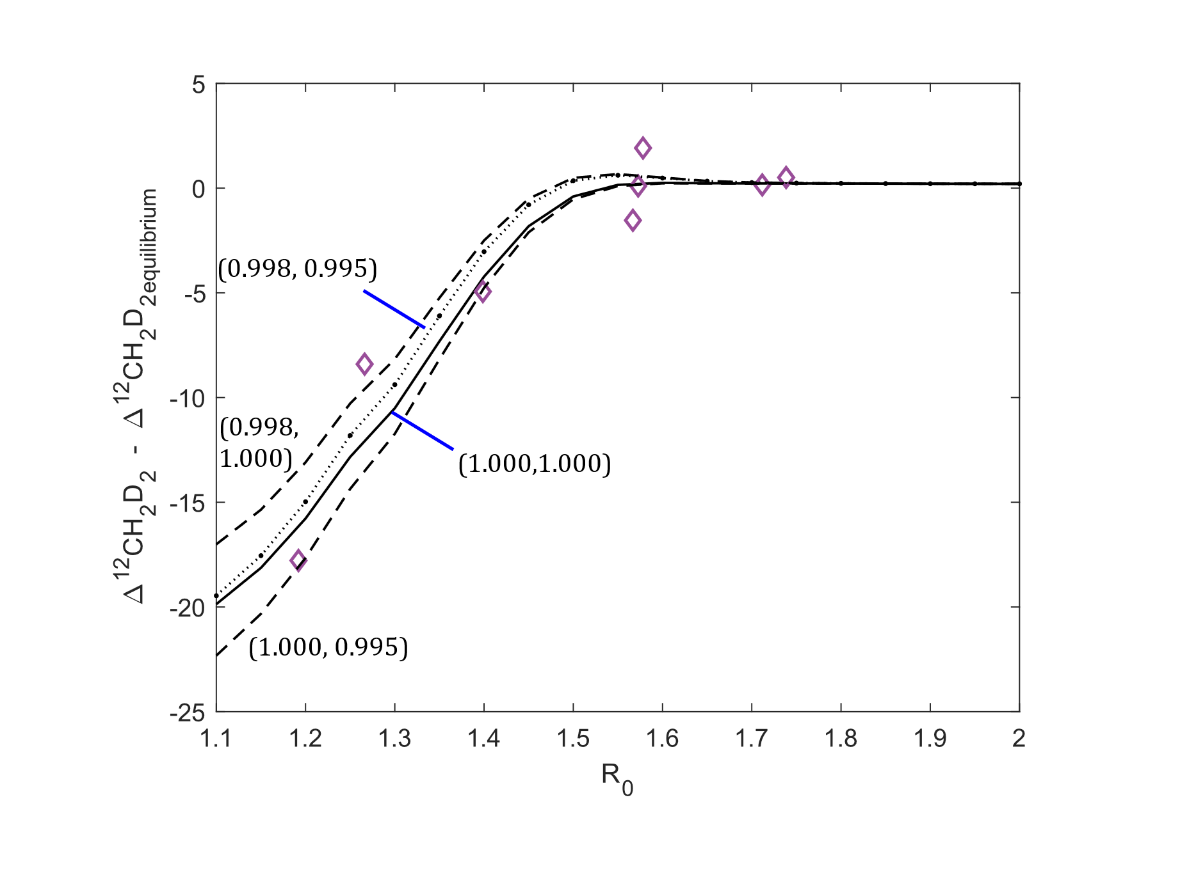

- Basin modeling of selective wells in the Eagle Ford Shale
Virginia Fee 3H
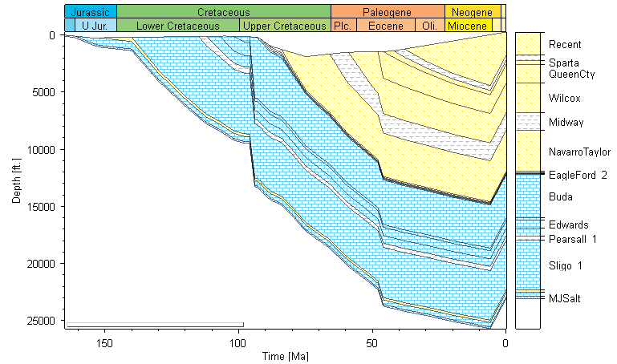

Irvin Minerals 1S
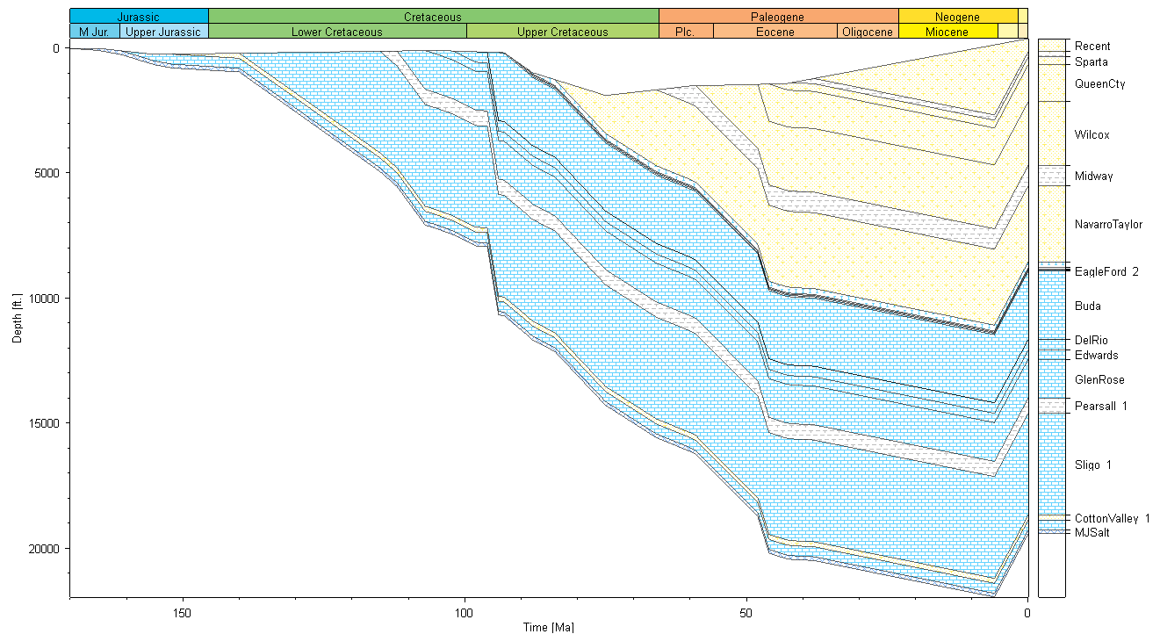

- List of publications and reports with compound-specific hydrogen isotope data of C1, C2 and C3
Reference | Note
Krouse (1983) | Partially excluded – data with well depth shallower than 1700m are excluded due to microbial activity
Prinzhofer and Huc (1995) | Included
Rich et al. (1995) | Excluded due to biogenic methane
Hulston et al. (2001) | Included
Strapoć et al. (2007) | Excluded due to biogenic methane
Boreham and Edwards (2008) | Excluded due to biodegradation
Liu et al. (2008) | Excluded due to thermochemical sulfate reduction (TSR)
Jin et al. (2009) | Excluded due to the possibility of abiotic origin
Burruss and Laughrey (2010) | Included
Rodriguez and Paul Philp, (2010) | Included
Dai et al. (2012) | Included
Dai et al. (2014) | Partially excluded – some samples from the Sichuan Basin have the sample ID as Dai et al., (2012)
Ni et al. (2015) | Included
Wang et al. (2015) | Partially excluded to avoid over-representation of the Sichuan Basin, Ordos Basin and Turpan-Hami Basin (as they have been presented in earlier studies)
Meng et al. (2017) | Excluded due to biodegradation
Thiagarajan et al., (2020) | Partially excluded; samples from Jen-Olla and Genesis are biogenic.
Geoscience Australia, ’ORGCHEM’ database | Samples from the Browse Basin and Otway Basin.

Literatures cited:
Boreham C. J. and Edwards D. S. (2008) Abundance and carbon isotopic composition of neo-pentane in Australian natural gases. Org. Geochem. 39, 550–566.
Burruss R. C. and Laughrey C. D. (2010) Carbon and hydrogen isotopic reversals in deep basin gas: Evidence for limits to the stability of hydrocarbons. Org. Geochem. 41, 1285–1296.
Dai J., Ni Y. and Zou C. (2012) Stable carbon and hydrogen isotopes of natural gases sourced from the Xujiahe Formation in the Sichuan Basin, China. Org. Geochem. 43, 103–111.
Dai J. X., Ni Y. Y., Hu G. Y., Huang S. P., Liao F. R., Yu C., Gong D. Y. and Wu W. (2014) Stable carbon and hydrogen isotopes of gases from the large tight gas fields in China. Sci. China Earth Sci. 57, 88–103.
Eldrett J. S., Minisini D. and Bergman S. C. (2014) Decoupling of the carbon cycle during ocean anoxic event 2. Geology 42, 567–570.
Hulston J. R., Hilton D. R. and Kaplan I. R. (2001) Helium and carbon isotope systematics of natural gases from Taranaki Basin, New Zealand. Appl. Geochemistry 16, 419–436.
Jin Z., Zhang L., Wang Y., Cui Y. and Milla K. (2009) Using carbon, hydrogen and helium isotopes to unravel the origin of hydrocarbons in the wujiaweizi area of the Songliao Basin, China. Episodes 32, 167–176.
Koepp M. (1978) D/H isotope exchange reaction between petroleum and water : A contributory determinant for D/H-isotope ratios in crude oil? Short Pap. Fourth Int. Conf. Geochronology. Cosmochronol. Isot. Geol. 1978, 221–222.
Krouse H. R. (1983) Stable isotope research in support of more effective utilization of gas fields in Alberta: Final report to the Alberta-Canada Energy Resource Research Fund.,
Liu Q. Y., Dai J. X., Li J. and Zhou Q. H. (2008) Hydrogen isotope composition of natural gases from the Tarim Basin and its indication of depositional environments of the source rocks. Sci. China, Ser. D Earth Sci. 51, 300–311.
Meng Q., Wang Xiaofeng, Wang Xiangzeng, Shi B., Luo X., Zhang L., Lei Y., Jiang C. and Liu P. (2017) Gas geochemical evidences for biodegradation of shale gases in the Upper Triassic Yanchang Formation, Ordos Basin, China. Int. J. Coal Geol. 179, 139–152.
Ni Y., Zhang D., Liao F., Gong D., Xue P., Yu F., Yu J., Chen J., Zhao C., Hu J. and Jin Y. (2015) Stable hydrogen and carbon isotopic ratios of coal-derived gases from the Turpan-Hami Basin, NW China. Int. J. Coal Geol. 152, 144–155.
Prinzhofer A. A. and Huc A. Y. (1995) Genetic and post-genetic molecular and isotopic fractionations in natural gases. Chem. Geol. 126, 281–290.
Rich K., Muehlenbachs K., Uhrich K. and Greenwood G. (1995) Carbon isotope characterization of migrating gas in the heavy oil fields of Alberta, Canada. In Proceedings - SPE International Heavy Oil Symposium Society of Petroleum Engineers. pp. 215–224.
Rodriguez N. D. and Paul Philp R. (2010) Geochemical characterization of gases from the Mississippian Barnett Shale, Fort Worth Basin, Texas. Am. Assoc. Pet. Geol. Bull. 94, 1641–1656.
Strapoć D., Mastalerz M., Eble C. and Schimmelmann A. (2007) Characterization of the origin of coalbed gases in southeastern Illinois Basin by compound-specific carbon and hydrogen stable isotope ratios. Org. Geochem. 38, 267–287.
Thiagarajan N., Xie H., Ponton C., Kitchen N., Peterson B., Lawson M., Formolo M., Xiao Y. and Eiler J. (2020) Isotopic evidence for quasi-equilibrium chemistry in thermally mature natural gases. Proc. Natl. Acad. Sci., 201906507.
Wang X., Liu W., Shi B., Zhang Z., Xu Y. and Zheng J. (2015) Hydrogen isotope characteristics of thermogenic methane in Chinese sedimentary basins. Org. Geochem. 83–84, 178–189.
Wang Y., Sessions A. L., Nielsen R. J. and Goddard W. A. (2009) Equilibrium ²H/¹H fractionations in organic molecules: II. Linear alkanes, alkenes, ketones, carboxylic acids, esters, alcohols and ethers. Geochim. Cosmochim. Acta 73, 7076–7086.

