Supplementary text to accompany the manuscript, “The Reunion mantle plume is not oxidized” by Maryjo Brounce, Edward Stolper, and John Eiler

Analytical Methods
1. EPMA
Major elements and S and Cl abundances in the melt inclusions and major elements in the olivines were measured using the JEOL JXA-8200 electron microprobe at the California Institute of Technology. Melt inclusions were measured in three locations at the center of each melt inclusion, and melt embayments were measured at the outlet of the embayment, in the center of the melt pools. During major element analysis, the beam was operated at 10 nA, 15 keV, and 10 μm diameter. The elements Si, Ti, Al, Fe, Mn, Mg, Ca, Na, and K were measured in two sweeps on five spectrometers, with Na and K measured in the first sweep to minimize alkali loss. All elements were measured with 20 second peak count times and 10 second background count times. All data were subject to ZAF correction procedures. Albite (Na), TiO₂ (Ti), microcline (K), VG-2 (Si), fayalite (Fe), fosterite (Mg), anorthite (Ca, Al), and Mn-bearing olivine (Mn) were used as primary calibration standards. The USGS glasses BIR-1g and BHVO-1g were used as secondary standards and checked repeatedly throughout data analysis. Sulfur and chlorine were measured separately using a beam operated at 80 nA, 15 keV, and 10 μm diameter, with 120 second peak counting times and 60 second background peak times. Pyrite was used as a primary calibration standard for S and no sample-by-sample peak searching was done. Scapolite was used as the primary calibration standard for Cl. The VG-2 and A-99 glasses were used as secondary standards and checked repeatedly throughout data analysis. Major element compositions of the olivine hosts were measured adjacent to the melt inclusions and at the rim of the olivines. A focused beam was operated at 10 nA and 15 keV. The elements Si, Mg, Fe, Ni were measured with 60 second peak counting times and 30 second background counting times. Fayalite (Fe), forsterite (Mg, Si), and Ni-bearing olivine (Ni) were used as primary calibration standards. San Carlos and Springwater olivine were used as secondary standards during each run. Melt inclusions were measured in three locations near the center of each melt inclusion, and melt embayments were measured in the center of the channels, and in three positions along the channel, spaced evenly apart. All olivine analyses were on spots far enough away both from the melt inclusion walls (so as to avoid strongly zoned olivine immediately adjacent to the melt inclusion; Saper and Stolper, 2020) and from the outermost rims of the olivine grains (so as to minimize the effects syneruptive crystallization of olivine on the outer edge; Newcombe et al., 2014; Saper and Stolper, 2020).

2 FTIR
Dissolved H₂O and CO₂ contents were measured via transmission FTIR at the University of California Riverside on a Thermo-Nicolet iS50 spectrometer coupled with a Continuum microscope. Spectra were collected between 1000 and 6000 cm⁻¹ using a tungsten-halogen source, KBr beamsplitter, and a liquid nitrogen colled MCT-A detector. The bench, microscope and samples were continuously purged with H₂O- and CO₂-minimized air generated by a Ballston purge-gas generator. Aperture dimensions were selected for each sample depending on the geometry of the geometry of the melt inclusion. Dissolved total H₂O concentrations using the 3530 cm⁻¹ absorption band. Interference fringes were present between 2000 – 2700 cm⁻¹ in each sample measurement, permitting the thickness of each sample to be calculated using an index of refraction of n=1.546 and the equation t = m/[2n(v₁-v₂)] where m = the number of fringes present in the selected interval of wavenumbers v₁ and v₂. Glass densities and absorption coefficients relevant to each absorption band were calculated according to (Luhr, 2001).
Supplementary data table 1. Photomicrographs of melt inclusions analyzed in this study
Sample Name | Plane polarized light | Cross polarized light | Reflected light
Reunion-1 | 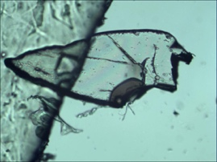 | 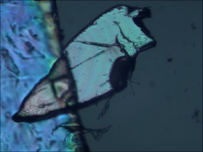 | 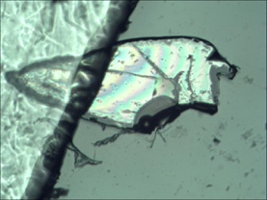
Reunion-4 | see supplementary table 2
Reunion-8 | 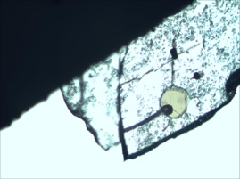 | 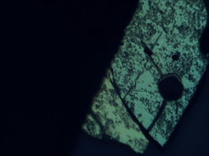 | 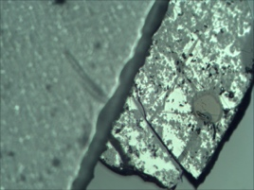
Reunion-9 | 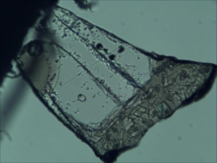 | 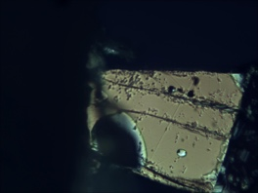 | 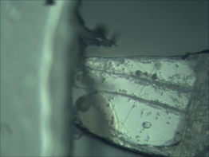
Reunion-10 | 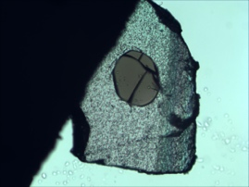 | 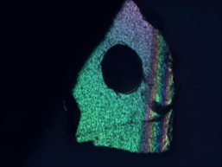 | 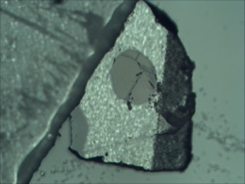
Reunion-11 | 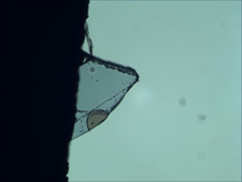 |  | 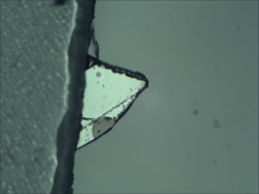
Reunion-12 | 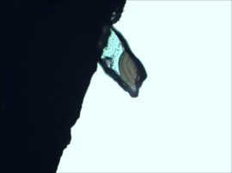 | 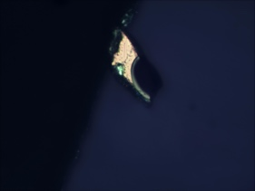 | 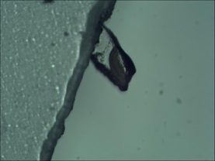
Reunion-14 | 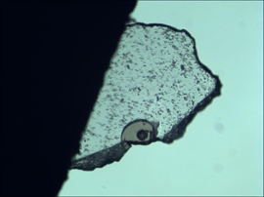 | 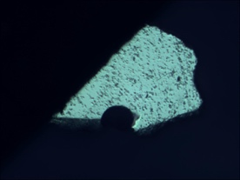 | 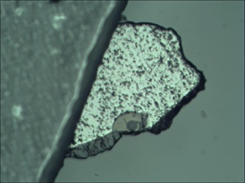
Reunion-15 | See supplementary table 2

Supplementary data table 2. Backscatter electron images of melt inclusions analyzed in this study
Sample name | BSE image
Reunion-4 | 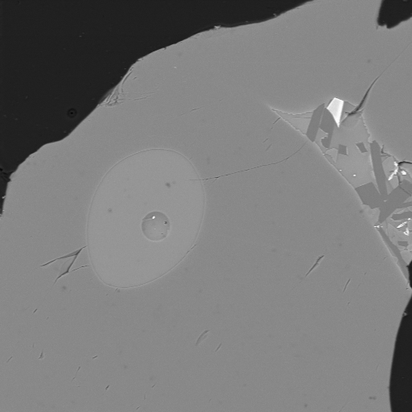
Reunion-15 | 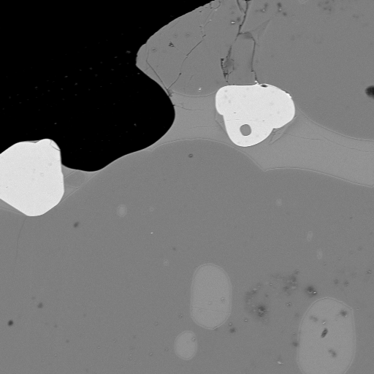

Supplementary data table 3. Representative photomicrographs of olivine grains in the bulk sample examined in this study (note: these specific samples were not analyzed).
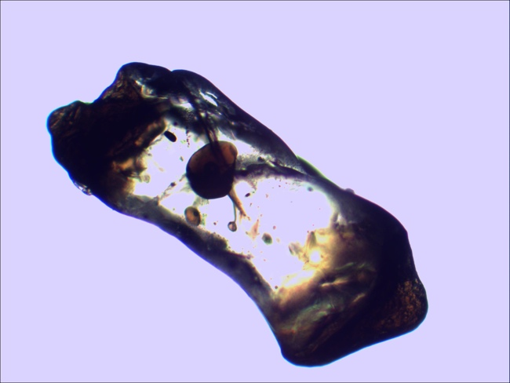 | 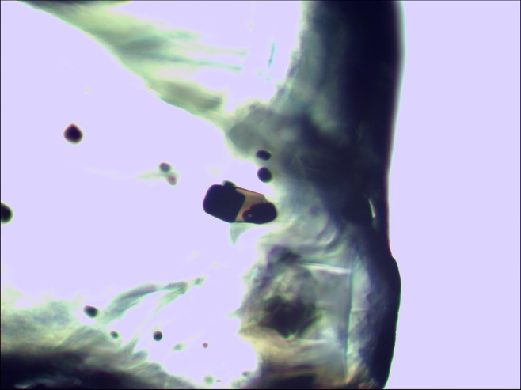
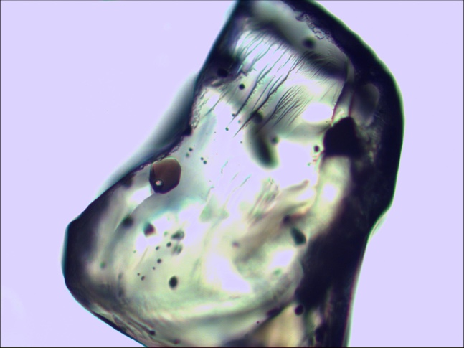 | 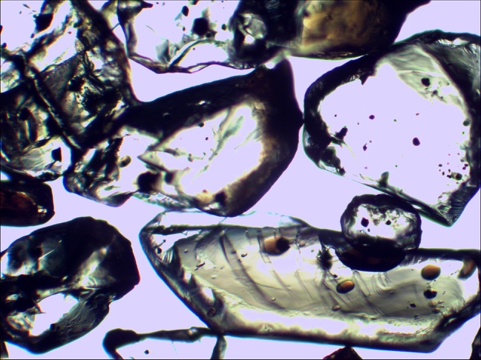
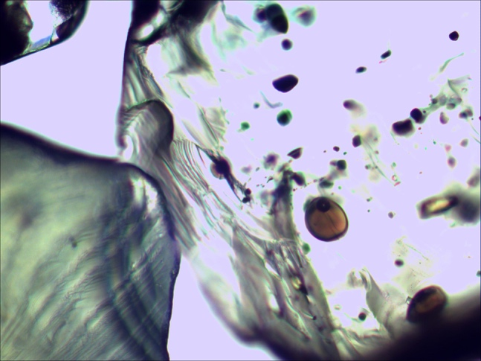 | 