Supporting information
S1 Appendix: Analytical analysis for single-morphogen patterning circuit in continuum
S2 Appendix: Stability analysis for single-morphogen patterning circuit in discrete lattice
S1 Figure: Single-morphogen patterning circuit with Gierer–Meinhardt kinetics
S2 Figure: Pattern initiation is robust with a wide range of perturbations
S3 Figure: Removal of morphogen influx causes pattern stripes “fill-in” the empty space
S1 Movie: Single-morphogen circuit patterning initiated with global random noise
S2 Movie: Propagation pattern formation triggered by localized perturbation

S1 Appendix: Analytical analysis for single-morphogen patterning circuit in continuum
The following analysis considers a two-component system, and the conclusion is valid for a multiple-component pattern. Given a single-morphogen patterning circuit,
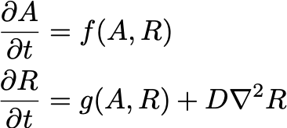
the necessary and sufficient condition to generate stable spatial patterns is that the Jacobian matrix stays stable without diffusion and becomes unstable for some wavenumber k with diffusion. denoting J(k) as
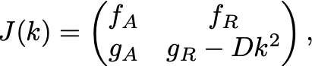
where k is the wavenumber (k = 1, 2, 3, …). The eigenvalue is the solution of
when k is large, the equation becomes,
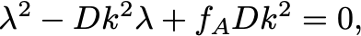
Assuming Re(λ₁) ≤ Re(λ₂), then
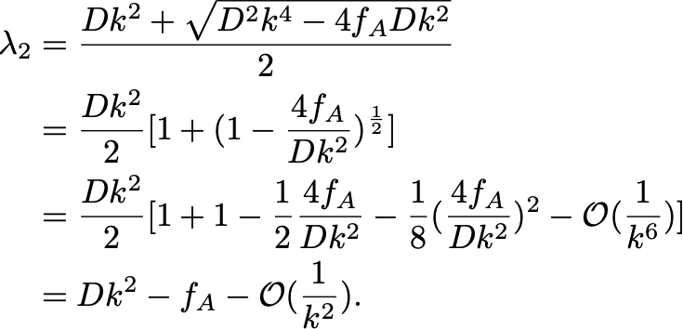
is monotonic increasing as the function of k when k is large.

S2 Appendix: Stability analysis for single-morphogen patterning circuit in discrete lattice
- Steady-state of the isolated system:
Given the lattice ODE of a single-morphogen patterning circuit, firstly we solve the steady-state without diffusion terms.
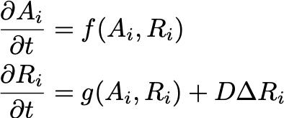
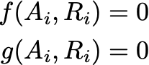
The steady-state concentrations, denoted as A₀ and R₀, are valid for all lattice nodes.

- Stability analysis on 1-D or 2-D discrete lattice:
Similar to the calculation in Plahte's work (Plahte 2001), denoting C = [A₁, R₁, A₂, R₂, ... A_{N}, R_{N}], the linearized kinetics of the whole system near the steady-state is
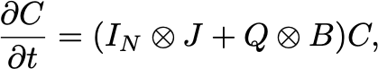
where
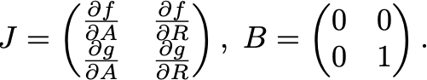
Q is the matrix describing the connectivity of the lattice. For all diagonal elements, Q_{ii} = - c, where c is the number of cells directly connected with cell i. If diffusive molecules can directly transfer between cell i and cell j, Q_{ij} = 1. Otherwise, Q_{ij} = 0. If the connectivity matrix Q can be diagonalized with matrix U and U⁻¹, then we have,
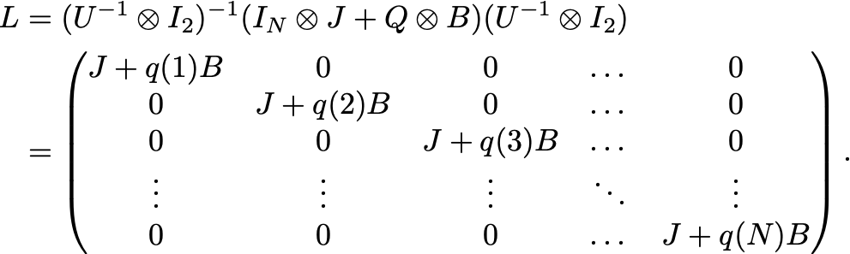
Since L is a block-diagonal matrix, which means,
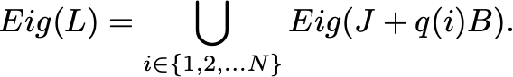
The whole lattice is stable, if and only if all of J+q(k)B are stable. Meanwhile, The lattice would be unstable as long as one of the J+q(k)B is unstable.

- Connectivity matrix:
In our work, we study the patterning on both 1-D lattice and 2-D square lattice. In later analysis, we only demonstrate two analytical solutions from two specific boundary conditions. The simulation also repeats with other types of boundary conditions, which have no simple analytical solution for eigenvalues. The MATLAB code numerically solves the eigenvalues of the connectivity matrix from given boundary conditions in simulation.

- Dispersion relation:
The 1-D dispersion relation, the maximum of the real part of the Jacobian eigenvalues as the function of wavenumber k, is symmetric since q(k₀) = q(N - k₀). In the Dispersion curve, we only show the left half, from k = 0 (isolated system) to k = N/2.

S1 Figure: Single-morphogen patterning circuit with Gierer–Meinhardt kinetics
S2 Figure: Pattern initiation is robust with a wide range of perturbations
S3 Figure: Removal of morphogen influx causes pattern stripes “fill-in” the empty space

Code reporting
Simulation code and data are accessible from CaltechDATA. Wang, S., García-Ojalvo, J., & Elowitz, M. B. (2022). Periodic spatial patterning with a single morphogen (Version 1.0) [Data set]. CaltechDATA. https://doi.org/10.22002/D1.20060

