Supplementary Material for
⁴⁰Ar/³⁹Ar constraints on the age and thermal history of the Urucum Neoproterozoic banded
iron-formation, Brazil
Thiago Piacentini (t.piacentini@uq.edu.au), Paulo M Vasconcelos, Kenneth A Farley

This document includes:
⁴⁰Ar/³⁹Ar step-heating spectra for manganese oxides from the São Domingos underground mine

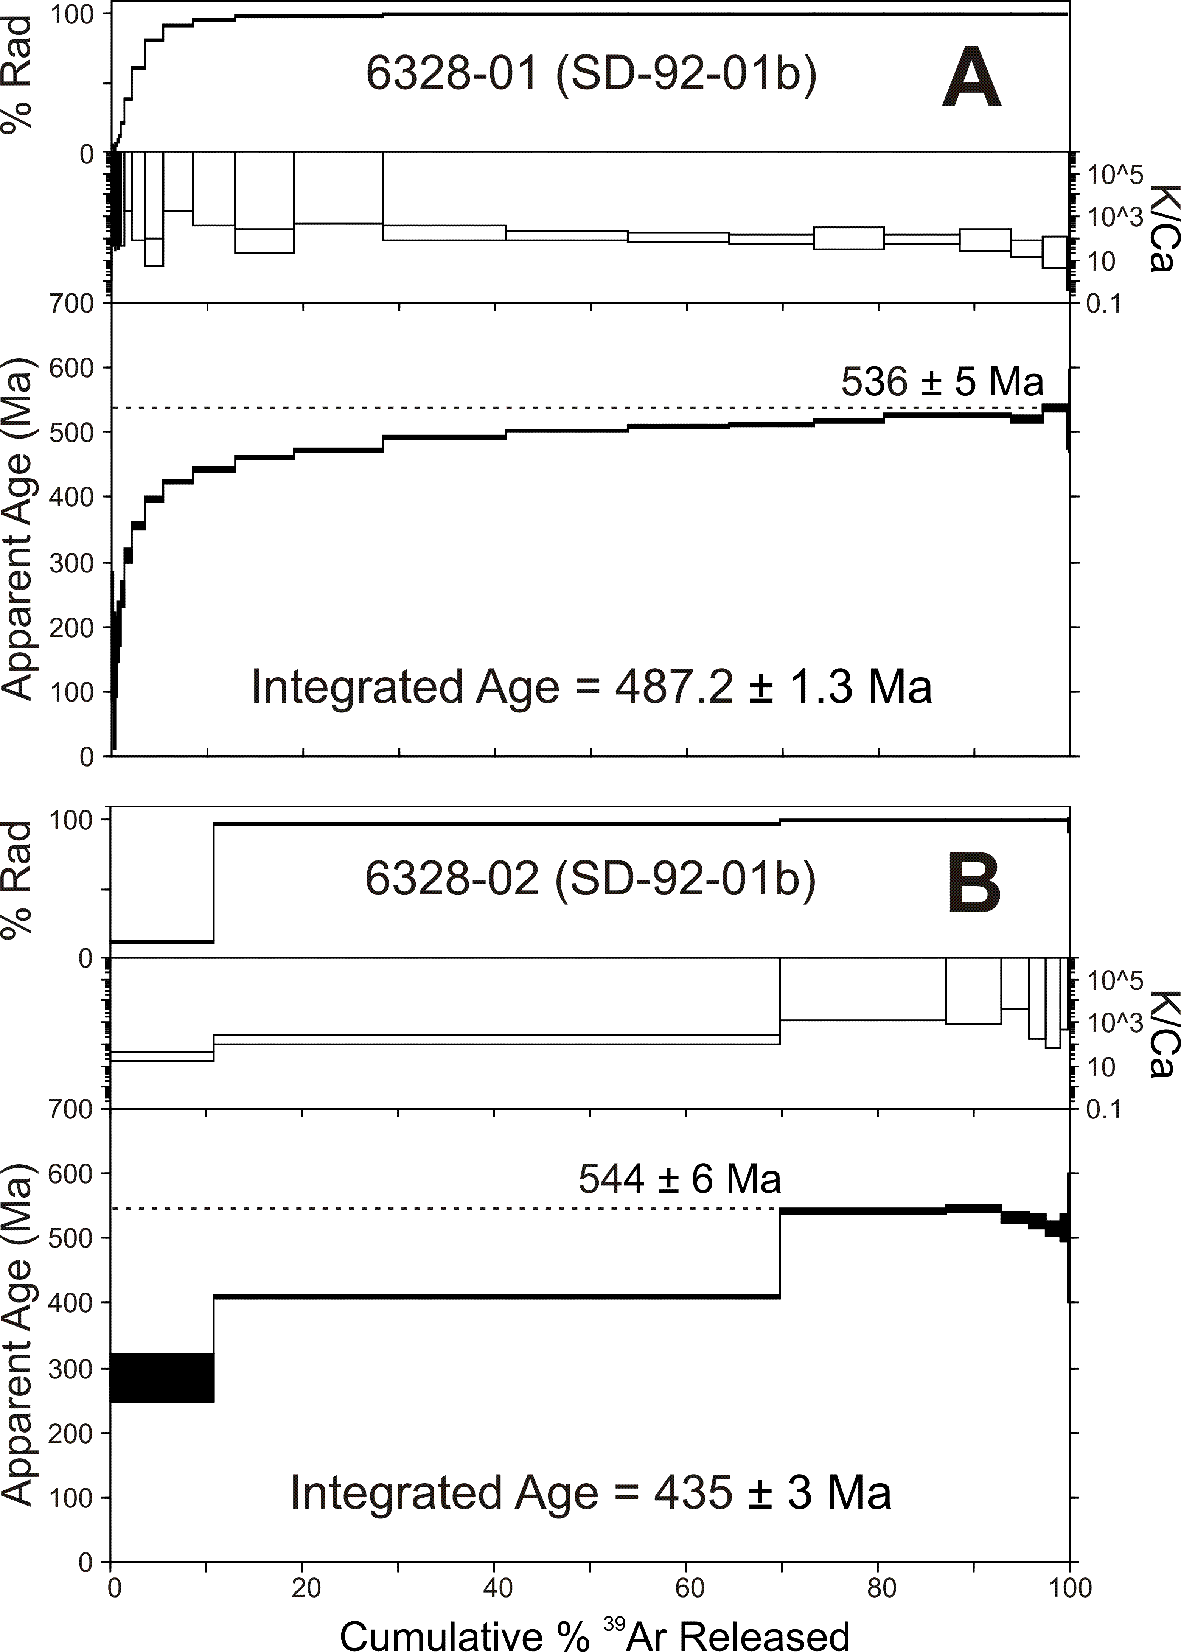
A) and B) are ⁴⁰Ar/³⁹Ar result of sample SD.92.01b located on the border of the plateau. ⁴⁰Ar* distribution is not homogeneous within replicates.

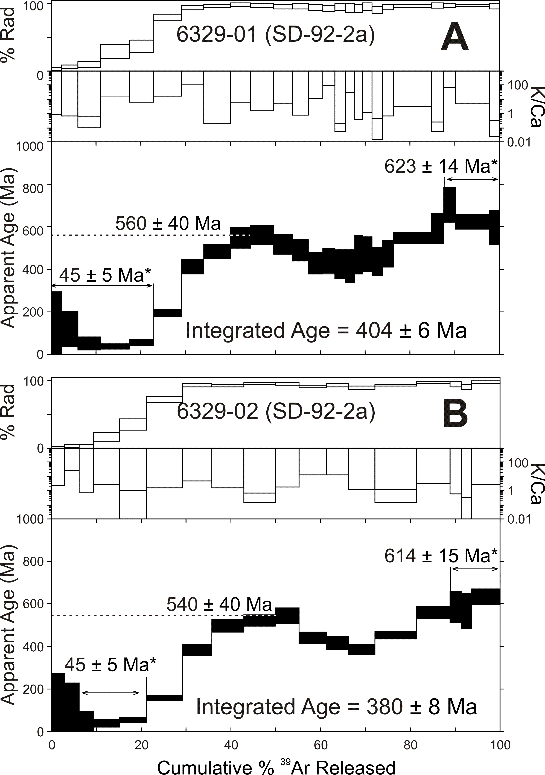
A) and B) are ⁴⁰Ar/³⁹Ar results for replicate grains of sample SD.92.02a located 20 m from the border of the plateau. Sample SD.92.2a consist of braunite crystals that are replaced by supergene cryptomelane The pattern shown on the age spectra may suggest early gas released from younger phase (supergene cryptomelane), followed by gas originating from the cores of older phases (braunite). Ages older than 600 Ma could represent older remnants phases or most likely excess Argon – further investigations need to be carried to understand braunite age spectra.

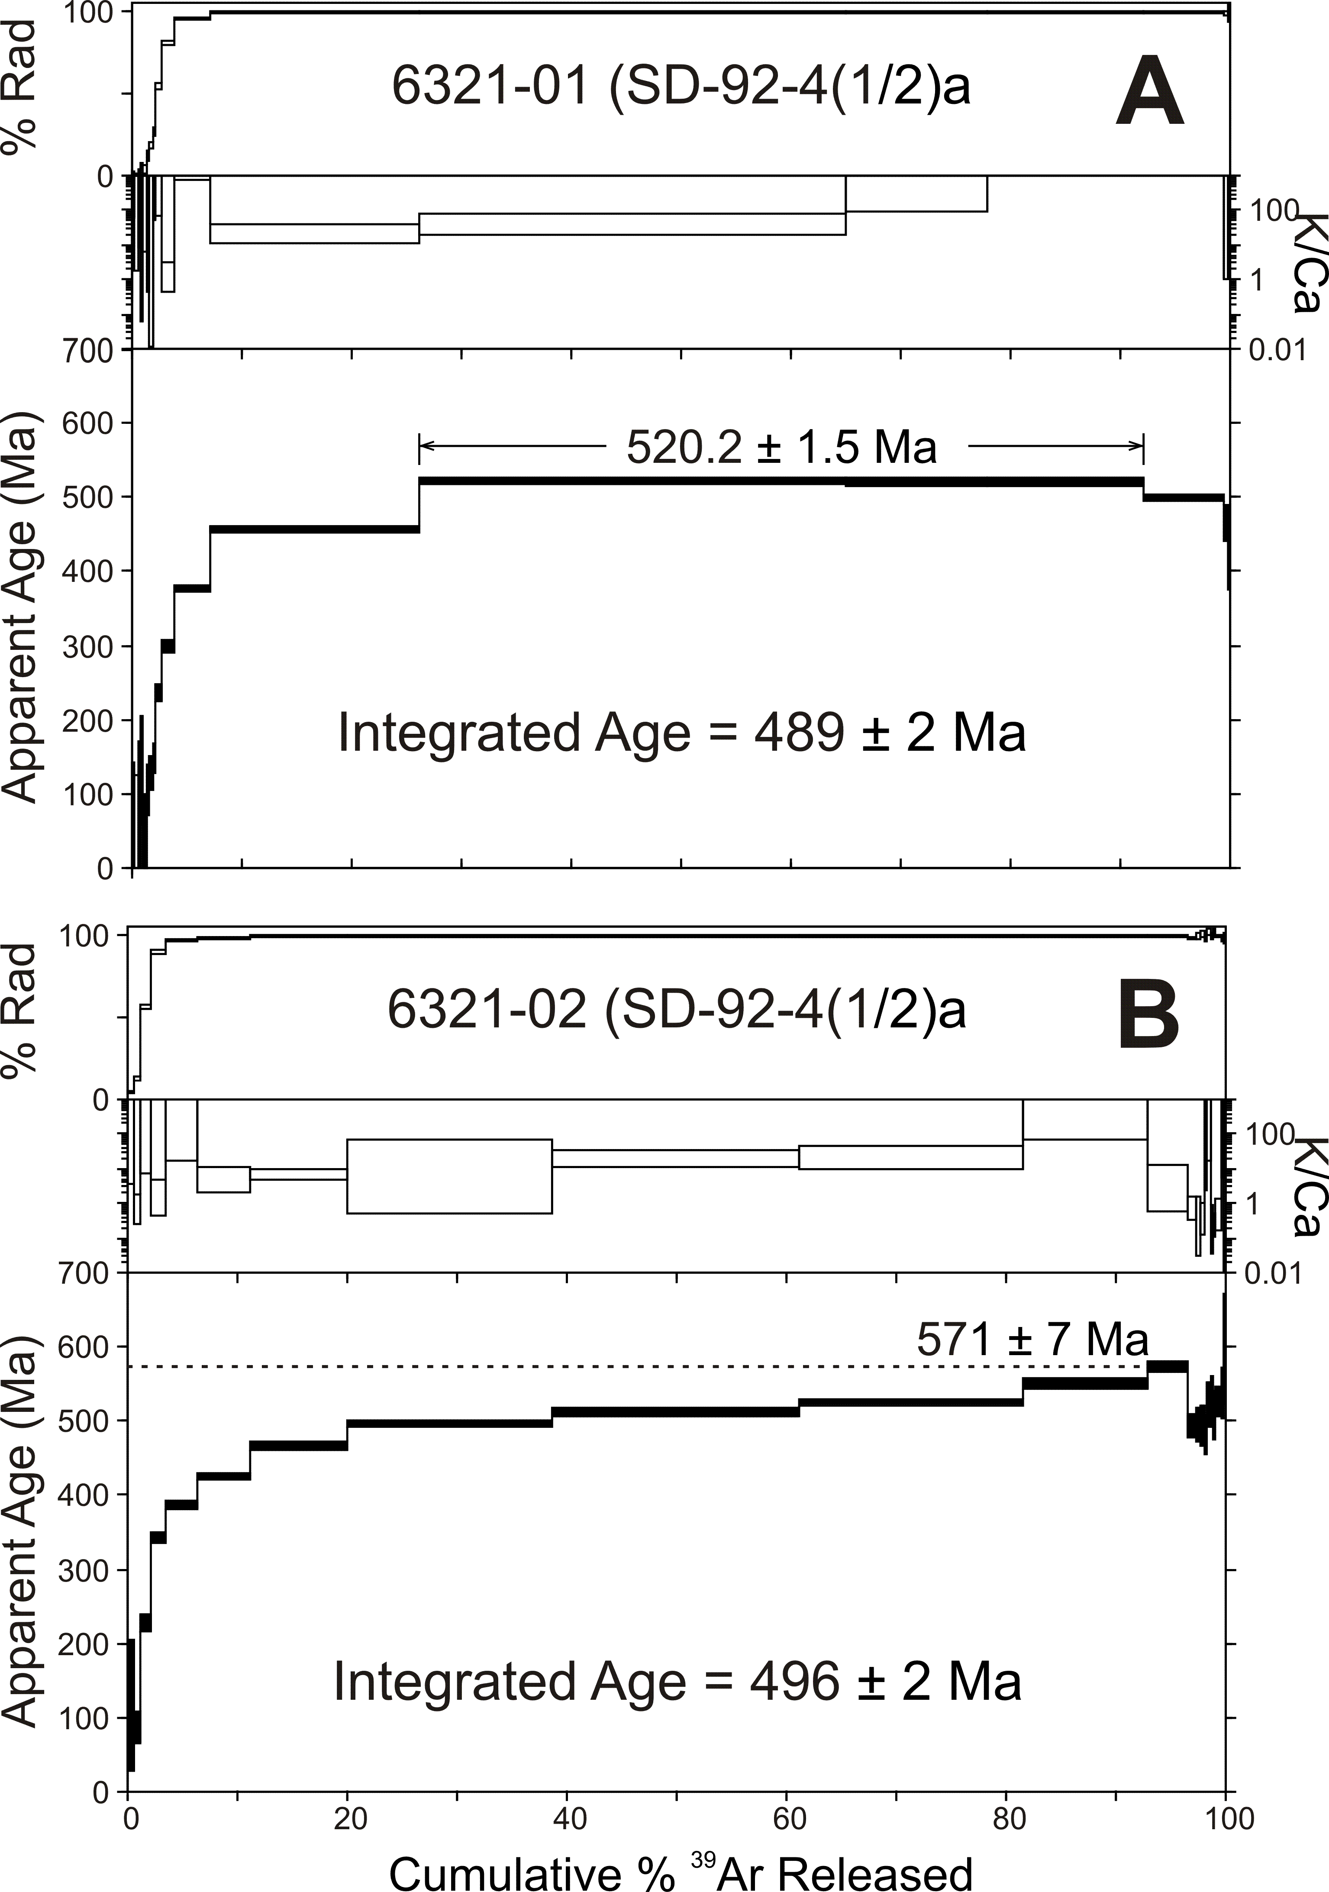
A) and B) are ⁴⁰Ar/³⁹Ar results for replicate grains of sample SD.92.4(1/2)a located 60 m from the border of the plateau.

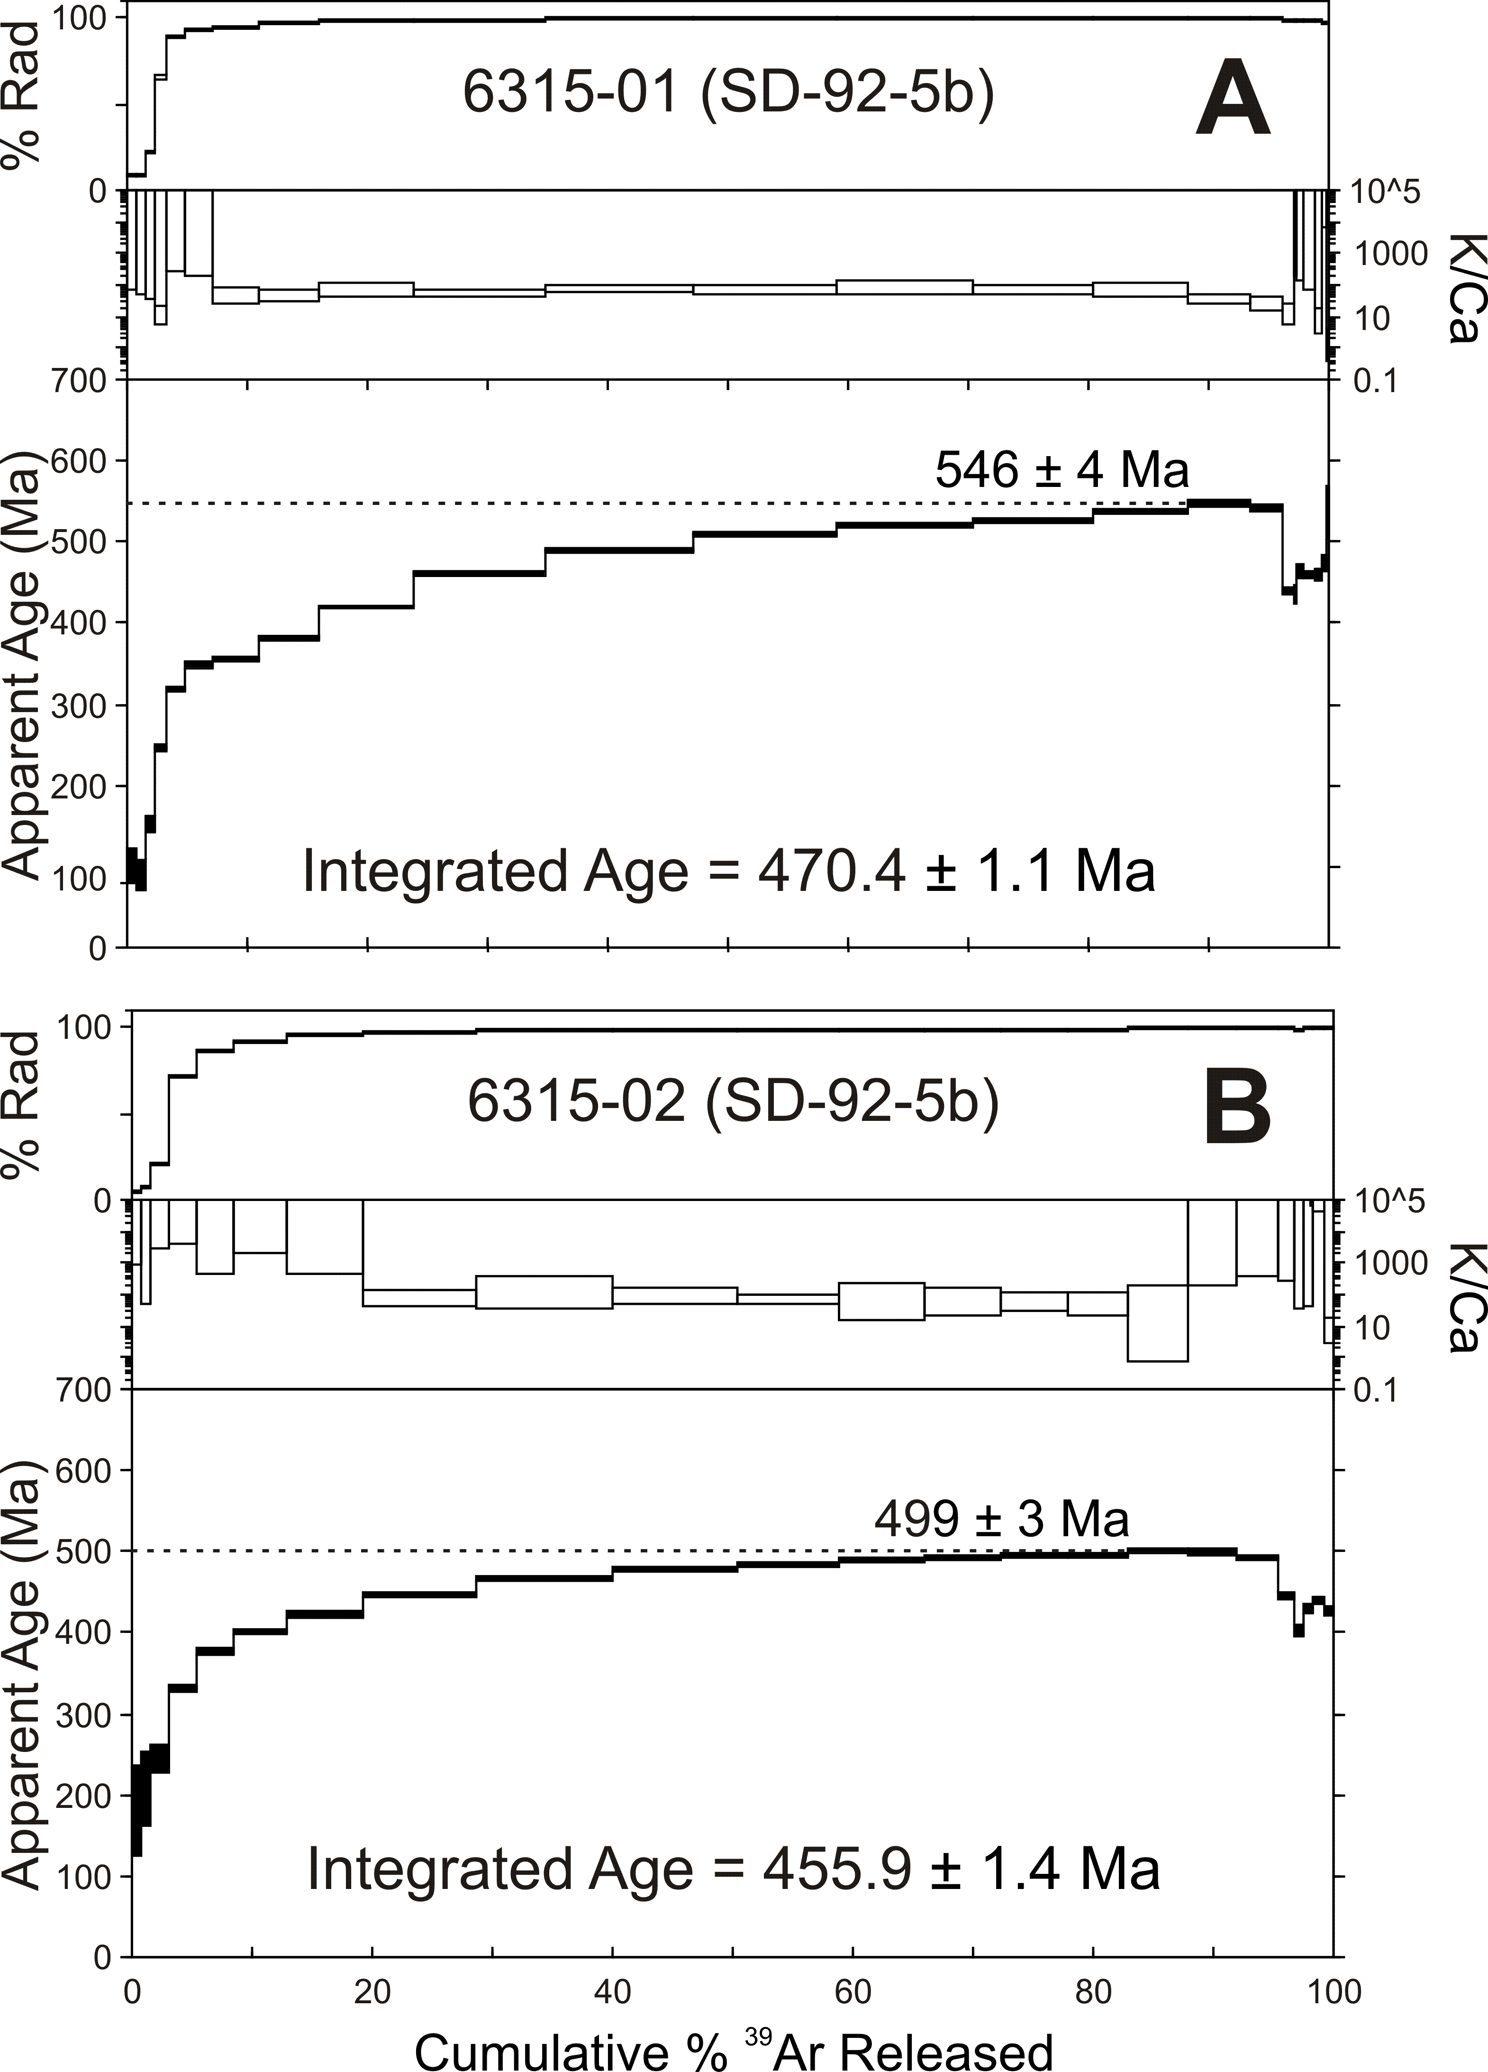
A) and B) are ⁴⁰Ar/³⁹Ar results for replicate grains of sample SD.92.5b located 80 m from the border of the plateau. Heating spectra rise steadily and asymptotically approach a limit; however, replicates probably represent different generations..

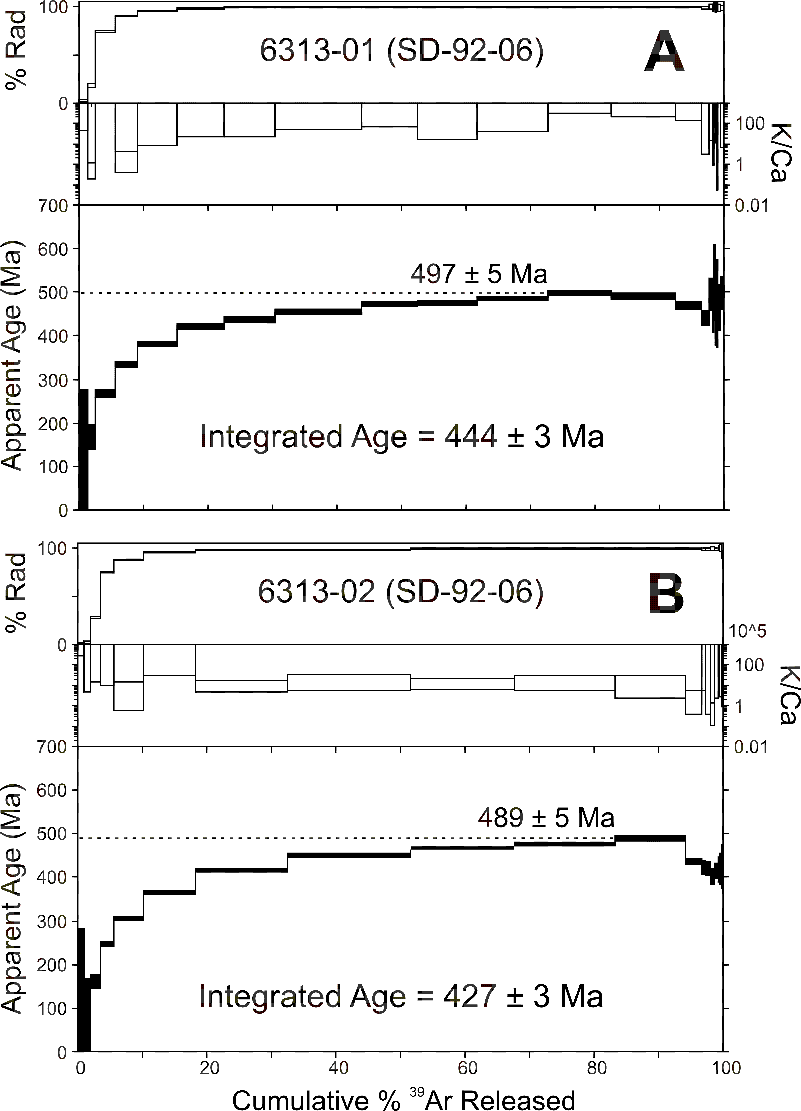
A) and B) are ⁴⁰Ar/³⁹Ar results for replicate grains of sample SD.92.6 located 100 m from the border of the plateau.

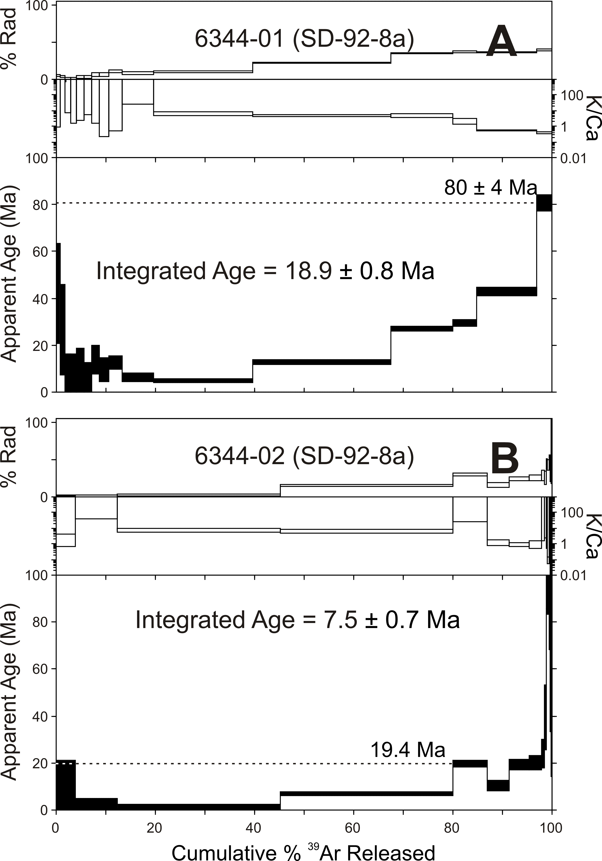
A) and B) are ⁴⁰Ar/³⁹Ar results for replicate grains of sample SD.92.8a located 140 m from the border of the plateau. Low ⁴⁰Ar* yield is owed to replacement of braunite by supergene phases (e.g., pyrolusite) inhibiting our attempts to retrieve chronological information in this sample.

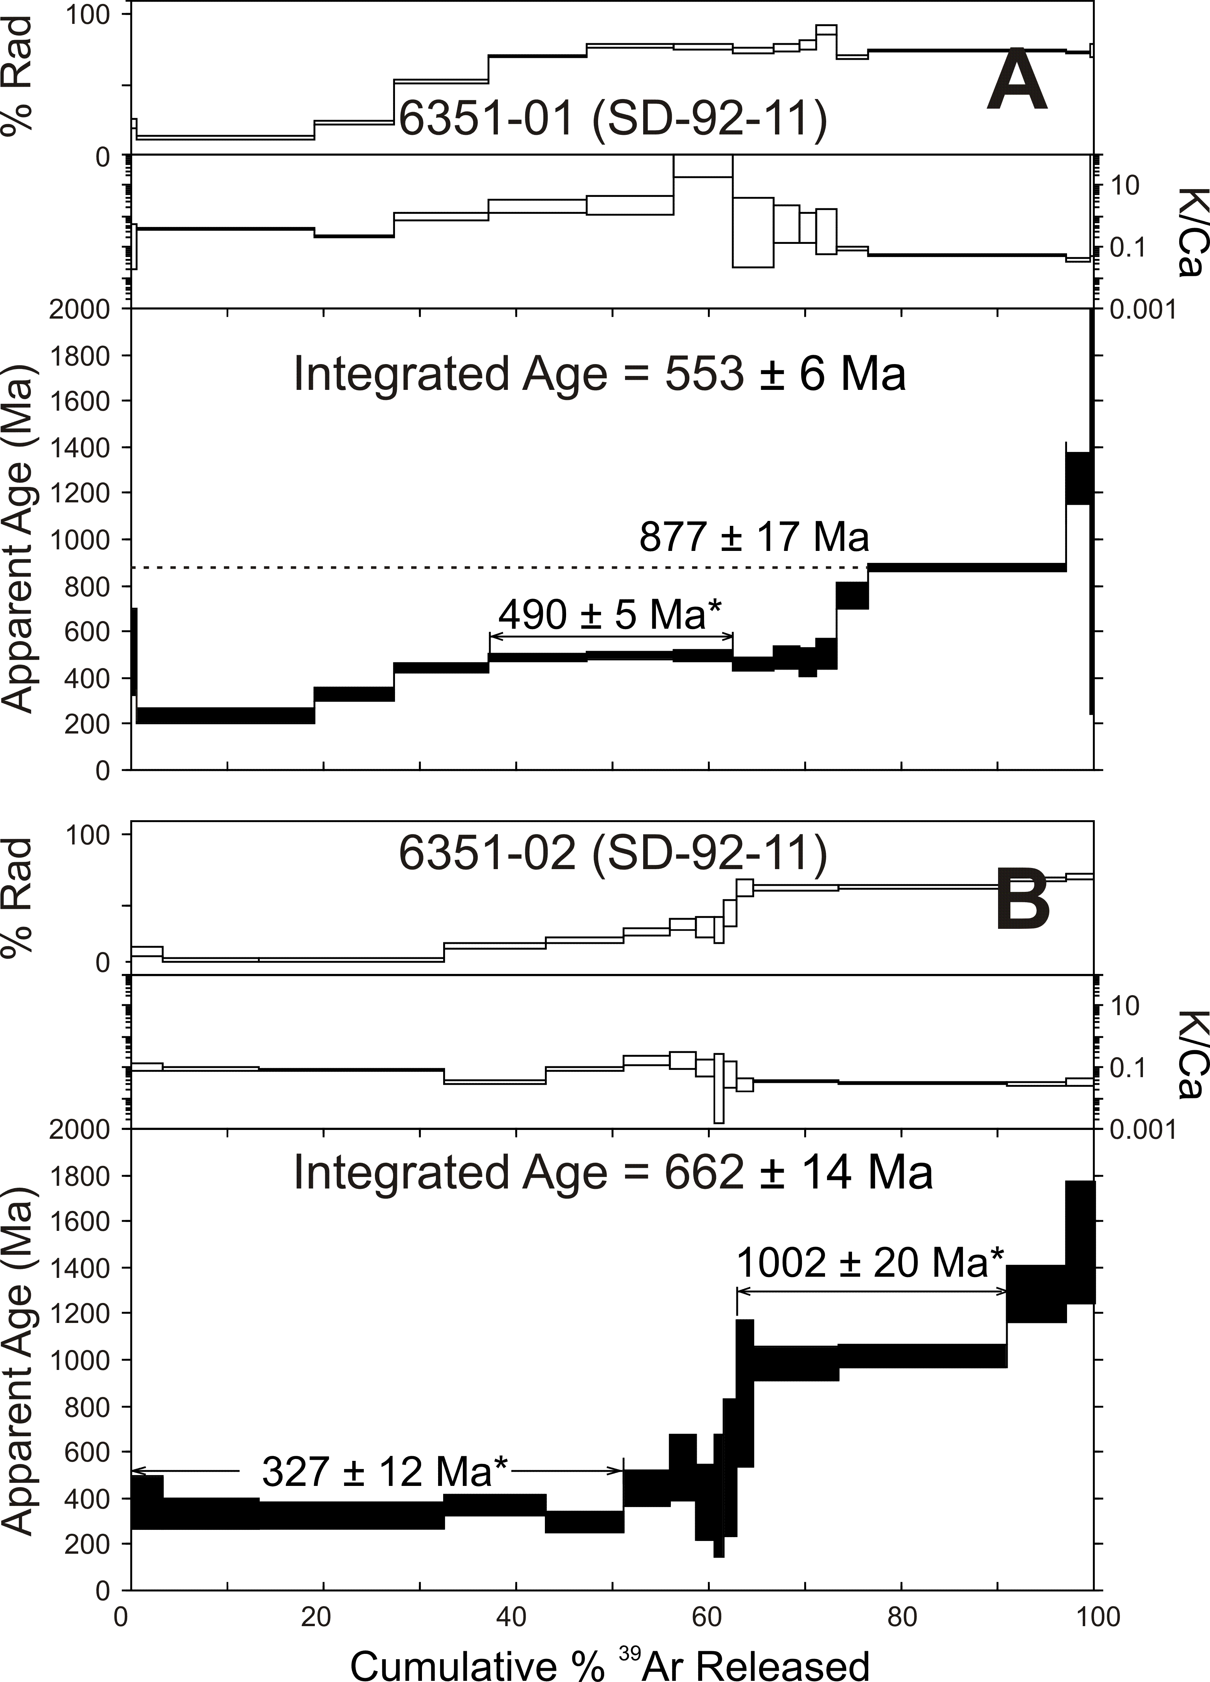
A) and B) are ⁴⁰Ar/³⁹Ar results for replicate grains of sample SD.92.11 located approximately 200 m from the border of the plateau.

