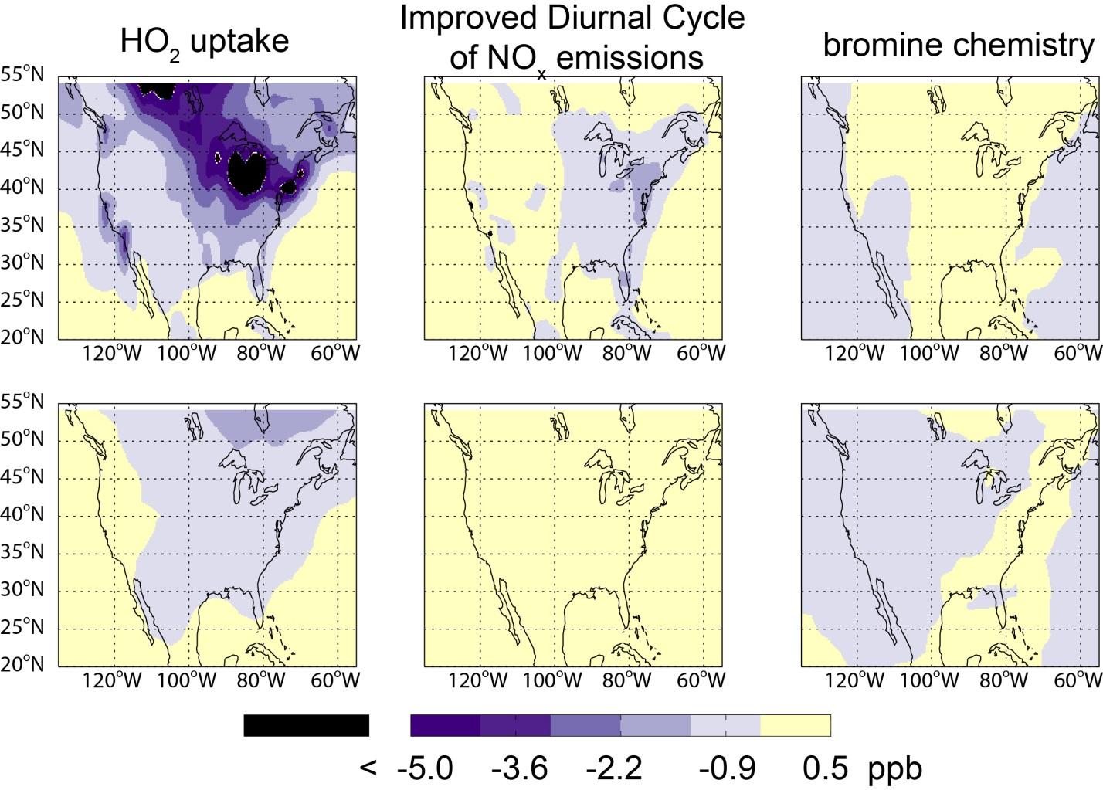
Figure S1 Impact of individual model updates on mean afternoon (1300 – 1700 LT) ozone concentrations in surface layer (upper panels) and 500 hPa (lower panels) during July 2004. The left column is due to the improved HO2 aerosol uptake, the middle column is due to the improved diurnal cycle of NOx emissions, and the right column is due to the recently implemented bromine chemistry.

