Supplementary: Artifacts in back-projection images from water resonance phases

Han Yue^{1*}, Jorge C. Castellanos², Chunquan Yu², Lingsen Meng³ and Zhongwen Zhan²

- Department of Geophysics, School of Earth and Planet Sciences, Peking University, Beijing, China, 100871
- Seismological Laboratory, Department of Earth and Planetary Sciences, Caltech, Pasadena, CA, 91125
- Department of Earth and Planetary Sciences, UCLA, Los Angeles, CA, 90095

Details of algorithms and techniques used in this paper are summarized in the following paragraphs.

- Mainshock and calibration event parameters (From GCMT solution)

Events | Time |  | Hypocenter  (PDE:lat/lon/dep) | Centroid location  (lat/lon/dep) |  | M_{w} | Focal mechanism  Strike/Dip/Rake
Mainshock | 2012/01/10 18:37:13 |  | 2.543/92.903/20 | 2.59/92.98/24 | 7.2 |  | 103/81/-173
Calibration  Evt 1 | 2007/10/04  12:40:30 | 2.433/93.210/19 |  | 2.47/92.83/12 | 6.2 |  | 110/63/170
Calibration  Evt 2 | 2006/04/19  02:36:48 | 2.65/93.24/30 |  | 2.70/93.22/17.2 | 6.2 |  | 111/66/-176
Table S1
- Relocation of radiators

Arrival times are identified from the peaks of each trace. To identify the arrival of peaks, a sinusoidal reference arrival time is sketched with respect to the first water phase. The time of the peak located within $±5s$ of the manually peaked arrival time is identified as the arrival time of peaks. The arrival time of the 2nd-4th water phase peaks are identified in the same way with a reference time shifted by n*10 s from the first phase.

Theoretical arrival time at the i^{th} station from j^{th} radiator is calculated by
$$t_{i}={dist}_{j}*{rayp}_{i}*\cos\left({azi}_{j}-{azi}_{i}\right)+t_{j}$$

The meaning of each parameter is listed as following

$t_{i}$ : the relative arrival time of the picked arrival reference to the
hypocentral arrival.
azi_{i} : Azimuth of the i^{th} station reference to the epicenter.
dist_{j} and azi_{j} : the associated distance and azimuth of the j^{th} radiator
location reference to the epicenter.
rayp_{i} : the ray parameter to the particular station.
T_{j} : the initial time of radiator reference to the hypocentral initial
time.

Parameters dist_{j}, azi_{j} and t_{j} are taken as inversion parameters. Inversion is made as a least square problem to find the point which minimize the objection function defined as :
$${{min⁡\sum_{i}{(Δ}t}_{ij})}^{2}={{min⁡\sum_{i}{(t_{obsi}-}t}_{j})}^{2}$$
where t_{obsi} and t_{i} are the observed and theoretical arrival time at the i^{th} station.

- Global Back-projection

P waves are aligned at the initial arrival of the calibration event, the travel time to each station is taken as the time lapse between the calibration event PDE initial time (2007/10/04 12:40:30.5) and the picked arrival time. The same travel times are used to align the mainshock waveform reference to its PDE initial time (2010/01/10 18:37:13). Back-projection with this alignment assume every waveform is aligned referenced to the calibration event hypocentral arrival, that the uncertainty of epicenter location of the PDE catalog no longer influence the BP technique.

We use the 4th order root stacking algorithm to beamform P and SH waves recorded at teleseismic distances. The detailed algorithm is described in [Xu et al., 2009]. Waveforms are pre-filtered with a 2nd order band-pass filter with corner frequencies at 0.01 and 0.2 Hz. Azimuth bin of 30 degrees are used to calculate station density to down-weight traces at high station coverage. 5s stacking window is adopted. To perform global beam-forming polarity of phases need to be corrected to stack waveforms constructively over different azimuths. P wave polarity calculated from the focal mechanism (from Global Centroid Moment Tensor catalog: strike/dip/rate 103/81/-173) are used to flip recordings with different initial polarities. We assume a thrust focal mechanism for the near trench area with respect to the back-ground seismicity and reported focal mechanisms [Fan and Shearer, 2016]. We calculate the theoretical polarity at each station with respect to the focal mechanism given by the GCMT solution. Traces at negative polarity domain are flipped before stacking. For the area near the trench, we calculated the theoretical polarity of those “aftershocks” and no flip need to be applied to the data. Polarities are calculated for two domains with different focal-mechanism. BP images are animated in movie S1 and S2 for the mainshock and calibration event, respectively. Theoretical wavefront of P, S and Rayleigh waves are labeled on those movies for comparison. Locations of the peaks in the array based BP images are masked on the global BP images in those movies.

- Array Back-projection
To beamform P waves from regional array, we selected 512 and 563 teleseismic P wave records from European and Japanese arrays respectively (figure 2). All P waves are aligned at the initial arrival and pre-filtered with a band-pass filtering with corner frequencies at (0.1-2 Hz). We used MUSIC (MUltiple SIgnal Classification) BP technique in the array backprojection.

- Waveform and BP of the second calibration event
To further confirm if the similar features found in the mainshock and calibration waveforms are commonly presented in the regional earthquakes, we used another small earthquake (2006/4/19) as a calibration event. The detailed information of second calibration event are provided in table S1. Because this event happens closer to the trench, the depth phases and near source water phases are mingled with the localized water phases near the trench, we only picked two clear sinusoidal moveout in the coda segment (figure S1). P wave back-projection images are plotted in figure S1b, that the beam-forming techniques are the same as that used in the mainshock and first calibration event BP. Significant coherent energy is also beamformed near the trench, which is consistent with the feature found in both the main and calibration events. An artificial coherent radiator is observed to the north of the epicenter of the second calibration event, which appears to be not related to the rupture process, because the dimension of a M_{b}=6.2 earthquake should be around several kilometers. Such artifact may be caused by beamformed depth phases.
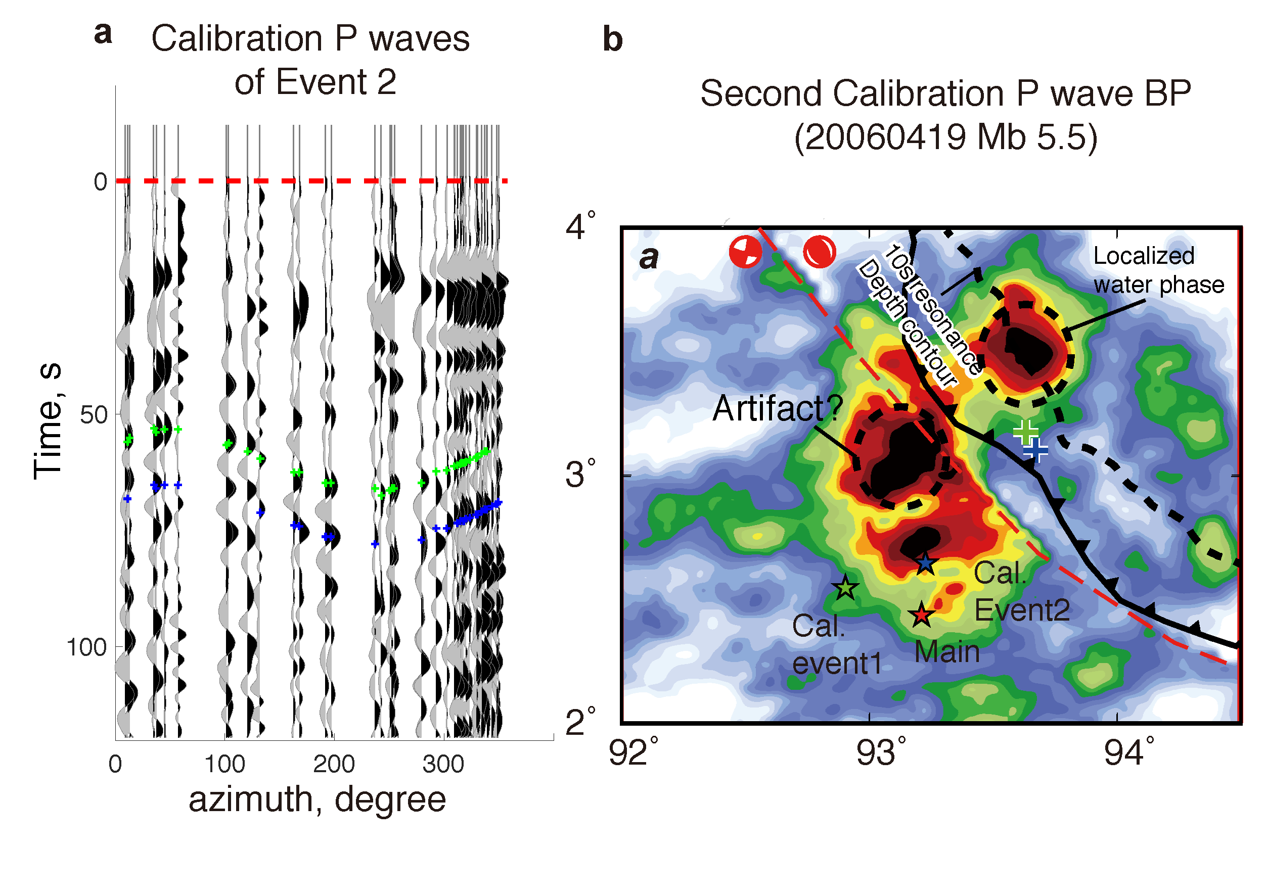
Figure S1. a. teleseismic P waves of the second calibration event are aligned at 0 s (red dashed line) and sorted by azimuth. Predicted arrival times from the coherent radiators are marked with color coded “+”. The same colors are used to mark the inverted point source locations in figure S1b. b. Time integrated P wave beam amplitude are plotted with a white-black color scale as the background map. Epicenter locations of the mainshock and two calibration events are marked with red, green and blue filled stars. Coherent radiators are marked with color coded “+”. The same colors are used to mark the associated predicted arrival times in figure 2a. The focal mechanisms used to calculate the stacking polarity are indicated with red filled beach balls in two domains with the boundary indicated by a red dashed curve. The trench is marked by a black barbed curve. The bathymetry counter (along 3.75 km depth) are plotted with a black dashed curve. The near trench radiator that is caused by localized water reverberation phases are marked with a dashed ellipse. A suspected “artificial” coherent radiator is marked with a dashed ellipse.

- Temporal-spectral analysis
Temporal-spectral analysis are performed for the waveforms record at BJT station. Teleseismic displacement recordings are recovered from temporal integration of raw velocity recordings. Mean value and linear trend are performed before a non-causal band-pass filter with corner frequencies at 0.001 and 1 Hz. Source and coda waveforms are approximately separated at 30s after the initial arrival (figure 4). The resonance periods of the mainshock and calibration event also shows small discrepancy, which may reflect different reverberation locations (figure 3). The near trench radiators of the calibration event locate seaward (deeper) from the mainshock radiators (figure3), which are supposed to produce longer reverberation period assuming layer resonance.

- Finite difference modeling
The 2D velocity model is parameterized with two domains, a water layer (Vp = 1.5 km/s, Vs=0 km/s and Den=1.027 g/cm³) overlain on an elastic half space (Vp = 5.8 km/s and Vs = 3.2 km/s and Den=2.6 g/cm³) Figure S2. The dimension of the modeling domain is 1428 km and 1210 km in the x and z directions, respectively. The bathymetry, interface between two domains, is cut along profile AB (Figure 3a) from Etopo1 (https://www.ngdc.noaa.gov/mgg/global/global.html) model and set as the interface between those two domains. Hypocenter is placed at (100 km from left edge of the model) and 20 km depth (15 km beneath water). Grid size is 200 m to ensure modeling accuracy. Modeling is performed with a GPU based 2D finite difference code [Li et al., 2014] and the time cost of each modeling is approximately 1 hour. Dynamic wavefield is animated as a video (movie_S3) with 0.2 s time sampling.
Figure S2. Hypocenter is marked with a green filled star. Velocity for the water layer and elastic half space is labeled. The interface is parameterized from the real bathymetry model from profile AB.

- Back-projection of synthetic waveforms
Synthetic wavefield is received by an array of 50 receivers located 700 km depth beneath the hypocenter. Those receivers are distributed between 100 km to 600 km with 10 km spacing. Vertical displacement waveforms received by those receivers are plotted in figure S3. To back-project the synthetic waveform to the 1D profile, we use a 4th order root stacking algorithm which is similar to the global BP image. Because we are only concerned about the coherency of stacking instead of the amplitude, no polarity flip is adopted to the waveforms.
HF synthetic BP image is plotted in figure S3, which presents a different pattern from the LF synthetic BP images. Near trench radiators are less significant than the LF BP images. Significant coherent radiators are imaged between the epicenter and the trench, which is mostly related to the short wavelength structures of the bathymetry. The peak to peak interval of those radiators are ~13s, which is close to the water resonance period at the ocean bottom.
Figure S3. a. Synthetic waveforms are plotted with black-gray filled curves and sorted by distance from the left edge of the model. Hypocenter and receiver locations are plotted in the subpanel in the lower left. Projection of hypocenter and the trench are indicated by red arrows. Theoretical arrival of P, S and trench reverberations phases are marked in green, orange and black dashed curves. b. 1D HF (0.5 – 2 Hz) BP image from the synthetic waveforms. Energy are more efficiently beamformed at negative topography gradient.

Details of the water phase excitation, e.g. influence from the source finiteness and duration, migration of reflection point and time variation of characteristic frequency, require 3D modeling with realistic velocity structure, which need to be discussed in future studies.

Fan, W., and P. M. Shearer (2016), Fault interactions and triggering during the 10 January 2012 Mw 7.2 Sumatra earthquake, Geophysical Research Letters, 43(5), 1934-1942.
Li, D., D. Helmberger, R. W. Clayton, and D. Sun (2014), Global synthetic seismograms using a 2-D finite-difference method, Geophysical Journal International, 197(2), 1166-1183.
Xu, Y., K. D. Koper, O. Sufri, L. Zhu, and A. R. Hutko (2009), Rupture imaging of the Mw 7.9 12 May 2008 Wenchuan earthquake from back projection of teleseismic P waves, Geochemistry, Geophysics, Geosystems, 10(4).

