**SUPPLEMENTARY INFORMATION**

**Conservation of vibrational coherence in ultrafast electronic relaxation:**

**The case of diplatinum complexes in solution**

Roberto Monnia, Gerald Auböcka,§, Dominik Kinschela, Kathrin M. Langea,#, Harry B. Grayb, Antonín Vlčekc,d,*, and Majed Cherguia,*

a *Ecole Polytechnique Fédérale de Lausanne, Laboratoire de spectroscopie ultrarapide, ISIC and Lausanne Centre for Ultrafast Science (LACUS), FSB, Station 6, CH-1015 Lausanne, Switzerland*

b *Beckman Institute, California Institute of Technology, Pasadena, California 91125, United States*

c *School of Biological and Chemical Sciences, Queen Mary University of London, Mile End Road, London E1 4NS, United Kingdom*

d *J. Heyrovský Institute of Physical Chemistry, Czech Academy of Sciences, Dolejškova 3, CZ-182 23 Prague, Czech Republic*

§ Current address: CTR Carinthian Tech Research AG; Europastrasse 4/1, 9524 Villach/St. Magdalen, Austria

# Helmholtz-Zentrum Berlin, Hahn-Meitner-Platz 1, 14109 Berlin, Germany

* Corresponding authors: a.vlcek@qmul.ac.uk; Majed.chergui@epfl.ch

**Materials and Methods**

**SI.1 Sample preparation**

The experiments reported in this work concern the tetra-butyl ammonium (TBA, Bu4N+) salts of tetrakis(-pyrophosphito)diplatinate(II), [Pt2(-P2O5H2)4]4- (hereafter abbreviated Pt(pop)) and its perfluoroborated derivative [Pt2(-P2O5(BF2)4]4– (abbreviated Pt(pop-BF2)). The samples were prepared and characterized using literature procedures {Che, 1985 #7638}{Durrell, 2012 #4912}. Two different concentrations were used depending on the pump wavelengths: For 360 nm excitation, the sample consisted of 36 mg of the sample dissolved in 20 mL of spectroscopic grade acetonitrile (MeCN, Sigma Aldrich). For UV excitation, 120-130 mg were dissolved in 20 mL of MeCN. The higher concentration in the latter case is needed to compensate for the lower absorption cross-section. Pt(pop-BF2) solutions were handled under argon to prevent hydrolysis by air moisture.

For both Pt(pop) and Pt(pop-BF2), the thickness of the flow-cell was varied depending on the excitation wavelength. Under 360 nm excitation, the cross section of the singlet band was enough for a ~0.3 sample absorbance at the pump wavelength in a 100 m flow-cell. On the other hand, under 260-280 nm excitation (UV2 band), the cross section is small and a higher concentration, as well as a thicker flow cell (200 m) are needed in order to obtain absorbance of ~0.3. A fluence of ~1.3 mJ/cm2 was used for both wavelengths.

**SI.2 Optical Set-up**

The experiments were performed on a 2D UV transient absorption (TA) set-up, which has been described elsewhere.1,2 Briefly, ~0.4 mJ of the output of a 20 kHz, cryogenically-cooled, amplifier (Wyvern, KM labs, 780 nm, 50 fs, ~0.6 mJ) are injected into a Non-collinear Optical Parametric Amplifier (NOPA) (Topas White, Light Conversion) to provide pulses in the visible range between 560 nm and 650 nm. The typical output energy is ~15 J and ~60% of it is used to generate narrow-band pump pulses. Visible pulses are focused onto a 0.5 mm-thick BBO crystal for frequency doubling, in order to generate UV pump pulses (360 nm, 280 nm and 260 nm) with typical band-width of ~2 nm and energies of ~150 nJ. Pump pulses are chopped at half the laser repetition rate and focused onto the sample with typical focal spot diameter of 100 m. In our experiments, 60 fs Full Width at Half Maximum (FWHM) pump pulses were used, leading to an Instrumental Response Function (IRF) of 80 fs FWHM. Visible probe pulses were generated by focusing ~0.5% (~1 J) of the remaining output of the amplifier (~0.2 mJ) onto a 5 mm-thick CaF2 window, in order to generate a white light super-continuum. The probe region in our experiments spans from ~340 nm to ~600 nm, covering the main absorption features of the Pt(pop) and Pt(pop-BF2), namely the singlet and triplet bands.3 After focusing onto the sample (35 m diameter at focal spot) the probe is coupled into a 100 m multi-mode fiber and sent to a spectrometer to be spectrally resolved and detected on a single shot basis by means of a fast CMOS array detector.

**SI.3 Data treatment**

The data were analyzed by global fit (GF) of several kinetic traces using the fitting function:

+ (Eq. S1)

Where *H*(*t*) is the Heaviside step function, *G*(*t*) is a Gaussian function (with FWHM equal to the experimental IRF) convoluted with the sum of exponential decays (with amplitude *ai* and time-constants *i*) and exponentially damped sine functions. The *t*0 factor is related to the time zero definition. In this way, it is possible to account for the population times, through the sum over *“i”*, and for the exponentially damped oscillatory pattern, through the sum over *“j”*. The damped oscillatory pattern is described by the sin(*t* + **) term multiplied by the damping exponential represented by *Dj*. The sine functions describe the oscillatory patterns whose frequencies (in cm-1) are retrieved with a very small uncertainty and cross-checked by Fast Fourier Transforms (FFT, see below).

Global analysis of the GVD-corrected data-matrix *M(,t)m×n* was performed by the Singular Value Decomposition (SVD) technique. The SVD procedure starts decomposes the data matrix *M(,t)m×n* to the product of three matrices:

*M(,t) = S()m×m × Wm×n × T(t)T n×n* (Eq. 2)

If the data matrix can be described by a linear combination of terms and, in the case of pure stochastic noise, the columns present in the *S()m×m* and *T(t)Tn×n* matrices are known as singular spectra (also called “eigenspectra”) and singular kinetic vectors (also called “eigentraces”) respectively. *Wm×n* is a matrix that has *wij* = *wji* = 0 while *wii* ≠ 0. The latter entries are also called *“singular values”* and represent the contribution of each eigenspectrum (and the corresponding eigentrace) to the data matrix. In the case of noise-free data there are *n* non-vanishing singular values, while the presence of noise acts as a perturbation of the latter and the respective singular vectors.

A global fit (GF) of the relevant eigentraces allows retrieving the typical times *k* with their respective uncertainties and amplitudes *aik*. The latter can be used to construct the Decay Associated Spectra (DAS), which give the spectra contribution associated to a given time-constant as:

${DAS}_{k}(λ)$ = $\sum_{k}{a_{ik }w_{ii}}U_{k}(λ)$ (Eq. 3)

where Uk () is the eigenspectrum related to the *k*-th eigentrace.

**SI.4 FFT Map procedure**

Having performed the above SVD on the data matrix and fitted the eigentraces with a sum of exponentials, we then subtracted the exponential decays in the original matrix *M(,t)m×n*, to obtain a reconstructed matrix (*MRec(,t)*) that contains only the oscillatory pattern. This can be done by summing up the DAS obtained with the SVD as follows:

$M_{Rec}\left(λ, t\right)= \sum_{n}{{DAS}_{n} \exp^{(-\frac{t}{τ_{n}})}}$ (Eq. S4)

Equation S4 indicates that each DAS is multiplied by its exponential decay. By subtracting the reconstructed data matrix from the original data matrix, it is possible to obtain a residual matrix that contains only the wave-packet information. The last step is to perform an FFT along the time axis so as to obtain a matrix *N( )* that gives the amplitude of the FFT as a function of wavelength and frequency. The results are presented as FFT plots (Fig. S3), which display the whole set of frequency-wavelength FFT plots for the data presented in Figures 3 and 5.

**SI.5 Data fitting**

In the GF of the experimental time traces (containing the exponential and the oscillatory parts) by means of equation S1, all fit parameters were free, except for a long-lived component (fixed at 500 ps) representing the triplet-state lifetime and, in the case of Pt(pop-BF2), also the lifetime of the relaxed lowest excited singlet 1A2u. All fits were convoluted with the experimental IRF. The resulting fit parameters are given in Table 1 for the exponential parts and Table 2 for the oscillatory parts. Frequencies retrieved by the FFT analysis (Fig. S3) are in excellent agreement with those obtained from the GF.

In fitting the kinetic parts, a point of caution needs to be made: the use of 2- or 3-exponentials as done here implies kinetically distinct processes, which may not be the correct physical picture. Furthermore, some of the relaxation processes may occur over tens of ps, which is not really reflected in our multi-exponential fits. Nevertheless, we consider the multi-exponentials fits used here as phenomenologically precise enough to extract the oscillatory components of the time traces and discuss the kinetic times in the context of vibrational relaxation and dephasing.

**Figures**

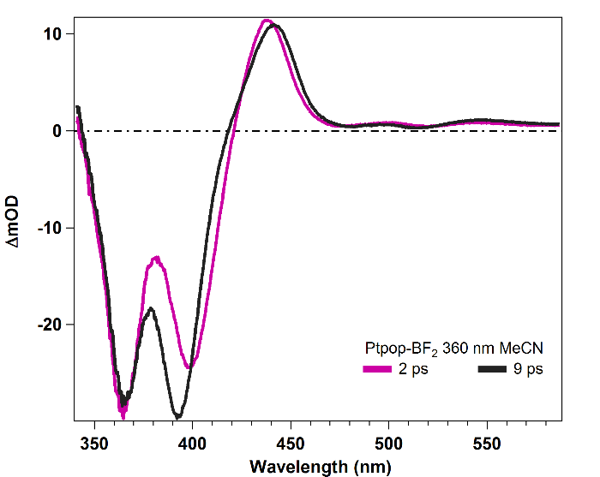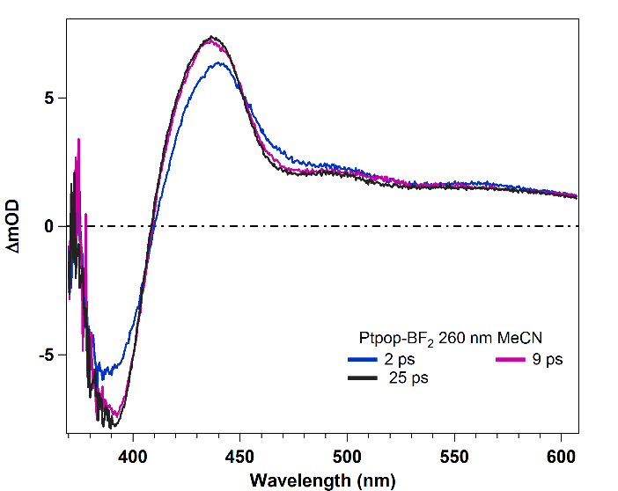

**b**

**a**

**Fig. S1.** Transient absorption spectra of Pt(pop-BF2) in MeCN measured at selected time delays after 360 (left, a) and 260 nm (right, b) excitation.

C:\Users\vlcek\Documents\Manuscripts\Pt(popBF2)Calc\Coherence\Paper\Fig ns for SI.emf

**Fig. S2.** Nanosecond time-resolved spectra of Pt(pop-BF2) in MeCN. Spectra were recorded at 1.3, 1.5, 1.7, 2, 2.5, 3, 4, 5, 7, and 20 ns in the directions of the arrows. Top: full spectrum. Middle: detail of the short-wavelength region. Bottom: detail of the long-wavelength region. Excited at 355 nm with ~0.8 ns laser pulses, probed with femtosecond white-light continuum. Because of pump-probe overlap at early times, the 1.3 ns spectrum corresponds predominantly to the 1A2u excited state. The triplet spectra slowly decay at longer time delays (not shown).

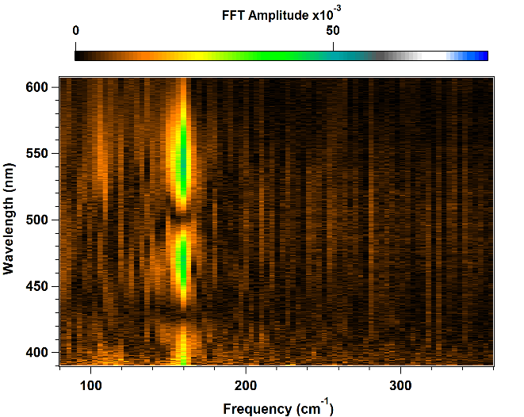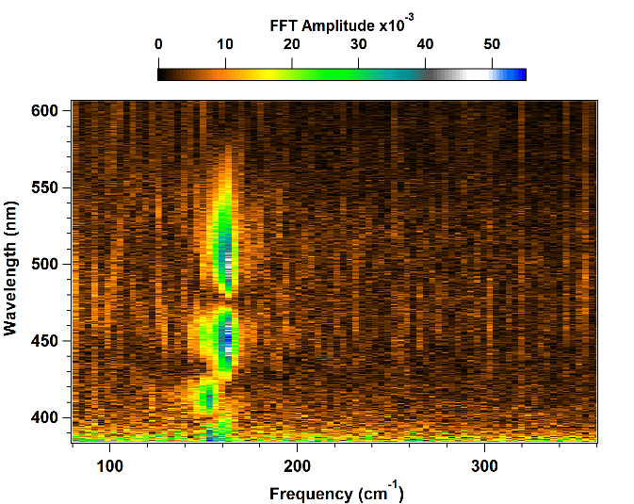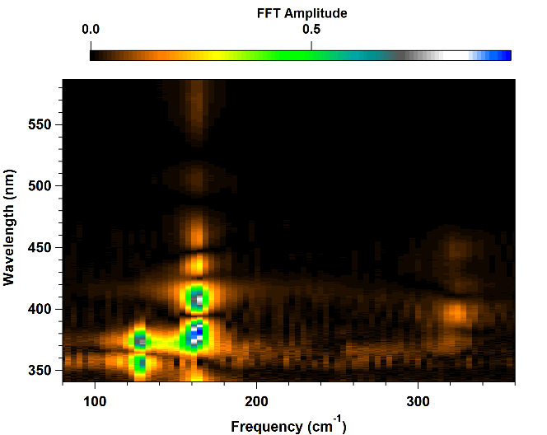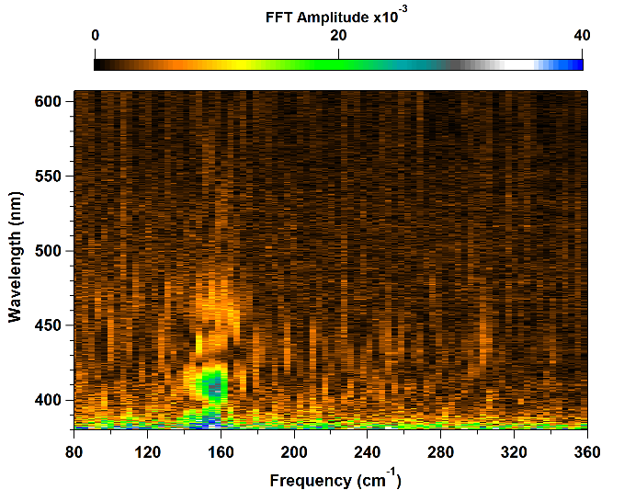

**d**

**a**

**b**

**c**

**Figure S3.** Fast Fourier Transform (FFT) maps of the oscillatory pattern of Pt(pop) in MeCN upon 280 nm excitation (a), Pt(pop) in water excited at 270 nm (b), Pt(pop-BF2) in MeCN excited at 360 nm (c) and 260 nm (d). In (a) only one frequency appears at 160 ± 3 cm-1, due to the 3A2u state. In (b), the FFT map of the oscillatory pattern reveals the presence of two main frequencies centred at ~150 cm-1 and 160 cm-1, due to wave packet oscillations in 1A2u and 3A2u states, respectively. These values agree with those obtained by GF. In (c), there are three main frequencies: 128 ± 3 cm-1 (1A1g ground state), 163 ± 3 cm-1 (1A2u) and 323 ± 3 cm-1 (1A2u overtone). The latter is mainly localized around 400 nm, suggesting that it is due to the probing of the central part of the 1A2u potential energy surface. The FFT map of the oscillatory pattern resulting for 260 nm excitation of Pt(pop-BF2) (d) shows the presence of one frequency at 159 ± 3 cm-1, stemming from the 1A2u state.