Supporting Information
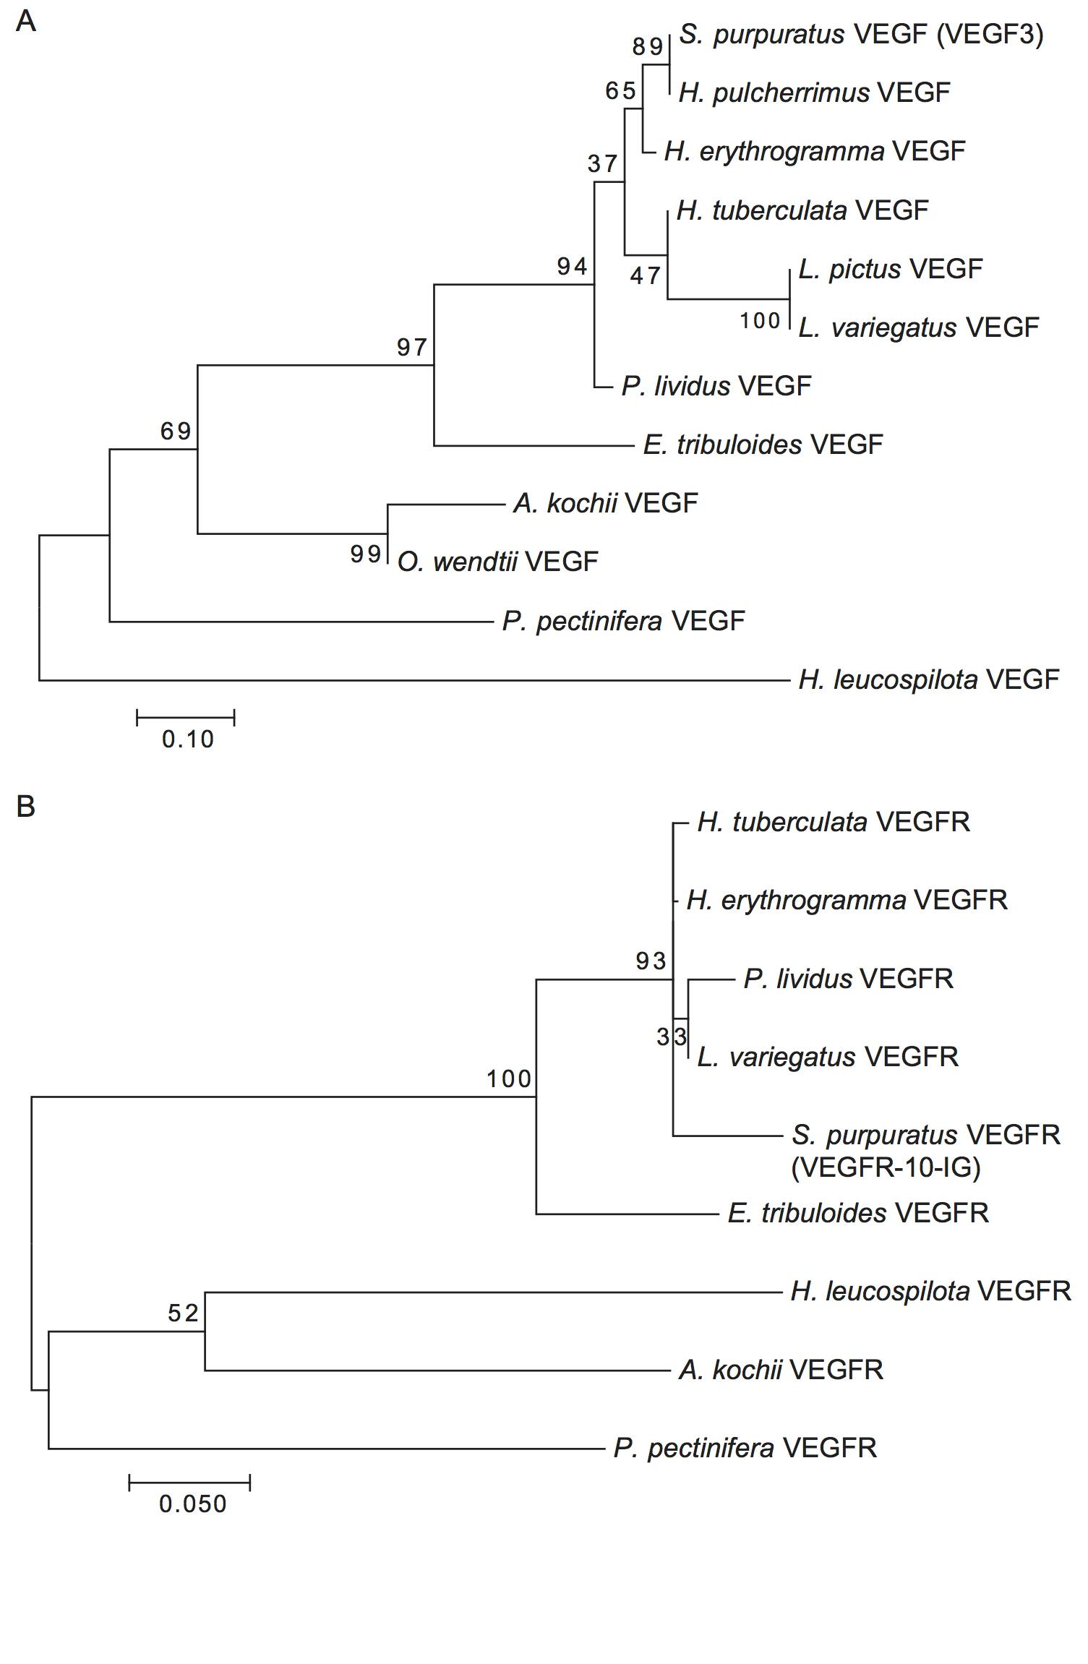
Supplementary Figure 1. Phylogenetic reconstruction of echinoderm VEGF and VEGFR to support the orthology of cloned E. tribuloides sequences used in this study. Amino acid sequences were aligned in MEGA7 with ClustalW and maximum likelihood trees were constructed from 1000 replicates using the default parameters. Bootstrap values are shown for internal nodes. Branch length reflects number of amino acid substitutions per site. (A) Phylogenetic tree of VEGF (VEGF3 in S. purpuratus) orthologs including the partial sequence for the VEGF ortholog studied here in the cidaroid E. tribuloides. (B) Phylogenetic tree of VEGFR (VEGFR-10-IG in S. purpuratus) orthologs including the partial sequence for the VEGFR ortholog studied here in the cidaroid E. tribuloides.

