Implications of the ammonia distribution on Jupiter from 1 to 100 bars as measured by the Juno microwave radiometer.

Supplementary online material

Ingersoll, A. P. et al. [2017], Geophys. Res. Lett.

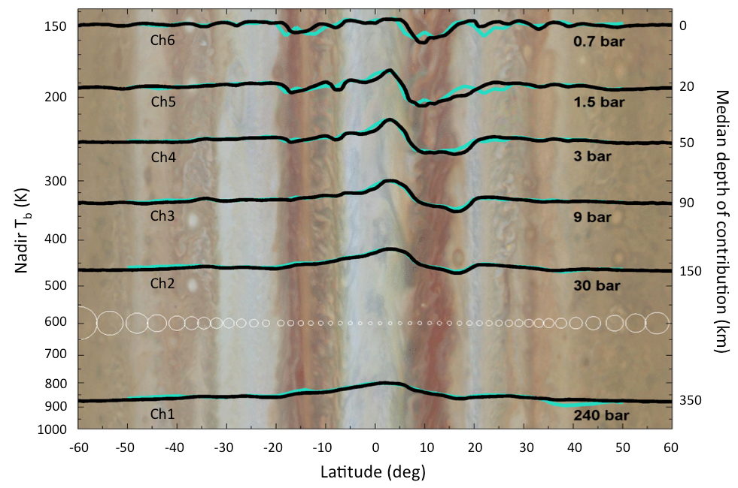

Figure S1. MWR nadir brightness temperatures from August 27, 2016, black, and December 11, 2016, green. Temperature increases downward on the y-axis, left. Depths and pressures corresponding to the brightness temperatures are given at right. White circles are the footprint sizes. Only a small fraction of the footprints are shown. The actual offsets of their centers are 10% of the footprint diameters. From Bolton et al. [2017] and Janssen et al. [2017].

