Supporting Information of
Strong SH-to-Love Wave Scattering off the Southern California Continental Borderland
Chunquan Yu^{1*}, Zhongwen Zhan¹, Egill Hauksson¹, Elizabeth Cochran²
¹ Seismological Laboratory, California Institute of Technology, Pasadena, CA 91125, USA
² Earthquake Science Center, United States Geological Survey, Pasadena, CA 91106, USA

This file includes
Text S1
Table S1
Figures S1-S7

Text S1 Phase coherence for random noise
In eqn. 1, if $N$ traces have a random distribution at time $t$, the probability density function (pdf) of $c(t)$ is given by [Jammalamadaka and Sengupta, 2001]
$P_{N}\left(c\left(t\right)\right)=N^{2}c(t)\int_{0}^{∞}{J_{0}\left(Nc\left(t\right)z\right)}{J_{0}\left(z\right)}^{N}zdz$ (S1)
where $J_{0}$ is the Bessel function of order zero. This integral has no known analytic solution. For relatively large $N$, eqn. S1 can be approximated by
$P_{N}\left(c\left(t\right)\right)≅2Nc(t)e^{-N{c(t)}^{2}}$ (S2)
It is not difficult to derive the probability of phase coherence larger than $c_{0}(t)$, that is
$P_{N}\left(c(t)>c_{0}\left(t\right)\right)≅e^{-N{c_{0}(t)}^{2}}$ (S3)
If $c(t)$ is sampled $X$ times, the probability of maximum phase coherence larger than $c_{0}(t)$ is given by
$P_{N,X}\left(c_{max}>c_{0}\left(t\right)\right)≅1-{\left(1-e^{-N{c_{0}\left(t\right)}^{2}}\right)}^{X}$ (S4)
From eqn. S4, we can numerically derive the pdf of maximum phase coherence $P_{N,X}\left(c_{max}\right)$.
Figure S2 shows the expectation of $c_{max}$ (${E[c}_{max}]$) as a function of $N$ for $X=2000$. This $X$ value is chosen to give good fit to numerical experiment results using realistic station distribution in Southern California. ${E[c}_{max}]$ decreases as $N$ increases. It means that the more stations used in phase coherence analysis, the lower maximum coherence value random noise can reach. The two dashed lines mark the 95% confidence interval of the estimated $c_{max}$. In our back-projection image (Figure 3), we mute the amplitudes of data points whose phase coherence are not significantly above noise level, that is below the top dashed line in Figure S2.

References
Brocher, T. M. (2005), Empirical relations between elastic wavespeeds and density in the Earth's crust, Bull. Seismol. Soc. Am., 95(6), 2081-2092.
Jammalamadaka, S. R., and A. Sengupta (2001), Topics in circular statistics, World Scientific.
Li, D., D. Helmberger, R. W. Clayton, and D. Sun (2014), Global synthetic seismograms using a 2-D finite-difference method, Geophys. J. Int., 197(2), 1166-1183.
ten Brink, U. S., J. Zhang, T. M. Brocher, D. A. Okaya, K. D. Klitgord, and G. S. Fuis (2000), Geophysical evidence for the evolution of the California Inner Continental Borderland as a metamorphic core complex, J. Geophys. Res.: Solid Earth, 105(B3), 5835-5857.

Table S1 37 deep events from the Tonga-Kermadec-Fiji subduction zone used in this study.
Event  ID* | Origin Time  (UT) | Lat.  (ºN) | Lon.  (ºE) | Depth  (km) | Magnitude  (M_{W}) | Distance (º)  (to MWC)
9811425 | 2002/08/19,11:01:01.0 | -21.80 | -179.50 | 579 | 7.4 | 80.90
9811437 | 2002/08/19,11:08:25.0 | -23.80 | 178.40 | 694 | 7.7 | 83.68
9851553 | 2002/10/17,04:23:53.0 | -19.70 | -178.60 | 589 | 6.2 | 78.86
9855193 | 2002/10/22,11:39:04.0 | -20.50 | -178.60 | 552 | 6.2 | 79.40
14023392 | 2004/01/11,09:29:09.0 | -20.10 | -179.20 | 672 | 6.0 | 79.54
14106728 | 2004/11/17,21:09:13.0 | -20.00 | -178.80 | 620 | 6.6 | 79.20
14132656 | 2005/03/19,17:34:45.0 | -21.90 | -179.60 | 590 | 6.3 | 81.04
14208020 | 2006/01/02,22:13:40.0 | -19.90 | -178.20 | 583 | 7.2 | 78.72
14215820 | 2006/02/26,03:08:27.0 | -23.60 | -180.00 | 536 | 6.4 | 82.46
12246015 | 2006/06/02,07:31:37.0 | -20.75 | -178.74 | 592 | 6.0 | 79.67
12310335 | 2007/09/25,05:15:59.9 | -30.96 | 179.88 | 408 | 6.2 | 87.54
12316115** | 2007/10/05,07:17:54.7 | -25.24 | 179.41 | 535 | 6.5 | 83.96
12319411 | 2007/10/16,21:05:47.5 | -25.62 | 179.42 | 550 | 6.6 | 84.21
12329775 | 2008/01/15,17:52:15.6 | -21.91 | -179.52 | 596 | 6.5 | 80.99
12335587 | 2008/07/03,03:02:36.6 | -23.32 | -179.81 | 569 | 6.2 | 82.15
23733759 | 2009/11/09,10:44:54.4 | -17.21 | 178.41 | 585 | 7.2 | 79.30
23909767 | 2009/11/22,07:48:20.8 | -17.79 | -178.44 | 523 | 6.3 | 77.45
23973767 | 2009/11/22,22:47:28.2 | -31.59 | 179.42 | 439 | 6.2 | 88.26
36908199 | 2010/12/28,08:34:17.8 | -23.37 | -179.79 | 552 | 6.3 | 82.17
36946279 | 2011/02/21,10:57:53.1 | -26.08 | 178.44 | 562 | 6.4 | 85.18
36995199 | 2011/04/03,14:07:09.3 | -17.65 | -178.58 | 552 | 6.4 | 77.45
37003519 | 2011/07/22,06:56:40.2 | -20.23 | -178.53 | 601 | 6.0 | 79.17
37004399 | 2011/07/29,07:42:23.2 | -23.65 | 179.82 | 522 | 6.7 | 82.61
37005679 | 2011/08/19,03:54:27.6 | -16.53 | -176.91 | 413 | 6.2 | 75.52
37007999 | 2011/09/15,19:31:02.7 | -21.56 | -179.37 | 626 | 7.3 | 80.65
37014919 | 2012/01/24,00:52:06.0 | -24.96 | 178.61 | 583 | 6.3 | 84.31
37196613 | 2014/05/04,09:15:53.0 | -24.64 | 179.08 | 528 | 6.6 | 83.78
37206325 | 2014/07/21,14:54:41.0 | -19.83 | -178.46 | 616 | 6.9 | 78.85
37228653 | 2014/11/01,18:57:22.2 | -19.70 | -177.73 | 434 | 7.1 | 78.26
37232725 | 2014/12/30,21:17:23.9 | -20.34 | -178.55 | 598 | 6.1 | 79.26
37234173 | 2015/01/28,02:43:19.9 | -20.91 | -178.35 | 484 | 6.1 | 79.51
37248221 | 2015/04/28,16:39:39.0 | -20.87 | -178.64 | 579 | 6.1 | 79.68
37250797 | 2015/06/16,06:17:00.5 | -20.41 | -178.91 | 653 | 6.0 | 79.55
37251261 | 2015/06/21,21:28:16.8 | -20.46 | -178.35 | 561 | 6.0 | 79.20
37368885 | 2016/05/27,04:08:44.2 | -20.83 | -178.67 | 572 | 6.4 | 79.67
37368909 | 2016/05/28,05:38:51.4 | -22.02 | -178.16 | 417 | 6.6 | 80.14
37382565 | 2016/09/24,21:28:41.6 | -19.85 | -178.27 | 596 | 6.9 | 78.73
* Earthquake catalogue from US National Earthquake Information Center (NEIC)
** Selected event in the main text
Figures
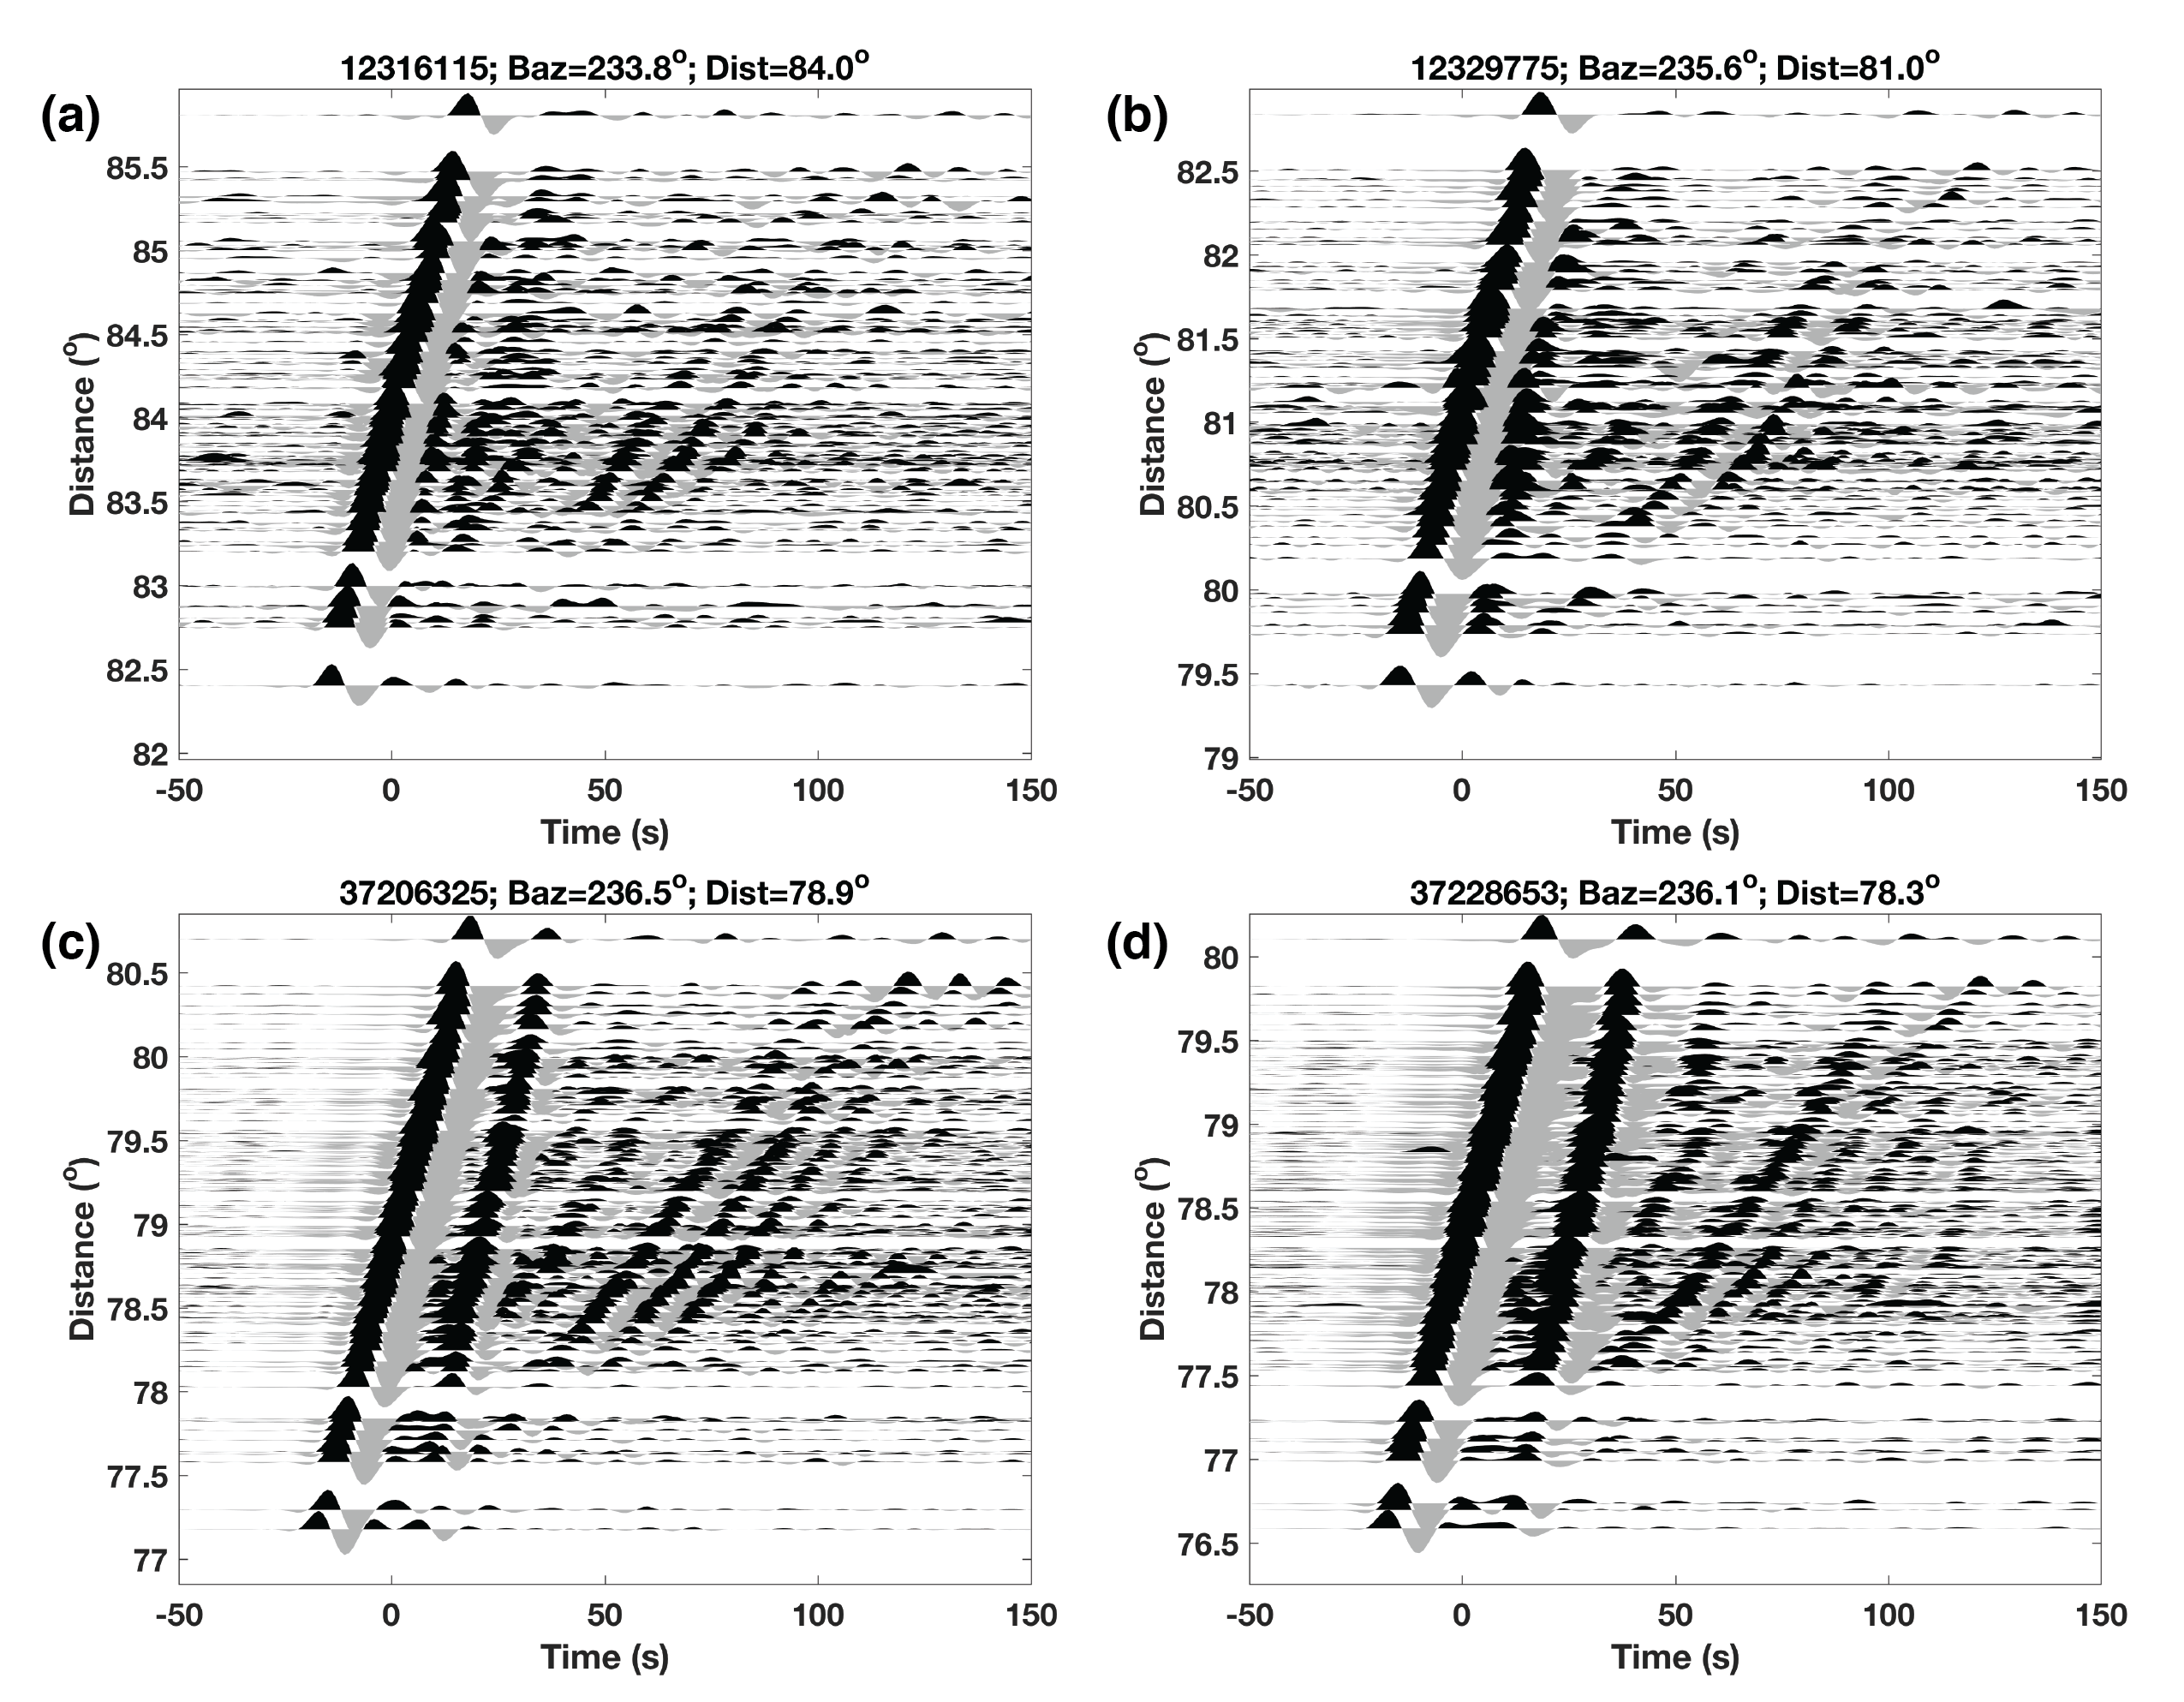
Figure S1 Tangential-component seismograms of four different deep events from the Tonga-Kermadec-Fiji subduction zone. Event information can be found in Table S1. Seismograms are sorted by epicentral distance and bandpass filtered between 0.02 and 0.1 Hz with a two-pass Butterworth filter. Note that strongly scattered waves are consistently observed.

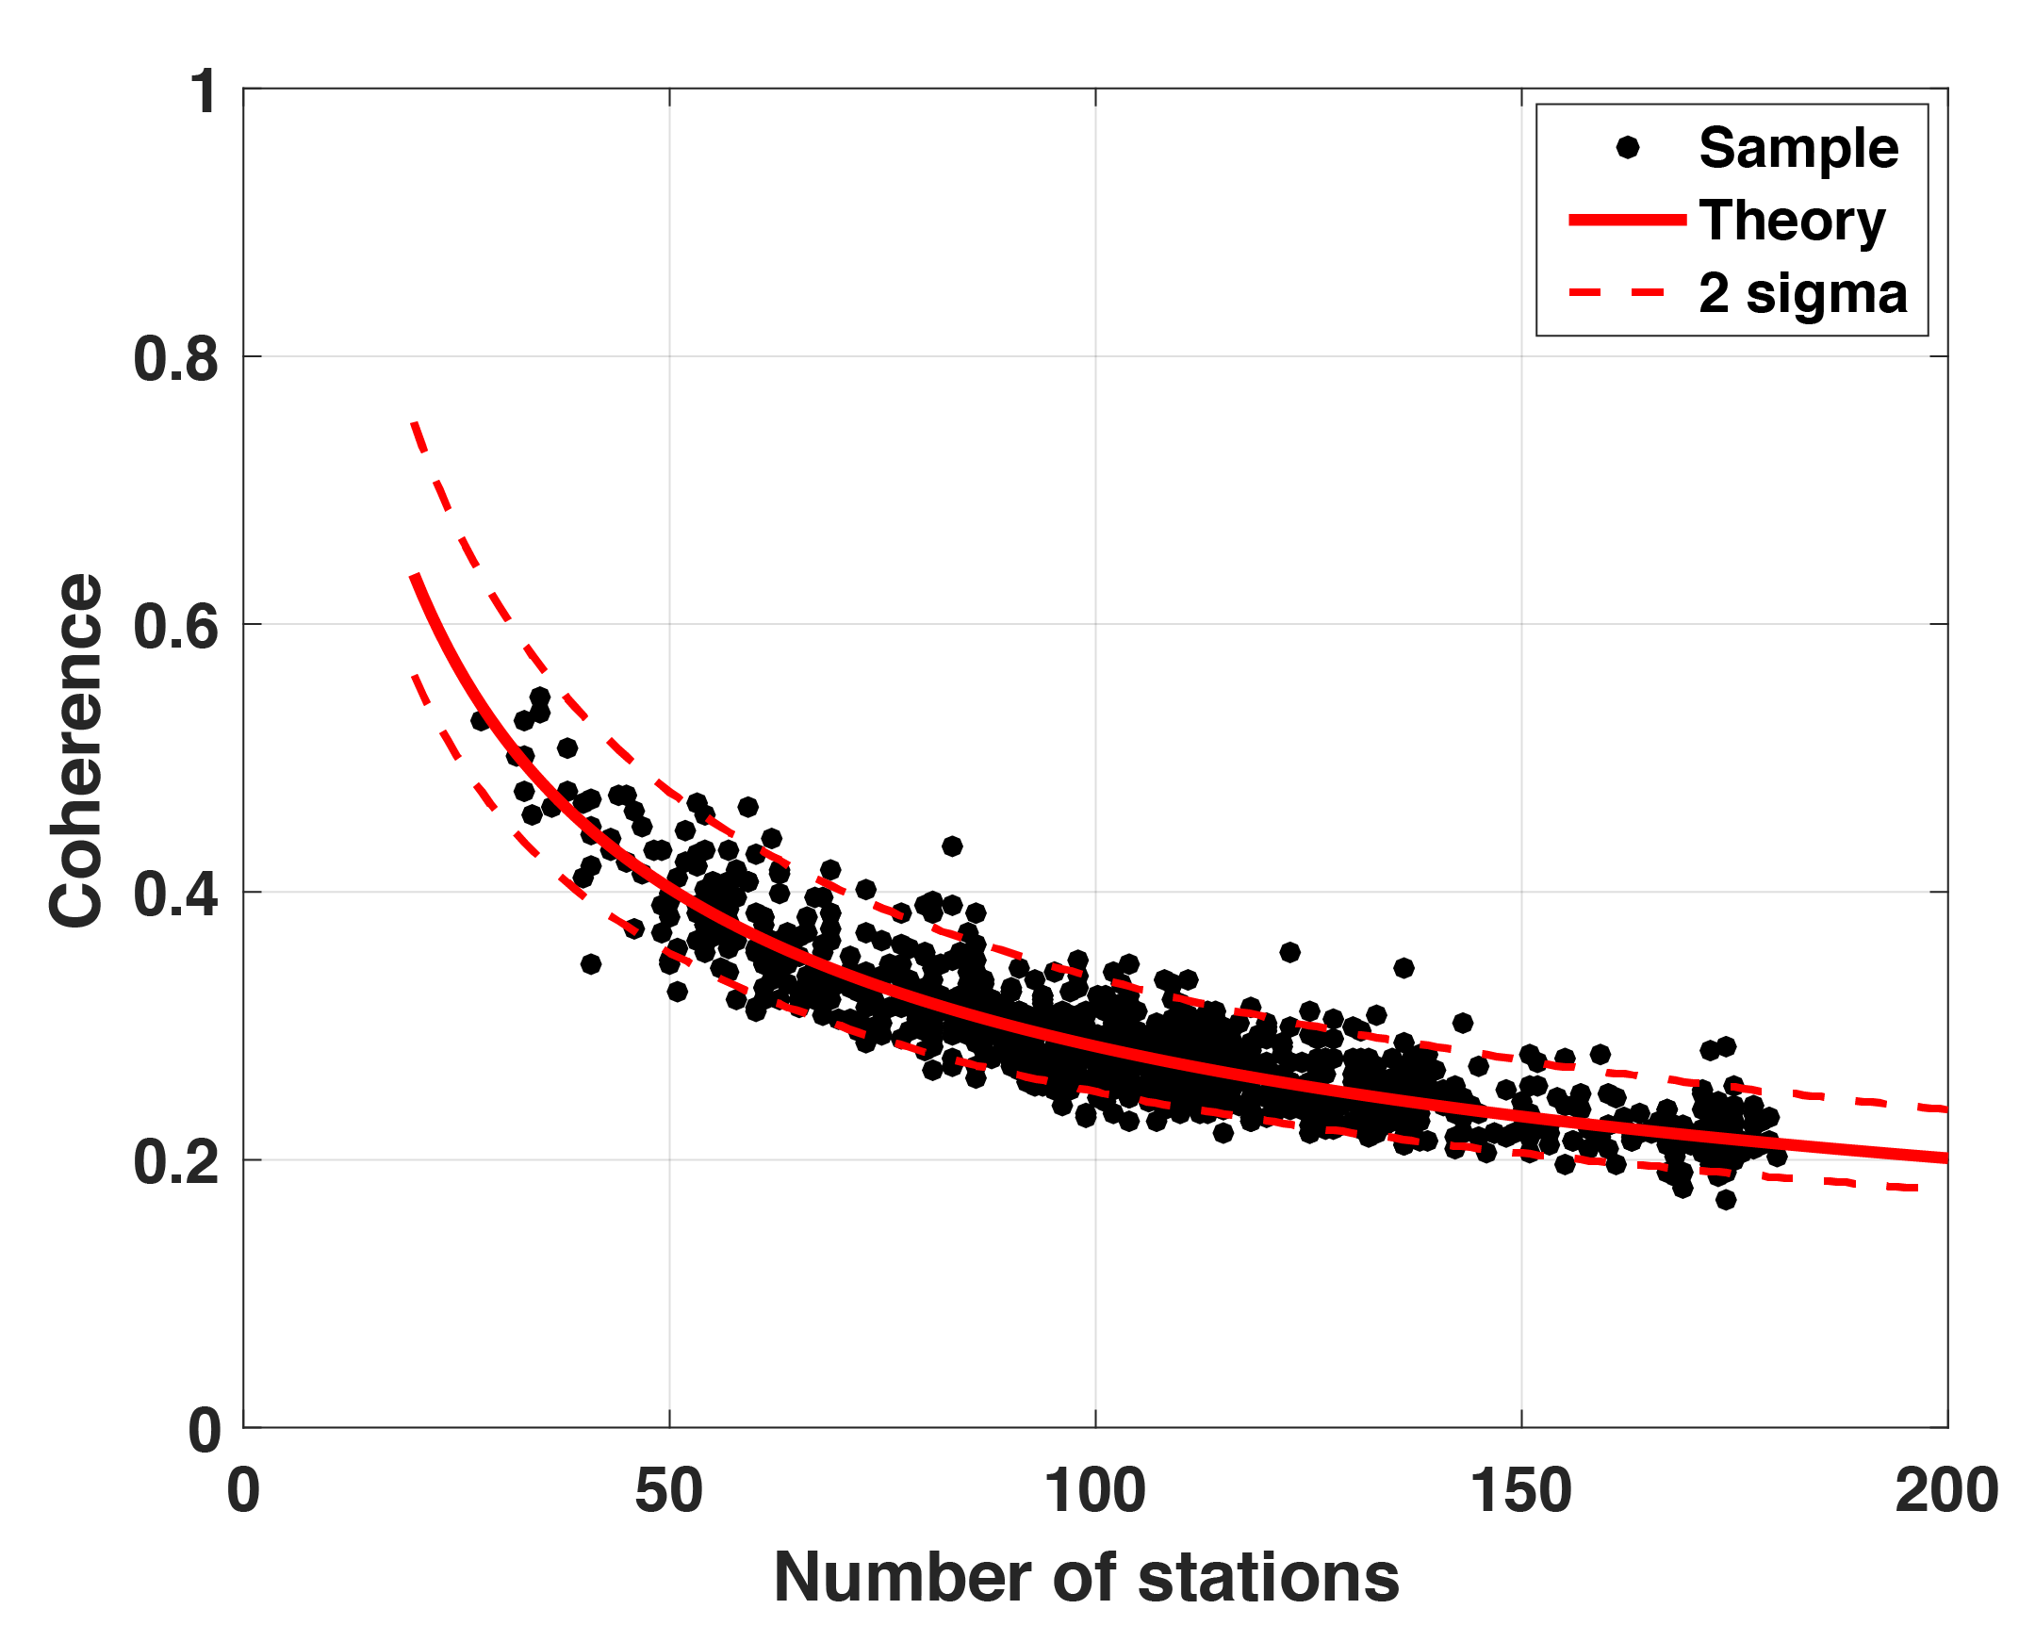
Figure S2 Maximum value of phase coherence of random noise. The solid line is the expectation of maximum coherence for 2000 resampling. Two dashed lines show 95% confidence intervals. Black dots are numerical realizations for white noise using realistic station distribution in SCSN.

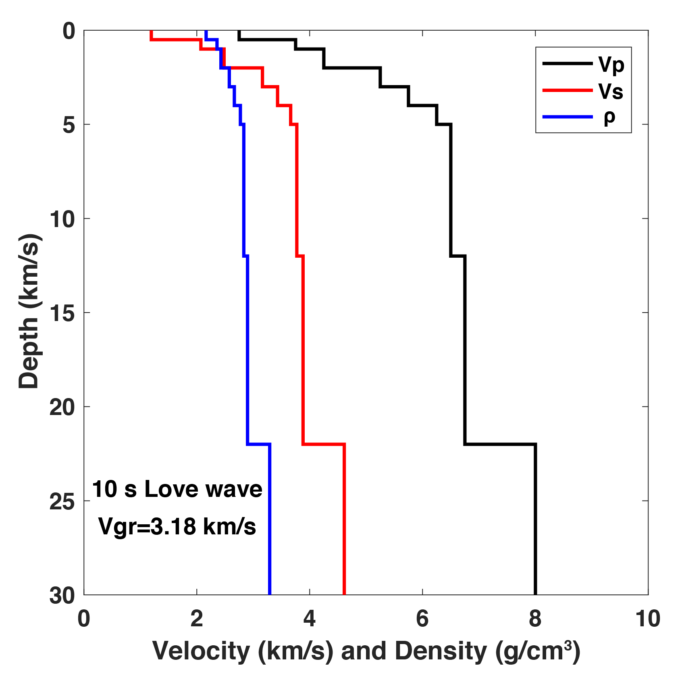
Figure S3 An averaged velocity and density model across the California Inner Continental Borderland. P-wave velocity structure is estimated from Plate 2b of ten Brink et al. [2000]. S-wave velocity and density structures are empirically calculated using Brocher [2005].
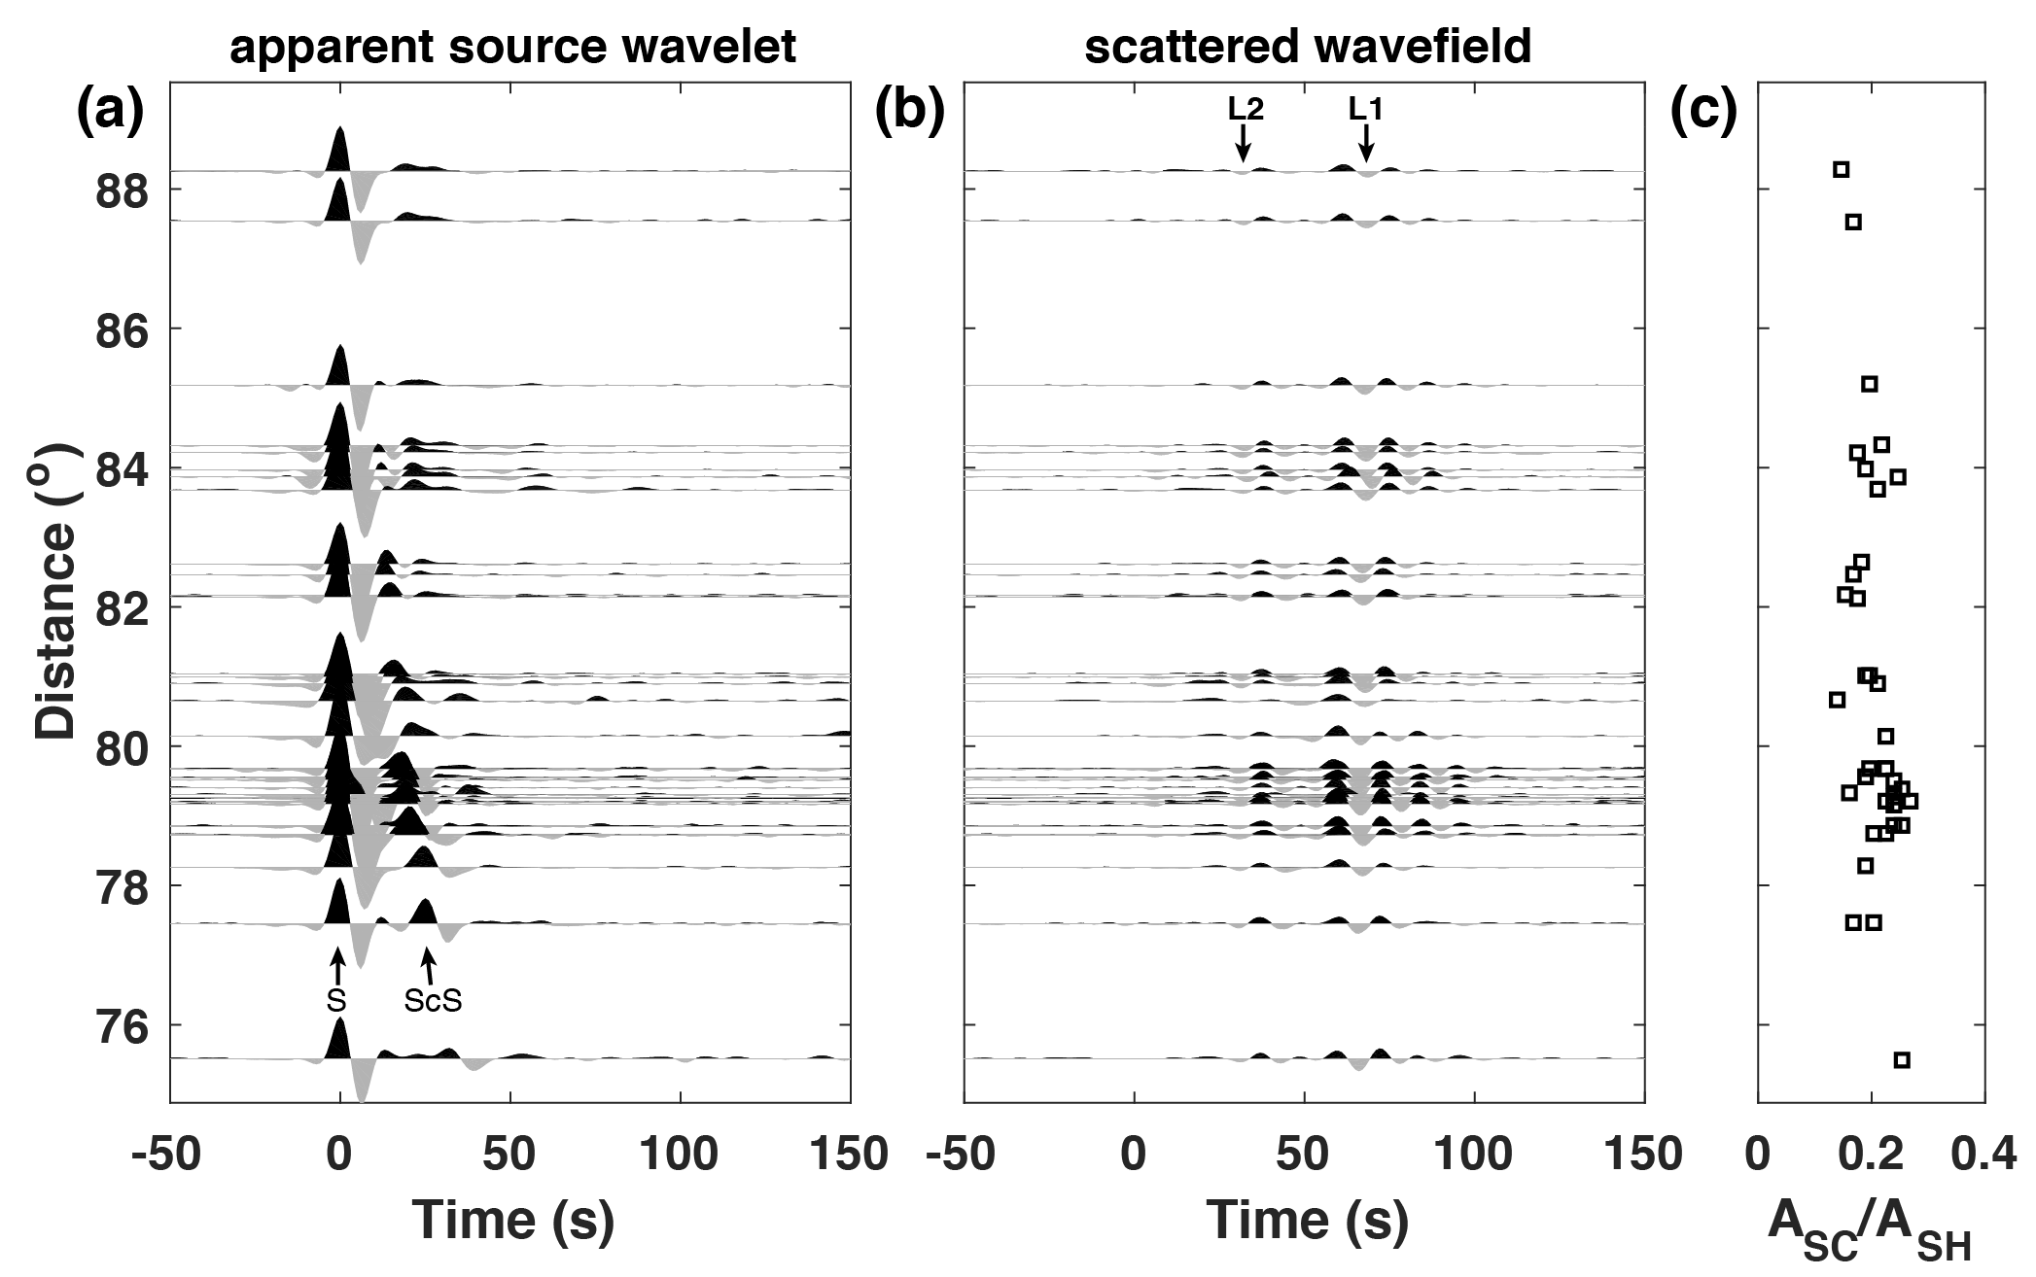
Figure S4 (a) Apparent source wavelet and (b) scattered wavefiled extracted at station CI.MWC. Totally, there are 37 events (Table S1). Waveforms are aligned by the SH arrival. (c) Amplitude ratio between the strongest scatter and the direct SH. Note “L1” and “L2” are consistently observed at nearly constant time, suggesting they are generated by the SH phase.

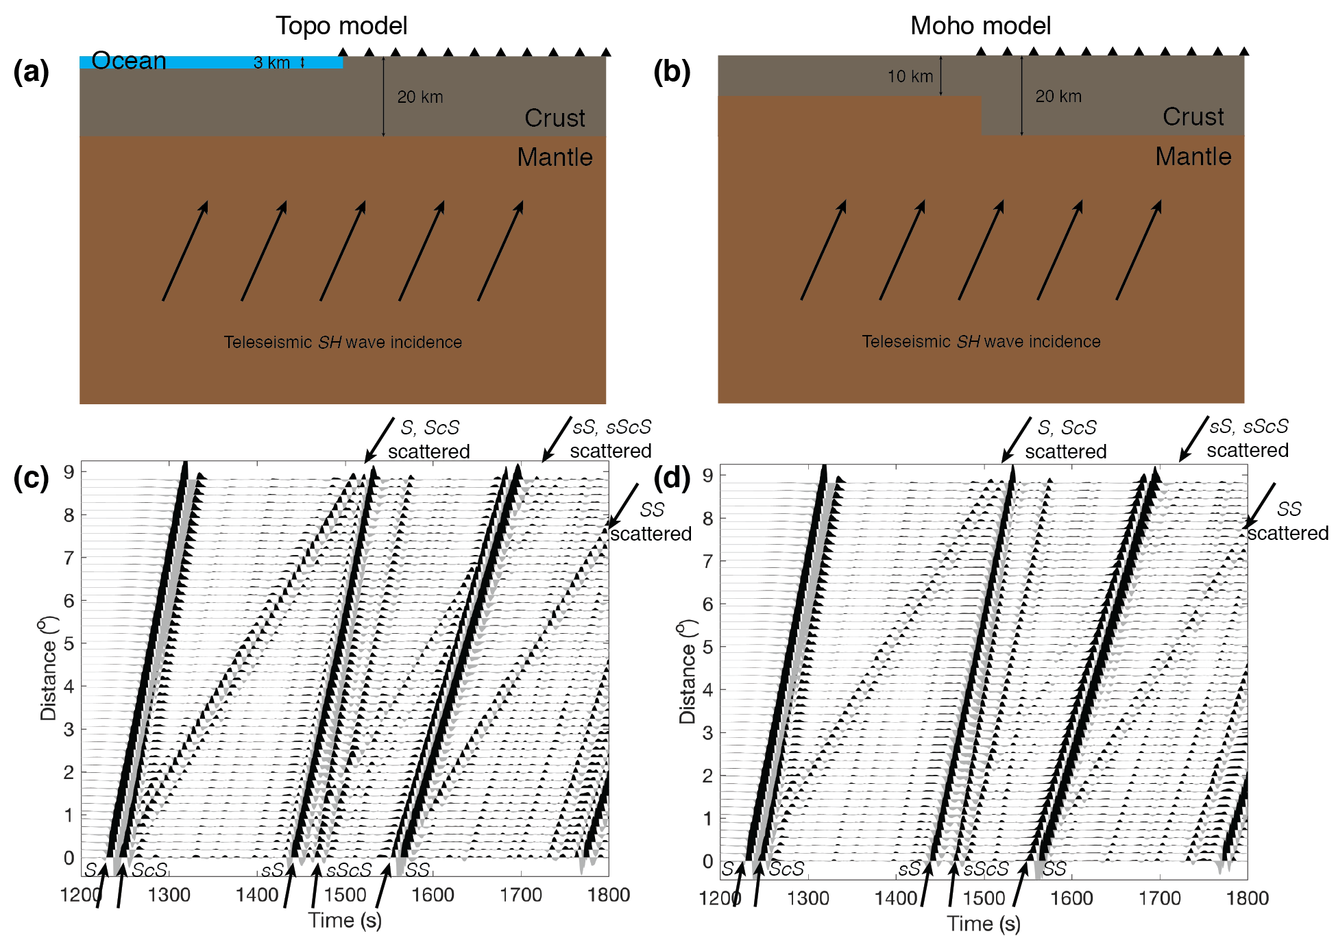
Figure S5 Synthetic waveforms for two different models. Model (a) has a 3-km step at the surface. Model (b) has 10-km offset at the Moho. (c) and (d) are simulated waveforms for model (a) and (b), respectively, using the global 2-D finite-difference method of Li et al [2014]. Note scattered Love waves are much stronger in model (a) than in model (b).

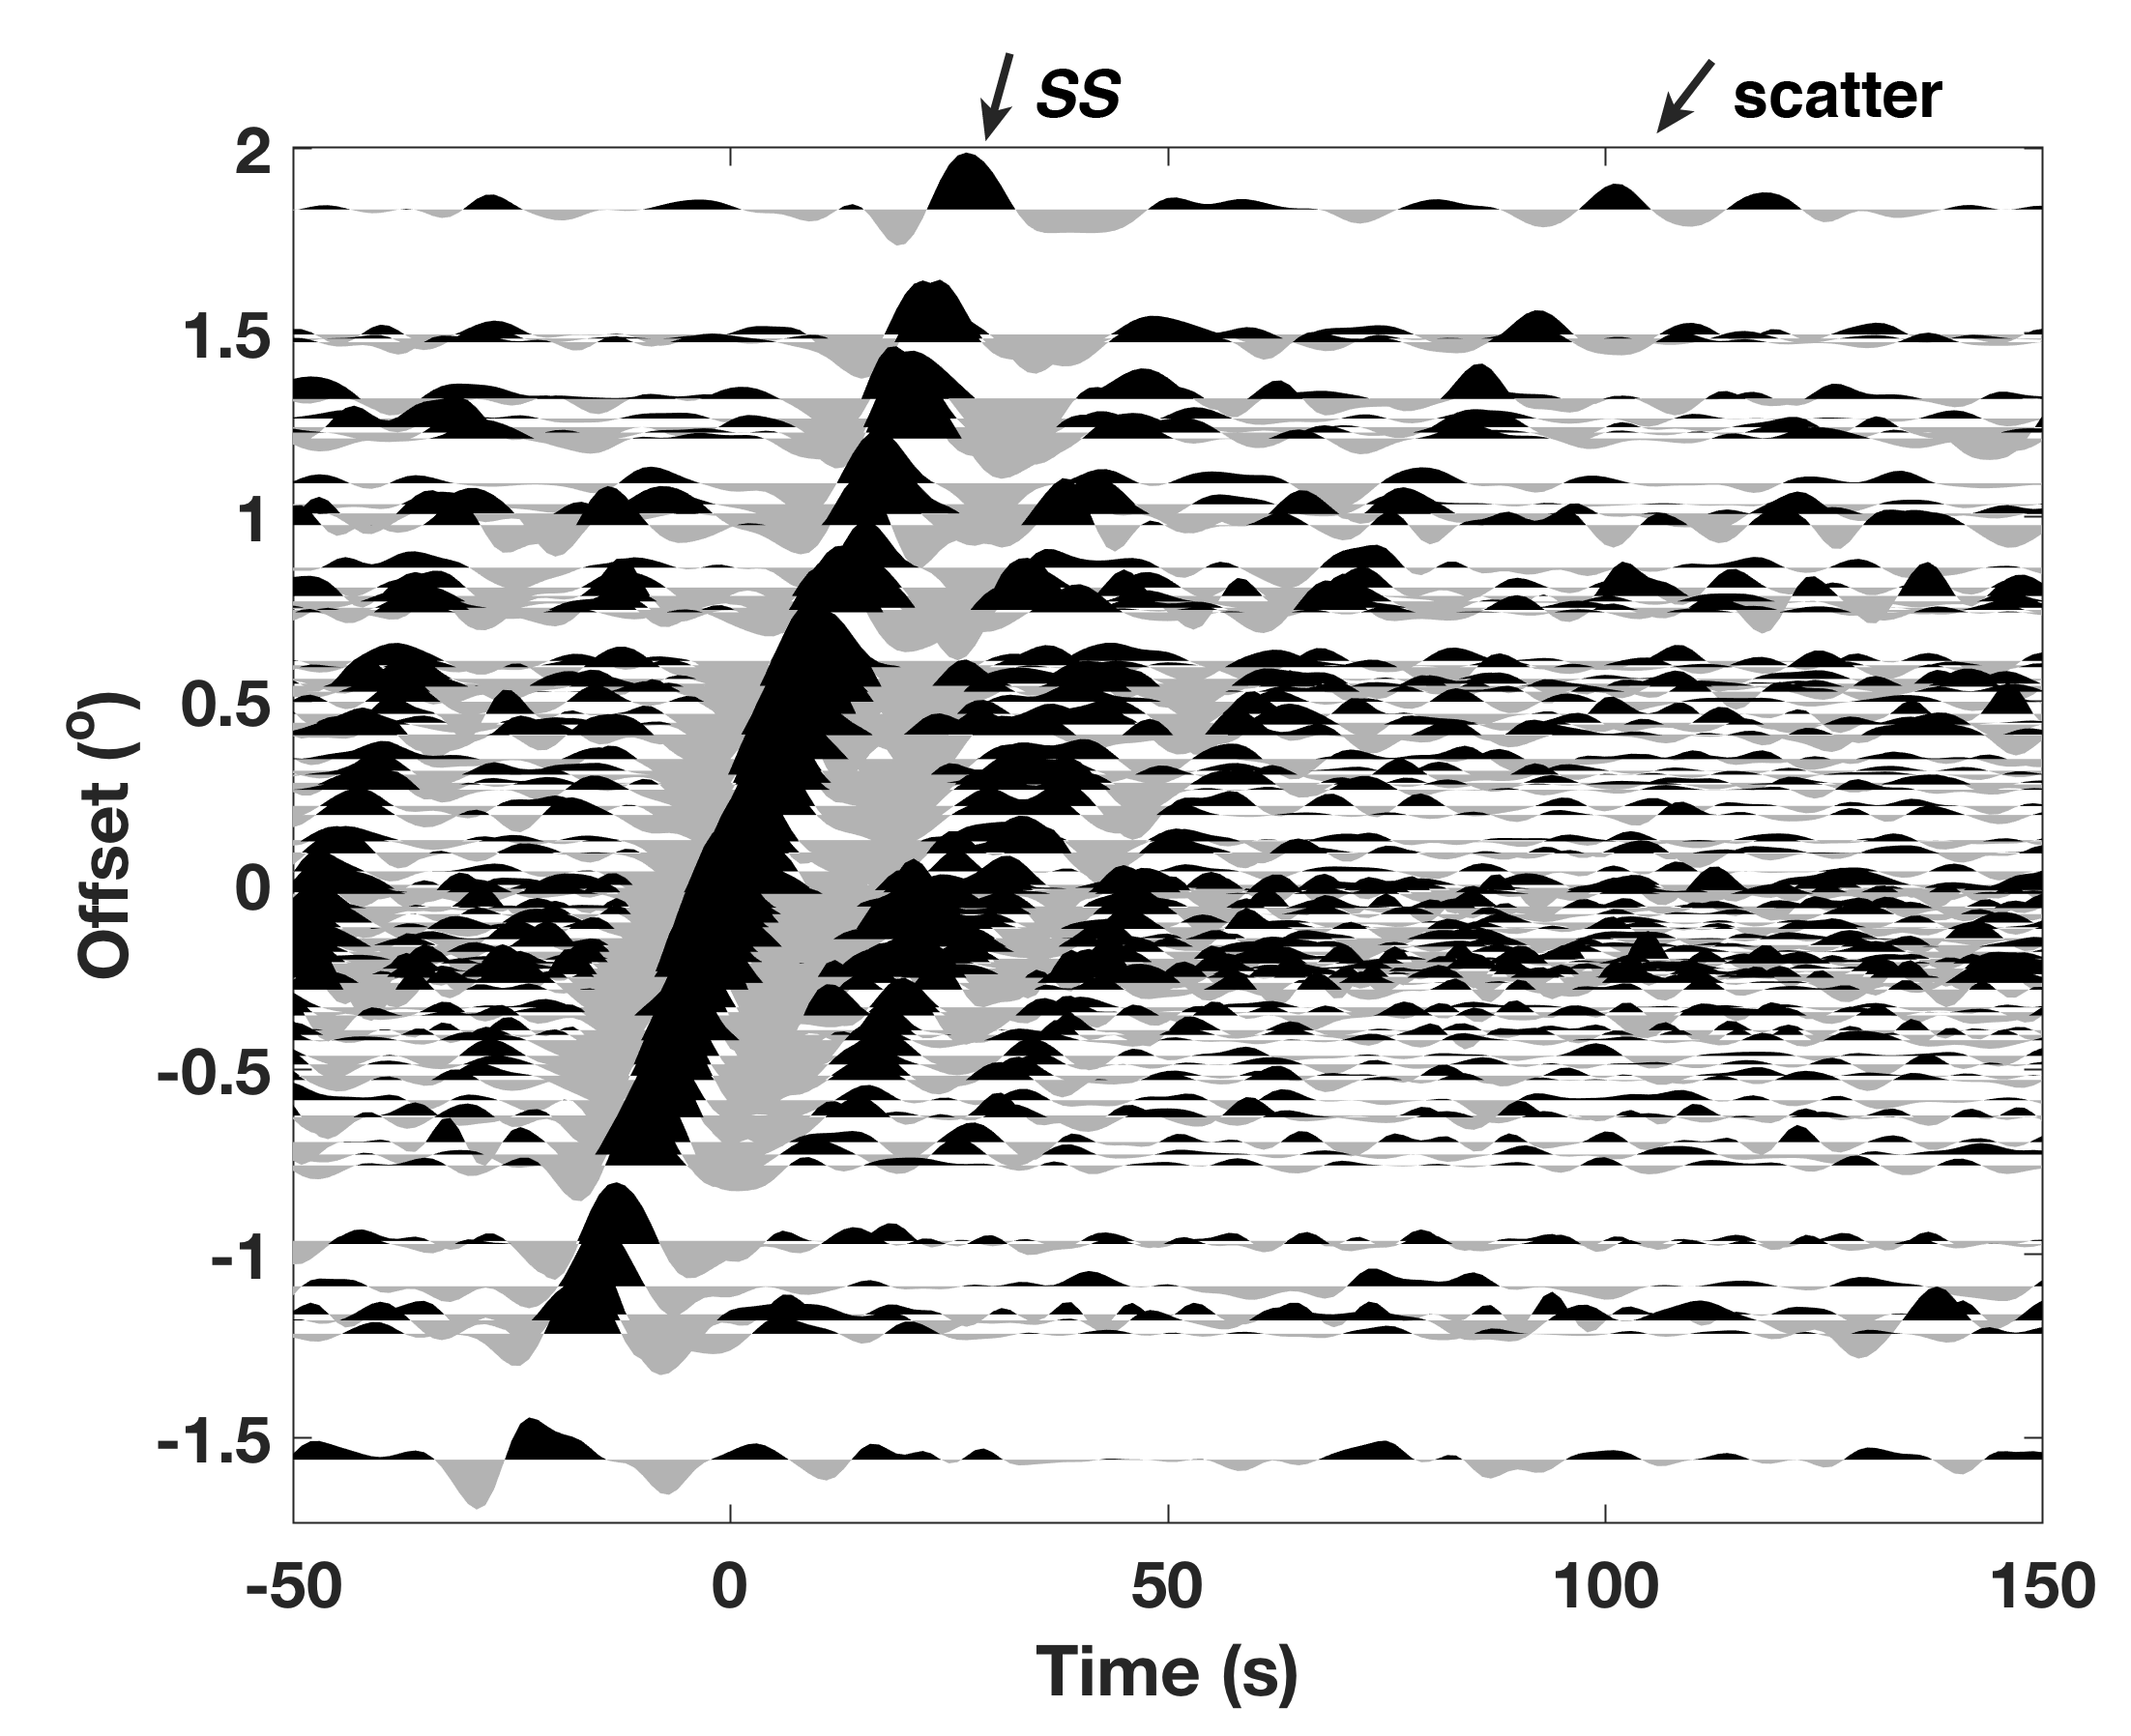
Figure S6 Tangential-component SS waveforms for the selected Tonga-Kermadec-Fiji event. The layout is the same as Figure 2a.

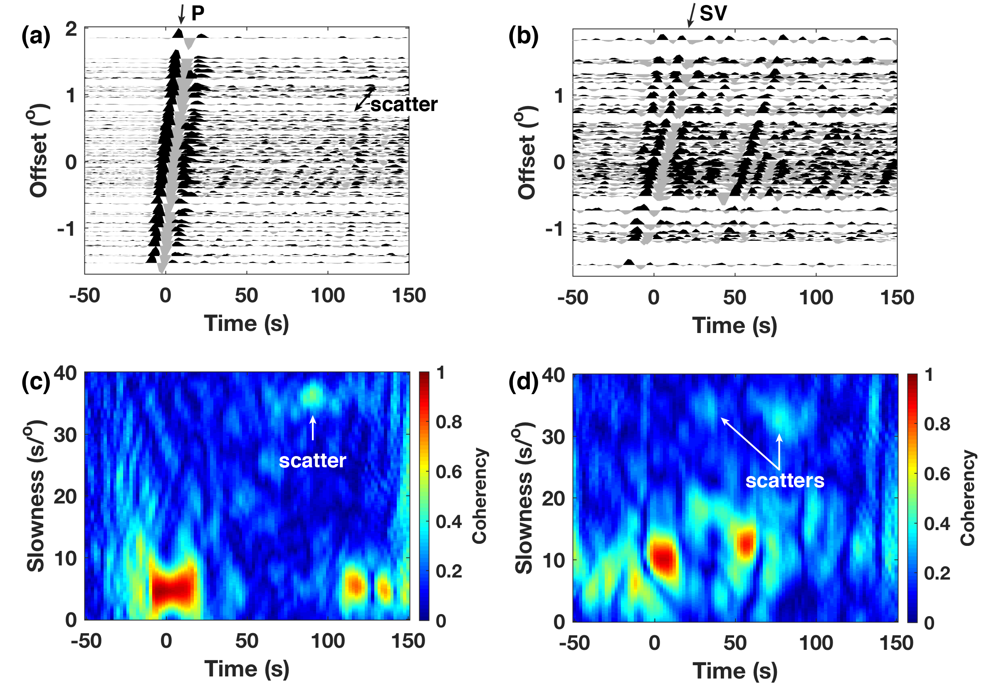
Figure S7 Observation of P-to-Rayleigh and SV-to-Rayleigh scatterings for the selected Tonga-Kermadec-Fiji event. (a) and (b) are vertical-component P and SV waveforms, respectively. The layout is the same as Figure 2a. (c) and (d) are their corresponding phase coherence analysis along the optimal slowness-time cross section. P-to-Rayleigh scattering is clearly observed in both (a) and (c). Due to phase interference, SV-to-Rayleigh scattering can only be identified through phase coherence analysis.

