Enantioseparation and identification for the rationalization of the environmental impact of four polychlorinated biphenyls

Fangjie Guo,^{[a]} Qiaozhi Tang,^{[a]} Jingqian Xie,^{[a]} Lu Zhao,^{[a]} Kai Liu,^{[b]} and Weiping Liu*^{[a]}

Supporting Information
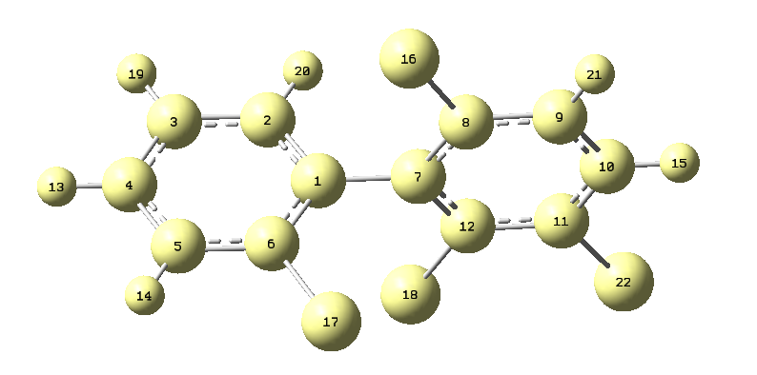
Figure S1. The atom serial number in Gaussian view of PCB45 (S).

Table S1. Effects of column temperature on the retention and separation factor of four PCBs on OD-H and OJ-H.
 | Factor | 10 °C | 15 °C | 20 °C | 25 °C | 30 °C
OJ-45 | t₀ | 6.527 | 6.163 | 6.437 | 6.397 | 6.330
 | t₁ | 12.587 | 11.460 | 11.580 | 11.271 | 11.030
 | t₂ | 15.060 | 13.403 | 13.377 | 12.916 | 12.527
 | k₁ | 0.928 | 0.859 | 0.799 | 0.762 | 0.742
 | k₂ | 1.307 | 1.175 | 1.078 | 1.019 | 0.979
 | a | 1.408 | 1.367 | 1.349 | 1.338 | 1.319
OD-95 | t₀ | 6.270 | 6.250 | 6.210 | 6.193 | 6.170
 | t₁ | 15.903 | 15.597 | 14.480 | 14.363 | 13.917
 | t₂ | 17.827 | 17.497 | 15.933 | 15.973 | 15.427
 | k₁ | 1.536 | 1.496 | 1.332 | 1.319 | 1.256
 | k₂ | 1.843 | 1.800 | 1.566 | 1.579 | 1.500
 | a | 1.200 | 1.203 | 1.176 | 1.197 | 1.195
OD-136 | t₀ | 6.277 | 6.250 | 6.220 | 6.200 | 6.170
 | t₁ | 18.380 | 17.620 | 16.563 | 16.130 | 15.510
 | t₂ | 22.377 | 21.167 | 19.470 | 19.010 | 18.147
 | k₁ | 1.928 | 1.819 | 1.663 | 1.602 | 1.514
 | k₂ | 2.565 | 2.387 | 2.130 | 2.066 | 1.941
 | a | 1.330 | 1.312 | 1.281 | 1.290 | 1.282
OD-149 | t₀ | 6.278 | 6.250 | 6.223 | 6.197 | 6.170
 | t₁ | 13.563 | 13.143 | 12.650 | 14.010 | 11.943
 | t₂ | 15.757 | 15.197 | 14.397 | 15.643 | 13.520
 | k₁ | 1.160 | 1.103 | 1.033 | 1.261 | 0.936
 | k₂ | 1.510 | 1.432 | 1.314 | 1.524 | 1.191
 | a | 1.301 | 1.298 | 1.272 | 1.209 | 1.273

Table S2. Van ’t Hoff equations and thermodynamic parameters of the four PCBs.
PCB | lnk =-ΔH°/RT+ΔS°/R | R² | ΔH°(KJ mol⁻¹) | ΔS(J mol⁻¹) | Results
45P₁ | lnk = 3.3869/T - 0.4004 | 0.973 | -0.407 | -0.048 | enthalpy-driven
45P₂ | lnk = 4.3143/T - 0.1498 | 0.980 | -0.519 | -0.018 | enthalpy-driven
95P₁ | lnk = 3.0437/T + 0.1481 | 0.871 | -0.366 | 0.018 | dual-driven
95P₂ | lnk = 3.159/T + 0.3188 | 0.845 | -0.380 | 0.038 | dual-driven
136P₁ | lnk = 3.5225/T + 0.3255 | 0.927 | -0.424 | 0.039 | dual-driven
136P₂ | lnk = 4.1005/T + 0.5536 | 0.939 | -0.493 | 0.067 | dual-driven
149P₁ | lnk = 1.5194/T + 0.0007 | 0.127 | -0.183 | 0.000 | none enthalpy/entropy-driven
149P₂ | lnk = 2.2318/T + 0.1986 | 0.327 | -0.268 | 0.024 | none enthalpy/entropy-driven
PCB | lnα=-ΔΔH°/RT+ΔΔS°/R | R² | ΔΔH°(KJ mol⁻¹) | ΔS°(J mol⁻¹) | Results
45 | lnk = 0.9274/T + 0.2505 | 0.983 | -0.112 | 0.030 | -
95 | lnk = 0.1152/T + 0.1707 | 0.115 | -0.014 | 0.021 | -
136 | lnk = 0.578/T + 0.2281 | 0.884 | -0.070 | 0.027 | -
149 | lnk = 0.7124/T + 0.1978 | 0.412 | -0.086 | 0.024 | -

