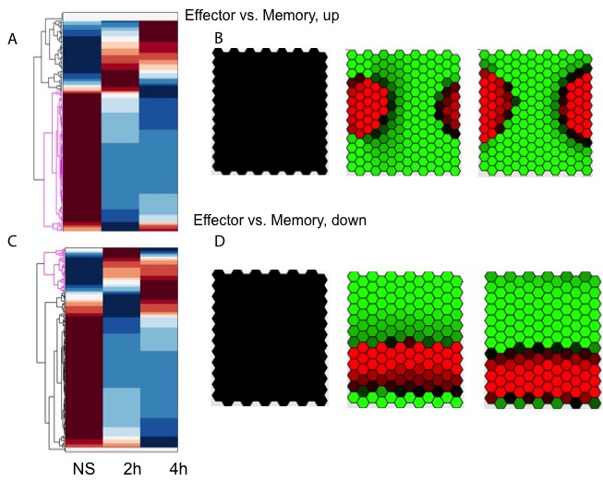
S17 Fig. Gene dynamics of human CD8⁺ T cells that are highly correlated with effector-vs-memory regulation. The dynamic change of genes up-regulated in comparison of effector CD8 T cells versus memory CD8 T cells as a function of T₁ represented by heatmap (A) and GATE self-organizing map (B). The dynamic change of genes down-regulated in comparison of effector CD8 T cells versus memory CD8 T cells as a function of T₁ represented by heatmap (C) and GATE self-organizing map (D).

