Supplementary material of
Mapping Mantle Transition Zone Discontinuities Beneath the Central Pacific With Array Processing of SS Precursors
Chunquan Yu^{1,2*}, Elizabeth A. Day^{1,3}, Maarten V. de Hoop⁴, Michel Campillo^{1,5}, Robert D. van der Hilst¹
1 Department of Earth, Atmospheric and Planetary Sciences, Massachusetts Institute of Technology, Cambridge, Massachusetts, USA
2 Now at Seismological Laboratory, California Institute of Technology, Pasadena, California, USA
3 Department of Earth Science and Engineering, Imperial College, London, UK
4 Department of Computational & Applied Mathematics, Rice University, Houston, Texas, USA
5 Institut des Sciences de la Terre, Université Joseph Fourier, Grenoble, France

Contents of this file
Supplementary Figure S1

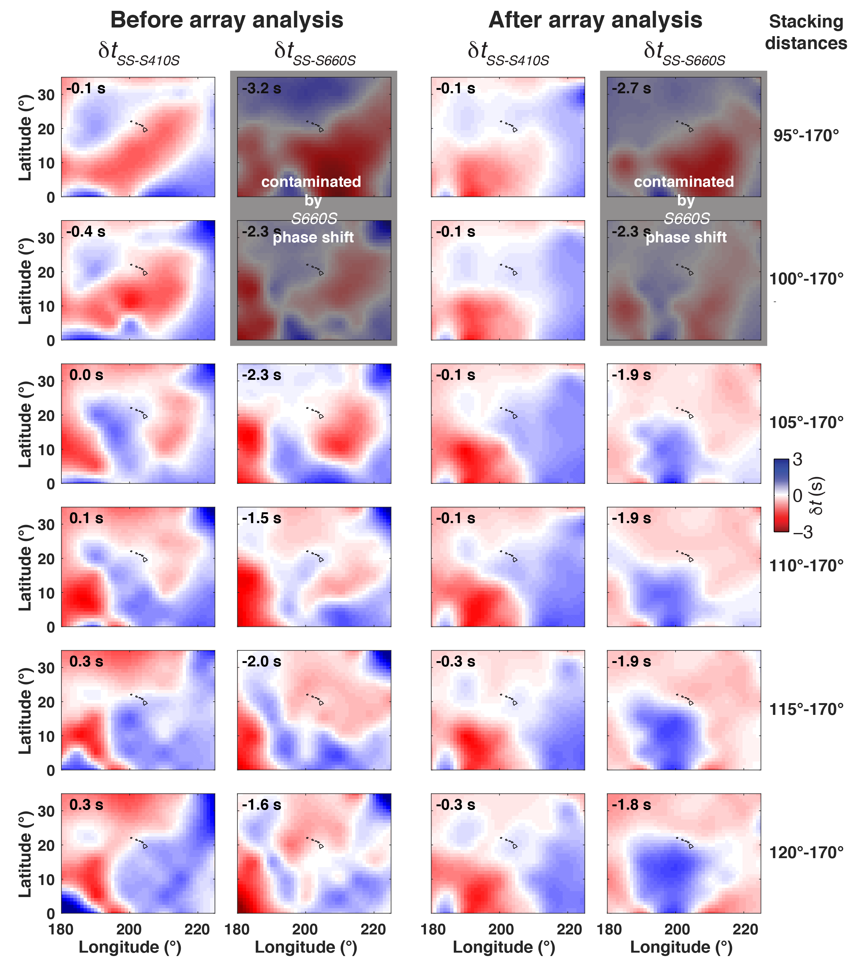
Figure S1 Comparison of travel time perturbations of T_{SS-S410S} and T_{SS-S660S} (relative to those calculated from the ak135 model) before and after array processing. Each row shows results for different stacking distance ranges. Note after array analysis, T_{SS-S410S} and T_{SS-S660S} are both stable over various distance ranges in terms of both mean values and lateral variations.

