Supplementary Information
Modeling biogenic secondary organic aerosol (BSOA) formation from monoterpene reactions with NO₃: A case study of the SOAS campaign using CMAQ
Momei Qin^{a,e}, Yongtao Hu^{b}, Xuesong Wang^{a,}*, Petros Vasilakos^{c}, Christopher M. Boyd^{c}, Lu Xu^{c,h}, Yu Songª, Nga Lee Ng^{c,d}, Athanasios Nenes^{c,d, i, j}, Armistead G. Russell^{b,}*
a State Key Joint Laboratory of Environmental Simulation and Pollution Control, College of Environmental Sciences and Engineering, Peking University, Beijing, China.
b School of Civil and Environmental Engineering, Georgia Institute of Technology, Atlanta, GA, USA.
c School of Chemical & Biomolecular Engineering, Georgia Institute of Technology, Atlanta, GA, USA.
d School of Earth and Atmospheric Sciences, Georgia Institute of Technology, Atlanta, GA, USA.
e Now at School of Civil and Environmental Engineering, Georgia Institute of Technology, Atlanta, GA, USA.
h Now at Division of Geological and Planetary Sciences, California Institute of Technology, Pasadena, CA, USA.
i Institute of Chemical Engineering Sciences, Foundation for Research and Technology-Hellas, Patras, Greece
j Institute for Environmental Research and Sustainable Development, National Observatory of Athens, Palea Penteli, Greece

Fig.S1 Diurnal trends of observed (black line) and simulated (red line) monoterpenes in the base case at Centreville during the SOAS campaign. The shaded area reflects a 95% Gaussian confidence interval. Normalize mean bias (NMB) and correlation coefficient (r) are shown in the figure.
Fig. S2 Diurnal trends of observed (black line) and simulated CO with the based model (red line) and the detailed model (blue line) at Centreville during the SOAS campaign. The shaded area reflects a 95% Gaussian confidence interval.
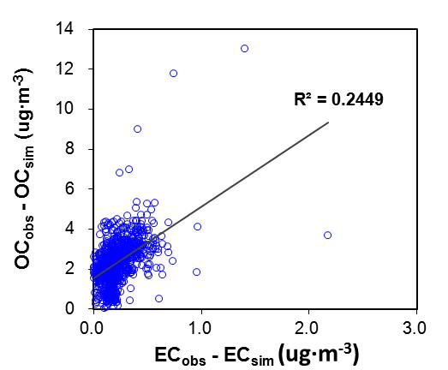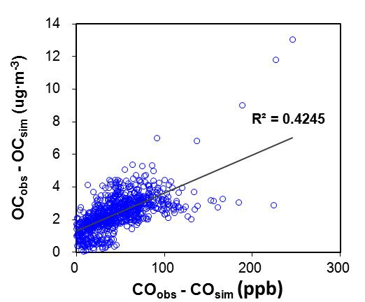
Fig.S3 Scatter plots of (OC_{obs}−OC_{sim}) vs. (EC_{obs}−EC_{sim}) and (OC_{obs}−OC_{sim}) vs. (CO_{obs}−CO_{sim}), with blue circles representing hourly measurements or simulations at Centreville during the SOAS campaign. The liner regression shows links between model biases of OC and that of EC or CO.
Fig. S4 Diurnal trends of observed (black line) and simulated isoprene-formed SOA (SOA_{I}) with the based model (red line), the detailed model (blue line), and the aging model (green line) at Centreville during the SOAS campaign. The shaded area reflects a 95% Gaussian confidence interval. Normalize mean bias (NMB) and correlation coefficient (r) are shown in the figure.
Fig. S5 Simulated OA (without isoprene-formed OA) in the original aging case (Aging) and three sensitivity tests with (1) SOA yield for limonene + NO₃ of 40% (Lim40), (2) 50% reduction in reaction rates of SVOCs with oxidants (Half), (3) No O3 aging (No_O3), compared to the measured total concentration of less-oxidized oxygenated OA (LO-OOA) and more-oxidized oxygenated OA (MO-OOA). Normalize mean bias (NMB) and correlation coefficient (r) are shown in the figure.
Fig. S6 Simulated (a) O₃ (b) OH (c) NO₃ concentration during the SOAS campaign. The location of Centreville site is labeled as a circle.
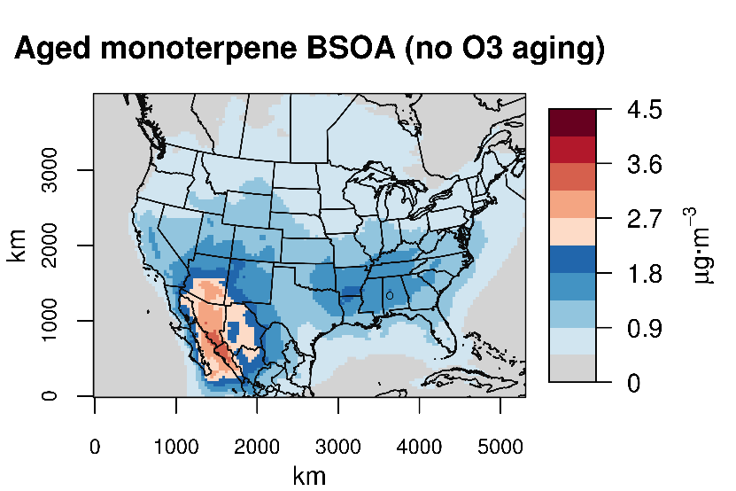
Fig. S7 Simulated monoterpene-formed SOA (SOA_{M}) via multigenerational oxidation in the case without O₃ aging (No_O3) during the SOAS campaign. The location of Centreville site is labeled as a circle.
Fig. S8 Percentage contributions of (a) monoterpene loss rate to OH and O₃ versus NO₃, (b) reactions with OH and O₃, reactions with NO₃ and aged SVOCs (AVOCs) to monoterpene BSOA at Centreville during the SOAS campaign.

Fig. S9 Diurnal trends of observed (black line) and simulated HNO₃ with the based model (red line) and the detailed model (blue line) at Centreville during the SOAS campaign. The shaded area reflects a 95% Gaussian confidence interval.
Fig. S10 Diurnal trends of observed (black line) and simulated (red line) temperature at Centreville during the SOAS campaign. The shaded area reflects a 95% Gaussian confidence interval.
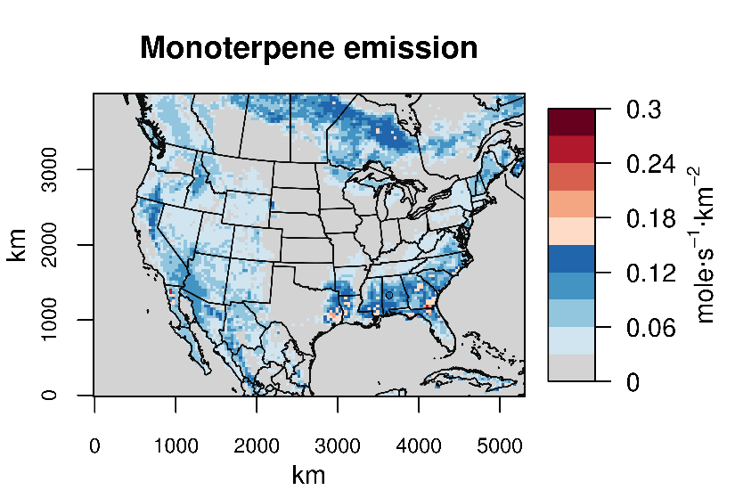
Fig. 11 Simulated monoterpene emission during the SOAS campaign.
Table S1 Monoterpenes involved reactions and rate parameters (available at http://www.engr.ucr.edu/~carter/SAPRC/)
Monoterpene | Rate parameters |  |  |  | Reaction
 | k（300） | A | Ea | B
α-pinene | 5.18$×10$⁻¹¹ | 1.21$×10$⁻¹¹ | −0.866 |  | A-PINENE + OH = 0.799 xHO2 + 0.004 xRCO3 + 1.042 RO2C + 0.197 RO2XC + 0.197 zRNO3 + 0.002 xCO + 0.022 xHCHO + 0.776 xRCHO + 0.034 xACET + 0.02 xMGLY + 0.023 xBACL + yR6OOH + 6.2 XC
 | 8.55$×10$⁻¹⁷ | 5.00$×10$⁻¹⁶ | 1.053 |  | A-PINENE + O3 = 0.009 HO2 + 0.102 xHO2 + 0.728 OH + 0.001 xMECO3 + 0.297 xRCO3 + 1.511 RO2C + 0.337 RO2XC + 0.337 zRNO3 + 0.029 CO + 0.051 xCO + 0.017 CO2 + 0.344 xHCHO + 0.24 xRCHO + 0.345 xACET + 0.008 MEK + 0.002 xGLY + 0.081 xBACL + 0.255 PROD2 + 0.737 yR6OOH + 2.999 XC
 | 6.09$×10$⁻¹² | 1.19$×10$⁻¹² | −0.974 |  | A-PINENE + NO3 = 0.056 xHO2 + 0.643 xNO2 + 0.007 xRCO3 + 1.05 RO2C + 0.293 RO2XC + 0.293 zRNO3 + 0.005 xCO + 0.007 xHCHO + 0.684 xRCHO + 0.069 xACET + 0.002 xMGLY + 0.056 xRNO3 + yR6OOH + 0.301 XN + 5.608 XC
 | 3.20$×10$⁻¹¹ |  |  |  | A-PINENE + O3P = PROD2 + 4 XC
β-pinene | 7.35$×10$⁻¹¹ | 1.55$×10$⁻¹¹ | −0.928 |  | B-PINENE + OH = 0.811 xHO2 + 0.005 xRCO3 + 0.999 RO2C + 0.184 RO2XC + 0.184 zRNO3 + 0.002 xCO + 0.784 xHCHO + 0.046 xRCHO + 0.035 xACET + 0.007 xMGLY + 0.781 xPROD2 + yR6OOH + 3.145 XC
 | 1.57$×10$⁻¹⁷ | 1.20$×10$⁻¹⁵ | 2.583 |  | B-PINENE + O3 = 0.123 HO2 + 0.07 xHO2 + 0.353 OH + 0.067 xRCO3 + 0.458 RO2C + 0.093 RO2XC + 0.093 zRNO3 + 0.393 CO + 0.092 CO2 + 0.23 HCHO + 0.011 xHCHO + 0.006 xRCHO + 0.104 xACET + 0.285 HCOOH + 0.007 xMGLY + 0.063 xBACL + 0.77 PROD2 + 0.23 yR6OOH + 3.007 XC
 | 2.51$×10$⁻¹² |  |  |  | B-PINENE + NO3 = 0.33 xHO2 + 0.059 xRCO3 + 2.435 RO2C + 0.611 RO2XC + 0.611 zRNO3 + 0.027 xCO + 0.027 xHCHO + 0.258 xRCHO + 0.393 xACET + 0.001 xGLY + 0.33 xRNO3 + yR6OOH + 0.67 XN + 2.168 XC
 | 2.70$×10$⁻¹¹ |  |  |  | B-PINENE + O3P = 0.4 RCHO + 0.6 PROD2 + 5.2 XC
limonene | 1.63$×10$⁻¹⁰ | 4.28$×10$⁻¹¹ | −0.797 |  | D-LIMONE + OH = 0.827 xHO2 + 0.003 xRCO3 + 0.972 RO2C + 0.17 RO2XC + 0.17 zRNO3 + 0.288 xHCHO + 0.539 xRCHO + 0.053 xMEK + 0.019 xMVK + 0.012 xIPRD + 0.287 xPROD2 + yR6OOH + 4.996 XC
 | 2.17$×10$⁻¹⁶ | 2.95$×10$⁻¹⁵ | 1.556 |  | D-LIMONE + O3 = 0.009 HO2 + 0.021 xHO2 + 0.729 OH + 0.482 xMECO3 + 0.058 xRCO3 + 0.619 RO2C + 0.177 RO2XC + 0.177 zRNO3 + 0.029 CO + 0.017 CO2 + 0.089 xHCHO + 0.5 xRCHO + 0.015 xMACR + 0.007 xIPRD + 0.263 PROD2 + 0.738 yR6OOH + 4.492 XC
 | 1.22$×10$⁻¹¹ |  |  |  | D-LIMONE + NO3 = 0.076 xHO2 + 0.626 xNO2 + 0.002 xRCO3 + 1.11 RO2C + 0.296 RO2XC + 0.296 zRNO3 + 0.078 xHCHO + 0.009 xCCHO + 0.641 xRCHO + 0.039 xMACR + 0.009 xMVK + 0.028 xIPRD + 0.069 xRNO3 + yR6OOH + 0.304 XN + 5.453 XC
 | 7.20$×10$⁻¹¹ |  |  |  | D-LIMONE + O3P = PROD2 + 4 XC
sabinene | 1.17$×10$⁻¹⁰ |  |  |  | SABINENE + OH = 0.235 xHO2 + 0.399 xRCO3 + 2.649 RO2C + 0.366 RO2XC + 0.366 zRNO3 + 0.18 xHCHO + 0.4 xRCHO + 0.139 xACET + 0.058 xBACL + 0.178 xPROD2 + yR6OOH + 3.51 XC
 | 8.40$×10$⁻¹⁷ | 5.00$×10$⁻¹⁶ | 1.063 |  | SABINENE + O3 = 0.133 HO2 + 0.073 xHO2 + 0.303 OH + 0.038 xRCO3 + 0.285 RO2C + 0.058 RO2XC + 0.058 zRNO3 + 0.423 CO + 0.1 CO2 + 0.17 HCHO + 0.072 xACET + 0.307 HCOOH + 0.076 xBACL + 0.83 PROD2 + 0.17 yR6OOH + 3.038 XC
 | 1.00$×10$⁻¹¹ |  |  |  | SABINENE + NO3 = 0.438 xHO2 + 2.257 RO2C + 0.562 RO2XC + 0.562 zRNO3 + 0.009 xRCHO + 0.43 xACET + 0.456 xRNO3 + yR6OOH + 0.544 XN + 2.575 XC
 | 6.27$×10$⁻¹¹ |  |  |  | SABINENE + O3P = 0.4 RCHO + 0.6 PROD2 + 5.2 XC
△3-carene | 8.80$×10$⁻¹¹ |  |  |  | 3-CARENE + OH = 0.85 xHO2 + 0.85 RO2C + 0.15 RO2XC + 0.15 zRNO3 + 0.85 xRCHO + yR6OOH + 6.55 XC
 | 3.76$×10$⁻¹⁷ | 5.00$×10$⁻¹⁶ | 1.542 |  | 3-CARENE + O3 = 0.009 HO2 + 0.003 xHO2 + 0.728 OH + 0.502 xMECO3 + 0.058 xRCO3 + 0.592 RO2C + 0.175 RO2XC + 0.175 zRNO3 + 0.029 CO + 0.017 CO2 + 0.058 xHCHO + 0.505 xRCHO + 0.008 MEK + 0.255 RCOOH + 0.737 yR6OOH + 5.356 XC
 | 9.10$×10$⁻¹² |  |  |  | 3-CARENE + NO3 = 0.015 xHO2 + 0.744 xNO2 + 0.811 RO2C + 0.241 RO2XC + 0.241 zRNO3 + 0.002 xCO + 0.002 xCCHO + 0.744 xRCHO + 0.002 xACET + 0.015 xRNO3 + yR6OOH + 0.241 XN + 6.22 XC
 | 3.20$×10$⁻¹¹ |  |  |  | 3-CARENE + O3P = PROD2 + 4 XC
Other monoterpenes | 1.41$×10$⁻¹⁰ | 3.31$×10$⁻¹¹ | −0.864 |  | OTERP + OH = 0.759 xHO2 + 0.042 xRCO3 + 1.147 RO2C + 0.2 RO2XC + 0.2 zRNO3 + 0.001 xCO + 0.264 xHCHO + 0.533 xRCHO + 0.036 xACET + 0.005 xMEK + 0.009 xMGLY + 0.014 xBACL + 0.002 xMVK + 0.001 xIPRD + 0.255 xPROD2 + yR6OOH + 5.056 XC
 | 4.63$×10$⁻¹⁶ | 6.34$×10$⁻¹⁵ | 1.560 |  | OTERP + O3 = 0.052 HO2 + 0.067 xHO2 + 0.585 OH + 0.126 xMECO3 + 0.149 xRCO3 + 0.875 RO2C + 0.203 RO2XC + 0.203 zRNO3 + 0.166 CO + 0.019 xCO + 0.045 CO2 + 0.079 HCHO + 0.15 xHCHO + 0.22 xRCHO + 0.165 xACET + 0.004 MEK + 0.107 HCOOH + 0.043 RCOOH + 0.001 xGLY + 0.002 xMGLY + 0.055 xBACL + 0.001 xMACR + 0.001 xIPRD + 0.409 PROD2 + 0.545 yR6OOH + 3.526 XC
 | 4.71$×10$⁻¹¹ | 9.20$×10$⁻¹² | −0.974 |  | OTERP + NO3 = 0.162 xHO2 + 0.421 xNO2 + 0.019 xRCO3 + 1.509 RO2C + 0.397 RO2XC + 0.397 zRNO3 + 0.01 xCO + 0.017 xHCHO + 0.001 xCCHO + 0.509 xRCHO + 0.175 xACET + 0.001 xMGLY + 0.003 xMACR + 0.001 xMVK + 0.002 xIPRD + 0.163 xRNO3 + yR6OOH + 0.416 XN + 4.473 XC
 | 4.02$×10$⁻¹¹ |  |  |  | OTERP + O3P = 0.147 RCHO + 0.853 PROD2 + 4.441 XC

Table S2 Parameters (α and $c^{*}$) for NO₃ chemistry of β-pinene in the detailed and aging model
 | $$α_{1}$$ | $$α_{2}$$ | $$c_{1}^{*}$$ | $$c_{2}^{*}$$
β-pinene | 0.4960 | 1.1870 | 1.1364 | 219.9736

Table S3 Evaluation of model performance on hourly concentration of major gases (CO and NO₂) and daily concentration of aerosols (sulfate, nitrate, ammonium, EC, and OC). Calculation of the metrics follows Yu et al. (2006).

Species | Case | FAC2 | MB | NMB | NME | r
CO | base | 94.1 | -38.1 | -28.4 | 30.7 | 0.08
 | detailed | 95.5 | -36.4 | -27.2 | 28.3 | 0.26
 | aging | 95.5 | -36.5 | -27.2 | 28.3 | 0.27
NO₂ | base | 68.8 | 0.04 | -7.5 | 51.7 | 0.56
 | detailed | 68.1 | 0.03 | -5.4 | 51.8 | 0.57
 | aging | 68.4 | 0.03 | -5.7 | 51.8 | 0.57
Sulfate | base | 66.7 | -0.35 | -19.8 | 42.6 | 0.50
 | detailed | 68.9 | -0.32 | -18.5 | 43.3 | 0.49
 | aging | 68.9 | -0.20 | -11.2 | 44.6 | 0.47
Nitrate | base | 0.0 | -0.16 | -99.1 | 99.1 | 0.32
 | detailed | 0.0 | -0.16 | -99.2 | 99.2 | 0.23
 | aging | 0.0 | -0.16 | -99.1 | 99.1 | 0.21
Ammonium | base | 40.0 | -0.26 | -46.8 | 49.8 | 0.60
 | detailed | 44.4 | -0.26 | -46.1 | 49.9 | 0.58
 | aging | 51.1 | -0.24 | -42.3 | 47.7 | 0.58
EC | base | 9.1 | -0.21 | -71.6 | 71.6 | 0.69
 | detailed | 9.1 | -0.21 | -71.4 | 71.4 | 0.69
 | aging | 9.1 | -0.20 | -69.7 | 69.7 | 0.68
OC | base | 22.7 | -1.76 | -63.7 | 64.6 | 0.51
 | detailed | 50.0 | -1.19 | -43.0 | 46.9 | 0.56
 | aging | 72.7 | 0.47 | 17.0 | 43.4 | 0.58

The rate constants are given by k(T) = A · (T/300)^{B} · e ^{−Ea/RT}, where the units of k and A are cm³·molec⁻¹·s⁻¹, Ea are kcal·mol⁻¹, T is K and R = 0.0019872 kcal·mol⁻¹·deg⁻¹。
FAC2, fraction of predictions within a factor or two

