Supplementary Material
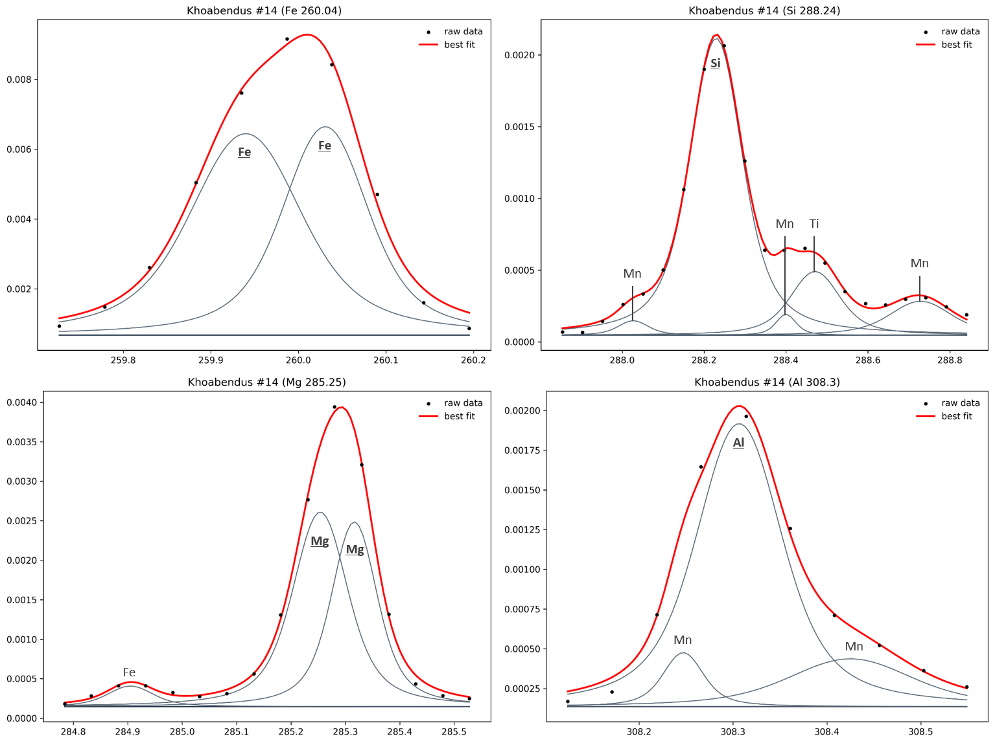
Figure S1: Fitted profiles for Fe, Si, Mg and Al peaks selected in the UV part of the spectrum. Black dots represents ChemCam LIBS data points. Individual elemental peaks (in grey) that compose the fit are each identified by the corresponding element name; peaks underlined are taken into account for the calculation of the intensity area. Each peak is fitted using Voigt profiles, with some degree of liberty given to the position of the peak (0.25nm) and to the full width at half maximum (FWHM; 0.1 - 0.5nm) based on the resolution of the ChemCam instrument in the UV (0.2nm FWHM, Wiens et al. 2012).
ChemCam target point | Sol | Observation | Fe-rich | Mg-rich | Al-rich | Elevation
Richardson_2 #2 | 130 | Vein - Light-toned |  | X |  | -4521.33
Rapitan #9 | 135 | Vein - Light-toned |  | X |  | -4520.83
Measles_Point #9 | 306 | Vein - Light-toned |  | X |  | -4518.22
Denault #4 | 317 | Vein - Light-toned | X | X |  | -4518.39
San_Sou #1 | 627 | Vein - Light-toned |  | X |  | -4478.04
Manly #2 | 719 | Vein - Light-toned | X |  |  | -4457.34
Deep_Spring #9 | 728 | Vein - Light-toned | X |  |  | -4457.44
San_Timoteo #1 | 925 | Vein - Light-toned | X |  |  | -4450.98
Indianola #2 | 938 | Vein - Light-toned |  | X |  | -4450.51
Thermopolis #1 | 1155 | Vein - Light-toned |  | X |  | -4434.54
Tsumeb #9 | 1162 | Vein - Light-toned | X |  |  | -4433.76
Tsumeb #10 | 1162 | Vein - Light-toned | X |  |  | -4433.76
Zaris #9 | 1166 | Vein - Light-toned | X |  |  | -4432.34
Etosha #2 | 1168 | Vein - Light-toned | X |  |  | -4429.39
Dordabis #3 | 1169 | Vein - Light-toned | X |  |  | -4427.46
Rehoboth #1 | 1187 | Vein - Light-toned | X |  |  | -4422.42
Grillental #10 | 1194 | Vein - Light-toned | X |  |  | -4421.69
Auob #10 | 1201 | Vein - Light-toned | X |  |  | -4419.98
Ugab #2 | 1266 | Vein - Light-toned | X |  |  | -4430.22
Rooibank #3 | 1266 | Vein - Light-toned | X |  |  | -4432.28
Rooibank #4 | 1266 | Vein - Light-toned | X |  |  | -4432.28
Rooibank #5 | 1266 | Vein - Light-toned | X |  |  | -4432.28
Rooibank_60A #2 | 1266 | Vein - Light-toned |  | X |  | -4432.28
Rooibank_60A #3 | 1266 | Vein - Light-toned | X | X |  | -4432.28
Rooibank_60A #5 | 1266 | Vein - Light-toned | X |  |  | -4432.28
Rubikon_ccam #7 | 1326 | Vein - Light-toned |  | X |  | -4429.15
Omulonga #1 | 1366 | Vein - Light-toned | X |  |  | -4435.77
Khoabendus #5 | 1381 | Vein - Light-toned | X |  |  | -4428.11
Khoabendus #6 | 1381 | Vein - Light-toned | X |  |  | -4428.11
Khoabendus #14 | 1381 | Dark-toned Feature | X | X | X | -4428.11
Khoabendus #15 | 1381 | Vein - Light-toned | X |  |  | -4428.11
Khoabendus #16 | 1381 | Vein - Light-toned | X |  |  | -4428.11
Khoabendus #17 | 1381 | Vein - Light-toned | X |  |  | -4428.11
Khoabendus #18 | 1381 | Vein - Light-toned | X |  | X | -4428.11
Luanda #3 | 1398 | Vein - Light-toned | X | X |  | -4421.65
Soyo #3 | 1434 | Vein - Light-toned | X | X |  | -4401.30
Calonda #10 | 1445 | Vein - Light-toned | X | X |  | -4393.50
Malembo #1 | 1469 | Vein - Light-toned | X | X | X | -4375.56
Malembo #2 | 1469 | Vein - Light-toned |  | X |  | -4375.56
Malembo #3 | 1469 | Vein - Light-toned | X | X | X | -4375.56
Hadley_Point #4 | 1518 | Dark-toned Feature | X |  |  | -4340.52
Hunters_Beach_3 #5 | 1542 | Dark-toned Feature | X |  |  | -4335.28
Blue_Hill #4 | 1545 | Vein - Light-toned | X |  |  | -4335.37
Blue_Hill #6 | 1545 | Dark-toned Feature | X | X |  | -4335.37
Blue_Hill #7 | 1545 | Vein - Light-toned | X | X |  | -4335.37
Blue_Hill #8 | 1545 | Dark-toned Feature | X | X |  | -4335.37
Western_Head #3 | 1546 | Dark-toned Feature | X | X |  | -4335.58
Western_Head #9 | 1546 | Dark-toned Feature | X |  |  | -4335.58
Blue_Hill_2 #3 | 1548 | Vein - Light-toned | X | X |  | -4335.36
Blue_Hill_3 #6 | 1548 | Dark-toned Feature | X | X |  | -4335.36
Blue_Hill_3 #7 | 1548 | Dark-toned Feature | X | X |  | -4335.36
Bear_Brook #5 | 1550 | Dark-toned Feature | X | X |  | -4335.31
Bear_Brook #6 | 1550 | Dark-toned Feature | X | X |  | -4335.31
Canon_Brook #3 | 1550 | Dark-toned Feature | X | X |  | -4335.39
Mars_Hill #8 | 1580 | Dark-toned Feature |  |  |  | -4324.84
Benner_Hill_2 #4 | 1583 | Dark-toned Feature |  |  |  | -4321.32
Patch_Mountain #1 | 1611 | Dark-toned Feature | X | X |  | -4311.78
Patch_Mountain #2 | 1611 | Dark-toned Feature | X | X |  | -4311.78
Peaks_Island #2 | 1664 | Vein - Light-toned |  | X |  | -4298.66
Yellow_Island #5 | 1666 | Vein - Light-toned | X |  |  | -4298.57
Table S1: ChemCam analyses on dark-toned features and light-toned veins showing Fe, Mg or Al enrichments compared to host rock values.

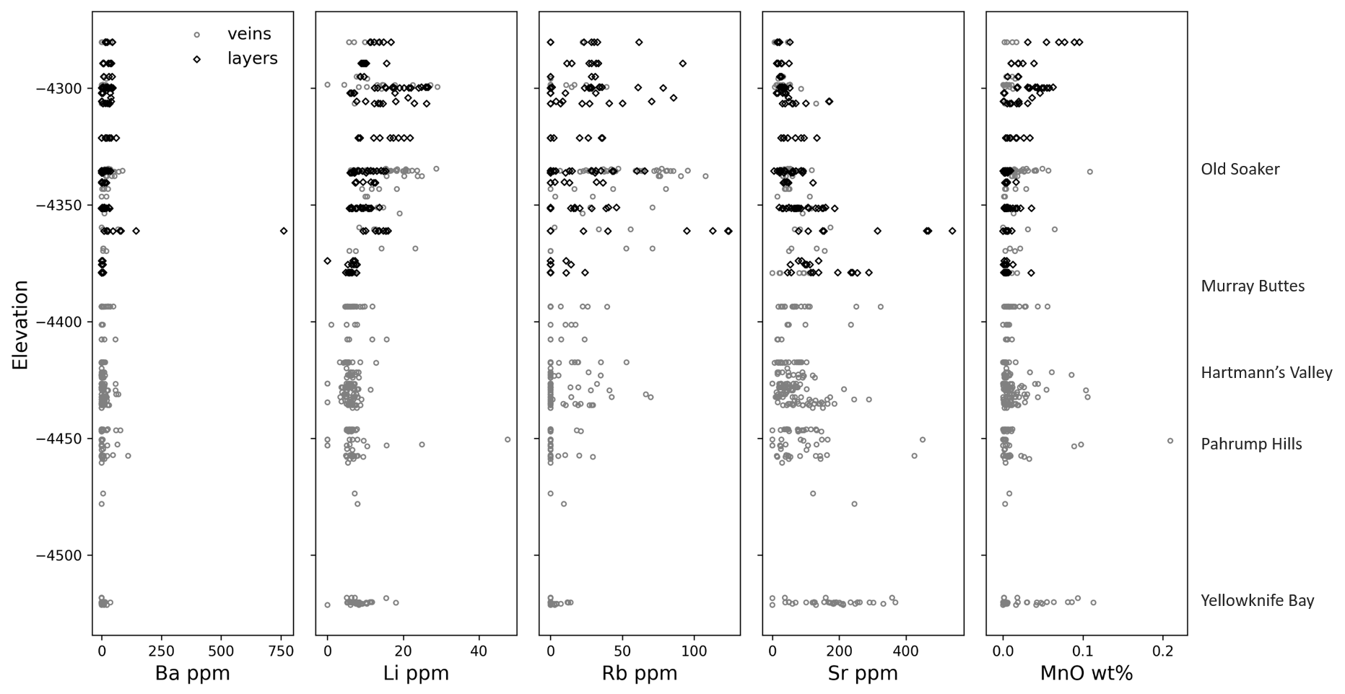
Figure S2: Distribution of minor elements in light-toned veins and layers in the stratigraphy (indicated by localities at given elevations). Sub-horizontal Ca-sulfate layers do not show noticeable variations in minor element abundances compared to Ca-sulfate veins.
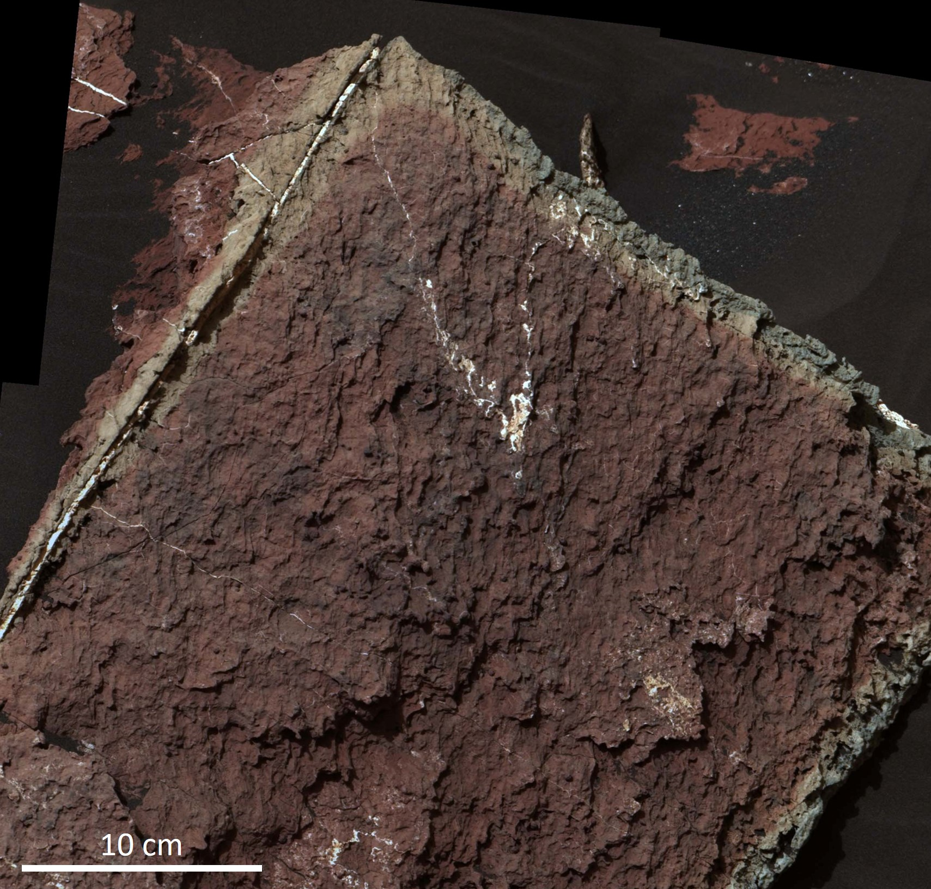
Figure S3: Mastcam mosaic of the Third Lake outcrop, observed on sol 1612 (Mastcam images: 1612MR0082450010801054E02, 1612MR0082450020801055E01, 1612MR0082450030801056E01 and 1612MR0082450040801057E01).

