Supporting information
Urine microbial fuel cells in a semi-controlled environment for onsite urine pre-treatment and electricity production

Clement A. Cid¹, Andrew Stinchcombe², Ioannis Ieropoulos², and Michael R. Hoffmann¹

¹Linde-Robinson Laboratories, California Institute of Technology, Pasadena, CA
²Bristol BioEnergy Centre, Bristol Robotics Laboratory, University of the West of England, BS16 1QY, UK

Number of pages: 4 (including the cover page)
Number of figures: 2
Number of tables: 0
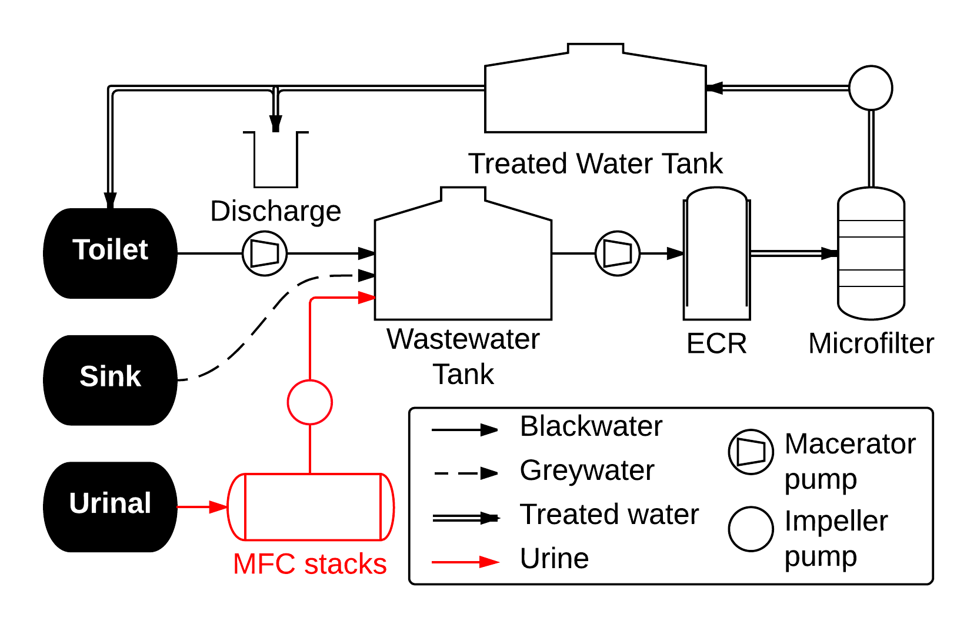

Figure S1: Integration of the MFC stacks within the treatment scheme of the self-contained wastewater treatment and recycling system developed by Hoffmann et al. [1].

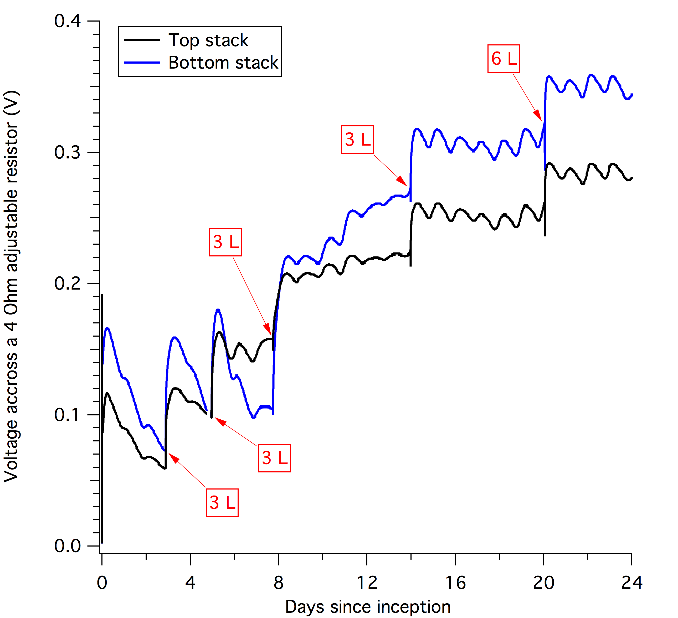

Figure S2: Potential measured across a 4 Ω resistor for each independent stack. The red arrows indicate a feeding event: each stack was slowly drained of the anolyte volume written and replaced by the same quantity of fresh urine.

Genomic DNA extraction protocol (based on Mo Bio and modified by the Orphan research group at the California Institute of Technology):
Anode felts were cut in pieces of 0.5 cm by 1 cm. Each felt was placed in a 15-mL conical centrifuge tube with 10 mL of a 70% ethanol solution in an ice bath. The mixture was sonicated for three sessions of 10 s each at 5 W power with 30 s break between sessions. After sonication, the felt was discarded and the remaining mixture was quickly filtered using a disposable filter funnel system with 0.45 µm filter membrane. Anolyte samples were directly filtered on a similar disposable filter funnel.
After filtration, the filter membrane was carefully inserted in the 5-mL Mo Bio PowerWater® Bead Tube with the top (cell) side of the membrane facing inwards. After adding 1 mL of Mo Bio PowerWater® PW 1 solution at 65 ºC, the tube was briefly vortexed and incubated at 65 ºC for 10 min in a heat block. At the end of the incubation period, the tube was attached vertically using Mo Bio Vortex Adapter and vortexed at maximum speed for 5 min. The tube and its content were then centrifuged at 4,000•g force for 1 min so all the supernatant could be transferred to an autoclaved 2-mL centrifuge tube and centrifuged at 13,000•g force for 1 min. The rest of the protocol was identical to steps 11 through 24 of the Experienced User Protocol published by Mo Bio [2].
16S rRNA gene sequencing and processing from Case et al. [3]:
Preparation for sequencing of the V4 region of the 16S rRNA gene was performed with universal primers according to the protocol recommended by the Earth Microbiome Project (http://www.earthmicrobiome.org/emp-standard-protocols/16s/) [4, 5], with minor modifications described elsewhere [6]. Raw sequences were generated on an Illumina MiSeq platform at Laragen, Inc. (Los Angeles, CA). In-house data processing was completed in QIIME1.8.0 and included joining paired ends, quality trimming, chimera checking, 97% OTU clustering, singleton removal, PCR contaminant removal, 0.01% relative abundance threshold removal, and rarefaction to 16,051 sequences per sample. Taxonomic assignments were generated according to an appended version of the Silva 115 database (for details, see [6]).

References:

1. Hoffmann, M.R., et al., Self-contained, pv-powered domestic toilet and wastewater treatment system. 2013, Google Patents.
2. Mo Bio. PowerWater® DNA Isolation Kit Sample. 2015; Available from: https://mobio.com/media/wysiwyg/pdfs/protocols/14900-S.pdf.
3. Case, D.H., et al., Methane seep carbonates host distinct, diverse, and dynamic microbial assemblages. MBio, 2015. 6(6): p. e01348-15.
4. Caporaso, J.G., et al., Ultra-high-throughput microbial community analysis on the Illumina HiSeq and MiSeq platforms. The ISME journal, 2012. 6(8): p. 1621-1624.
5. Caporaso, J.G., et al., Global patterns of 16S rRNA diversity at a depth of millions of sequences per sample. Proceedings of the National Academy of Sciences, 2011. 108(Supplement 1): p. 4516-4522.
6. Mason, O.U., et al., Comparison of archaeal and bacterial diversity in methane seep carbonate nodules and host sediments, Eel River Basin and Hydrate Ridge, USA. Microbial ecology, 2015. 70(3): p. 766-784.

