Supplementary Materials For

Pushing the Limit of Earthquake Detection with Distributed Acoustic Sensing and Template Matching: A Case Study at the Brady Geothermal Field

Zefeng Li* and Zhongwen Zhan
Seismological Laboratory, California Institute of Technology, Pasadena, CA, USA
*Corresponding author (zefengli@gps.caltech.edu)

Content
Figures S1-S4: DAS waveforms for four cataloged earthquakes.
Figure S5: Cross correlations of representative examples at different levels of visibility.
Figure S6: Comparison in the timings of the detected events and the vibroseis signals.
Table S1: Earthquake catalog in the Brady Geothermal Field by template matching.

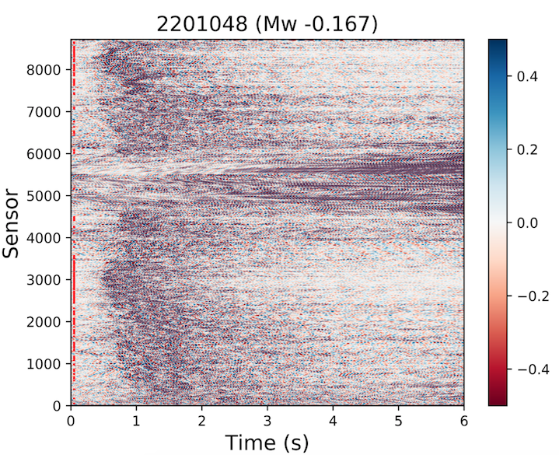
Figure S1: DAS waveforms of an M~ -0.167 catalog earthquake (event ID: 2201048). The red dots on the left indicate the sensors that are included in template matching (SNR>10). Each trace on individual sensors is normalized by the maximum of that trace.

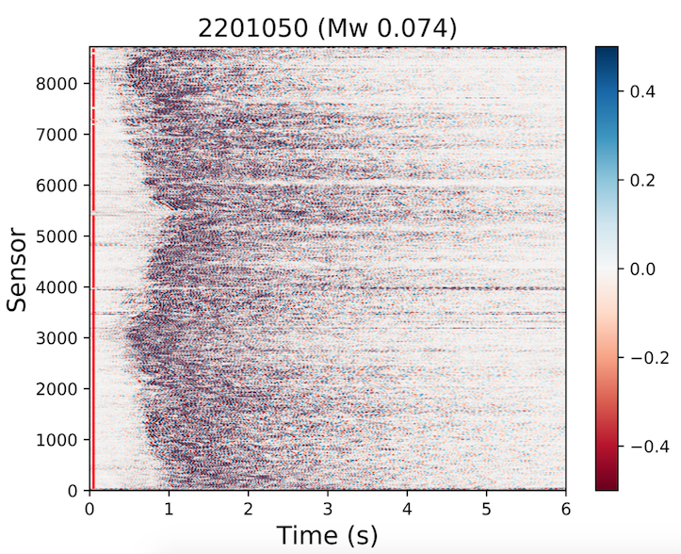
Figure S2: DAS waveforms of an M~ -0.074 catalog earthquake (event ID: 2201050). The red dots on the left indicate the sensors that are included in template matching (SNR>10). Each trace on individual sensors is normalized by the maximum of that trace.

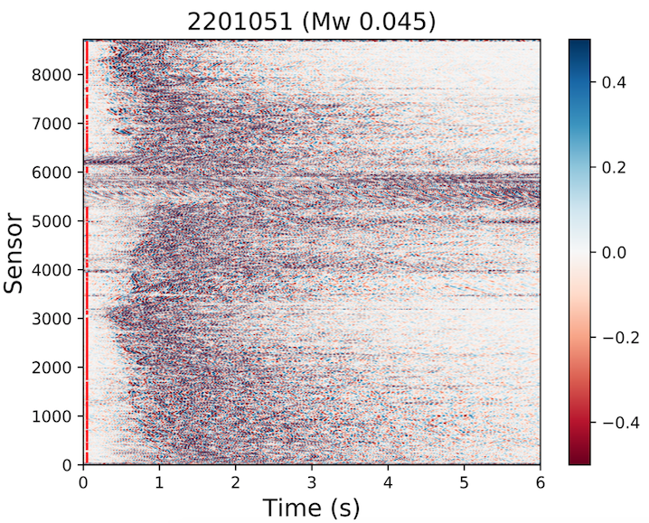
Figure S3: DAS waveforms of an M~ -0.045 catalog earthquake (event ID: 2201051). The red dots on the left indicate the sensors that are included in template matching (SNR>10). Each trace on individual sensors is normalized by the maximum of that trace.

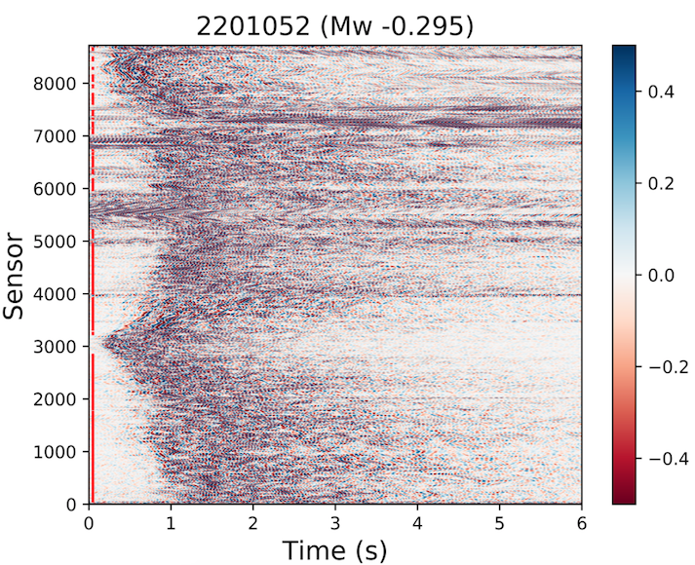
Figure S4: DAS waveforms of an M~ -0.295 catalog earthquake (event ID: 2201052). The red dots on the left indicate the sensors that are included in template matching (SNR>10). Each trace on individual sensors is normalized by the maximum of that trace.
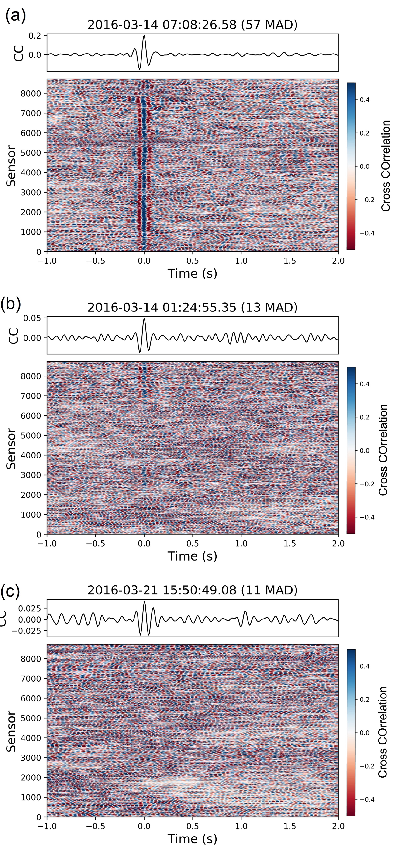
Figure S5. Cross correlations of representative examples at different levels of visibility. From top to bottom are: (a) visible on most of the sensors; (b) visible on part of the sensors; (c) invisible on almost all the sensors. The black curve in the upper panel is the stacked cross-correlation. The black vertical dashed line marks the event origin time. Note that the cross correlations are shifted using predicted travel time of the template location.

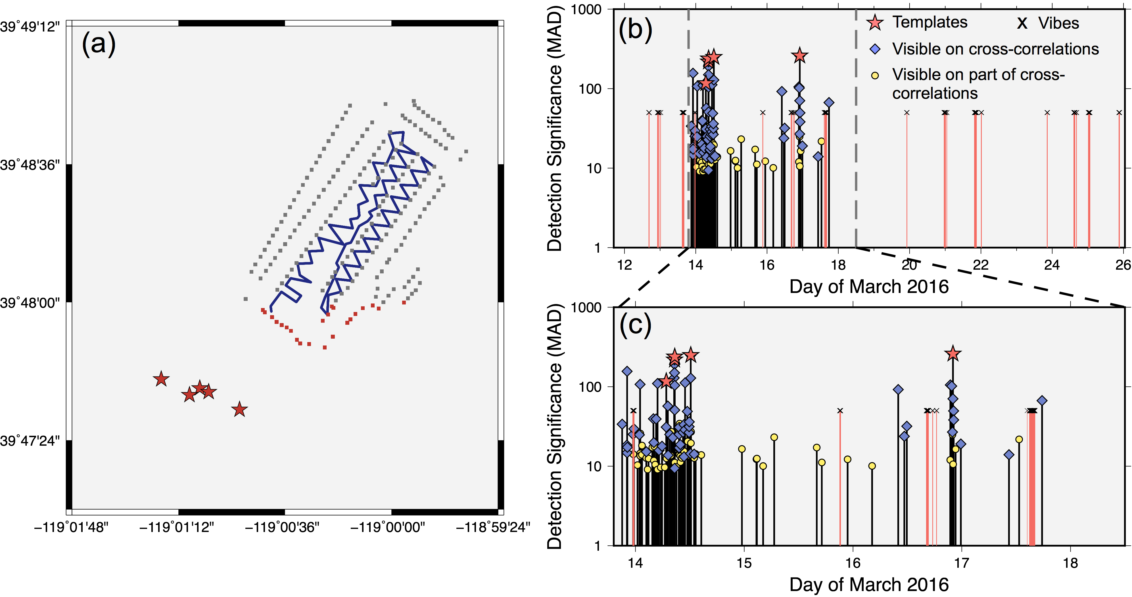
Figure S6. (a) Map of template earthquakes (red stars), Distributed Acoustic Sensing (DAS) array (blue line), and the active vibrator locations (squares) in the Brady Hot Springs Geothermal Field. The red squares mark the vibrator locations located to the southwest of the DAS array, whose timings are shown in (b) and (c). (b) Earthquake sequence detected by template matching and comparison with the timings of vibroseis experiments to the southwest. Note that there is no significant temporal correlation between the detected earthquakes and the vibroseis experiments. (c) Zoom-in plot of (b) during the shutdown period.
Table S1: Template Matching Earthquake Catalog in Brady Geothermal Field

Year | Mon | Day | Time | Times of MAD | Peak CC | Parent Template | Visibility  on WF* | Visibility  on CC*
2016 | 3 | 13 | 21:03:27.23 | 33.8 | 0.1 | 2201050 | 1 | 2
2016 | 3 | 13 | 22:06:13.86 | 18.43 | 0.06 | 2201050 | 0 | 2
2016 | 3 | 13 | 22:08:59.79 | 14.74 | 0.05 | 2201050 | 0 | 2
2016 | 3 | 13 | 22:09:08.25 | 156.23 | 0.51 | 2201050 | 2 | 2
2016 | 3 | 13 | 22:12:41.92 | 17.3 | 0.06 | 2201050 | 1 | 2
2016 | 3 | 13 | 23:28:41.92 | 25.17 | 0.09 | 2201050 | 0 | 2
2016 | 3 | 13 | 23:31:36.48 | 14.16 | 0.05 | 2201050 | 0 | 1
2016 | 3 | 13 | 23:38:41.17 | 29.49 | 0.12 | 2201052 | 0 | 2
2016 | 3 | 14 | 00:26:36.78 | 10.32 | 0.03 | 2201050 | 0 | 1
2016 | 3 | 14 | 00:51:45.28 | 24.79 | 0.07 | 2201050 | 0 | 2
2016 | 3 | 14 | 01:00:54.95 | 107 | 0.31 | 2201050 | 2 | 2
2016 | 3 | 14 | 01:01:19.34 | 14.47 | 0.04 | 2201050 | 0 | 1
2016 | 3 | 14 | 01:02:47.54 | 13.5 | 0.06 | 2201049 | 0 | 1
2016 | 3 | 14 | 01:03:17.99 | 25.8 | 0.12 | 2201049 | 0 | 1
2016 | 3 | 14 | 01:24:55.35 | 13.91 | 0.05 | 2201051 | 0 | 1
2016 | 3 | 14 | 01:26:16.27 | 18.19 | 0.05 | 2201050 | 0 | 1
2016 | 3 | 14 | 02:22:50.98 | 12.67 | 0.04 | 2201050 | 0 | 1
2016 | 3 | 14 | 02:23:39.52 | 15.2 | 0.05 | 2201050 | 0 | 2
2016 | 3 | 14 | 02:40:12.88 | 9.09 | 0.05 | 2201049 | 1 | 1
2016 | 3 | 14 | 02:52:18.68 | 12.49 | 0.05 | 2201052 | 1 | 1
2016 | 3 | 14 | 03:42:22.69 | 17.2 | 0.06 | 2201050 | 0 | 1
2016 | 3 | 14 | 03:57:31.93 | 39.46 | 0.14 | 2201050 | 2 | 2
2016 | 3 | 14 | 04:02:50.45 | 11.76 | 0.05 | 2201051 | 0 | 1
2016 | 3 | 14 | 04:03:00.72 | 19.82 | 0.07 | 2201050 | 2 | 2
2016 | 3 | 14 | 04:11:02.19 | 17.74 | 0.07 | 2201051 | 1 | 1
2016 | 3 | 14 | 04:20:33.44 | 10.47 | 0.04 | 2201051 | 0 | 1
2016 | 3 | 14 | 04:32:52.88 | 39.25 | 0.16 | 2201052 | 1 | 2
2016 | 3 | 14 | 04:51:42.17 | 109.73 | 0.37 | 2201050 | 2 | 2
2016 | 3 | 14 | 04:51:46.56 | 9.08 | 0.03 | 2201050 | 0 | 1
2016 | 3 | 14 | 05:12:05.02 | 15.79 | 0.06 | 2201050 | 0 | 2
2016 | 3 | 14 | 05:34:22.68 | 9.65 | 0.04 | 2201052 | 0 | 1
2016 | 3 | 14 | 05:51:18.85 | 17.82 | 0.07 | 2201050 | 1 | 2
2016 | 3 | 14 | 06:27:11.67 | 9.67 | 0.04 | 2201050 | 0 | 1
2016 | 3 | 14 | 06:46:13.76 | 31.07 | 0.12 | 2201050 | 1 | 2
2016 | 3 | 14 | 06:47:46.45 | 116.59 | 0.46 | 2201050 | 2 | 2
2016 | 3 | 14 | 06:50:43.16 | 12.57 | 0.05 | 2201050 | 0 | 1
2016 | 3 | 14 | 06:52:39.64 | 9.95 | 0.04 | 2201050 | 0 | 0
2016 | 3 | 14 | 07:08:26.58 | 57.1 | 0.2 | 2201050 | 2 | 2
2016 | 3 | 14 | 07:12:33.03 | 13.77 | 0.06 | 2201051 | 0 | 2
2016 | 3 | 14 | 07:33:29.82 | 25.07 | 0.11 | 2201051 | 0 | 2
2016 | 3 | 14 | 07:48:07.03 | 13.6 | 0.06 | 2201051 | 0 | 1
2016 | 3 | 14 | 07:56:28.98 | 27.09 | 0.1 | 2201052 | 1 | 1
2016 | 3 | 14 | 08:07:00.45 | 10.24 | 0.04 | 2201052 | 0 | 0
2016 | 3 | 14 | 08:13:41.19 | 22.78 | 0.08 | 2201052 | 2 | 2
2016 | 3 | 14 | 08:32:04.29 | 129 | 0.54 | 2201050 | 2 | 2
2016 | 3 | 14 | 08:36:16.07 | 191.26 | 0.8 | 2201050 | 2 | 2
2016 | 3 | 14 | 08:36:26.66 | 149.64 | 0.63 | 2201050 | 2 | 2
2016 | 3 | 14 | 08:37:10.54 | 218.29 | 0.92 | 2201050 | 2 | 2
2016 | 3 | 14 | 08:37:25.94 | 9.4 | 0.07 | 2201049 | 0 | 2
2016 | 3 | 14 | 08:39:05.24 | 238.69 | 1 | 2201050 | 2 | 2
2016 | 3 | 14 | 08:39:10.43 | 11.1 | 0.05 | 2201050 | 0 | 1
2016 | 3 | 14 | 08:39:14.47 | 50.89 | 0.21 | 2201050 | 1 | 2
2016 | 3 | 14 | 08:39:35.50 | 104.02 | 0.44 | 2201050 | 2 | 2
2016 | 3 | 14 | 09:03:11.10 | 9.81 | 0.04 | 2201051 | 0 | 1
2016 | 3 | 14 | 09:32:48.30 | 14.21 | 0.05 | 2201050 | 0 | 1
2016 | 3 | 14 | 09:34:04.70 | 16.75 | 0.07 | 2201051 | 2 | 2
2016 | 3 | 14 | 09:37:03.65 | 17.05 | 0.06 | 2201050 | 0 | 2
2016 | 3 | 14 | 09:37:32.46 | 25.17 | 0.08 | 2201050 | 0 | 2
2016 | 3 | 14 | 09:37:35.94 | 27.25 | 0.11 | 2201051 | 0 | 1
2016 | 3 | 14 | 09:37:39.27 | 30.88 | 0.12 | 2201051 | 0 | 2
2016 | 3 | 14 | 09:39:49.86 | 13.95 | 0.04 | 2201050 | 0 | 1
2016 | 3 | 14 | 09:43:49.74 | 34.37 | 0.14 | 2201051 | 0 | 1
2016 | 3 | 14 | 09:52:31.42 | 13.37 | 0.05 | 2201051 | 0 | 1
2016 | 3 | 14 | 09:53:53.64 | 18.71 | 0.06 | 2201050 | 0 | 2
2016 | 3 | 14 | 09:55:29.29 | 11.28 | 0.04 | 2201051 | 0 | 1
2016 | 3 | 14 | 10:13:28.23 | 12.72 | 0.04 | 2201050 | 0 | 1
2016 | 3 | 14 | 10:29:26.53 | 26.73 | 0.09 | 2201052 | 2 | 2
2016 | 3 | 14 | 10:42:07.20 | 33.28 | 0.11 | 2201050 | 2 | 2
2016 | 3 | 14 | 10:42:13.77 | 13.18 | 0.04 | 2201050 | 2 | 2
2016 | 3 | 14 | 10:43:30.04 | 15.4 | 0.05 | 2201050 | 1 | 1
2016 | 3 | 14 | 10:55:47.68 | 28.63 | 0.09 | 2201050 | 1 | 2
2016 | 3 | 14 | 10:56:20.77 | 111.87 | 0.39 | 2201052 | 2 | 2
2016 | 3 | 14 | 11:25:57.75 | 48.88 | 0.27 | 2201048 | 1 | 2
2016 | 3 | 14 | 11:31:51.93 | 20.47 | 0.06 | 2201050 | 0 | 1
2016 | 3 | 14 | 11:34:53.62 | 13.6 | 0.07 | 2201048 | 0 | 1
2016 | 3 | 14 | 11:49:24.07 | 26.54 | 0.1 | 2201051 | 0 | 2
2016 | 3 | 14 | 11:50:42.14 | 31.45 | 0.1 | 2201050 | 1 | 2
2016 | 3 | 14 | 11:52:25.36 | 36.17 | 0.13 | 2201052 | 1 | 2
2016 | 3 | 14 | 12:07:50.75 | 14.42 | 0.05 | 2201050 | 0 | 2
2016 | 3 | 14 | 12:11:09.73 | 128.38 | 0.52 | 2201051 | 2 | 2
2016 | 3 | 14 | 12:11:34.92 | 249.23 | 1 | 2201051 | 2 | 2
2016 | 3 | 14 | 12:13:59.30 | 19.52 | 0.08 | 2201051 | 0 | 1
2016 | 3 | 14 | 12:15:15.11 | 27.07 | 0.09 | 2201050 | 0 | 1
2016 | 3 | 14 | 12:57:07.83 | 14.2 | 0.05 | 2201050 | 0 | 2
2016 | 3 | 14 | 12:57:11.43 | 12.67 | 0.08 | 2201048 | 0 | 1
2016 | 3 | 14 | 13:16:36.21 | 14.25 | 0.06 | 2201051 | 1 | 1
2016 | 3 | 14 | 14:31:10.79 | 13.82 | 0.06 | 2201051 | 0 | 1
2016 | 3 | 14 | 23:28:59.73 | 16.48 | 0.06 | 2201051 | 1 | 1
2016 | 3 | 15 | 02:41:38.17 | 12.25 | 0.04 | 2201051 | 0 | 1
2016 | 3 | 15 | 02:47:12.87 | 12.47 | 0.04 | 2201051 | 0 | 1
2016 | 3 | 15 | 04:09:48.68 | 10.05 | 0.03 | 2201050 | 0 | 1
2016 | 3 | 15 | 06:36:30.04 | 23.16 | 0.08 | 2201051 | 0 | 1
2016 | 3 | 15 | 15:59:52.25 | 17.18 | 0.06 | 2201051 | 0 | 1
2016 | 3 | 15 | 17:06:43.72 | 11.15 | 0.03 | 2201050 | 0 | 1
2016 | 3 | 15 | 22:48:12.07 | 12.21 | 0.04 | 2201051 | 0 | 1
2016 | 3 | 16 | 04:12:52.59 | 10.09 | 0.04 | 2201051 | 0 | 1
2016 | 3 | 16 | 09:58:31.75 | 92.14 | 0.29 | 2201052 | 1 | 2
2016 | 3 | 16 | 11:18:54.13 | 23.76 | 0.08 | 2201052 | 0 | 2
2016 | 3 | 16 | 11:52:05.56 | 31.79 | 0.09 | 2201050 | 2 | 2
2016 | 3 | 16 | 21:27:32.66 | 11.99 | 0.05 | 2201052 | 0 | 1
2016 | 3 | 16 | 21:28:20.39 | 105.19 | 0.43 | 2201052 | 2 | 2
2016 | 3 | 16 | 21:46:20.25 | 101.8 | 0.41 | 2201052 | 2 | 2
2016 | 3 | 16 | 21:56:19.38 | 26.91 | 0.11 | 2201052 | 0 | 2
2016 | 3 | 16 | 21:56:40.60 | 24.96 | 0.1 | 2201052 | 0 | 1
2016 | 3 | 16 | 22:03:03.44 | 70.44 | 0.27 | 2201052 | 2 | 2
2016 | 3 | 16 | 22:03:10.25 | 259.75 | 1 | 2201052 | 2 | 2
2016 | 3 | 16 | 22:05:43.89 | 10.58 | 0.04 | 2201052 | 0 | 1
2016 | 3 | 16 | 22:11:54.95 | 49.6 | 0.19 | 2201052 | 1 | 2
2016 | 3 | 16 | 22:12:23.81 | 38.22 | 0.15 | 2201052 | 1 | 2
2016 | 3 | 16 | 22:38:15.47 | 16.39 | 0.06 | 2201052 | 0 | 1
2016 | 3 | 16 | 23:47:47.26 | 19.01 | 0.07 | 2201051 | 0 | 2
2016 | 3 | 17 | 10:25:09.60 | 13.95 | 0.04 | 2201050 | 0 | 2
2016 | 3 | 17 | 12:39:31.48 | 21.75 | 0.09 | 2201051 | 1 | 1
2016 | 3 | 17 | 15:39:47.84 | 9.06 | 0.04 | 2201052 | 0 | 0
2016 | 3 | 17 | 17:42:59.30 | 66.8 | 0.2 | 2201050 | 2 | 2
2016 | 3 | 21 | 15:50:49.08 | 11.5 | 0.04 | 2201052 | 0 | 0

* 0: Invisible on most of the sensors
1: Visible on part of the sensors
2: Visible on most of the sensors

