Geophysical Research Letters
Supporting Information for
Constraining the Dip of Shallow, Shallowly-Dipping Thrust Events Using Long-Period Love Wave Radiation Patterns: Applications to the 25 October 2010 Mentawai, Indonesia and 4 May 2018 Hawaii Island Earthquakes
Thorne Lay¹, Lingling Ye^{2,3}, Hiroo Kanamori⁴, and Kenji Satake³
¹Department of Earth and Planetary Sciences, University of California Santa Cruz, Santa Cruz, CA, USA.
²Guangdong Provincial Key Lab of Geodynamics and Geohazards, School of Earth Sciences and Engineering, Sun Yat-sen University, Guangzhou, China.
³Earthquake Research Institute, University of Tokyo, Tokyo, Japan.
⁴Seismological Laboratory, California Institute of Technology, Pasadena, CA, USA.

Contents of this file

Figures S1 to S2

Introduction
Supplementary figures that demonstrate the sensitivity of the long-period Love wave radiation patterns to centroid depth (Figure S1) and rake (Figure S2).

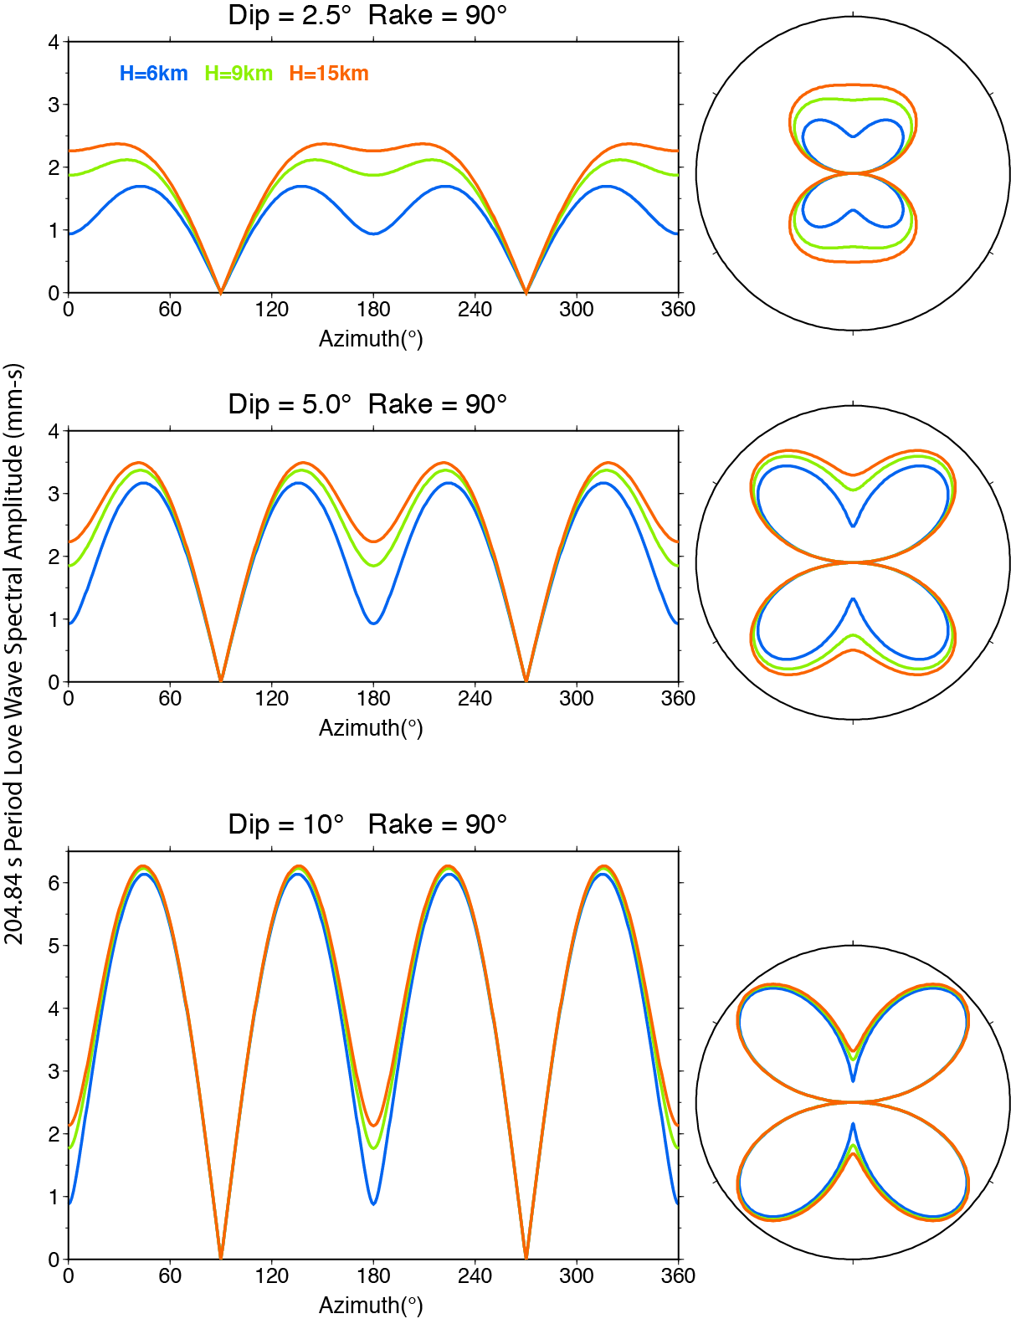

Figure S1. Love wave azimuthal radiation patterns for period, T = 204.84 s for point-source step-function double-couples at depths of 6, 9 and 15 km in the PREM structure with strike φ = 0°, rake λ = 90°, seismic moment M₀ = 1.0 x 10²⁰ Nm, and dip δ varying from 0° to 10°. Note that as depth increases, there is more pronounced variation in radiation pattern as a function of dip.
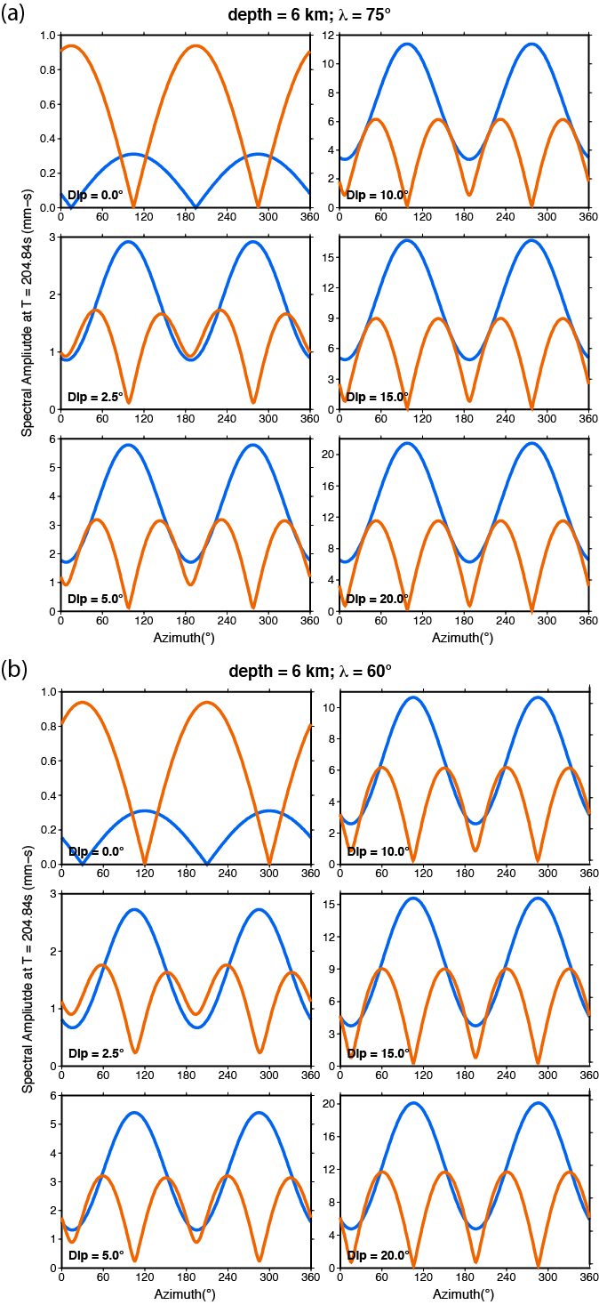

Figure S2. Rayleigh wave (blue) and Love wave (orange) azimuthal amplitude radiation patterns for period, T = 204.84 s for point-source step-function double-couples 6 km deep in the PREM structure, with strike φ = 0°, (a) rake λ = 75° or (b) rake λ = 60°, for seismic moment M₀ = 1.0 x 10²⁰ Nm, and dip δ varying from 0° to 20°. These can be compared with the patterns for λ = 90° shown in Figure 1. Note variation in vertical scales.

