Supplementary Information

S1. Naming Conventions
Prior to landing, the MSL science team split the Curiosity rover landing ellipse into quadrangles, with each quadrangle measuring 1.5 km on a side. Quadrangles were named after towns with populations of <100,000, and whose names corresponded to a geological formation or significant geological landmark on Earth. The Pahrump Hills outcrop in Gale crater is located in the Shoshone quadrangle, named for Shoshone Village in Inyo County, California located just outside Death Valley National Park and the Nopah Range Wilderness Area. Target names for rocks, soils, and outcrops analyzed by the Curiosity rover while it traversed through the Shoshone quadrangle were selected from a list of geological formations, outcrops, and landmarks located in southeastern California, Nevada, and Utah. The Pahrump Hills outcrop was named after the Pahrump Hills Shale Member of the Lower and Middle Cambrian Carrara Formation present in southern Nevada and southeastern California. At Pahrump Hills, the Curiosity rover was commanded to drive to specific areas within the outcrop, which were given names in keeping with the California, Nevada, and Utah naming scheme.

S2. Grain Size Measurements
Grain size measurements were made in MAHLI images using one of three different methods, depending on the abundance, distribution, and size of grains present in each image, respectively. For the MAHLI image of Devils Punchbowl target on the Kanosh boulder, grains were relative large (sand-sized) and easily resolvable, but not distributed uniformly throughout the image, likely due to variations in facet orientation and lighting conditions. As a result, grain shapes, where observed, were traced manually in ArcGIS which enabled calculation of long and short axes, grain aspect ratio, and grain orientation. Individual grain traces were fit to a rectangle by width using the ArcGIS minimum bounding geometry algorithm. The length (long axis) of the rectangular fit was used to estimate grain size. Grain shape was determined by the calculated aspect ratio applied to the classification scheme of Blatt et al. (1972) in which grains exhibiting aspect ratios less than 1.5:1 are equant or circular, those with aspects greater than 2.5:1 are elongate, and intermediate aspect ratios between 1.5:1 and 2.5:1 are subequant or subcircular. Grain rounding and sorting were estimated via a visual assessment of the two-dimensional grain traces after Powers (1953) and Harrell (1984), respectively.

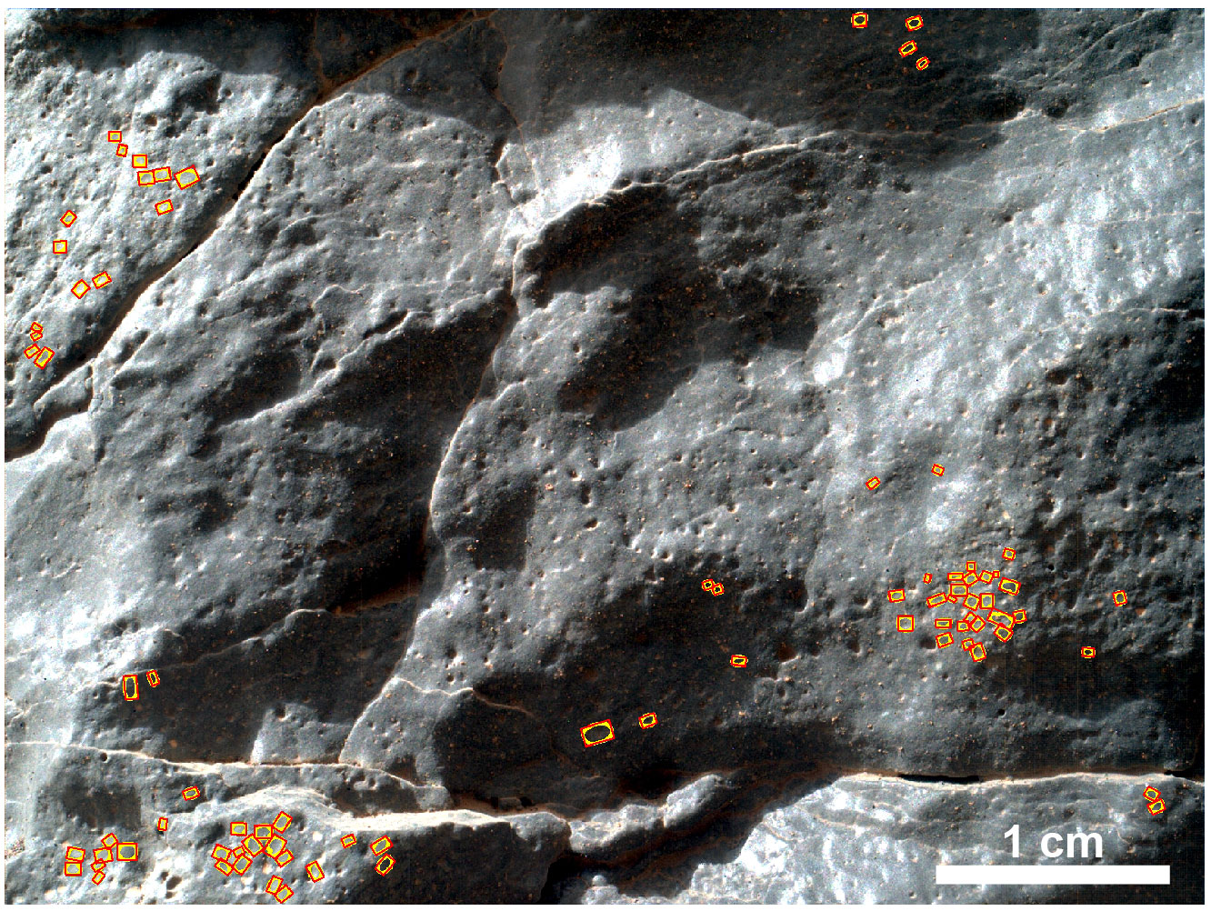
Fig. S2-1. Grain shape traces (yellow) from a MALHI z-stack image of the Salsberry Peak Kanosh cobble near Pahrump Hills (0942MH0001630000303662R00) fit with minimum bounding geometry (MBG) rectangles (red).

For the Sierra Nevada target of the Whale Rock area, grains were distributed throughout the observable rock exposed in the corresponding MAHLI image but were small enough to make individual grain shape traces difficult. To quantitatively assess both the grain size and the proportion of the rock that was composed of matrix versus grains, the Hilliard Single-Circle Procedure (Hilliard, 1964) was employed. In this method, the proportion of resolvable grains versus matrix composed of grains below the resolution of MAHLI was calculated via four 100 mm circumference circles that were positioned within the image field of view. Discernible grain boundaries were then marked along each circle and color-coded based on size as grain or matrix.

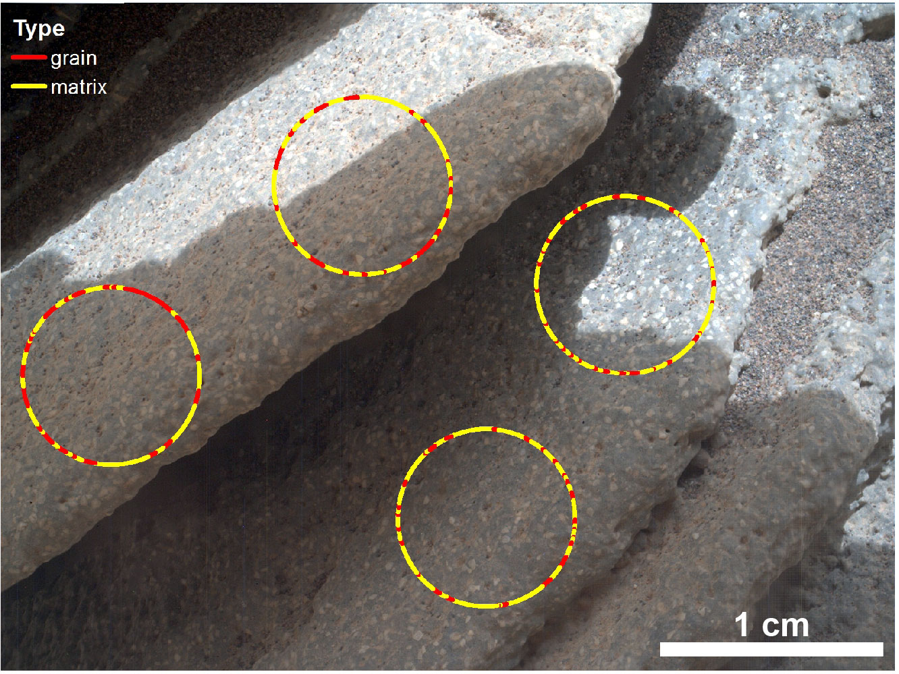
Figure S2-2. Relative proportions of grains (red portion of the circle) and matrix (yellow portion of the circle) measured in Sierra Nevada MAHLI z-stack (MH0004580000302120R00) via the circular intercept method.

For the Goldstone target of the Chinle area, as well as other several other targets of the thinly laminated mudstone, grains were sparse enough throughout the MAHLI images and sufficiently small (diameter ~2-10 pixels) that neither grain tracing nor the Hilliard Single-Circle procedure was usable for assessing grain size. For these images, long-axes diameters were measured for any resolvable grains present within the image.

S3. Lamination Thickness Measurements
The method employed in this study for making measurements of laminae thickness is described in greater detail in the text.
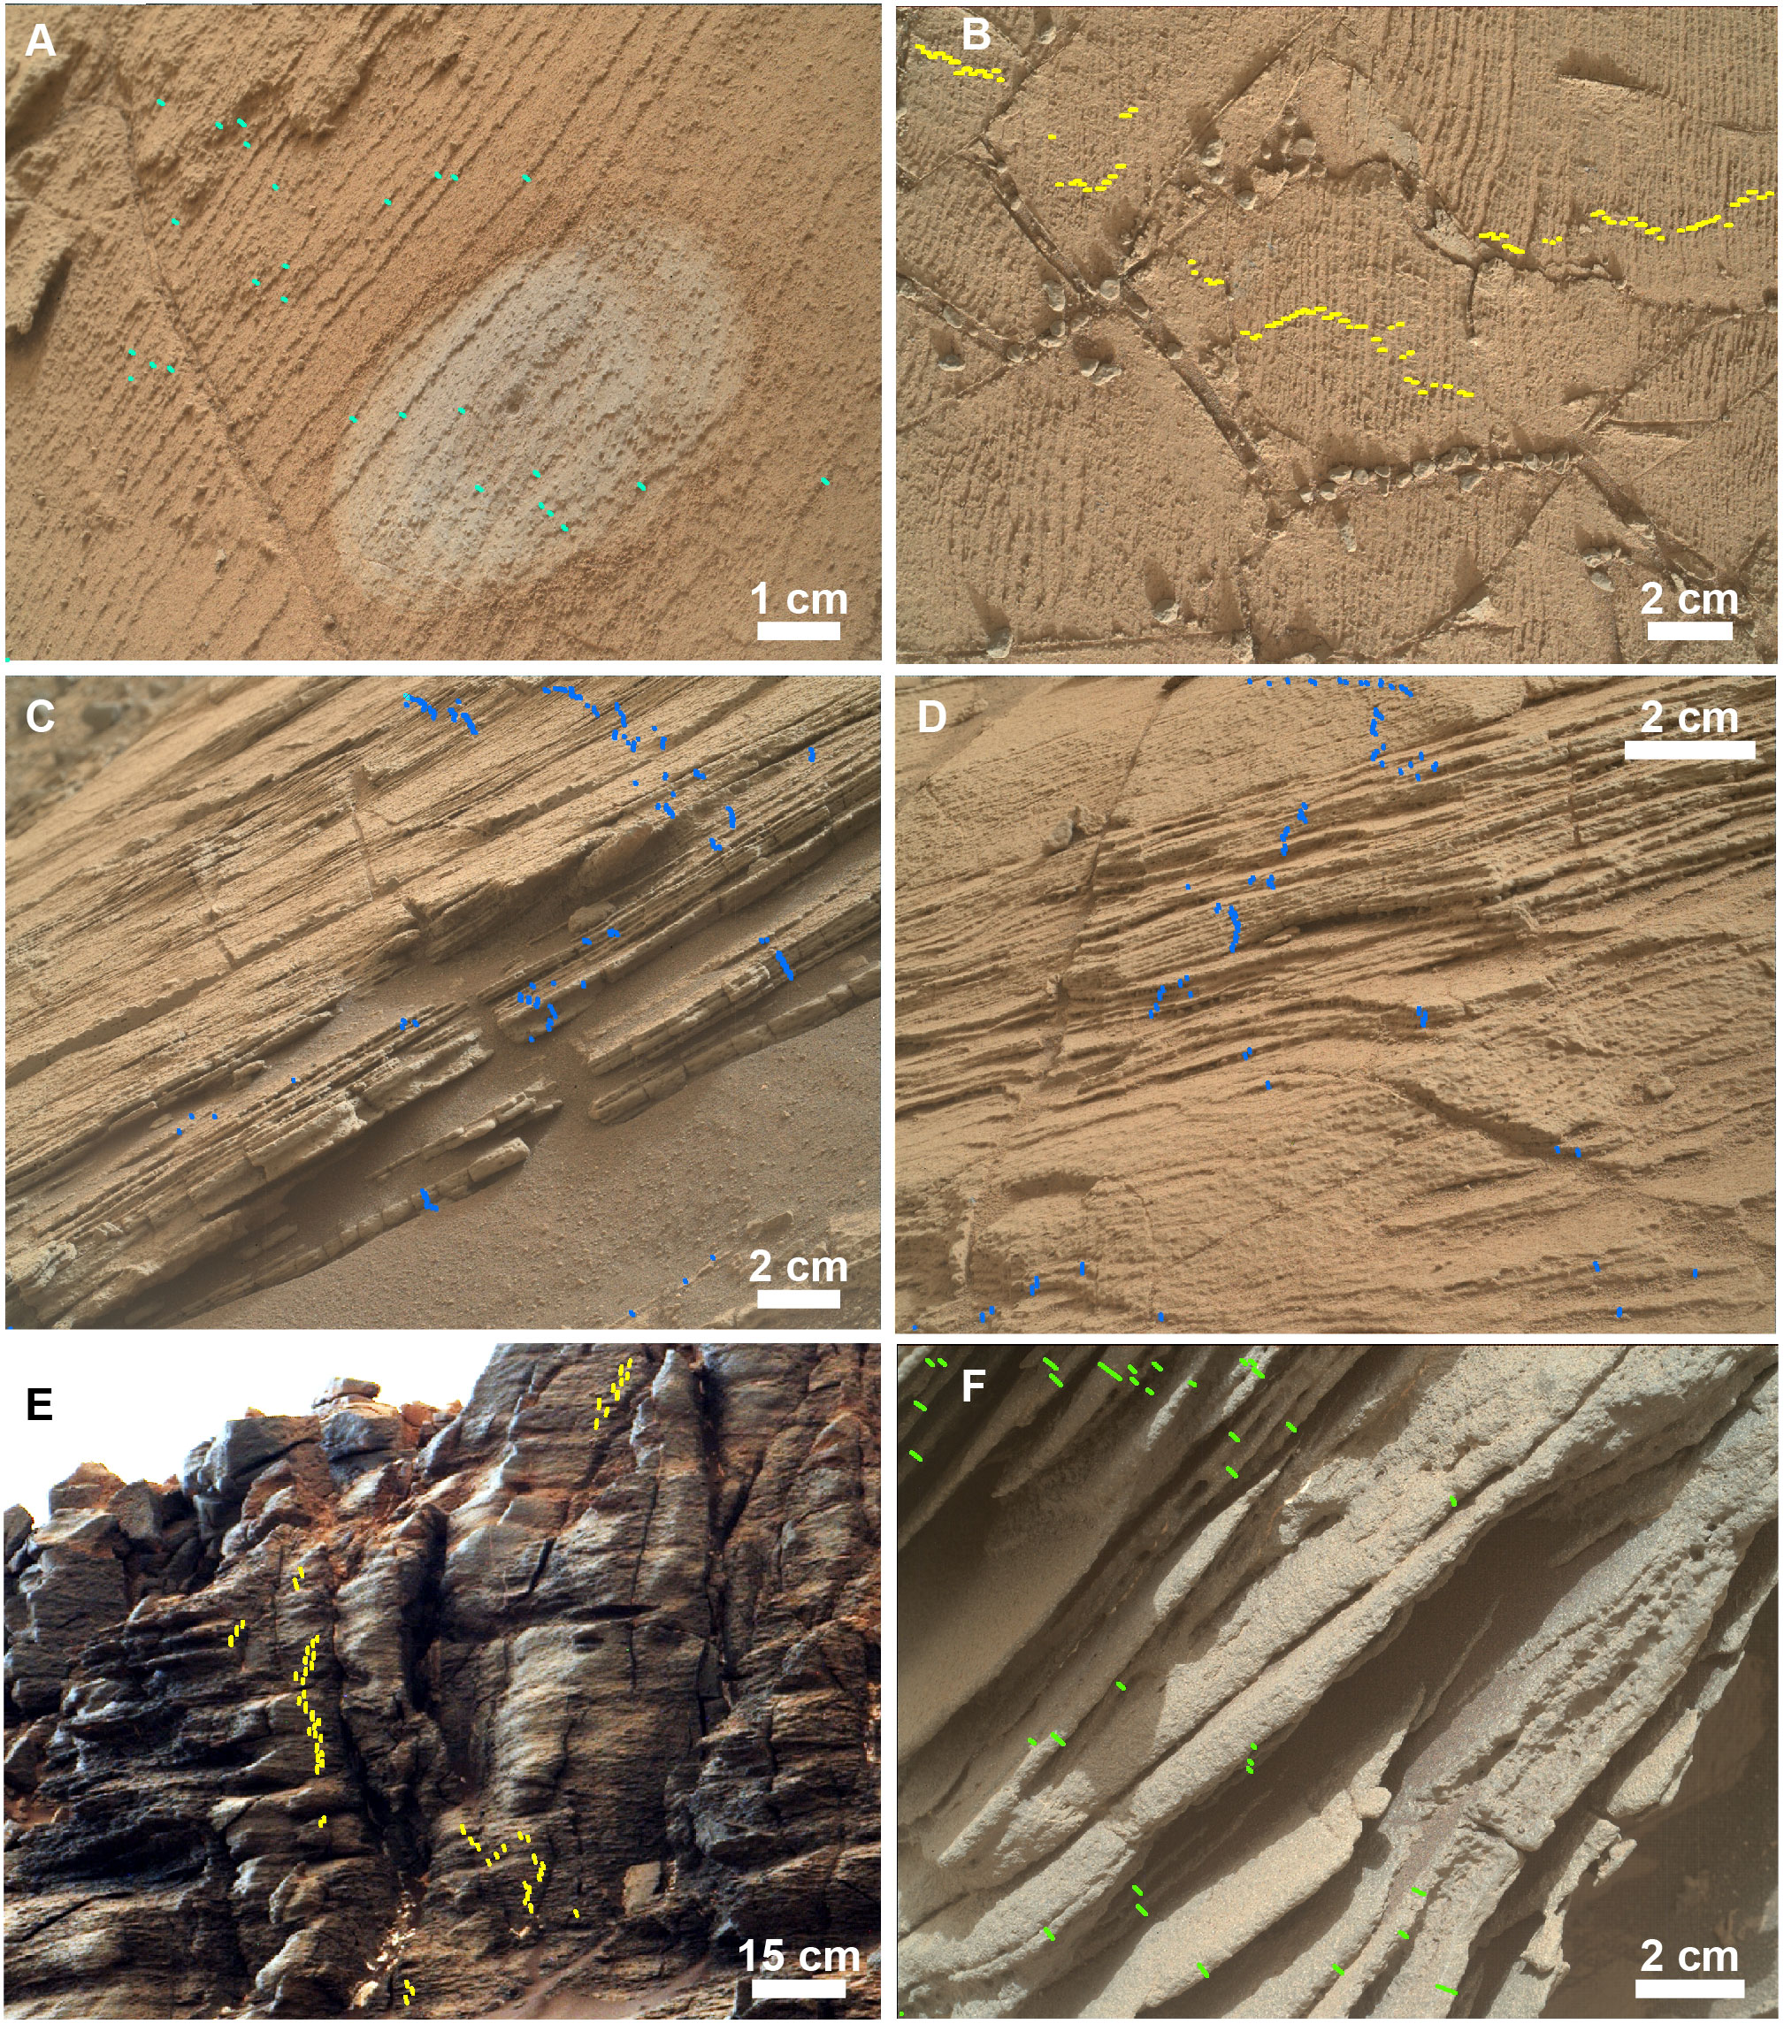
Fig. S3-1. Locations of laminae measurements at Pahrump Hills outcrop. (A) Annotated thickness measurements (cyan) for laminations within the Pelona target at Shoemaker. MAHLI z-stack 0806MH0004420000300701R00 acquired on Sol 806, (B) Annotated thickness measurements (yellow) for laminations at Telegraph Peak. MAHLI image 0905MH0004240010302857C00 acquired on Sol 905, (C) Annotated thickness measurements (blue) for laminations at Chinle. MAHLI image 0828MH0004540000301734R00 acquired on Sol 828, (D) Annotated thickness measurements (blue) for laminations at Chinle. MAHLI image 0833MH0002270000301900R00 acquired on Sol 833, (E) Annotated thickness measurements (yellow) for laminations within Salsberry Peak. Mcam03776 acquired Sol 855, (F) Annotated thickness measurements (green) for laminations within the Sierra Nevada block at Whale Rock. MAHLI image 0860MH0001900010301979C00 acquired on Sol 860.

