C6H13O2-1 | 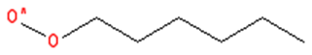 | 1-peroxyl-hexane
C6H13O2-2 | 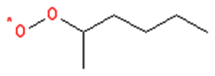 | 2-peroxyl-hexane
C6H13O2-3 | 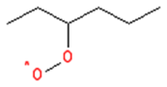 | 3-peroxyl-hexane
C6H12OOH1-3 | 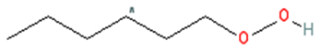 | 1-hydroperoxy-3-hexyl
C6H12OOH2-4 | 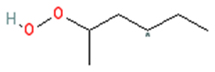 | 2-hydroperoxy-4-hexyl
C6H12OOH3-5 | 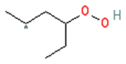 | 3-hydroperoxy-5-hexyl
C6H12OOH1-3O2 | 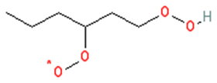 | 1-hydroperoxy-3-peroxyl-hexane
C6H12OOH2-4O2 | 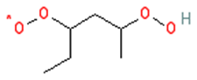 | 2-hydroperoxy-4-peroxyl-hexane
C6H12OOH3-5O2 | 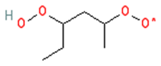 | 3-hydroperoxy-5-peroxyl-hexane
NC6KET13 | 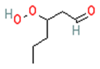 | 3-hydroperoxy-hexaldehyde
NC6KET24 | 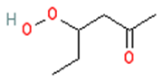 | 4-hydroperoxy-2-hexanone
NC6KET35 | 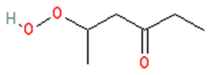 | 5-hydroperoxy-3-hexanone
Names and structures of some important LTC species
in LLNL reaction model

