Supplementary Information for
Differing Toxicity of Ambient Particulate Matter (PM)
in Global Cities

Jing Li^{1,2}, Haoxuan Chen¹, Xinyue Li¹, Minfei Wang¹, Xiangyu Zhang¹, Junji Cao^{3,*}, Fangxia Shen⁴, Yan Wu⁵, Siyu Xu⁶, Hanqing Fan⁷, Guillaume Da⁸, Ru-jin Huang³, Jing Wang^{9,10}, Chak K. Chan¹¹, Alma Lorelei De Jesus¹², Lidia Morawska¹², and Maosheng Yao^{1,*}

Correspondence to:
Maosheng Yao, email: Yao@pku.edu.cn, College of Environmental Sciences and Engineering, Peking University, Beijing 100871, China
Junji Cao, email: cao@loess.llqg.ac.cn, Institute of Earth Environment, Chinese Academy of Sciences, Xi'an 710049, China

This PDF file includes:

Tables S1 to S5
Figures S1 to S3
Captions for Excel files S1 to S2

Other Supplementary Materials for this manuscript include the following:

Excel files S1 to S2

Supplementary Tables
Table S1 Meteorological information in 19 sampling cities acquired from ClimaTemps (http://www.climatemps.com/)
City | Daily min. temp. (°C) | Daily max. temp. (°C) | Relative humidity (%) | Annual Precipitation (mm)
Seoul-KR | 8.21 | 16.88 | 68.5 | 1344
Beijing-CN | 6.49 | 17.67 | 55 | 548
Shanghai-CN | 12.45 | 19.85 | 68 | 1112
Guangzhou-CN | 18.66 | 26.23 | 81 | 1683
Hong Kong-CN | 21.37 | 25.6 | 78 | 2398
Brisbane-AU | 16 | 25 | 66.8 | 1225
Florianopolis-BR | 17.45 | 24.15 | 80 | 1544
Haikou-CN | 21.03 | 27.83 | 82 | 1625
Chennai-IN | 24.18 | 32.88 | 69.8 | 1312
Stolberg-DE | 5.58 | 13.22 | 65.5 | 663
Paris-FR | 8.54 | 15.52 | 78.1 | 650
Zurich-CH | 4.93 | 12.65 | 78.6 | 1086
Melbourne-AU | 11 | 20 | 55.8 | 639
Tours-FR | 6.9 | 15.4 | 79.6 | 684
Warsaw-PL | 4 | 12 | 78.3 | 515
Johannesburg-ZA | 10.08 | 21.9 | 59.2 | 713
Singapore-SGP | 23.92 | 30.86 | 80.4 | 2150
Bandung-ID | 18.6 | 27.8 | 80.6 | 1838
San Francisco-US | 9 | 19 | 68.3 | 500

Table S2 Spearman’s correlations of endotoxin fractions in PM with bacteria/fungal levels and the mass concentrations of PM_{2.5} and PM₁₀ across world cities.
Spearman’s correlation |  | Total bacteria (cells/mg) | Culturable bacteria (CFU/mg) | Culturable fungi (CFU/mg) | PM_{2.5} mass conc. (μg/m³) | PM₁₀ mass conc. (μg/m³)
Endotoxin (EU/mg) | Coef. | 0.489* | 0.172 | 0.163 | 0.560* | 0.459*
 | Sig. | 0.033 | 0.475 | 0.498 | 0.013 | 0.047
*p-value < 0.05.

Table S3 Spearman’s correlations of NIOG values with biological fractions and the mass concentrations of PM_{2.5} and PM₁₀ across world cities.
Spearman’s correlation |  | Endotoxin (EU/mg) | Total bacteria (cells/mg) | Culturable bacteria (CFU/mg) | Culturable fungi (CFU/mg) | PM_{2.5} mass conc. (μg/m³) | PM₁₀ mass conc. (μg/m³)
NIOG | Coef. | 0.009 | -0.112 | -0.258 | -0.481* | 0.296 | 0.202
 | Sig. | 0.968 | 0.641 | 0.281 | 0.037 | 0.213 | 0.401
*p-value < 0.05.

Table S4 Friedman Tests of Xi’an PM_{2.5}-contained trace elements in PM_{2.5} samples among 2004, 2009 and 2014 during summer and winter, respectively.
 | Friedman Tests Sig.
 | Summer (2004, 2009, 2014) | Winter(2004, 2009, 2014)
P | 0.074 | 0.311
Ca | 0.247 | 0.311
Ti | 0.247 | 0.311
V | 0.247 | 0.223
Cr | 0.549 | 0.846
Co | 0.819 | 0.607
Ni | 0.165 | 0.846
Cu | 0.549 | 0.311
Zn | 0.449 | 0.223
As | 0.247 | 0.311
Se | 0.282 | 0.011*
Mo | 0.247 | 0.069
Cd | 0.007* | 0.069
Tl | 0.074 | 0.135
Pb | 0.007* | 0.115
Th | 0.327 | 0.834
U | 0.015* | 0.311
Na | 0.022* | 0.513
Mg | 0.165 | 0.115
Al | 0.232 | 0.070
K | 0.091 | 0.846
Mn | 1.000 | 0.846
Fe | 0.449 | 0.311
Ba | 0.247 | 0.115
*p-value < 0.05.

Table S5 Spearman’s correlations of Xi’an PM_{2.5} NIOG values with PM_{2.5}-borne bacteria (PM_{2.5} sample size: 72) and different PM_{2.5}-borne trace elements in summer and winter (PM_{2.5} sample size: 36)
 | Spearman’s correlations
 | Coef. | Sig.
Total bacteria | 0.250* | 0,038
P | 0.346* | 0.045
Ca | 0.329 | 0.057
Ti | 0.318 | 0.066
V | -0.045 | 0.798
Cr | 0.373* | 0.030
Co | 0.021 | 0.907
Ni | 0.018 | 0.919
Cu | 0.125 | 0.477
Zn | 0.242 | 0.166
As | -0.035 | 0.841
Se | -0.293 | 0.092
Mo | 0.365 | 0.034
Cd | 0.119 | 0.499
Tl | 0.016 | 0.927
Pb | 0.106 | 0.546
Th | -0.077 | 0.663
U | 0.113 | 0.520
Na | 0.459* | 0.007
Mg | 0.319 | 0.065
Al | -0.337 | 0.051
K | 0.062 | 0.725
Mn | 0.183 | 0.298
Fe | 0.215 | 0.220
Ba | 0.225 | 0.200
*p-value < 0.05.

Supplementary Figures
Fig. S1 The correlation of the average ratio of culturable bacteria to fungi (B/F ratio) in ambient PM samples from 19 cities with annual average relative humidity (RH) and annual precipitation of these 19 cities.

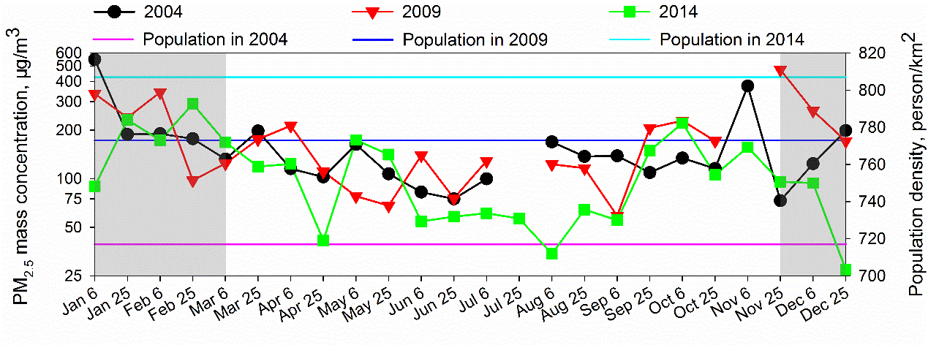
Fig. S2 24-hour average PM_{2.5} mass concentrations in 2004, 2009 and 2014; solid line: population density of Xi’an city in 2004, 2009 and 2014 according to Xi’an Statistical Yearbook (2005, 2010 and 2015)³; shadow zone: the yearly heating seasons (from November 15 to March 15) in Xi’an.

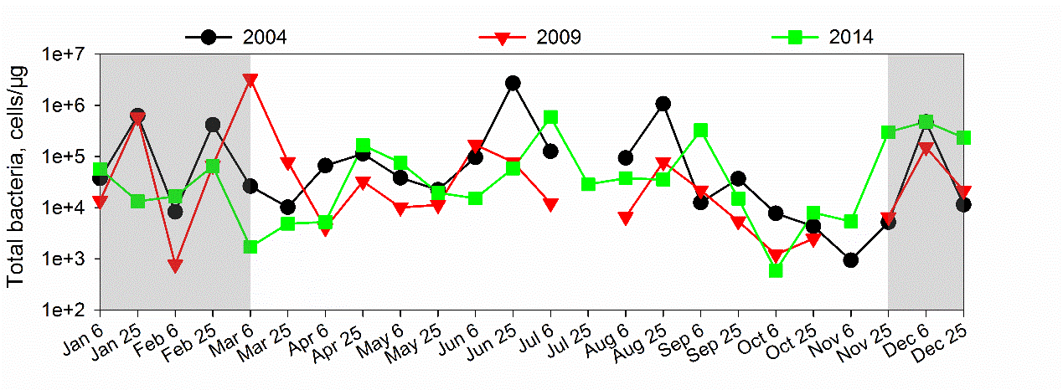
Fig. S3 Concentrations of PM_{2.5}-borne total bacteria in 2004, 2009 and 2014; shadow zone: the yearly heating seasons (from November 15 to March 15) in Xi’an.

Captions for Excel files S1 to S2
Excel file S1
The information of total PM_{2.5} samples collected in Xi’an, China.

Excel file S2
The statistical data for energy consumption and the permanent population in Xi’an, China from 2004 to 2014.

