Supplementary Online Material
Ingersoll, A. P., Ewald, S. P., Trumbo, S. K., 2019. Time Variability of the Enceladus Plumes: Orbital Periods, Decadal Periods, and Aperiodic Change

1. Supplementary Figure 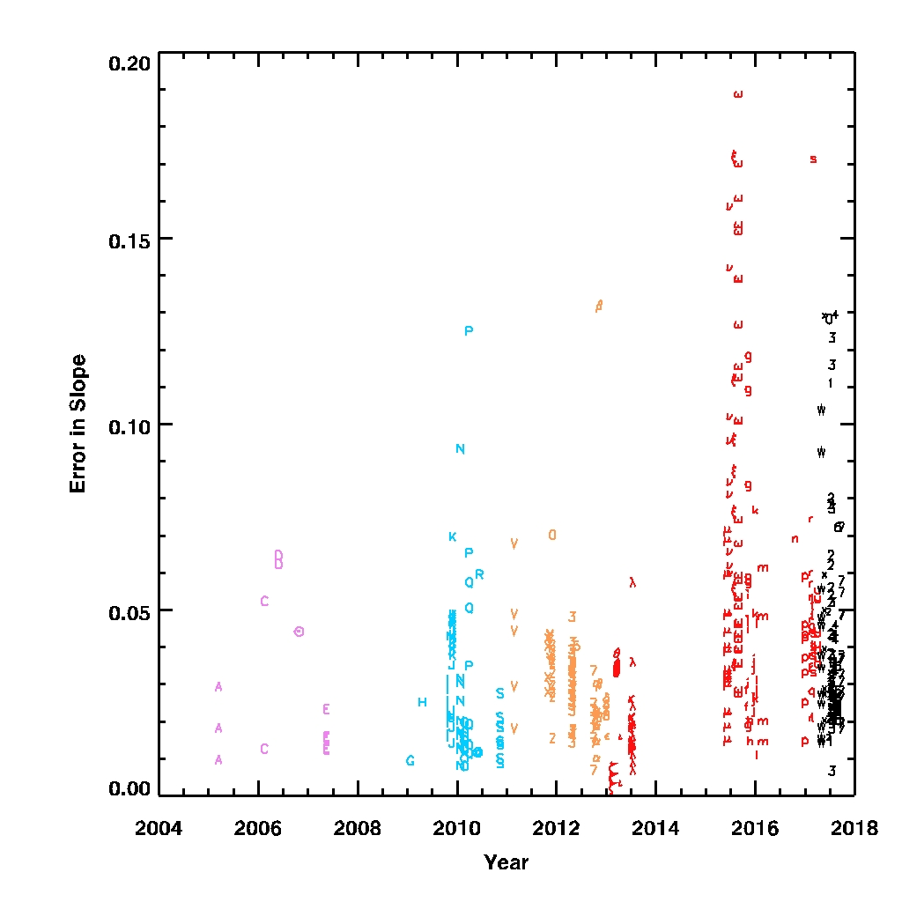

Figure S1. Error estimate for the slope d(log S)/d(log Z) shown in Figure 12.

2. Supplementary Description of Image Preparation

To find images suitable for processing, we searched the Planetary Data System (https://pds.nasa.gov/) for observations that specified target = Enceladus. Using the NAIF/SPICE subroutine library (version ICY 1.6.0, 03-May-2010) and kernel files from the FTP site at the Jet Propulsion Laboratory, we rejected observations where the scattering angle was larger than 30° or the spacecraft/Enceladus distance was larger than 16.5 times the radius of Saturn (projected image width > 6000 km). The former step was taken because the plume is much fainter at large scattering angles, and the latter step was taken because the spatial resolution was poorer at large distances. The NAIF kernels that we used are given in Supplementary Table S1.

We used CISSCAL (version 3.4 with IDL version 6.2; Porco et al., 2004; West et al., 2010) to convert the pixel values in the images to I/F, where I is the measured intensity in one of the ISS filters and πF is the incident solar flux at Enceladus in the same filter bandpass. CISSCAL also does flat-fielding and masking of saturated pixels. We manually examined all images and rejected those (1) with Saturn or other objects in the background, (2) with stray light clouding parts of the image, (3) with excessive electronic noise, and (4) those with large numbers of cosmic ray hits. Supplementary Table S2 gives the image ID number, event time, mean anomaly, spatial resolution, and the alphanumeric character [A–Z, 1–9 (red), α-ω, a-z, 0-7 (black)] for each of the 2415 images that were used in our study. Supplementary Table S3 gives the image ID number and event times for each of the 522 potentially useful images that were not used in our study.

Precise knowledge of the altitude requires precise knowledge of camera pointing. Uncertainties arise because the observation geometry changes rapidly as Cassini flies past Enceladus. In some cases, the bright limb of Enceladus provides a suitable reference point. In other cases the limb and the plume are overexposed, so the limb is invisible. In many of these cases we were able to use the dark limb, which stands out against the relatively bright E ring background. In some cases the camera missed Enceladus altogether and no limb was visible. These images were rejected, although they might become useful if enough stars could be identified in the background. Most of the images had the planet’s spin axis perpendicular to lines of pixels, and the others were rotated into this geometry to make the processing more uniform.

3. Supplementary Tables

Table S1. List of NAIF/SPICE kernels used in this analysis.
See Excel file Table S1.

Table S2. Catalog of all images used in the analysis. This is a separate Excel spreadsheet. There are 2415 images. The entries for each image are: filename, event time, alphanumeric group, filter, mean anomaly, pixel scale, scattering angle, slab density at 100 km, and the divisor used to convert I/F to kg/km⁻² .
See Excel file Table S2.

Table S3. Catalog of 522 Enceladus images with scattering angles less than 40° that were not used in the analysis. This is a separate Excel spreadsheet. Reasons for rejection include: other objects in the background, no visible limb for estimating altitude, saturated pixels, electronic noise, internal reflections, camera motion, insufficient background due to 45° rotation around camera axis. This table does not include images in the UV1 and IR3 filters, all of which were rejected either because they had low signal to noise or were outside the 0.8 – 11 km range of pixel scales.
See Excel file Table S3.

