

*Geophysical Research Letters*

Supporting Information for

**Atmospheric methane emissions correlate with natural gas consumption from residential and commercial sectors in Los Angeles**

Liyin He1,7, Zhao-Cheng Zeng1,7, Thomas Pongetti2, Clare Wong1,5, Jianming Liang3, Kevin R. Gurney3, Sally Newman1,6, Vineet Yadav2, Kristal Verhulst2, Charles E. Miller2, Riley Duren2, Christian Frankenberg1,2, Paul Wennberg1,4, Run-Li Shia1, Yuk L. Yung1,2 and Stanley P. Sander2,1*

1Division of Geological and Planetary Sciences, California Institute of Technology, Pasadena, California 91125

2Jet Propulsion Laboratory, California Institute of Technology, Pasadena, California 91109

3School of Informatics, Computing and Cyber Systems, Northern Arizona University, Flagstaff, Arizona 86011

4Division of Engineering and Applied Science, California Institute of Technology, Pasadena, California 91125

5Now at California State University, Northridge, California 91330

6Now at Bay Area Air Quality Management District, San Francisco, California 94105

7These authors contributed equally.

Corresponding author: **Stanley P. Sander** ([**ssander@jpl.nasa.gov**](mailto:ssander@jpl.nasa.gov))

**Contents of this file**

Text S1 to S3

Figures S1 to S13

**Text S1 Background XCH4 and XCO2 correction**

To derive an unbiased background XCH4 and XCO2 along the same path of the CLARS target mode, we combined the CLARS Spectralon retrievals and NOAA in situ flash dataset at Mt. Wilson (National Oceanic and AtmosphericAdministration, 2019). The NOAA in situ flash dataset gives the background estimate using in situ flask-based sampling at Mt. Wilson next to the CLARS facility. At night, the height of the boundary layer reduces to far below the CLARS facility and the flask record is very likely to represent background conditions for the lower troposphere over the region where there are no human activities. In areas not affected by human activities, the vertical profiles of XCO2 and XCH4 for the bottom 2-3km are very close (Tanaka et al. 2016). Therefore, to construct the background, we used the Spectralon measurements as the background for the atmosphere above the CLARS height, and the NOAA flask measurements at night as the background for the atmosphere below. in our calculation, we only used the nighttime flask samples collected between 22:00 and 6:00 LT. Corrected background XCH4 (or XCO2) can then be computed by averaging the mixing ratios of CH4 (or CO2) along the path 1, 2 and 3 weighted by their numbers of molecules, as shown in **Supplementary** **Figure S6(a)**, where the mixing ratio of path 1 is given by CLARS Spectralon retrievals and the mixing ratios of path 2 and 3 are given by NOAA in situ nighttime flash dataset. We can derive the corrected background XCH4 by the following formula (XCO2 in the similar way):

$corrected background X{CH}_{4} =\frac{c_{NOAA}^{{CH}_{4}}×\left(n_{2}+n_{3}\right)+c_{Spectralon}^{{CH}_{4}}×n_{1}}{n_{2}+n_{3}+n_{1}}$ (1)

where $c_{NOAA}^{{CH}_{4}}$ and $c_{Spectralon}^{{CH}_{4}}$ represent the mixing ratio obtained by NOAA in situ nighttime flash dataset and CLARS spectralon retrievals, respectively. $n_{1}$, $n_{2}$ and $n_{3}$ represent the number of air molecules along path 1, 2 and 3, respectively, which can be approximated by:

$n_{1}=\frac{P_{1}×S}{\left.gM_{air}cos{(}SZA\right)}$ (2)

$n_{2}=\frac{\left(P_{2}-P_{1})×S\right.}{\left.gM_{air}cos{(}SZA\right)}$ (3)

$n_{3}=\frac{\left(P_{2}-P_{1})×S\right.}{\left.gM_{air}cos{(}VZA\right)}$ (4)

where $P_{1}$ and $P_{2}$ are air pressures at the CLARS-FTS facility and the surface target, respectively; $g$ is the acceleration of gravity; S represents one unit area; $M_{air}$ represents the molar mass of air molecule. As a result, the corrected background XCH4 can be simplified by the following formula:

$corrected background X{CH}_{4} =c_{NOAA}^{{CH}_{4}}×F_{1}+c_{Spectralon}^{{CH}_{4}}×F_{2}$ (5)

where $F_{1}$ and $F_{2}$ are defined as:

$F_{1}=\frac{(P_{2}-P_{1})×(\cos\left(VZA\right)+\cos\left(SZA\right))}{P_{2}\cos\left(VZA\right)+(P_{2}-P_{1})\cos\left(SZA\right)}$ (6)

$F_{2}=\frac{P_{1}\cos\left(VZA\right)}{P_{2}\cos\left(VZA\right)+(P_{2}-P_{1})\cos\left(SZA\right)}$ (7)

The comparison between corrected background XCH4 and XCO2 and the CLARS spectralon retrievals are shown in **Supplementary Figure S6(b)**.

**Text S2 Hestia-LA CO2 emission inventory dataset**

Hestia-LA is a high spatial resolution bottom-up CO2 emission dataset that has been developed for the Los Angeles Basin (Gurney et al., 2012, 2019). Hestia-LA provides CO2 emissions associated with the combustion of fossil fuel and cement production in five counties (Los Angeles, Orange, San Bernardino, Riverside and Ventura) in the LA Basin (**Supplementary Figure S8**). The Hestia dataset provides more accurate estimates for CO2 emission in the LA Basin than other widely used datasets such as Open-source Data Inventory for Anthropogenic CO2 and Fossil Fuel Data Assimilation System (Wong et al., 2015). The random and systematic error in the Hestia-LA gives the uncertainty around 11% with 95% confidence interval (Gurney et al., 2019). We used Hestia Version 2.5 in this study to estimate monthly CH4 emissions, which was recently released in 2018 and expected to be a more accurate spatiotemporal inventory for the LA Basin. Hestia data are available from 2011 to 2014. We extrapolate using multivariable linear regression model to derive the emissions in 2015, 2016 and 2017. First, we used the monthly state-wide energy consumption of coal, geothermal, natural gases, other gases (including blast furnace gas and other manufactured and waste gases derived from fossil fuels), and petroleum electric power industry (U.S. Energy Information Administration, 2018) as independent variables (Hestia-LA CO2 emissions as dependent variable) to construct a regression model (**Supplementary Figure S9**). Then we applied this model to the year 2015, 2016, and 2017 to calculate their emissions. Hestia-LA data can be obtained by contacting Kevin Gurney ([Kevin.Gurney@nau.edu](mailto:Kevin.Gurney@nau.edu)).

**Text S3 Spike in emissions due to Alison Canyon**

The peak blowout of Aliso Canyon methane leakage occurred in November 2015. If we compare the November methane emissions for different years, as shown in Figure 1, we can clearly see the emission spike in November 2015, which agrees with the blowout time of Aliso Canyon methane leakage. This may be not clear from Figure 2 is because it is interfered by the high values in December from other years (especially 2012).

One of the assumptions underlying in the methane emission derivation is that the 33 discrete surface target sites are sufficient to represent the average $\frac{{XCH}_{4xs}}{{XCO}_{2xs}}$ over SOCAB. During the Aliso Canyon blowout period, the enhancement of $\frac{{XCH}_{4xs}}{{XCO}_{2xs}}$ varies among different target sites, depending on the distance with the Aliso Canyon, as well as the wind speed and direction. In Figure S4, monthly $\frac{{XCH}_{4xs}}{{XCO}_{2xs}}$ in the beginning of Alison Canyon blowout (November, 2015) is the highest from 2011 to 2017.



**Figure S1.** Schematic diagram of CLARS-FTS observation geometries. CLARS has two modes of observation: (1) the Los Angeles Basin Survey mode (LABS; indicated by the red arrows) in which the instrument targets reflection points in the LA basin and retrieves the GHG slant column abundances influenced by the boundary layer and (2) the Spectralon Viewing Observation mode (SVO; indicated by the blue arrow) which measures the background GHG slant column abundances influenced by in the free troposphere.

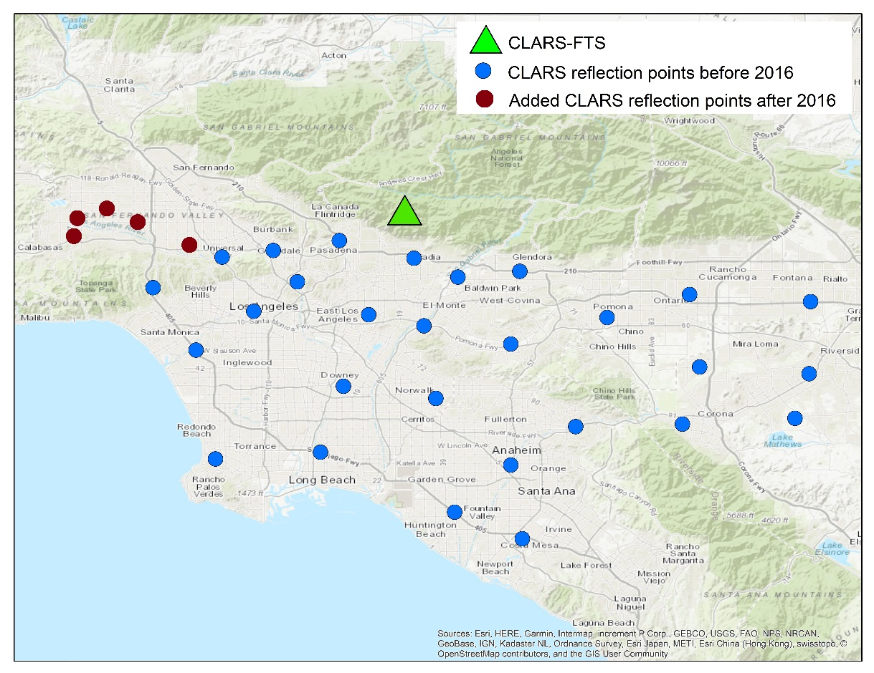

**Figure S2**. The spatial distribution of the 33 reflection points targeted by CLARS-FTS from its location on Mount Wilson. Precise locations of the target points (colored blue) are given by Wong et al. (2015). After November 2015, five new target points were added (red points).

(a)

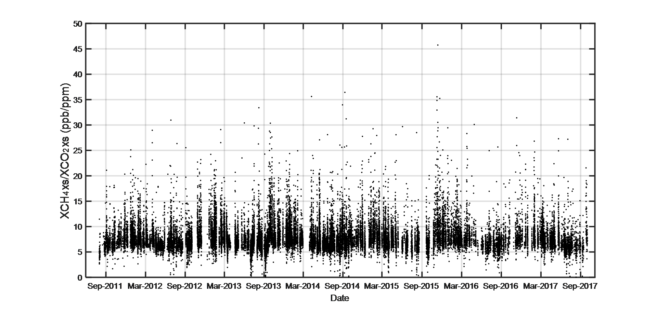

(b)



**Figure S3.** (a) Time series of XCH4xs/XCO2xs (in units of ppb ppm-1), including all measurements from CLARS-FTS from all surface targets in the LA basin from September 2011 to August 2017; (b) Same as (a), but shown as monthly averages. The associated uncertainty is indicated by the grey shading. See **Methodology** for the description.

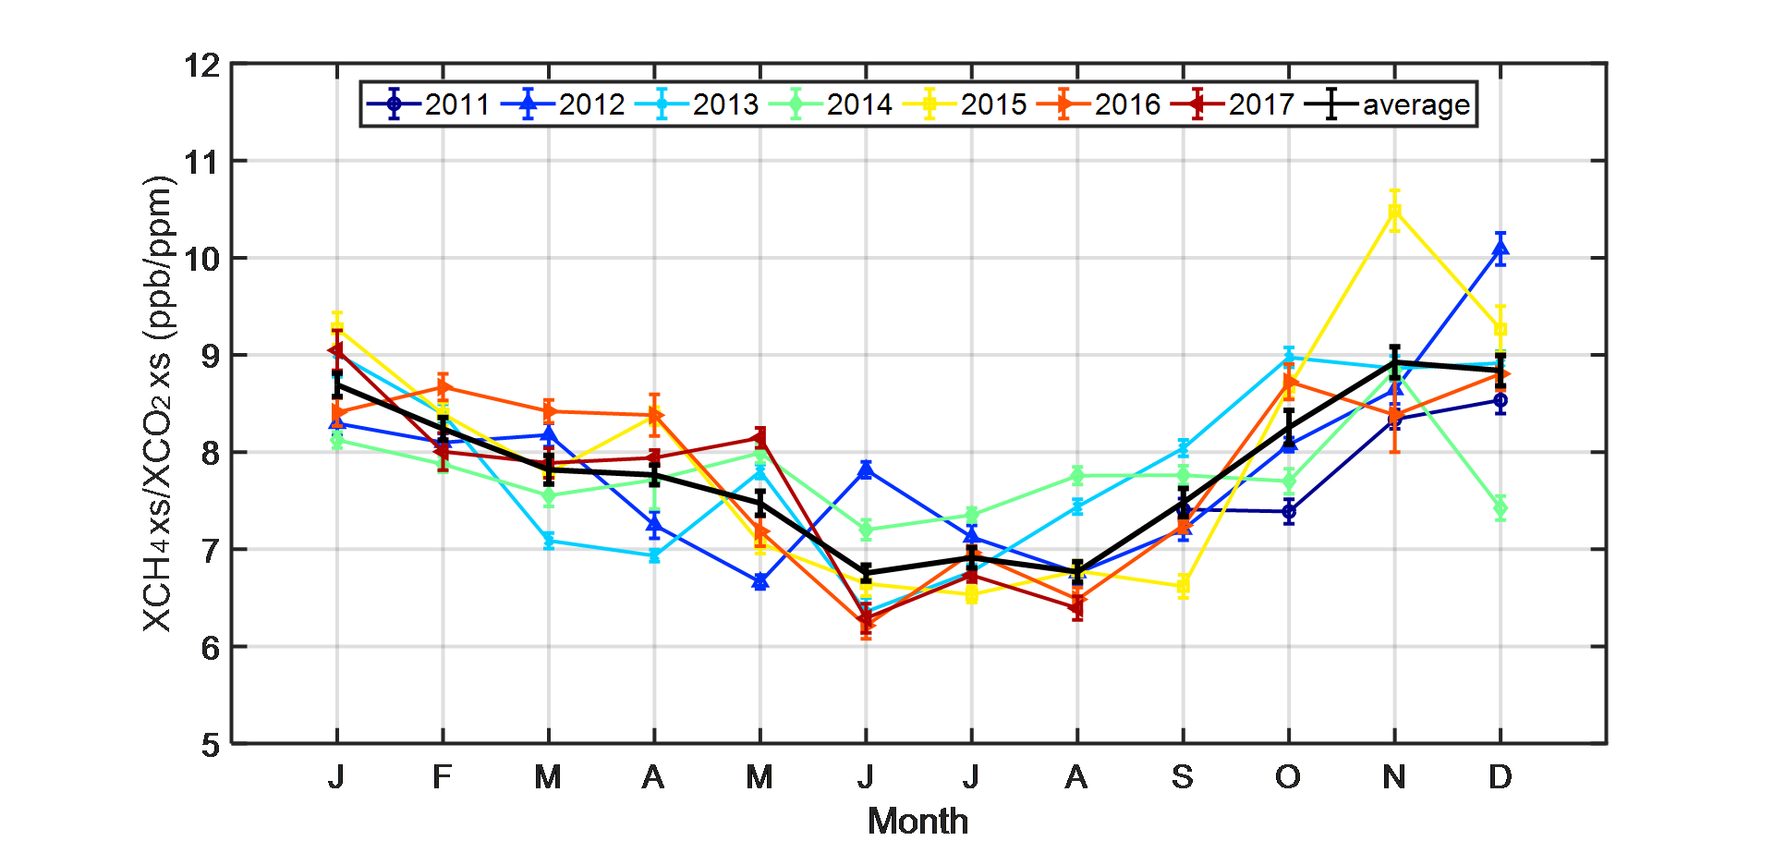

**Figure S4.** Monthly means of XCH4xs to XCO2xs ratio (in units of ppb ppm-1) and their corresponding uncertainties for all surface targets in the LA basin from September 2011 to August 2017. The uncertainty is calculated as the standard error of the observations for each month. The black line indicates the averaged ratio and standard deviation of the seven-year data record.

(a)

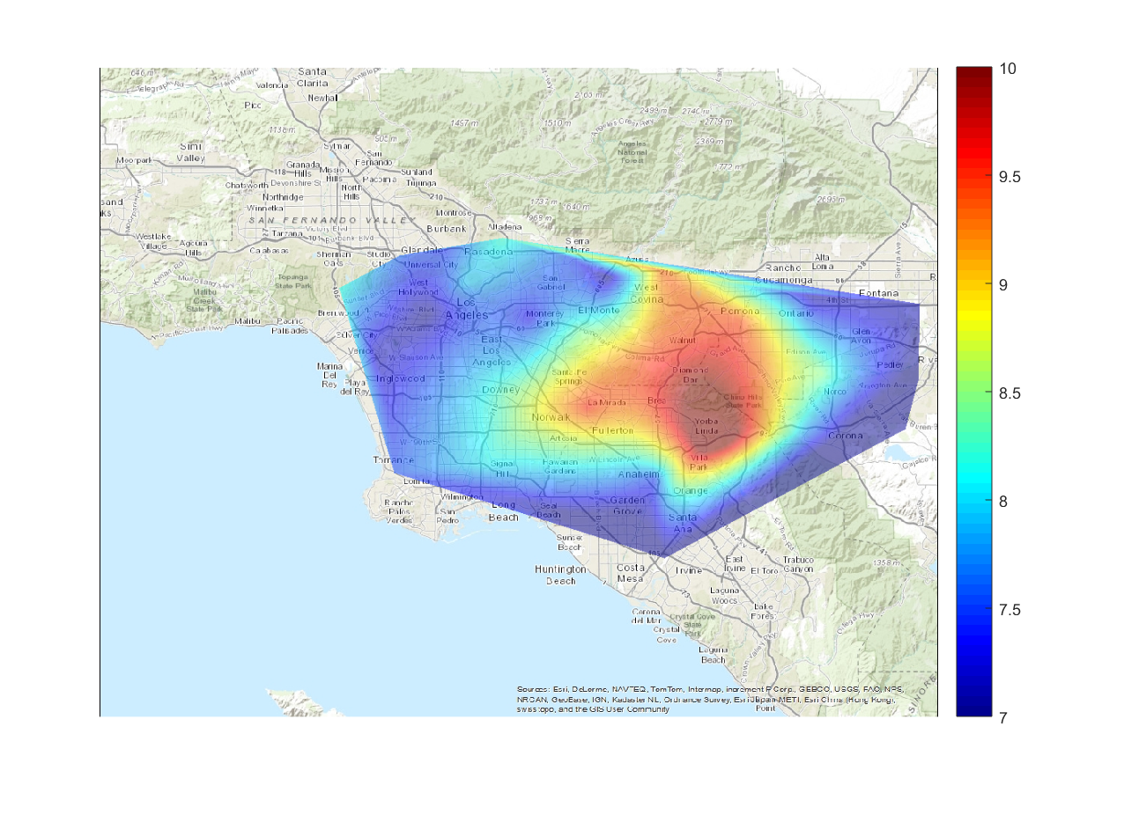

(b)

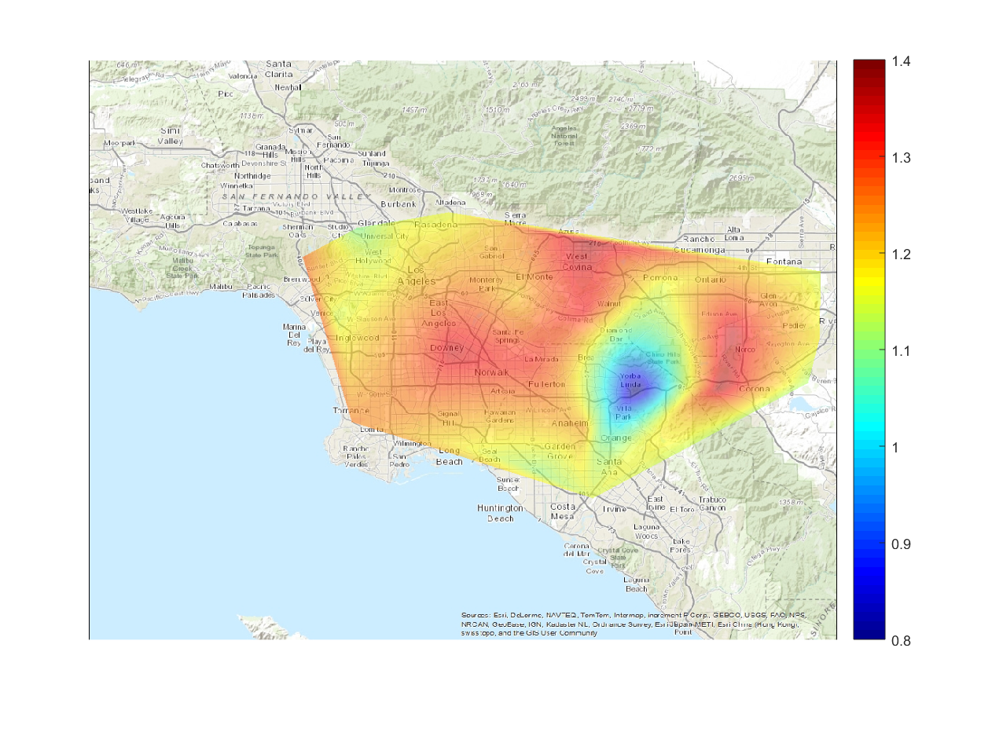

**Figure S5**. (a) The map of average XCH4xs/XCO2xs ratio from 2011 to 2017 in the LA basin. The five surface targets in the north-west part of the basin are not included since their measurements are only available after November 2015. (b) The averaged winter-summer ratio of XCH4xs/XCO2xs, calculated by dividing the excess ratio in winter (December, January, and February) by that in summer (June, July, and August) and averaged from 2011 to 2017. This winter-summer ratio is an indicator of the seasonal magnitudes of the XCH4xs/XCO2xs as shown in **Supplementary Figure S4**.

(a)

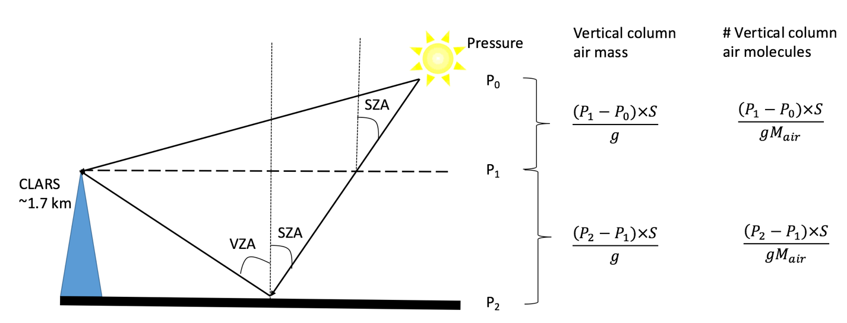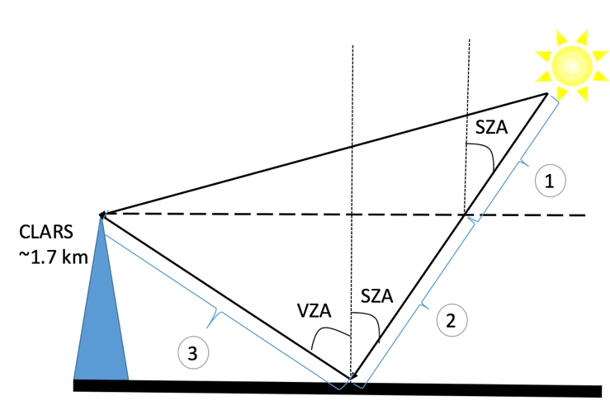

(b)

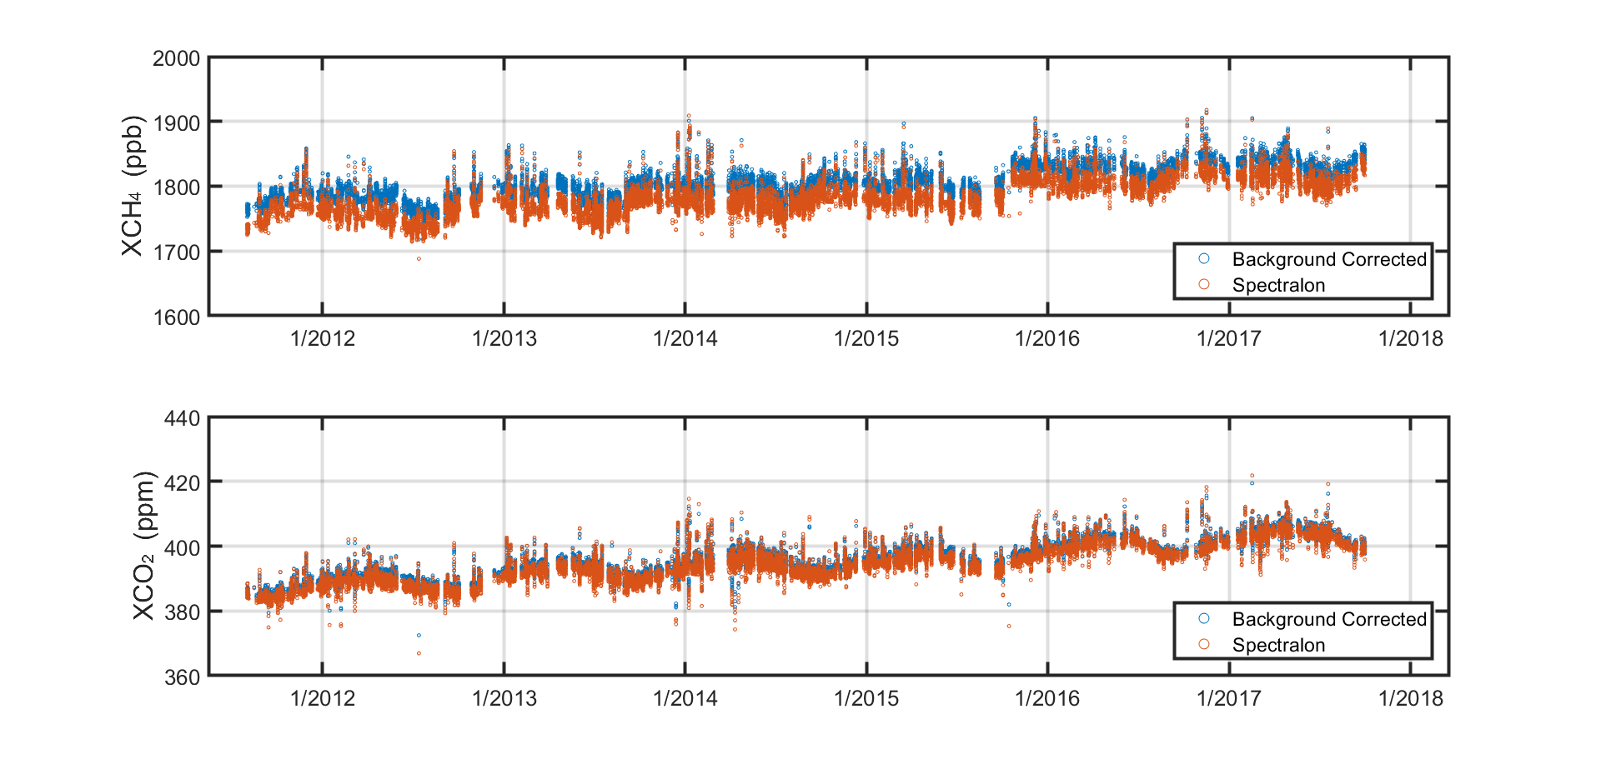

**Figure S6.** (a) Schematic graph to demonstrate the calculation of background XCH4 and XCO2 in the study area. Solar zenith angle (SZA) and view zenith angle (VZA) are involved as the geometry factor to calculate the slant column density of gas molecules. P0, P1, and P2 are the atmospheric pressures at top of atmosphere, CLARS height, and surface, respectively; S is the surface area and g is the acceleration of gravity (9.8 m/s2 in this study), and $M_{air}$ is the molar mass of air molecules. The details of the calculation are described in **Supplementary S1**; (b) Comparison of XCH4xs (upper panel) and XCO2xs (lower panel) between calculated background (see **Supplementary S1**) and the CLARS Spectralon retrievals from September 2011 to August 2017.



**Figure S7**. Monthly natural gas consumption from the residential, commercial, industrial and power plant sectors in the SOCAB, including the four counties of Los Angeles, Orange, Riverside, and San Bernardino. Residential, commercial and industrial data are available publicly on the SoCal Gas database (Southern California Gas Company, 2018).

Power plant data are provided by the California Energy Commission online database

(California Energy Commission, 2018). There are strong seasonal variabilities of natural gas consumption in all sectors. The consumption from the residential and commercial sectors peaks in winter, while the power plant sector usually peaks in late summer. The consumption from the industrial sector is variable with multiple peaks between autumn and spring.

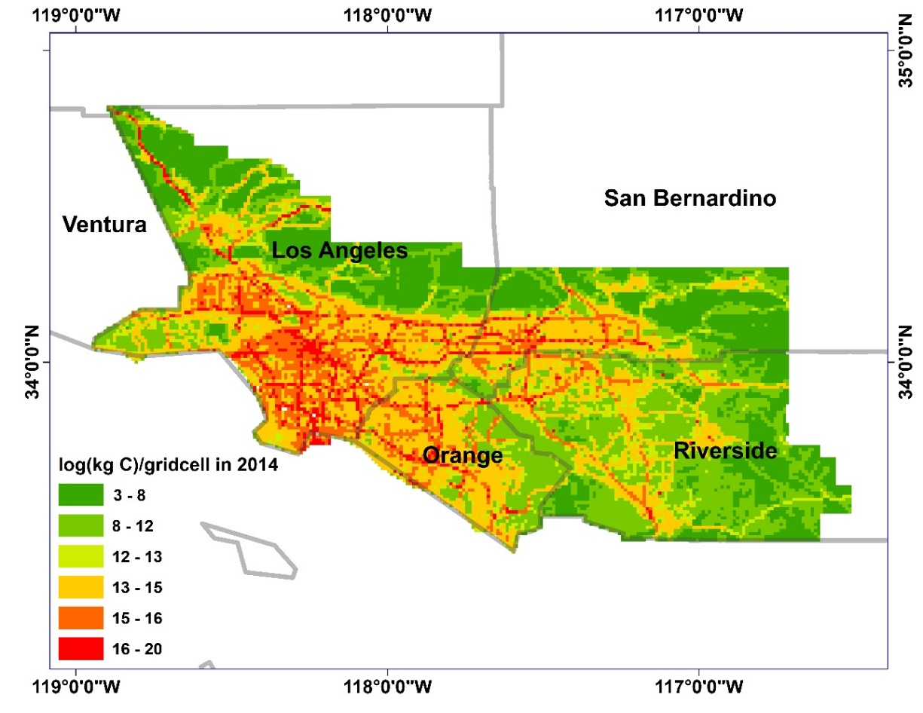

**CLARS coverage**

**Figure S8**. Spatial pattern of carbon dioxide emissions (in logarithmic scale) in the SOCAB in 2014 from Hestia v2.5 data (Gurney et al. 2019, 2012). Areas with larger carbon emissions are represented in red while areas with smaller carbon emissions are represented in green. The emission value represents the total within each 1km x 1km grid cell. The black box shows the coverage of CLARS, accounting for around 85% of total CO2 emissions in SOCAB.



**Figure S9**. Monthly mean CO2 emissions in the SOCAB from 2011-2017. The blue line shows the monthly emissions from Hestia v2.5 data from 2011 to 2014. The data are extrapolated for the years 2015, 2016 and 2017 using a multivariable linear regression model. This model is based on the observed linear correlation between CO2 emissions and monthly state-wide energy consumption of coal, geothermal, natural gas, other gases (including blast furnace gas, and other manufactured and waste gases derived from fossil fuels), and petroleum for the electric power industry. Since there is a strong and consistent seasonality in CO2 emissions, we include an additional regressor (month-dependent) in the regression model to capture the seasonality. All the energy consumption data are available from 2011 to 2017 (U.S. Energy Information Administration, 2018). The Hestia data and the reconstructed CO2 emissions from 2011 and 2014 is highly correlated (R2=0.92), indicating that the linear regression model should provide a reliable extrapolation for 2015-2017.



**Figure S10.** Similar to **Figure 2** in the main text but including power plant section in the natural gas consumption. These are time series of monthly CH4 emissions from 2011 to 2017 inferred from CLARS-FTS measurements (black line, left axis) and monthly natural gas consumption in the SOCAB, including consumption from the residential, commercial, industrial and power plant sectors (red dashed line, right axis). The uncertainty in monthly CH4 emissions is shaded in grey.

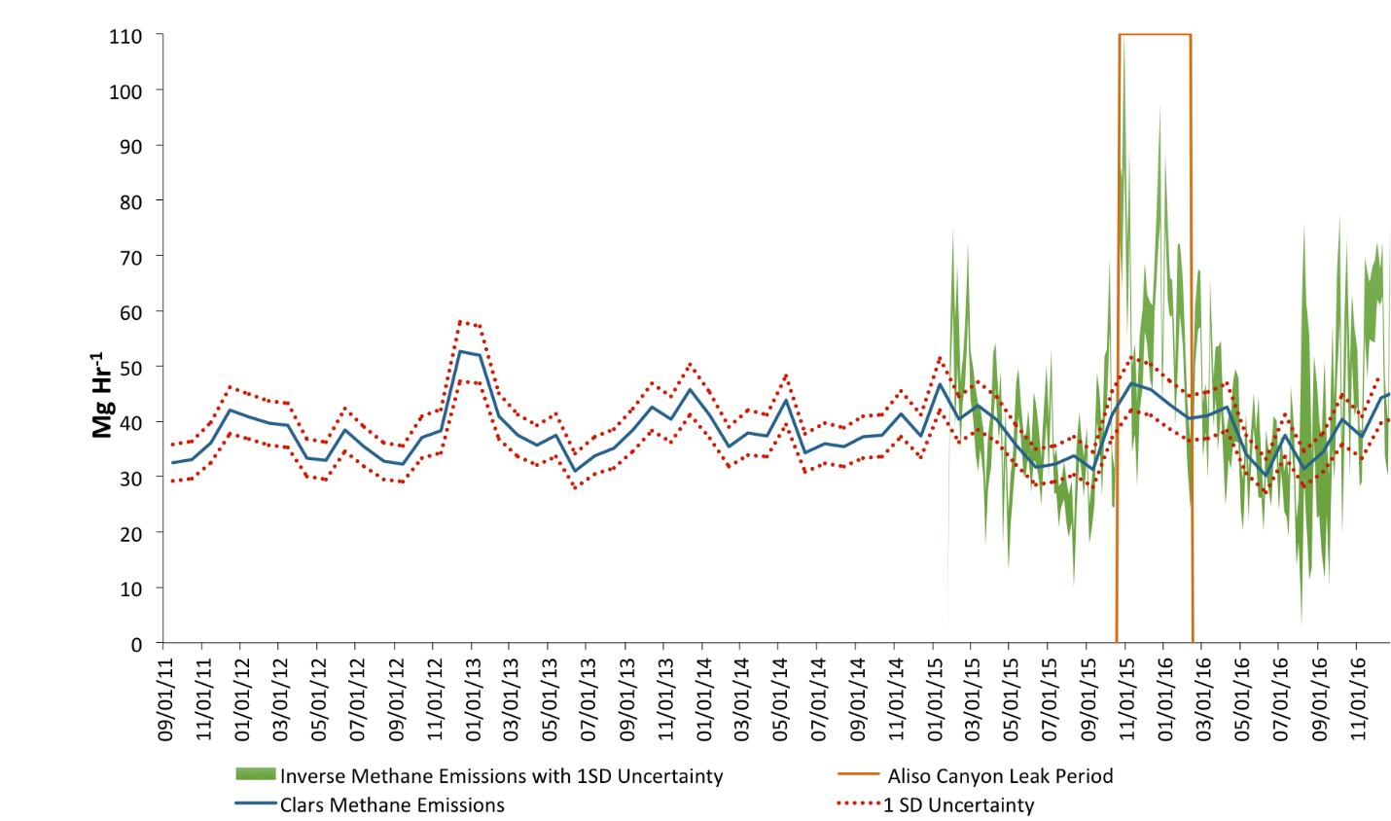

**Figure S11**. Comparison between CH4 emissions in the SOCAB derived from CLARS-FTS remote sensing data and from WRF-STILT inversions using *in-situ* tower data (Yadav et al., 2019).



**Figure S12.** Similar to Figure 3 in the main text but including power plant section in the natural gas consumption. This shows the correlation between monthly methane emissions inferred from CLARS measurements and the monthly total natural gas consumption, including residential, commercial, industrial and power plant, in SOCAB from September 2011 to August 2017. The red line is from the linear regression results. To investigate the contribution of different sectors of natural gas consumption on the CH4 emissions, the following multi-variable regression is implemented:

$$E_{CH4}|_{monthly}^{top-down}= a0+a1×\left(NG|_{monthly}^{residential}+NG|_{monthly}^{commercial}\right)+$$

$$a2×NG|_{monthly}^{industrial}+a3×NG|_{monthly}^{power plant}$$

The best-fit regression coefficients are 33.97, 0.0137, 0.0038 and -0.0172 for a0, a1, a2 and a3, respectively. 32.6% of the variance between the model and observations is explained by residential/commercial consumption, 9.1% is explained by industrial consumption, and 12.9% is explained by power plant consumption. The power plant sector is not included in the model described in the main text because of its relatively poorer correlation with derived CH4 emissions. R2 decreases by 7% when the power plant emissions are included in the regression model.

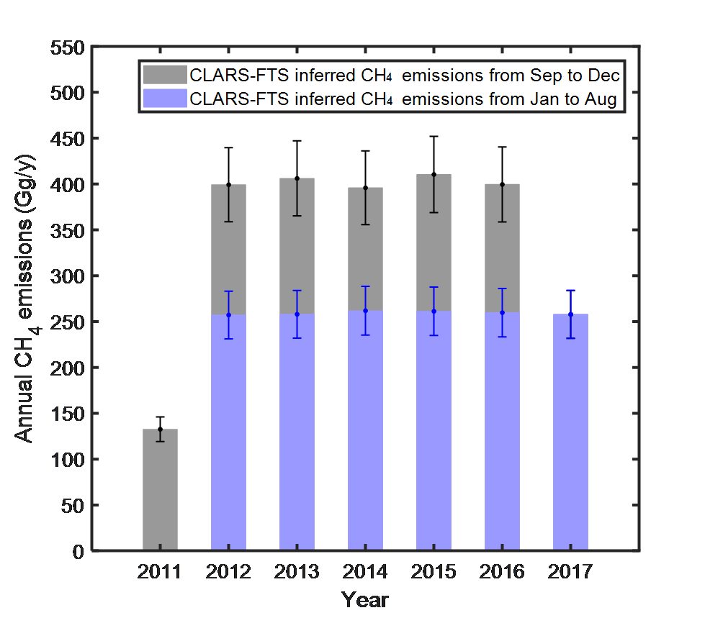

**Figure S13.** CH4 emissions and uncertainties in SOCAB inferred from CLARS measurements from September 2011 to August 2017. For the sake of comparison, CH4 emissions from Sep to Dec within a year is shown as grey bars and from Jan to Aug is shown as light blue bars. As indicated from this figure, there is no significant trend for annual methane emissions from 2011 to 2017.